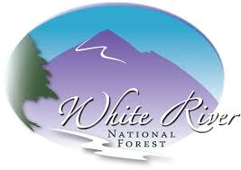
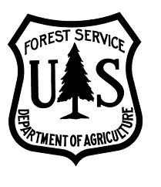
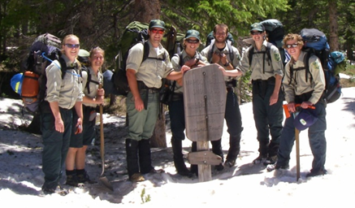
Wilderness Ranger Internship Opportunities

Colorado
2015
June 1st
to
August 17th
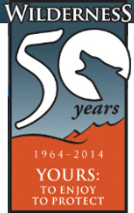
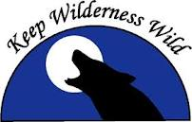
White River National Forest

Desired Qualifications/Experience:
Demonstrated outdoor leadership with backcountry travel and living skills
Physically fit, self-reliant, problem solver
Good public communication skills
Traditional tool use, safety and maintenance
Wilderness Act, ethics and Leave No Trace knowledge/practice
Natural system understanding
Multi-day backpacking experience
Clear, detailed reporting of pertinent
observations
GPS, GIS and photo/video editing familiarity
Critical safety awareness
Commitment to program dates (6/01 – 8/17)
Enrolled in an accredited internship course
Able and interested to extend season through September
Position Duties Include:
4 day backpacking patrols of ~30 miles at high elevation in seasonal conditions over weekends and holidays
Carrying a 50 lb pack plus tools
Visitor education on Wilderness ethics/regulations
Trail maintenance using traditional tools
Natural and social resource monitoring
Restoration of impacted sites
Sign/TH installation and maintenance
Invasive species treatment
Community outreach for Wilderness awareness
Program reporting and review
Various other duties in support of the Wilderness and district programs

The White River National Forest in Colorado is recruiting applicants for several Wilderness Ranger internship positions for the summer of 2015. The ranger interns’ primary duty is to conduct educational patrols of the Forest’s Wilderness areas. The ideal applicant is an experienced outdoor leader who is passionate about the stewardship of wild lands and interested in a career in natural resource management. Interns will receive intensive training and education in natural resource management from an inter-disciplinary, field based perspective. This is a volunteer position that includes field per diem reimbursement ($140/week), housing, and an exceptional career/life experience. View the 2014 Wilderness Program Report @ https://www.youtube.com/watch?v=VfJUNQgWRF8
To Apply

The USFS is an Equal Opportunity Employer
aspenwilderness@gmail.com
before March 1st

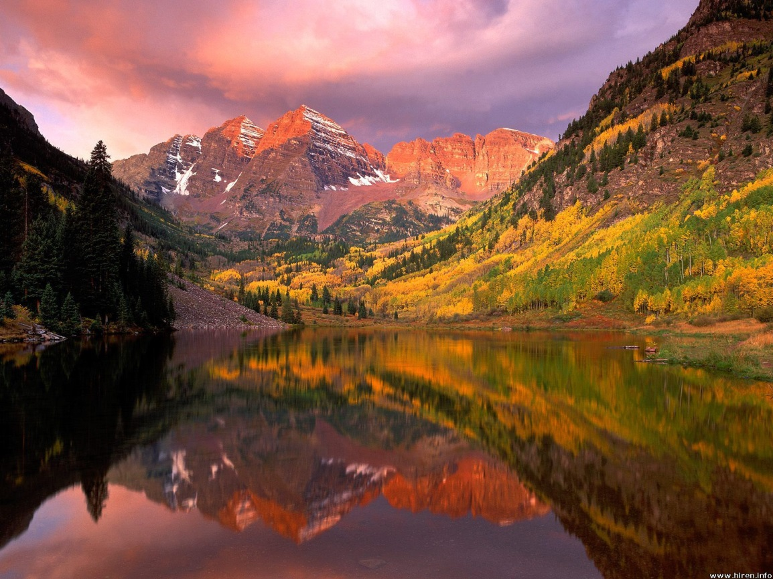
To Apply
Email a cover letter and resume to Andrew Larson
aspenwilderness@gmail.com
before March 1st

