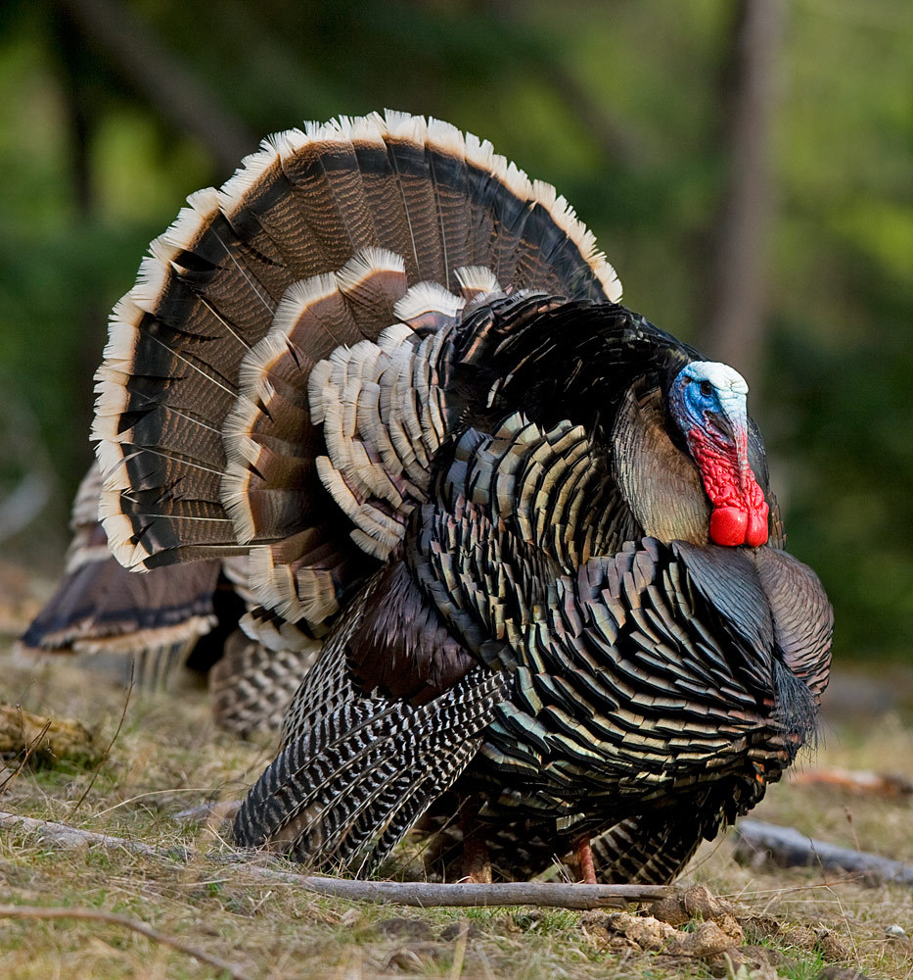
Tierra Seca
University of Arizona Student Chapter
Society for Range Management

College of Agriculture and Life Sciences
School of Natural Resources and the Environment

Tierra Seca Meeting Minutes 11/19/2014

- Call to Order: 12:05
  - Members in attendance: 17
  - Approve meeting minutes from 11/5/2014: Approved
- President’s Report:
  - Introductions
  - Last meeting of the semester is 12/3
  - Spring 2015 Tierra Seca Treasurer nominations
    - Nominees: Morgan Gourley, Cassidy Solper
      - 12/3 Co-Run Meeting with Jen M.
      - Description:
        - Liaison to ASUA for the purpose of organizational funding.
        - Maintains accurate and current account of all organizational funds.
        - Responsible for dispensing of funds in accordance with goals and programs established by the organization.
        - Collect membership dues each semester.
        - Completes annual Taxes for non-profit status of our organization.
      - Elections at end of this meeting!
  - Events Report
    - Elkhorn/Las Delicias Project Monitoring: Anna, Mike, Rachel, Joey attended – measured biotic crust and litter among other attributes
    - Homecoming Burrito Breakfast
    - USFWL Photo Contest Winners
      - Powerpoint
      - Calendars should be ready before the end of the semester!
  - Upcoming Events
    - Annual Tierra Seca VS. Wildlife (SNRE) Kickball Game!!
      - November 22nd, Saturday 2:00pm at Conner Park (Tucson/Glenn)
      - Brushfire BBQ & BYOB (alcohol permit-cans only!)
      - Bring dog, friends, ultimate Frisbees etc.
    - Volunteer/work with Gerry Berthelette
      - Email him for upcoming dates: gmberthelette@email.arizona.edu
      - Pima pineapple cactus monitoring – Going out Tuesday 11/25
    - Adopt-a-wash!
      - Location: Arroyo Chico wash from Cherry Fields to Fremont
      - Available! Waiting on neighbors to approve, but city and county urging them!
    - AZ SRM Winter Meeting
      - Jan 15th-16th – Putting on a practice Plant ID exam
      - More details in upcoming AZ SRM newsletter
      - Taking place in Tucson, AZ
- Vice President’s Report:
  - December Graduating Seniors? Mike, Will, Jen M.
  - Interest in guest speaker/inventory? Cattle work? - Professional development tour in Nogales (oak woodland) – working with cattle and monitoring for those interested. Dates still to come!

- Treasure’s Report:
  - Dues ($10 per semester)
    - Paid dues: Will Lawton, Trevor Chilcote, Mark McCabe, Jen Merems, Cassidy Solper, Gerald Berthelette, Jason Myrand, Royale Billy, Alexander Schaller, Stephanie Doerries, Kelsey Hawkes, Rachel Turner, Angel Medina, Leland Sutter, Michelle Grandall, Adriane Begaye, Emily Pecilunas, Morgan Gourley, Casey Cutman, Theresa Huckleberry, Jennifer Hanson, Emilio Corella, Mollie Weigand, Andy Warnick, Natalia Robins-Sherman, Alex Katz, Mike McIntire, Joey Dahms, Anna Collins
  - Account balances: Checking $_4352.77_; Savings $_395.07_
  - Pay your dues!!
- Miscellaneous:
  - Garden Plot: http://tierrasecauofa.wix.com/tierra-seca-garden
    - Carrots, Snow Peas, Purple and Red Russian Kale, Swiss Chard, Brussels Sprouts, Australian Brown Onions, Spinach and Gold Rush Bush Beans – all sprouted, three basil plants ready to harvest
    - All seeds from Native Seed Search
    - Garden plot renewal officially secured!
    - Contact Trevor Chilcote if interested in helping (no experience necessary!)
    - tchilcote@email.arizona.edu
  - SNRE Seminars
    - Every Wednesday 3:00-4:00pm in Marley 230
    - This week – Sallie Hejl – The Desert Southwest Cooperative Ecosystem Studies Unit: roles, benefits and opportunities
  - Tierra Seca items:
    - Koozies: $5.00
    - T-Shirts: $10.00
      - Ordered! Ready! Will be at next meeting!
      - Field Shirts: Still in the works…
  - Hunter Safety Course
    - http://www.azgfd.gov/i_e/edits/hunter_education.shtml
    - Next safety course: January in Safford
  - Aluminum Can Drive
    - Updates: Boxes and flyers set up around BSE soon - please donate cans if you have them!
  - Other new business or discussion or fundraising ideas?

- Elections:
  - Results: Cassidy wins, congratulations! She will co-run the next meeting with Jen M. and be our new treasurer
  - New Officer Transitions:
    - Need to update the authorized people on the Tierra Seca bank account to reflect change in treasurer at the election that took place November 19th, 2014. Jennifer Merems is to come off our bank account at Arizona State Credit Union (#40XXX2007) and Cassidy Solper is to be added as treasurer.
- Adjournment: 12:33

Facebook club link: https://www.facebook.com/uofatierraseca
President: Emily Pecilunas: epecilunas@email.arizona.edu,
Vice President: Leland Sutter lelandsutter@email.arizona.edu
Secretary: Jennifer Hanson jmh7@email.arizona.edu
Treasurer: Jennifer Merems jlmerems@email.arizona.edu

