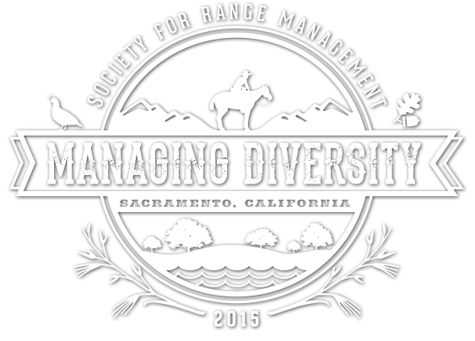
Student Workshop onEcological Sites: Concepts and Applications
Annual Society for Range Management Meeting
Sacramento, California
- All day field workshop Wednesday February 4, 7:30 am-6:00pm for junior, senior, and graduate level students.
- The workshop focuses on the ecological site concept, how to determine ecological site designations and how ecological sites are used to inform management.
- Participants will visit rangelands in California Gold Country at selected locations in Calaveras and Amador Counties.
- Guided by NRCS personnel involved in ESD development at regional, state, and
national levels.
- Registration: $20- includes transportation, snacks and lunch. Students should register for this workshop when registering for the SRM meeting.
- For more information contact Karen Hickman (Karen.hickman@okstate.edu) or Laurie Abbott (labbott@nmsu.edu).
