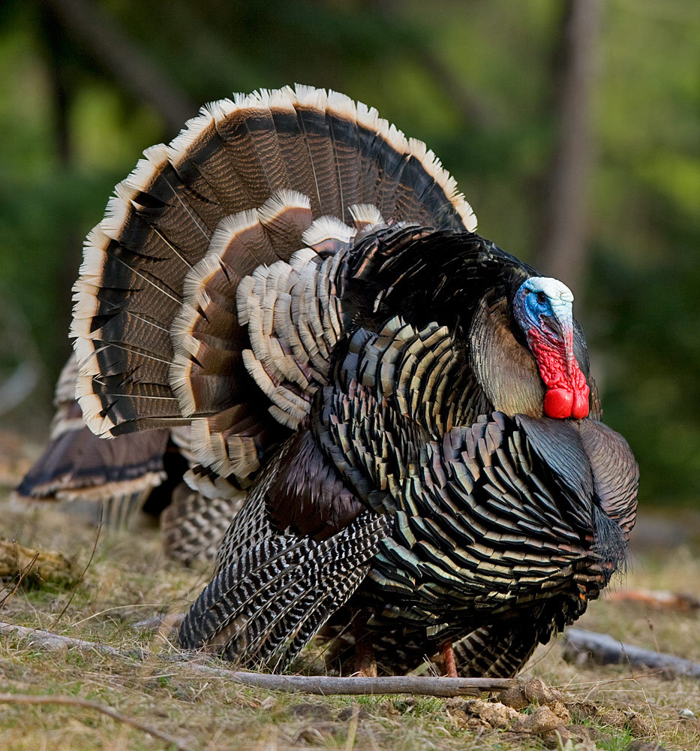
Tierra Seca
University of Arizona Student Chapter
Society for Range Management

College of Agriculture and Life Sciences
School of Natural Resources and the Environment

Tierra Seca Meeting Agenda 11/19/2014

- Call to Order:
  - Members in attendance:
  - Approve meeting minutes from 11/5/2014
- President’s Report:
  - Introductions
  - Last meeting of the semester: 12/3
  - Spring 2015 Tierra Seca Treasurer nominations
    - Nominees:
      - 12/3 Co-Run Meeting with Jen M.
      - Description:
        - Liaison to ASUA for the purpose of organizational funding.
        - Maintains accurate and current account of all organizational funds.
        - Responsible for dispensing of funds in accordance with goals and programs established by the organization.
        - Collect membership dues each semester.
        - Completes annual Taxes for non-profit status of our organization.
  - Events Report
    - Elkhorn/Las Delicias Project Monitoring
    - Homecoming Burrito Breakfast
    - USFWL Photo Contest Winners
      - Powerpoint
  - Upcoming Events
    - Annual Tierra Seca VS. Wildlife (SNRE) Kickball Game!!
      - November 22nd, Saturday 2:00pm
      - Brushfire BBQ & BYOB (alcohol permit-cans only!)
      - Bring dog, friends, ultimate Frisbees, whatever
    - Volunteer/work with Gerry Berthelette
      - Email him for upcoming dates: gmberthelette@email.arizona.edu
      - Pima pineapple cactus monitoring
    - Adopt-a-wash!
      - Location: Arroyo Chico wash from Cherry Fields to Fremont
      - Available! Waiting on neighbors to approve, but city and county urging them!
    - AZ SRM Winter Meeting
      - Jan 15th-16th (I’m pretty positive)
      - More details in upcoming AZ SRM newsletter
      - Taking place in Tucson, AZ
- Vice President’s Report:
  - Graduating Seniors?
  - Interest in guest speaker/inventory? Cattle work?

- Treasure’s Report:
  - Dues ($10 per semester)
    - Paid dues: Will Lawton, Trevor Chilcote, Mark McCabe, Jen Merems, Cassidy Solpher, Gerald Berthelette, Jason Myrand, Royale Billy, Alexander Schaller, Stephanie Doerries, Kelsey Hawkes, Rachel Turner, Angel Medina, Leland Sutter, Michelle Grandall, Adriane Begaye, Emily Pecilunas, Morgan Gourley, Casey Cutman, Theresa Huckleberry, Jennifer Hanson, Emilio Corella, Mollie Weigand, Andy Warnick, Natalia Robins-Sherman, Alex Katz, Mike McIntire, Joey Dahms
  - Account balances: Checking $______; Savings $______
  - Pay your dues!!
- Miscellaneous:
  - Garden Plot: http://tierrasecauofa.wix.com/tierra-seca-garden
    - Carrots, Snow Peas, Purple and Red Russian Kale, Swiss Chard, Brussels Sprouts, Australian Brown Onions, Spinach and Gold Rush Bush Beans
    - All seeds from Native Seed Search
    - Waiting to secure renewal?
    - Contact Trevor Chilcote if interested in helping (no experience necessary!)
    - tchilcote@email.arizona.edu
  - SNRE Seminars
    - Every Wednesday 3:00-4:00pm in Marley 230
  - Tierra Seca items:
    - Koozies: $5.00
    - T-Shirts: $10.00
      - Ordered! Ready! Will be at next meeting!
      - Field Shirts: In the works…
  - Hunter Safety Course
    - http://www.azgfd.gov/i_e/edits/hunter_education.shtml
  - Aluminum Can Drive
    - Updates?
  - Other new business or discussion or fundraising ideas?

- Elections:
  - Results:
- Adjournment:

Facebook club link: https://www.facebook.com/uofatierraseca
President: Emily Pecilunas: epecilunas@email.arizona.edu,
Vice President: Leland Sutter lelandsutter@email.arizona.edu
Secretary: Jennifer Hanson jmh7@email.arizona.edu
Treasurer: Jennifer Merems jlmerems@email.arizona.edu

