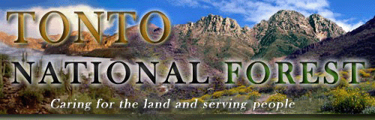
POSITION OUTREACH
Pathways Student Intern
Forest Plan Revision Team Vegetation Ecologist
GS-0499-05 (Part Time – Indefinite)
Response Requested by September 26, 2014

The Tonto National Forest is in the process of revising its Land Management Plan to incorporate changed conditions, best available science, and new public issues. This notification is being circulated in an effort to recruit a student intern in support of this planning process.

ABOUT THE POSITION:
The vegetation ecologist intern will participate as a member of our interdisciplinary team working together to assess, plan, evaluate, document, and predict effects of planned forest management. The intern must demonstrate knowledge of vegetation, soil, and environmental characteristics and ecological classifications. He/she will coordinate with timber management functions in areas that influence forest plan analysis, and will work with the forest fire or wildland fire specialist to determine the role of fire dependent regimes. The candidate must be able to manage data applicable to the management of vegetation communities and incorporate information into the planning process and the geographic information system (GIS).

PATHWAYS PROGRAM:
The internship program is for current students in an accredited educational institution pursuing a qualifying degree or certificate. This program provides students with paid opportunities to work in agencies and explore Federal careers while completing their education. Qualifying at the GS-5 level requires completion of 4 academic years of post-high school leading to a bachelor's degree or equivalent degree. Visit www.opm.gov for more information on the Pathways Program.

ABOUT THE FOREST:
The Forest is the fifth largest in the United States and has six ranger districts operating in a complex, sensitive political, social, and media environment. The Forest receives national attention concerning such issues as recreation use, range management, fire management, minerals management, and the wildland urban interface. For more information about the Tonto National Forest, visit our website at www.fs.fed.us/r3/tonto.

OUTREACH RESPONSE:
If you are interested in applying for this position or receiving more information, please contact Kenna Belsky, Assistant Forest Planner at kennambelsky@fs.fed.us or 602-225-5378.

HOW TO APPLY:
Individuals stating their interest in this position will be notified when the vacancy announcement is posted on the USAJOBS website www.usajobs.gov so they can apply. We anticipate the announcement will be open October 20th – October 24th 2014.

