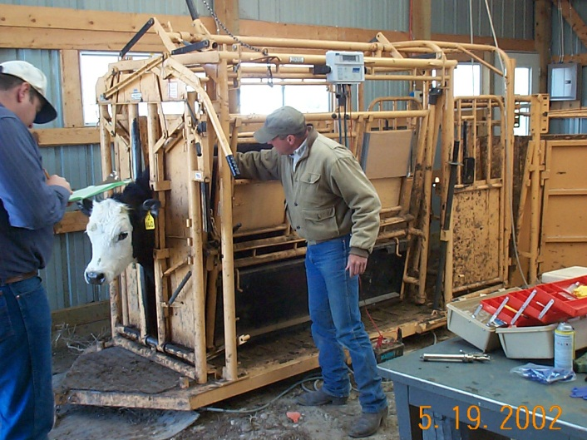

Summer 2014
Beef Cattle & Range Research Technician/Internship Positions Available

Mid May through late August
(We will accommodate university schedules)
$12/hour; 40 hours/week; housing provided

Department of Natural Resource Management
South Dakota State University

Application Deadline:
Until filled
Technicians/interns may be involved in one or several primary activities, including:
- Use of GPS collars on cattle and visual observations to determine landscape grazing use patterns
- Use of fistulated cattle to evaluate diet selection associated with prairie dog towns
- Weighing and body condition scoring of cattle in grazing research
- Routine cattle handling and health care
- Vegetation sampling (biomass, cover, density, tiller measurements, utilization, drying/weighing samples, etc.)
- Computer data entry
- General ranch/acreage maintenance activities
Training will be provided for all data collection techniques
Location:
- Initial location: the SDSU West River Ag Center in Rapid City, SD
- Based at research site located near McLaughlin, SD (north-central SD)
- Housing is provided
Will involve living in remote sites & camping in travel trailers
Required Skills/Experience for all positions:
- Ability to work in outdoor environment under a variety of weather and working conditions
- Self-starter, motivated, and dependable; able to pay attention to detail, follow experimental protocol carefully, and record data accurately
- Ability to work well alone and with others
- Effective oral, written and interpersonal skills
Desired Skills/Experience:
- Livestock handling and care experience, particularly low-stress cattle handling
- GPS and GIS experience
- Plant ID knowledge/experience
- Vegetation sampling training/experience
- Previous research experience and scientific interest/curiosity
To apply: 1) Send a letter of application indicating interest and a resume including your work experience, relevant courses (or unofficial transcripts), and names with contact information on 3 references to:
Janna Kincheloe
SDSU West River Ag Center
1905 Plaza Blvd.
Rapid City, SD 57702
Work: 605-394-2236
janna.kincheloe@sdstate.edu

