Temporary Wilderness Positions Available
Wind River Ranger District, Shoshone National Forest, PO BOX 186, Dubois, WY 82513

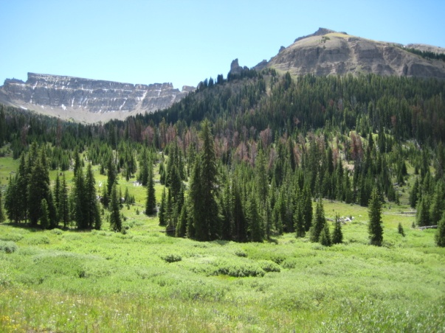

Job Description:
We are planning to hire 3-4 temporary employees (GS-4, GS-5, and one GS-6 Crew Leader) for the 2014 field season in the wilderness/trails program on the Wind River Ranger District in Dubois, WY. The Wind River Ranger District is on the Shoshone National Forest in western Wyoming. All positions are temporary seasonal full-time and will be based out of Dubois, WY.
Our summer season of employment will start May 27 for the GS 4 and GS 5 positions. For the GS 6 crew leader position, the position begins May 5. The season will run through Sept. 30, often with the availability to work through October. For the GS-4 position, we have flexibility to hire for a shorter work season to correspond with the candidate’s dates of college enrollment.
Employees will be expected to perform various job duties specific to the wilderness/trails program on the district throughout the season. These Wilderness duties shall include but are not limited to: annual trail maintenance using primitive hand tools (such as cross-cut saws, hand saws and pulaskis) in the Fitzpatrick, and Washakie Wilderness areas; campsite cleanup, visitor contacts, FPO (Forest Protection Officer) duties, trailhead signboard maintenance, monitoring projects, and may include trail reconstruction projects. 2014 is the 50th Anniversary of the passage of the 1964 Wilderness Act and there will be several educational opportunities and one event over the July 4th weekend that Wilderness seasonals will be asked to assist with.
All employees may help with fall hunting patrols and with education or law enforcement activities. Employees may also have the opportunity to assist in fire suppression activities on the Forest.
The job requires that the employee be willing to work long days (including weekends and holidays), to work in a backcountry camp and travel setting for up to 8 consecutive days, to work well with the public and as a team member, to traverse various types of terrain and to work in inclement weather. Some positions may require competency in riding horses and stock packing abilities. Employees must be at least 18 years old and possess a valid government issued driver’s license.

Location:

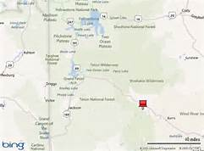

Dubois sits at an elevation of 6917’. Dubois summers are filled with weekly festivals, concerts and events- adding to the abundance of recreation opportunities available on the adjacent state, BLM, and Forest lands. There are two banks, numerous eateries, one grocery store and one health food store and numerous other small businesses in town. The local newspaper, The Frontier, and the Round-Up both come out weekly on Wednesdays. The National Bighorn Sheep Center is located in town as is The Headwaters Art Center. Dubois is approximately 70 miles away from the southern entrance of Yellowstone National Park and 50 miles east of Grand Teton National Park. Jackson, Wyoming is located approximately 75 miles to the west, while Lander and Riverton, Wyoming are located approximately 75 miles to the east.

Housing is likely available.

To Apply:

Applications should be submitted through USAJOBS website (https://www.usajobs.gov/). Announcement numbers will be provided to you after we receive your outreach information and contact you. Announcement numbers are currently NOT available. After receiving the announcement number for the position you are interested in applying for, type in the announcement number in the ‘Advanced Search’ tab, click on the job title and click ‘Apply Online’. If you have not done so, you will be asked to create a user profile to log in to apply. Enter all the mandatory information. Be as specific as possible when entering work experience and college transcripts as this will be used to qualify you for a position.

Title | Announcement  Number | Series/  Grade | Description

GS 4 Forestry - Wilderness | To Be Determined | GS-0462-4 $13.55 p/h | See above duties. Must be a licensed vehicle operator and at least 18 years old.
GS 5 Forestry Technician- Wilderness | To Be Determined | GS-0462-5 $15.15 p/h | See above duties. Must be a licensed vehicle operator and at least 18 years old.
GS 6 Forestry Technician- Wilderness | To Be Determined | GS-0462-6 $16.89 p/h | Responsible for leading the crew in the above listed duties. Prior experience as a leader or supervisor is a must. Knowledge about Wilderness and primitive use is a must. Must be a licensed vehicle operator and at least 18 years old.

IMPORTANT!!!: When you get to the Applicant Information section, be sure to choose Dubois, WY as your preferred location. If you don’t, we will not receive your application.
Please fill out and send the attached applicant information form to Lucinda Jann by February 14th, 2014 at the below email address. This will allow us to email the announcement number to you once it is provided.
Any additional information for these Wilderness positions can be attained from Lucinda Jann by calling (307) 455-4173 or emailing: ljann@fs.fed.us

APPLICANT INFORMATION.
Please respond by Febr. 14, 2014. The announcement number for these positions, with their closing dates, will sent to everyone who submits this Outreach Response form.

Position Title/Series/Grade:
Location:
PERSONAL INFORMATION:
Name:
Address:
E-mail:
Phone:
Current title/series/grade:
Are you currently a Federal employee?
IF YES, current Agency and location:

