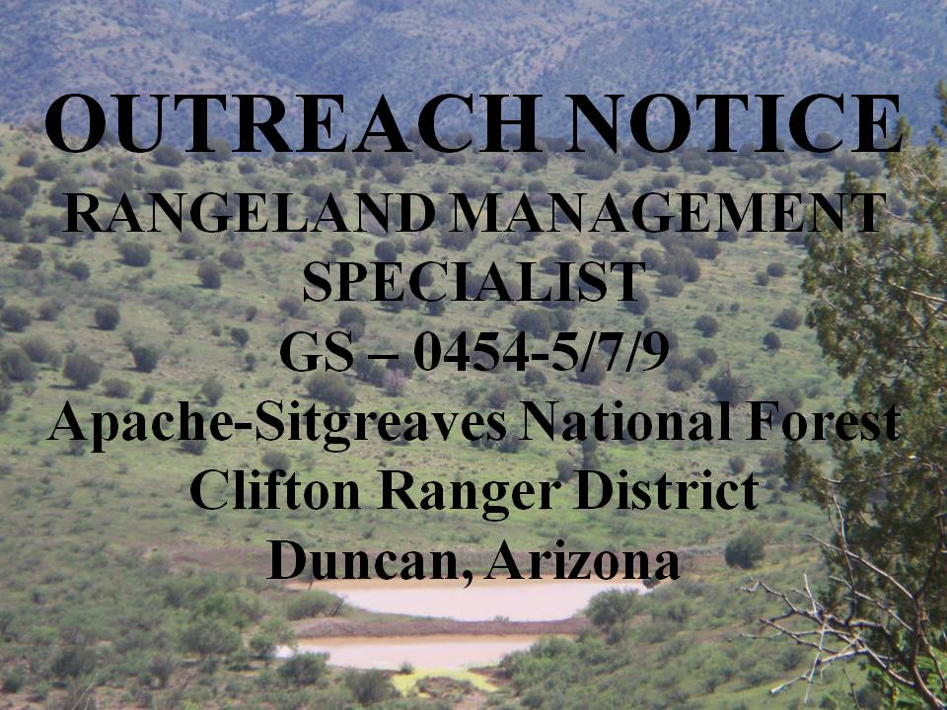

The Clifton Ranger District on the Apache-Sitgreaves National Forest, located in east-central Arizona, is looking for a highly motivated, self-starter who works well with people; enjoys challenging hard work and practices safety first. The District will soon be filling a Career-Ladder Rangeland Management Specialist GS-0454-5/7/9. This is a permanent full-time position with a duty station in Duncan, Arizona.

If interested, please fill out the outreach form at the bottom of this document and send to Ben Goodin, bgoodin@fs.fed.us by March 13th, 2014.

PLEASE NOTE: The purpose of this Outreach Notice is to determine the potential applicant pool for this position and to establish the appropriate recruitment method and area of consideration for the advertisement (i.e., service-wide, government-wide). Responses received from this outreach notice will be used to make this determination. Those interested in further information may contact the desired unit’s contact person listed above.

All interested applicants will be notified of the vacancy announcement number and closing date when it becomes available. The vacancy announcement for this position, when open, will be posted at the USA Jobs website, the U.S. Government’s official site for jobs and employment information: http://www.usajobs.opm.gov

Duties

This position performs professional work conserving, developing, and managing rangelands. It requires knowledge of the ecological requirements of native plants that are predominantly grasses and grass-like plants, herbs, and shrubs. The specialist is responsible for preparing, evaluating, and conducting environmental analyses (NEPA) for projects affecting rangelands. The incumbent develops conservation plans, designs and performs technical surveys, and performs rangeland improvement projects. The duties include planning, managing, producing, and writing allotment evaluations, and implementing allotment management plans. The specialist interacts with agency employees, permit holders, and the public on issues affecting rangelands. The incumbent reviews and monitors range allotments for compliance with federal law and agency policy, and ensure impacts to watersheds; wildlife and rangeland ecosystems are properly mitigated.
The primary duties for this position at the fully functioning GS-09 level include assisting the District Staff Rangeland Management Specialist with the management of the Rangeland Management and Invasive Plant Species programs. Administration of grazing permits includes allotment and pasture inspections, trend and condition monitoring in upland and riparian settings, annual utilization monitoring, and documentation of allotment visits and conversations with permittees. Communication with grazing permittees is a key part of this position. The specialist will record allotment inspections, conversations, and monitoring information for use in decision making. The specialist will cooperatively develop Annual Operating Instructions with permittees for the grazing season. The specialist will provide recommendations on range improvement projects, order materials within budget constraints and ensure the projects are completed to Forest Service standards. The specialist will assist the District Staff Rangeland Management Specialist with NEPA documents for range projects and other district/forest projects as needed.
Attendance at public and agency meetings on a variety of technical and professional topics will be required. Field conditions include regular exposure to high temperatures and rough terrain. Use of an ATV, 4-wheel drive vehicle, and horses will be necessary as a regular part of this job, as will hiking across uneven terrain at high elevations. If the position is hired at a GS-05 or 07 level, the employee will perform these tasks under close supervision until reaching the full GS-09 level.

ABOUT THE APACHE-SITGREAVES NATIONAL FOREST

The Apache-Sitgreaves National Forest is some of the most diverse in the Southwestern Region, encompassing about 2.5 million acres including an extensive amount of the Mogollon Rim and the White Mountains. The Forests stretch from Leonard Canyon south of Winslow, Arizona to the New Mexico state line, then south of Springerville, Arizona to Clifton, Arizona. The landscape varies from high desert to above timberline with the terrain being widely varied. The Forests' elevations range from approximately 3500 feet on the Clifton Ranger District to over 11,000 feet on the Mount Baldy Wilderness. The Mogollon Rim, a fault line rising 2,000 feet in some areas, runs through the Forests and is the southern boundary for much of the Sitgreaves National Forest.

Clifton Ranger District, over 500,000 acres in land area which is found below the Mogollon Rim, is best characterized as a rugged, isolated management unit with few roads and a diversity of life zones and associated plant and animal communities. It is one of the most diverse units in Arizona, with elevations ranging from about 3,500 to 9,000 feet in elevation, and includes about 125,000 acres of the Blue Range Primitive Area. The District lies between the Glenwood Ranger District of the Gila National Forest in New Mexico to the east, and the San Carlos Apache Indian Reservation to the west. The Coronado Trail National and State Scenic Byway bisect the District south to north, separating the Eagle Creek and Blue River watersheds. While the District is typically arid Southwestern forests and woodlands, the area is uniquely well watered, encompassing about 60 miles of live riparian habitats of the San Francisco river, Blue River, and Eagle Creek, along with numerous live and interrupted streams in side drainages. Lands within the unit provide habitats for virtually every game animal in Arizona from javelina to bighorn sheep, as well as a wide diversity of federally protected birds, mammals, and fish, including the Mexican Grey wolf. Rattlesnakes and bears are commonly encountered on the District, while wolves and mountain lions are less frequently seen.

The District has 15 full-time employees that cover diverse and varied programs including: range, fire, watershed, recreation, fisheries, wildlife, and threatened & endangered programs of work. The abundant sunshine and mild, dry climate allow for year-round field work typically interrupted by a few snow events at higher District elevations December through February.

COMMUNITY

The District exists entirely within Greenlee County, Arizona with the District Office located adjacent to the Gila River at the Three-Way Junction of U.S. Highway 191, State Route 75, and State Route 78 approximately 8 miles from Clifton, 20 miles from Duncan, and 30 miles from Safford. District employees have chosen to live in all of these communities based upon their individual needs. Government housing is not available.

Greenlee County has an abundance of Forest Service, Bureau of Land Management, and Arizona State Trust lands. The summer weather is generally hot and dry, with temperatures exceeding 100 degrees possible from June through August. Majority of the precipitation for the District comes from late summer Monsoon rains. Winters are mild, with nighttime temperatures commonly around freezing and daytime temperatures in the 50-70 degree range. Sunshine is abundant year-round, with the greatest chance of thunderstorms in late summer.

Outdoor recreational opportunities are plentiful and include hiking, camping, backpacking, mountain biking, bird watching, fishing, hunting (elk, bear, mountain lion, bighorn sheep, mule and whitetail deer, quail, and dove), rock hounding, horseback riding, and rock climbing.

Duncan a farming and ranching community of approximately 800 people established along the Gila River that offers few amenities, but an excellent rural lifestyle. Clifton is a small, unique historical mining town of approximately 7,735 (includes Loma Linda and Vista Verde) people established along the San Francisco River and originally associated with several open pit copper mines owned and operated by Phelps Dodge. Within the Duncan city limits, rural housing occurs within the subdivisions of York, Apache Grove, and Sheldon. Within the Clifton city limits, rural housing occurs within the subdivisions of Loma Linda, and Verde Lee. Morenci is an unincorporated town established and maintained by Freeport-McMoRan mining company.

The neighboring communities of Safford, Thatcher, and Pima (commonly referred to as the Gila Valley) located in neighboring Graham County area are about 30 – 50 minutes from the District Office and combined population of approximately 15,000 that support a variety of economic base.

Greenlee and Graham County has an abundance of Forest Service and Bureau of Land Management lands. The summer weather is generally hot and dry, with temperatures exceeding 100 degrees possible from June through August. Winters are mild, with nighttime temperatures commonly around freezing and daytime temperatures in the 50-70 degree range. Sunshine is abundant year-round, with the greatest chance of thunderstorms in late summer. Outdoor recreational opportunities are almost limitless, including hiking, camping, backpacking, mountain biking, bird watching, fishing, hunting (elk, bear, mountain lion, bighorn sheep, mule and whitetail deer, quail, and dove), rock hounding, horseback riding, and rock climbing.

HOUSING: Single family homes range within the commuting area, are priced from $80,000 to $200,000 with an average of nearly $115,000 with a minimum of 5 real estate office’s to select from for a home purchase. There are few rentals and long term mobile home parks.

MEDICAL: The Mt. Graham Hospital located in Thatcher offers a variety of medical/dental/ and specialty services. Ambulance Services are available in community areas. Morenci has a full-time Medical Clinic and Duncan has a part-time Medical Clinic that is open two days a week. Numerous specialists, including Dental, Optometry and Chiropractic provide services in both Safford and Clifton.

EDUCATION: Elementary, Middle, and High Schools are located within Duncan, Morenci, Safford, Thatcher, and Pima. Clifton has an Elementary and Middle School. Eastern Arizona College located in Thatcher provides an opportunity for a variety of AA/AS degrees along with general college education requirements that transfer to a 4-year university.

PUBLICATIONS: Local newspaper is the The Copper Era published in Clifton and the Eastern Arizona Courier published in Safford with the Arizona Republic and USA Today available by subscription or local purchase.

FINANCIAL: There is a CHASE Bank in Duncan and Morenci with numerous national and local banking options located in the Safford area.

SURROUNDING METROPOLITAN CENTERS: Tucson and Las Cruces New Mexico are 2.5 hours while Phoenix is 3.5 hours driving time from the District Office.

OTHER SERVICES – CLIFTON: There is a library, one motel, one convenience market with gas station, two restaurants, Chevy dealership, one tire shop, and various gift shops. DUNCAN: There are four restaurants, two convenience stores with gas stations. MORENCI: There are five restaurants, movie theatre, public library, and bowling. SAFFORD/THATCHER/PIMA: There is a variety of Mexican, American, Chinese, family, and fast-food restaurants, large movie theatre, bowling, miniature golf, batting cages, Discovery Park, several museums, fishing at Roper Lake and Cluff Ranch Ponds, and a library in Safford. variety of shopping needs including four large grocery chain stores including a Wal-Mart, four hardware stores including Home Depot, multiple car dealerships and tire shops, two feed and tack stores, and a diverse variety of specialty stores. One library is located in Safford.

WEB-PAGES FOR FURTHER INFORMATION FOR CLIFTON RD COMMUNITY:
- Apache-Sitgreaves National Forests – www.fs.fed.us/r3/asnf
- Graham County Chamber of Commerce: http://graham-chamber.com
- Greenlee County Chamber of Commerce: http://www.co.greenlee.az.us
- Eastern Arizona College: http://www.eac.edu
- Active Home Sale Listing: http://listingpreview.com

If you are interested in this position please respond to this outreach by completing and sending the attached Outreach Response document by email to bgoodin@fs.fed.us or calling 928-687-8600 for additional information.

OUTREACH RESPONSE

RANGELAND MANAGEMENT SPECIALIST
GS – 0454-5/7/9

Mail to: Clifton Ranger District
Attn: Rangeland Management Specialist Vacancy
397240 AZ Highway 75
Duncan, AZ 85534

E-Mail to: bgoodin@fs.fed.us

Name: ________________________________________

Address: _______________________________________

_______________________________________

Phone No.: _____________________________________
(Indicate if work/home or both)

E-Mail Address: ________________________________

Present Duty Station: _____________________________

Current Series/Grade: ____________________________

Current Position Title: _____________________________

If not a current permanent (Career or Career Conditional) employee, are you eligible to be hired under and of the following special authorities?

_______ Person with Disability
_______ Veterans Readjustment
_______ Disabled Veterans w/30% Compensatory Disability
_______ Veterans Employment Opportunities Act of 1998
_______ Former Peace Corp Volunteer
_______ Student Career Experience Program
_______ Other ____________________________________________

