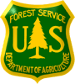
Nebraska National Forest and Grasslands
Pine Ridge Ranger District, Chadron, NE
& Wall Ranger District, Wall, SD
Two Rangeland Management Specialists, GS-0454-5/7/9

The Nebraska National Forests and Grasslands will be advertising to fill two Rangeland Management Specialist, GS-0454-5/7/9 positions. One duty location will be at the Pine Ridge Ranger District in Chadron, Nebraska, and one at the Wall Ranger District in Wall, South Dakota.
The Vacancy Announcements for both the Pathways Recent Graduates and Merit (current Federal employees) will be posted on the USAJOBS website starting Monday, July 15th, 2013. Applicants should carefully read both announcements to determine eligibility requirements specific to each.
The announcement numbers and application periods are as follows:
Recent Graduate (Pathways) announcement: 13-RG-0454-PW
Opens 7/15/2013 and closes 7/19/2013.

Merit announcement: 13-0207-4046-4084G-PW
Opens 7/15 and closes 7/24

Pathways Eligibility - The Pathways Recent Graduate Program is for individuals who have completed a qualifying educational program within the preceding 2 years (with exceptions for certain veterans and individuals graduating after December 27, 2010). It provides developmental opportunities for recent graduates. To learn more, please visit: http://www.opm.gov/HiringReform/Pathways/program/graduates/
Merit Eligibility - Current permanent federal employees with competitive status, reinstatement eligibles, persons with disabilities, VRA eligibles, certain military spouses, 30% or more disabled veterans, former Peace Corps or VISTA volunteers, CTAP eligibles, and Farm Service Agency permanent employees of county committees. Local commuting area only.
The official vacancy announcements for this Pathways Recent Graduate/Merit position will be posted on the U.S. Government’s official website for employment, www.usajobs.gov. The application period will be brief, beginning July 15th, 2013, so we recommend that you prepare your application in advance. The Pathways/Recent Graduate application period will be for five days ONLY, from Monday, July 15th – Friday, July 19th, 2013.

Rangeland Management Specialist, GS-0454-5/7/9

The position duties at the full performance level include, but are not limited to, the following:
- Participates by monitoring, gathering, analyzing, interpreting and evaluating data to determine if land management, economic, and social goals and objectives identified for the land involved are being achieved.
- Conducts short- and long-term monitoring of plant community change, trends, grazing impacts; precipitation; soil erosion hazards; and correlates other rangeland resource activities and uses. Gathers and assembles data concerning rangeland health, trends, ecological status of vegetation communities, site potential and desired plant community.
- Plans and carries out systematic ecosystem based rangeland surveys and inventories to identify and assess rangeland characteristics, amounts, types, values and susceptibility of various land areas to specific land uses.
- Prepares assigned portions of environmental assessments as a member of an interdisciplinary team.
- Prepares livestock management plans.
- Maintains continuing liaison with permittee, affected groups and others to ensure compliance with agreed upon plans.
- Receives, reviews, and acts on all livestock grazing applications. Provides information and guidance.
- Determines rangeland readiness for various rangeland uses.
- Prepares or initiates action on cooperative agreements for rangeland improvements.
- Maintains range allotment inspection books, livestock management strategies/practices, and compiles actual use information for various grazing areas.
- Investigates unauthorized livestock uses and takes direct action for removal of unauthorized/trespass livestock.

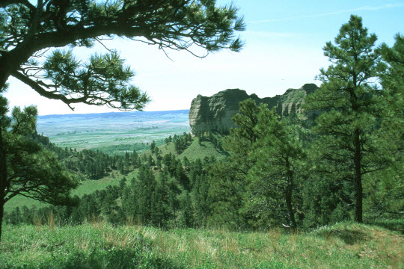

Pine Ridge Ranger District
Chadron, Nebraska

Pine Ridge RD Profile

The Nebraska National Forests and Grasslands are situated across five Ranger Districts and one Nursery in two states. The Pine Ridge Ranger District includes the Nebraska National Forest and Oglala National Grassland in the northwest corner of Nebraska.

Location

Chadron, Nebraska, is a full-service community of approximately 6,000 and is located in the northwest part of the state. The Pine Ridge area of Nebraska provides a wide range of recreation opportunities. Hunting, fishing, hiking, biking, horseback riding, wildlife watching and a variety of other outdoor activities are available in the immediate vicinity. Downhill skiing is within 2-1/2 hour drive in the Black Hills and world class skiing is within 400 miles in Colorado.

Chadron is the county seat of Dawes County and is located 100 miles south of Rapid City, South Dakota; 300 miles northeast of Denver, Colorado; and 450 miles northwest of Omaha, Nebraska. Chadron's elevation is 3,365 feet above sea level. Basic economic activities of Chadron include education, retail and wholesale sales, farming, ranching, transportation and tourism.

The community of Chadron offers a new hospital, a medical clinic with 5 doctors, a nursing home, 19 churches, public library, 3 banks, a theater, 2 senior citizen centers, 4 dentists, swimming pool, tennis courts, several city parks, a golf course, baseball and softball fields, soccer fields, youth programs, an outstanding volunteer fire department/volunteer emergency medical technicians, an airport with daily commercial flights to Denver, police department, sheriff's department, county and city offices, as well as a thriving retail business community.

Chadron is also the home of Chadron State College. Chadron State College has an annual enrollment of approximately 3,000 students and it employs approximately 260 individuals. The College offers both bachelor and master degree programs and is well known for its education (teaching) program. Chadron State College has a very impressive Physical Activity Center, which has an indoor track, weight facilities and racquetball courts and pool that are open to the general public through a membership program.

Chadron has an excellent school system. Elementary classes average 23-25 students per classroom. Total elementary enrollment is approximately 450 students. The Middle School houses students in grades 5-8 with an average enrollment of 320 students and the High School (grades 9-12) also has an average enrollment of 320 students. Special education classes are provided at all educations levels. Chadron is a great place to raise a family.

Chadron has available housing for both rental and purchase. Average rental prices range from $250 to $400 per month and average purchase prices range $70,000-$150,000. Rental availability can be difficult when Chadron State College is in session.

More information regarding the community is available through the Internet at www.chadron.com.

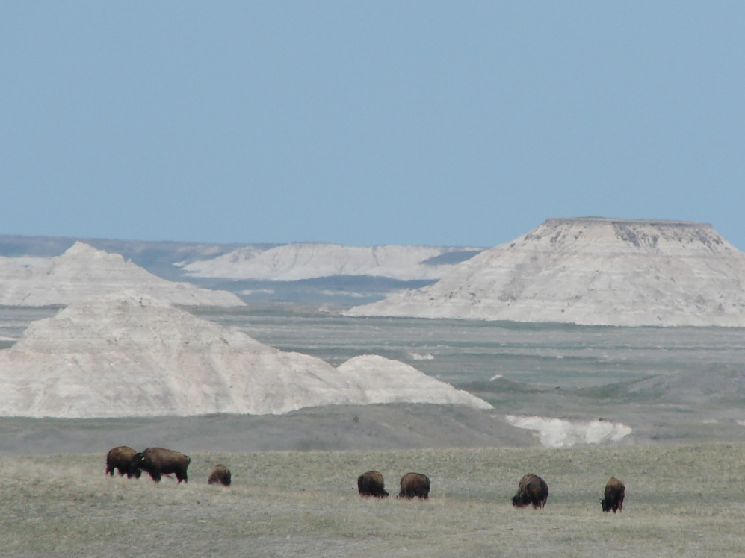

Wall Ranger District
Wall, South Dakota

Wall RD Profile

The Wall Ranger District administers the eastern half of the Buffalo Gap National Grassland, comprising approximately 267,500 acres of mixed and shortgrass grass prairie with intermingled badland formations. The Wall District is also home of the National Grasslands Visitor Center, a facility that is open year-round, interpreting the history, ecosystems and management of the 20 National Grasslands. The Conata Basin area of the Wall District supports one of the largest complexes of black-tailed prairie dogs and the most successful reintroduction of the endangered black-footed ferret on public land. The Buffalo Gap National Grassland land ownership pattern is public land with private land intermingled.

The Wall Ranger District staffs eight permanent full-time employees: the District Ranger, three Wildlife Biologists, a Range Management Specialist, the Engine Foreman and Assistant Engine Foremen, and an Administrative Assistant. The District staff also periodically assists with staffing of the National Grassland Visitor Center.

Badlands National Park (BNP) and Minuteman Missile National Historic Site (MMNHS) are within the proclaimed Wall Ranger District boundary and the Pine Ridge Indian Reservation is along our southern border. The District participates in a “Service First” agreement between the Forest Service and Park Service is signed providing BNP, MMNHS and NGVC/WRD the ability to formally share personnel and technology to both develop and deliver diverse integrated programs.

Wall, South Dakota

Wall is a full-service community with a population of approximately 820. It is located 55 miles east of Rapid City, South Dakota, on Interstate 90 and is about 400 miles northeast of Denver, Colorado, and 400 miles west of Minneapolis, Minnesota.

Wall offers four churches, ten motels, two banks, one medical clinic affiliated with Rapid City Regional Hospital, a dentist, a full service grocery store, public library, weekly local newspaper, and many tourism businesses. The public school building for grades K-12 was constructed in 2005.

Temperatures are moderate, though seasonal. The average July temperature is 87º F. Average annual precipitation is 15 inches. Elevation is 3,300 feet above sea level.

Recreation facilities in Wall include a school operated fitness facility, a golf course, a trap range, a city park and outdoor pool, and two private campgrounds. Only an hour away, the Black Hills National Forest offers many hiking trails. Outdoor opportunities on the Buffalo Gap National Grassland and surrounding area include hunting mule and whitetail deer, antelope, sharp-tailed grouse, fishing at numerous stock ponds, and rock-hounding.

The Wall Chamber of Commerce website is: http://www.wall-badlands.com

Interested applicants, or those desiring further information, should contact:

John Griesinger, District Ranger, Pine Ridge RD, 308-432-0393 or

Alan Anderson, District Ranger or Terri Harris, Rangeland Management Specialist, Wall RD, 605-279-2125

Pine Ridge RD, 125 North Main Street, Chadron, NE 69337, Attention John Griesinger, jdgriesinger@fs.fed.us

Wall RD, PO Box 425, Wall, SD 57790, Attention Alan Anderson, alandanderson@fs.fed.us
or Terri Harris, tharris@fs.fed.us

The announcement numbers and application periods are as follows:

Recent Graduate (Pathways) announcement number on USAJOBS: 13-RG-0454-PW
Application period opens 7/15/2013 and closes 7/19/2013.

Merit (current Federal employees) announcement number on USAJOBS : 13-0207-4046-4084G-PW
Application period opens 7/15/2013 and closes 7/24/2013.


https://www.usajobs.gov/

