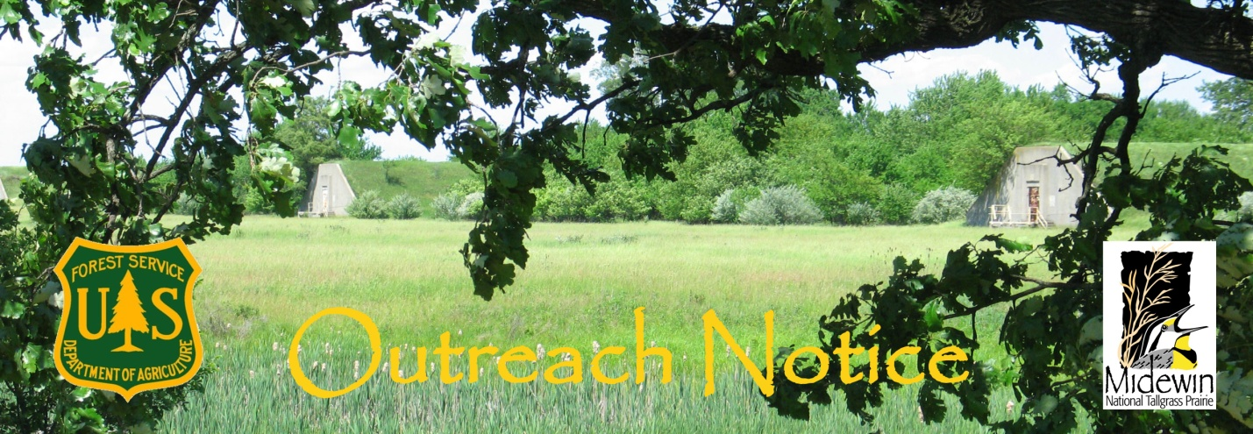
Outreach or Pre-Announcement Information
Note: This is not the official vacancy announcement
Midewin National Tallgrass Prairie
Wilmington, Illinois
RECENT GRADUATE PATHWAYS OPPORTUNITY
Rangeland Management Specialist GS-0454-7/9
Midewin National Tallgrass Prairie Vision: Create a legacy of restored prairie and conservation of open lands for future generations.
Our Mission: Ecosystem Restoration, Environmental Research, Outdoor Recreation, Environmental Education, Resource Conservation, Midewin Interagency Hotshot Crew.
As part of the Forest Service Pathways Recent Graduate Program the Midewin National Tallgrass Prairie will soon be filling one Rangeland Management Specialist position, GS-454-7/9 with a starting annual salary of $42,508 and eligibility for a conversion opportunity to a permanent full time position. This is a career ladder starting at grade 7 with promotion potential to grade 9.
The duty station will be in Wilmington, Illinois. Government housing is not available.
If you are interested in this challenging opportunity, please contact Renée Thakali at rthakali@fs.fed.us by close of business on May 24, 2013. You will be notified of the Vacancy Announcement for the Recent Graduate Program for this position as soon as it becomes available on www.usa.gov/.

For more information about the position:

Contact Person: Renée Thakali

Phone Number: (815) 423-2114

Email address: rthakali@fs.fed.us

The official vacancy announcement for this Pathways Recent Graduate position will be posted on the U.S. Government’s official website for employment, www.usajobs.gov. and you will have to apply online once the announcement is posted.

Major Duties
This position serves as the Rangeland Management Specialist for the Midewin National Tallgrass Prairie. The incumbent will have oversight of the management of 11 cattle allotments. Primary duties include: Issuance of Term Grazing permits, inspection of range allotments for compliance with management plans and annual operating instructions, which includes; monitoring numbers of livestock, forage (grass) lengths for grassland bird habitat management, and range improvement maintenance. The incumbent will maintain liaison with grazing permittees to ensure compliance. Keeps accurate records on the results of allotment inspections. Responsibilities also include oversight of the invasive species or weed control and range betterment programs. A large emphasis will be placed on fieldwork which includes; range readiness inspections, upland and riparian trend monitoring, and treating noxious weeds. Incumbent may participate in controlling weeds using chemical, biological, or mechanical treatments, including operating large tractors and mowers and prescribed fire. Duties may include construction and re-construction of fences and over-seeing water developments. The incumbent will be required to prepare specialist reports for analysis of range allotments and participate as an Interdisciplinary Team member on reviewing and making environmental assessments for proposed projects on Midewin National Tallgrass Prairie. A major focus in the next few years will be preparing for and managing a small herd of bison.

A valid State Driver's License is required for this position.
About the Pathways Program for Recent Graduates
The Recent Graduates Program is available to individuals who have completed qualifying degree or certificate programs in the previous two years. Qualified veterans may have an extended application period due to military service obligation. The Recent Graduates Program provides developmental experiences in the Federal Government. It is intended to promote possible careers in the civil service to individuals who, within the previous two years, graduated from qualifying educational institutions with an associates, bachelors, masters, professional, doctorate, vocational or technical degree or certificate from qualifying educational institutions. To be eligible, applicants must apply within the previous two years of degree or certificate completion except for veterans precluded from doing so due to their military service obligation, who will have up to six years after degree or certificate completion to apply. For more information about Federal employment information for veterans, go to OPM's Feds Hire Vets website.
In late June 2013, for a limited time, the Forest Service will advertise an agency wide Pathways job announcement for Recent Graduate opportunities using the USAJobs website: https://www.usajobs.gov/
- The application period will be brief, so we recommend that you prepare your application materials in advance on USAJOBS.gov
- You will need to complete an application for this position. During the application process, you will be asked to choose what duty locations you would be willing to accept. For this position enter WILMINGTON, ILLINOIS.
- Orientation, mentoring, and training plans are requirements of the programs.
Following successful completion of the program after one year, the selected candidate will be eligible for conversion to a permanent position.

What can you do in advance to prepare?
- Get familiar with USAJobs. See “How to Apply for a Job on USAJobs” at: http://www.fs.fed.us/fsjobs/USAJOBS_Instructions.pdf
- Create an account on USAJobs website. https://my.usajobs.gov/Account/Account
- Use the USAJobs tool to create a profile and resume
- Post all relevant documents to your USAJob account, i.e. current transcripts, degree completion documentation, letters of recommendations, and veterans preference documentation
- Sign-up for e-mail notifications for Forest Service job postings using the “save search” function in your USAJobs profile.
- You can learn more about how to apply for Pathways opportunities on USAJobs through an Office of Personnel Management video on YouTube: http://www.youtube.com/watch?v=ZQzXYVqBmZg&feature=youtu.be

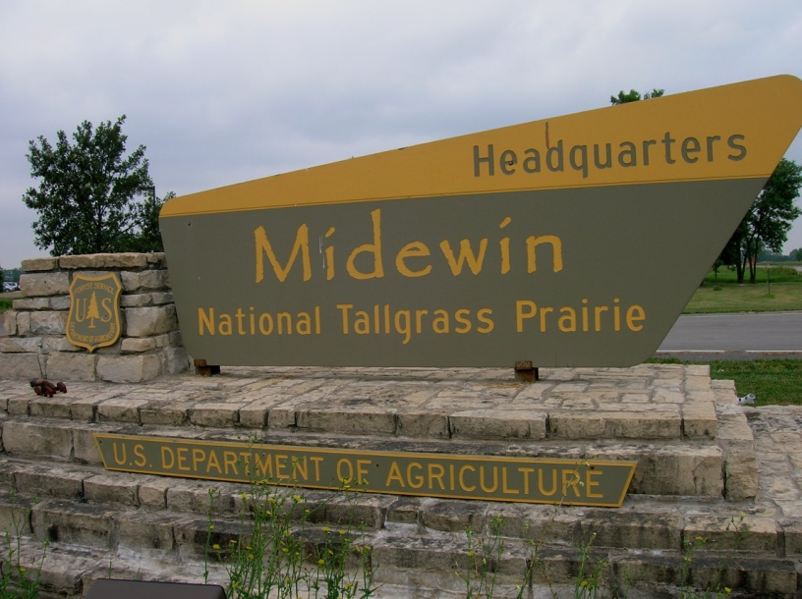
About the Midewin National Tallgrass Prairie
The Midewin National Tallgrass Prairie was established in 1996 and is administered by the Forest Service working to fulfill the Potawatomi name of its stewardship mission to “heal” the prairie. As part of the peacetime conversion of the former Joliet Army Ammunition Plant, Midewin is the newest unit of the National Forest System and the first national tallgrass prairie in the U.S. The Land and Resource Management Plan for Midewin has guidelines for all management activities that meet the four purposes outlined in the establishing legislation:
1. To manage the land and water resources to conserve and enhance native populations and habitats of fish, wildlife, and plants;
2. To provide opportunities for scientific, environmental, and land use education and research;
3. To allow continued agricultural use under certain conditions; and
4. To provide a variety of recreation opportunities.

Midewin operates in a fully integrated manner with a diverse group of partners. It is the largest open space, currently 19,000 acres, in northeastern Illinois. Check out our website at www.fs.fed.us/mntp/ to gain an overview of current and planned projects at Midewin.

The Midewin Area
Midewin is located 45 miles southwest of Chicago, the third largest metropolitan area in the country. Yet a rural atmosphere predominates throughout the small to mid-sized farming communities that surround Midewin. There are numerous schools, hospitals, doctors, churches, and communities to choose from and cultural opportunities are nearly limitless. Wilmington, Illinois is a full service community with a population of 5,000 and is located adjacent to the Kankakee River. Fishing is quite popular along the Kankakee and throughout various other rivers and small lakes that surround the area. The climate in this area is defined by four distinct seasons. Summer temperatures can reach into the 90’s, accompanied with occasional, high humidity. Spring and fall tend to be quite pleasant with average temperatures in the 60’s & 70’s. Winter temperatures frequently dip well below freezing and it is not unusual to see several inches of snow covering the ground December through early February.
The Midewin headquarters is located along State Highway 53 two miles north of the town of Wilmington, Illinois. Midewin team members live in many surrounding communities, ranging from the more urban Joliet, population 83,000, to smaller communities tucked around the area farm fields, like Essex, 500, or nearby Elwood, 1,000. For more information on Wilmington, see http://www.wilmington-il.com/ Many options for residing in larger communities are available within an half hour commute. No public transit is currently available to the Midewin headquarters office. The closest Metra train station providing access to Chicago is in Joliet, 20 miles to the north.
Medical facilities are plentiful, including easy access to nationally-recognized hospitals in Chicago. Cultural events range from performances at the historic Rialto Square Theater in Joliet, fine playhouses at local universities, a variety of weekend festivals celebrating local heritage in nearby small towns, to the greater theater, restaurant, and museum options in Chicago.

Reply by:  May 24, 2013 | MIDEWIN NATIONAL TALLGRASS PRAIRIE
 | OUTREACH RESPONSE FORM

To complete form, use tab key to move between fields (gray blocks), or left click on any field. Entries in check box fields are made by a single click to select or unselect. Type entries in other fields.

Please attach your current resumé to this outreach response form and email to rthakali@fs.fed.us by May 24, 2013.

Position Identification
Position Title: |  |  |  |  | Rangeland Management Specialist Recent Graduate
Series/Grade: |  |  |  |  | GS-0454-07/09
Location: |  |  | Midewin National Tallgrass Prairie, Wilmington, Illinois

Applicant Information

Your Name: |  |  |  |  |  |  |  |  |  | E-Mail Address:

Your Current Title, Series, Grade

Current Organization/Location:
Current Appointment: |  |  |  |  |  |  | Permanent Temporary Term Not Current Employee

If you are NOT a current permanent (career or career conditional) employee, are you eligible to be hired under any of the following authorities?
 | Reinstatement  Disabled Veteran with 30% Compensable Disability  Veteran’s Employment Opportunities Act of 1998  Other federal hiring authority (Please explain in box below) |  |  |  |  |  |  |  |  |  |  | Person With Disabilities  Returned Peace Corps Volunteer in last 12 months.  DEMO (external Recruitment. Check this box if you are not a current Forest Service permanent employee AND none of the other authorities apply.)

Position Interest

I would like to be considered for this position in the series identified.
 |  |  |  |  |  | Series currently identified and classified (0499)
 |  |  |  |  |  | Other appropriate series for which I am qualified

I would like to be considered for this position at the grade level identified.
 |  |  |  |  |  | Target grade level currently identified (GS-09).
 |  |  |  |  |  | Other grade level for which I am qualified (below target grade)

I would like to be considered for this position at the Wilmington, Illinois location

I wish to be considered for this position(s) as:
 |  | Permanent Assignment (lateral or promotion or change to lower grade)

Applicants May Use This Space to Identify Special Qualifications, Interests, and Needs or Provide Other Information:

