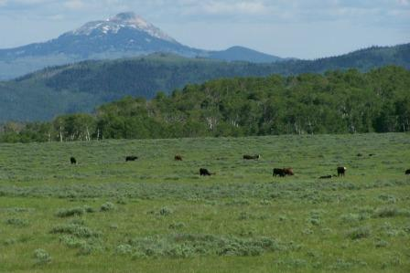

The Medicine Bow-Routt National Forests and Thunder Basin National Grassland (www.fs.usda.gov/mbr) is looking for summer employees interested in natural resources management to work this coming 2013 season. One Range Technician position will be filled at the GS-5 (~$15.00/hr) or GS-6 (~$16.73/hr) level. Applicants must be U.S. citizens and at least 18 years old at the time of employment. College graduates and/or those with other related work experience could qualify for the higher grade (GS-6). Work would begin in late May or early June, and candidates can potentially work through September.

This position will assist with natural resource management duties on the Forest and include both field and office work. Field work requires the ability to hike, wade, lift, carry and use equipment in rugged terrain and in all types of weather. The ability to work safely and work well in a team environment is necessary, including the ability to enjoy living in remote mountain or grassland settings. A valid driver's license is required, and overnight travel to different locations on the Forest may also be required.

Range Technician duties will include monitoring upland and riparian vegetation communities, administering the District’s noxious weed program, conducting inspections of grazing allotments, planning and oversight of range improvement construction (fences and water developments), and evaluating livestock grazing management. Operating an ATV and/or UTV may be required.

The duty station for this position will be Saratoga, Wyoming (www.saratogachamber.info/). Limited government housing may be available for about $4.90/day. Pets are prohibited in government housing and on the job. Other restrictions for use of government housing apply.

This is a great opportunity to spend a summer in the field and learn about the US Forest Service's role in natural resource management. It is our goal to recruit, retain, and develop a diverse, high-performing Federal workforce that draws from all segments of society and values fairness, diversity, and inclusion.

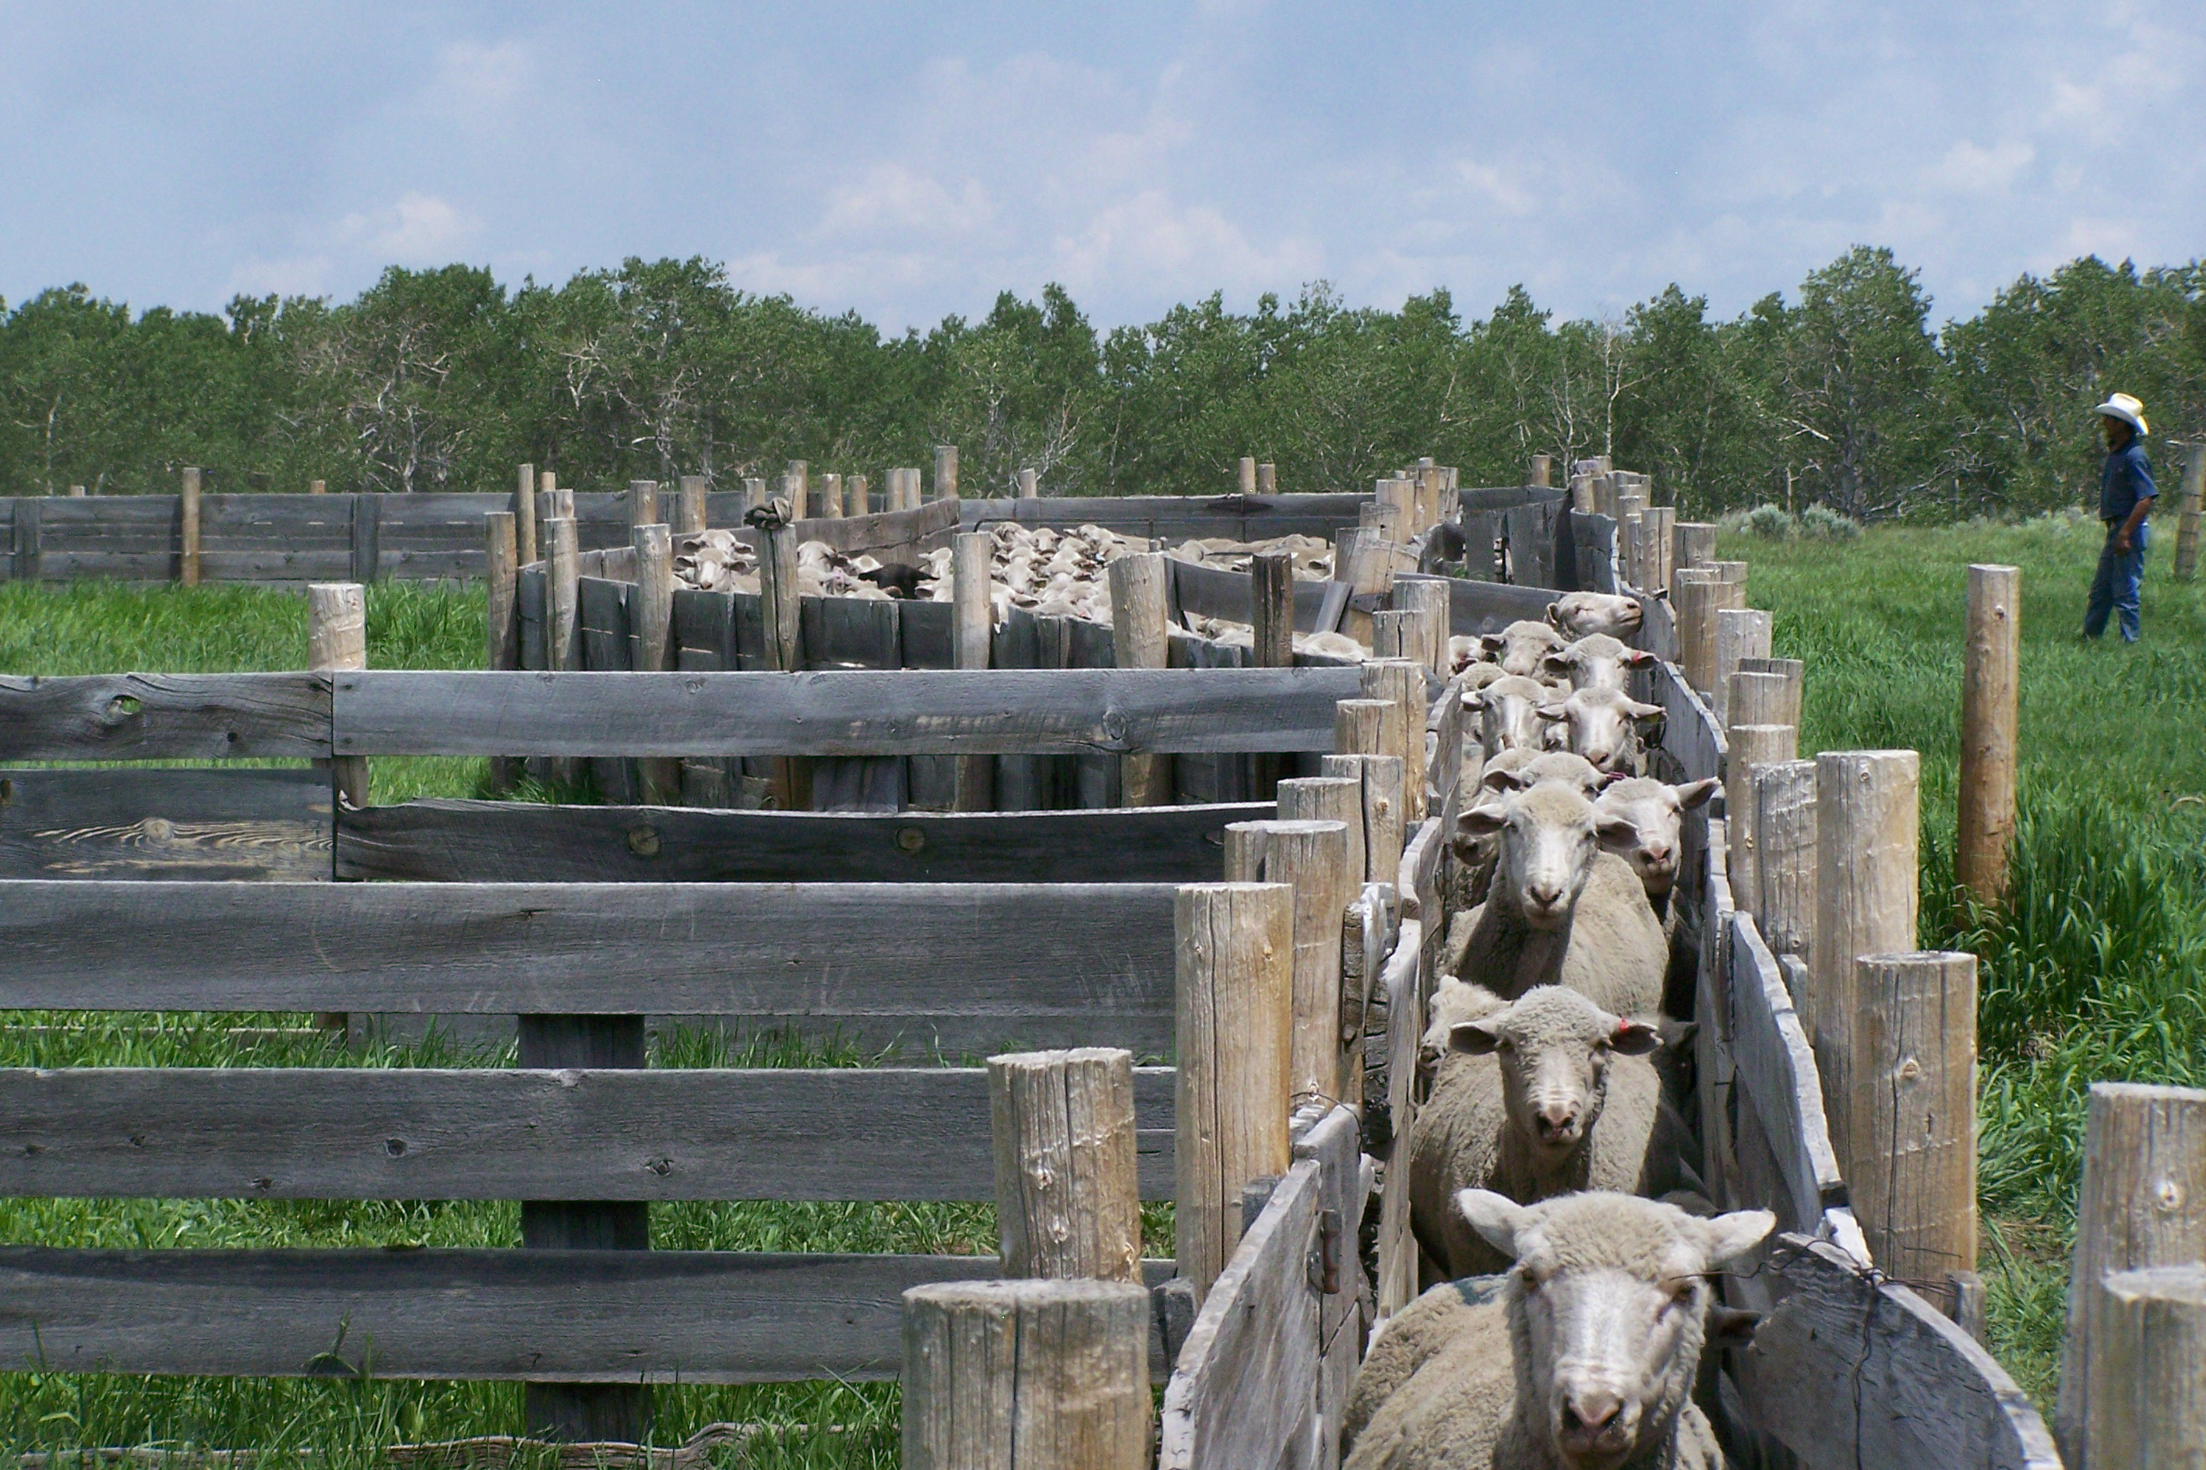

These positions are being advertised online at www.usajobs.gov. All applications must be submitted within the USAJOBS website. To apply create an account, profile, and application within www.usajobs.gov. Search for the announcement number(s) listed below that you are interested in and make sure you choose Saratoga, Wyoming to be considered for local positions.

Announcement # | Title | PP-Series-Grade | Duty Station
TEMPOCR-0455-5-RANGE-DT | Range Technician | GS-0455-05 | Saratoga, WY
TEMPOCR-0455-6-RANGE-DT | Range Technician | GS-0455-06 | Saratoga, WY

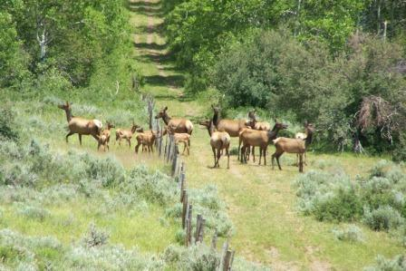

Applications should be competed in USAJobs by April 1, 2013
to receive full consideration for these positions.

If you have any questions or need additional information, you may contact:
Brad Weatherd or Becky Romios
Medicine Bow-Routt National Forests and Thunder Basin National Grassland
P.O. Box 249, Saratoga, Wyoming 82331
Phone: (307) 326-5258 FAX: (307) 326-5250
rromios@fs.fed.us
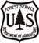

The U.S. Department of Agriculture (USDA) prohibits discrimination in all its programs and activities on the basis of race, color, national origin, gender, religion, age, disability, political beliefs, sexual orientation, and marital or family status. (Not all prohibited bases apply to all programs.) Persons with disabilities who require alternative means for communication of program information (Braille, large print, audiotape, etc.) should contact USDA's TARGET Center at 202-720-2600 (voice and TDD).
To file a complaint of discrimination, write USDA, Director, Office of Civil Rights, Room 326W, Whitten Building, 14th and Independence Avenue, SW, Washington, DC 20250-9410 or call (202) 720-5964 (voice or TDD). USDA is an equal Opportunity provider and employer.

