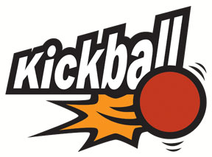
For more information, please contact:
Alanna Riggs: agr1@email.arizona.edu
Brianna Rico: ricobri@email.arizona.edu


This is the third annual Kickball Tournament between Tierra Seca and The Fish and Wildlife Club! This is a great opportunity to come socialize with other School of Natural Resource students and faculty, regardless if you are involved in either club!
We are welcoming everyone (and their dogs) to come hang out for an afternoon.
Food will be catered, drinks will be provided.
If you would like alcohol, you must bring it yourself and act responsibly. We have obtained the proper permits but ask that everyone be accountable for their own actions.

When: Sunday, March 24th
Time: Game starts at 2:00pm to whenever!
Place: Connor Park (SE of Glenn and Campbell)
What to Expect: Food, drinks, and fun!
Third Annual SNRE Kickball Tournament
Hosted by The Fish and Wildlife and Tierra Seca Clubs

