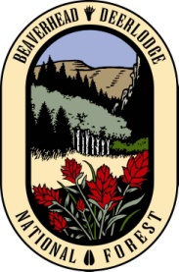
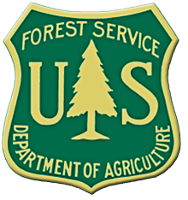

Outreach Notice
Range Technician GS-0499-04 Position

Pacific Northwest Region

Rogue River – Siskiyou National Forest
Siskiyou Mountain Ranger District

The Rogue River-Siskiyou National Forest is currently seeking candidates for a temporary GS-0499-04 Range Technician summer internship position.

About the Position(s): This position is an entry level range field position. Applicants must be a current undergraduate student in good academic standing who will be attending college as an undergraduate or graduate student in the fall of 2013. The position will be based out of the Siskiyou Mountain Ranger District, but maybe used on other districts on the Forest. Government housing may be available. Principle duties will include:
- Conducting range inspections
- Conducting range Improvement inventories and mapping
- Maintaining range improvements
- Optional Wildland Fire experience

The anticipated start date for this position is late May to early June; the end date is late August/ September (based on funding and availability of Intern).

HOW TO APPLY:
This position will be filled under the Pathways program. If you are interested in applying for this position, please submit your application through www.usajobs.gov/StudentsandGrads. Use the search function to find vacancy announcement number 13-INTERN-NTE-0499-PW. Select Jacksonville, Oregon as your location. The deadline for applying is MARCH 1, 2013.

For specific position information, applicants can contact:
Mark Hocken
Forest Range Program Manager
Rogue River-Siskiyou National Forest
(541) 899 – 3800 office
(541) 261-1085
mhocken@fs.fed.us
ABOUT THE AREA:

ABOUT SISKIYOU MOUNTAIN RANGER DISTRICT

The Siskiyou Mountain Ranger District is located within the Siskiyou Mountains West of Interstate 5; the Forest resides within the ancient and complex geology of the Siskiyou Mountains. This is a country of narrow canyons and high, steep ridges. Elevations range from almost sea level near the coast, to 7,533 feet at the summit of Mount Ashland (the highest point in Oregon west of the Cascades). The variety of environments includes open oak woodlands, dense conifer forests, and barren, rocky ridge tops.

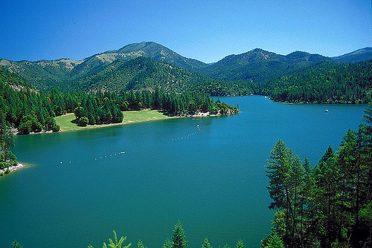

The Red Buttes Wilderness Area is also located on the district. Crater Lake National Park is located on the Northeast portion of the Forest. Applegate Lake is within 10 miles of the ranger station and Medford Oregon is within 20 mile of the ranger station. The Siskiyou Mountain District supports tremendous natural resources and multiple use programs including range management program, recreation, trail systems, fish habitat and a minerals program.

Southwest Oregon and the RRS NF are known for recreational activities. The Forest trails program includes the Pacific Northwest Trail, and numerous wilderness and non-wilderness trails. Check the Forest web site at: http://www.fs.usda.gov/detail/rogue-siskiyou/home/?cid=stelprdb5305069


USDA Non-Discrimination Statement
Revised 6/8/2005
“The U.S. Department of Agriculture (USDA) prohibits discrimination in all its programs and activities on the basis of race, color, national origin, age, disability, and where applicable, sex, marital status, familial status, parental status, religion, sexual orientation, genetic information, political beliefs, reprisal, or because all or part of an individual’s income is derived from any public assistance program. (Not all prohibited bases apply to all programs.) Persons with disabilities who require alternative means for communication of program information (Braille, large print, audiotape, etc.) should contact USDA’s TARGET Center at (202)720-2600 (voice and TDD). To file a complaint of discrimination, write to USDA, Director, Office of Civil Rights, 1400 Independence Avenue, S.W., Washington, DC 20250-9410, or call (800) 795-3272 (voice) or (202) 720-6382 (TDD). USDA is an equal opportunity provider and employer.”

