**************** OUTREACH ***************

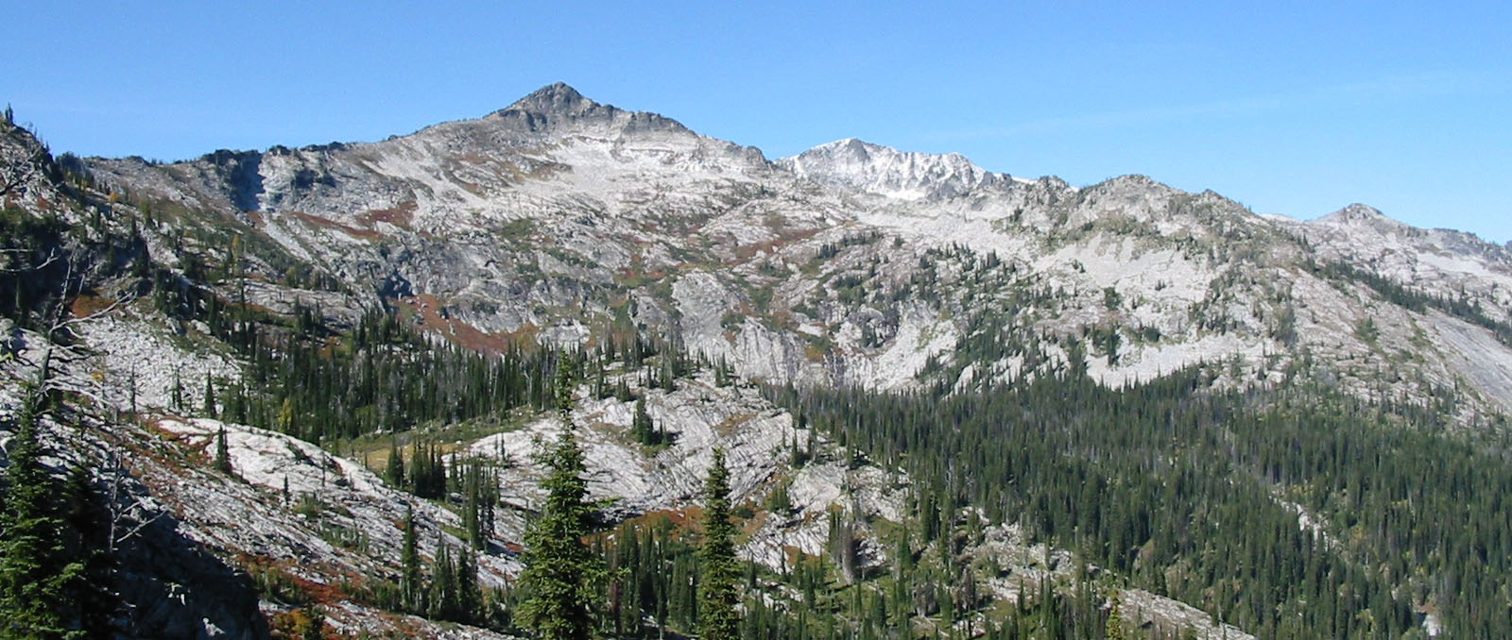
Bitterroot National Forest

GS-0462-3/4/5 Forestry Aid/Technician
(Trails)

WEST FORK RANGER DISTRICT

Darby, Montana

The Bitterroot National Forest, West Fork Ranger District will soon be hiring for trail crew positions at the GS-0462-3/4/5 Forestry Aid and Technician levels. These positions are located at Darby, Montana. If you are interested in applying for a position, please respond on the enclosed Outreach Notice Form by February 22, 2013.

About the Position: These positions will serve as the Bitterroot National Forest trail crew and be responsible for maintenance and construction of the trail system. Work will primarily be in back-country and Wilderness settings and consist of, but not limited to, logging out, brushing, clearing rocks and boulders, installing and maintaining drainage structures, building crib walls, turnpikes, puncheons, constructing minor re-routes, and re-treading. These positions will be physically strenuous and will be expected to work in the woods 8-10 days at a time in all types of weather conditions. Positions will require camping out in the field the majority of the time. Successful applicants will gain skills in primitive and motorized tool use/maintenance, trail construction/maintenance techniques, backpacking, stock use, first aid, ATV use, and teamwork. These are SEASONAL TEMPORARY positions with a maximum six month tour schedule (NTE 1039 hours). The anticipated start date for these positions is early to mid-May and ending in late September.

PHYSICAL DEMANDS: The work includes strenuous outdoor activity, such as hiking, climbing, riding and packing stock, and backpacking, often on steep, rough terrain in remote wilderness environments. Applicants can expect to hike 10+ miles per day. Elevations can range from 2,000 to over 7,000 feet and temperatures typically range from 30 to 110 degrees Fahrenheit.

LOCATION: The position is located at the West Fork Ranger Station, located on the West Fork Road 18 miles southwest of Darby, MT.

ABOUT THE AREA: The Bitterroot Valley is a river basin about 65 miles long from north to south and as much as 10 miles wide, bordered to the west by the dramatically carved Bitterroot Mountains and to the east by the gentler Sapphire Mountains. The valley is considered the banana belt of Montana. Summer temperatures are warm (normally in the low 90s) and winter temperatures mild with only occasional below zero readings.

Centrally positioned along the Bitterroot River, the town of Hamilton is a full service community of 5,000 people located 35 miles north of the West Fork Ranger Station and 45 miles south of the larger college community in Missoula. Ample community and real estate information is available on the web. A good place to start is the Bitterroot Valley Chamber of Commerce website http://www.bitterrootvalleychamber.com/

The area offers year-round recreation including camping, hiking, bicycling, and a variety of water sports – including fly-fishing the West Fork of the Bitterroot River out the front door of the West Fork Ranger Station. Winter recreationists will find miles of opportunity in the south end of the valley, from groomed snowmobile and cross-country ski trails to the family-friendly Lost Trail downhill ski area.

There is bunkhouse space available on a first come- first serve basis. General housing is available in the West Fork area and in Conner, Darby and Hamilton. Apartment rentals are from $300 to $500 month for 1 bedroom and $500 to $600+ per month for 2 bedrooms.

FOREST OVERVIEW: The Bitterroot National Forest and its four Ranger Districts cover 1.6 million acres in west central Montana and Idaho. Approximately 1,500 miles of wilderness and non-wilderness trails provide experiences for hikers, horseback riders, mountain bikers, motorcyclists and ATVs.

Approximately 50% of the Forest is designated wilderness - including portions of the Selway-Bitterroot, Frank Church River of No Return, & the Anaconda Pintler – and another 25% of the Forest is inventoried roadless. Neighboring national forests include the Nez Perce, Clearwater, Lolo, and Beaverhead-Deerlodge in Region 1 and the Salmon-Challis and Payette in Region 4.The Forest lies in 3 counties, Ravalli and Missoula in Montana and Idaho County, Idaho.

The Forest has been a leader in resource benefit fire for over 30 years and more than 600,000 acres of the Forest have burned since 2000. This presents a challenging mission to provide quality public access on fire-affected trails, especially in wilderness settings. The Forest is committed to maintaining a traditional-tool expertise on trail crews. Experience with the use of back-country and primitive tools are critical skills in this position.

CONTACT INFORMATION: Anyone interested in further information and/or have questions regarding these positions may contact Mark Smith, (406) 821-1218; Mailing address: West Fork Ranger District, 6735 West Fork Road, Darby, MT 59829; or email: markrsmith@fs.fed.us by February 22, 2013.

HOW TO APPLY

APPLY ONLINE at www.USAJOBS.gov by February 22, 2013 in order to be considered for these positions

Step 1: Create a USAJOBS account (if you do not already have one) at www.USAJOBS.gov. It is recommended that as part of your profile you set up automatic email notification to be informed when the status of your application changes. If you choose not to set up this automatic notification, then you will have to log into your USAJOBS account to check on the status of your application.

Step 2: Create a resume with USAJOBS or upload a resume into your USAJOBS account. You may want to customize your resume to ensure it documents duties and accomplishments you have attained that are directly related to this position, so your application will meet required qualifications. (Ensure you provide exact dates of employment so your qualifications are accurately documented: e.g. May 1, 2010 to Oct 29, 2010 will be calculated as 5 months of experience; listing May 2010 to Oct 2010 may be calculated as only 3 months of experience, assuming a start date in late May and an end date at the beginning of Oct).

Step 3: Search for the job announcement number (see JOA notes on position descriptions on the previous page). You may need to use the advance search option with the job title to find the correct job announcement number. Read the entire announcement and all the instructions before you begin. Click “Apply Online” and follow the prompts to complete the Occupational Questionnaire and attach any additional documents that may be required. You should ensure that you address the qualifying skills and accomplishments for the position for which you are applying in another part of your application (Resume or additional attachment). Make sure you select Darby, MT as a potential duty station.

The announcement numbers for these positions are:
Trails | Forestry Aid | GS-03 | TEMPOCR-0462-03-GEN-DT | Mark R Smith
Trails | Forestry Technician (Trail) | GS-04  GS-05 | TEMPOCR-462-04-TRAILS-DT  TEMPOCR-462-05-TRAILS-DT | Mark R Smith

You can update your application or documents anytime while the announcement is open. Simply log into your USAJOBS account and click on “Application Status”. Click on the position title and then select “Update Application” to continue.

Classification & Qualifications

General Schedule Qualification Standards
Forestry Technician Series, 0462

Individual Occupational Requirements

Specialized Experience (for positions at GS-4 and above)
In addition to the experience requirements described in the group coverage standard, seasonal experience may also be creditable. A season of experience is considered to be a period of no less than 3 months of continuous employment on a seasonal basis. Shorter periods may be combined to make a season, provided a total of at least 3 months' experience is shown. For any period where the work exceeded 3 months, the excess work is credited towards an additional season of experience. One season of experience is qualifying for GS-2; 2 seasons of experience qualify for GS-3; and 4 seasons of experience qualify for GS-4. Examples of qualifying specialized experience include:
- Forestry aid or technician work.
- Engineering, range, or soil conservation technician work that involved the application of cultural, resource conservation, or land management practices on non-forest or ranch lands when combined with knowledge of forestry operations and equipment.
- Farming or ranching work that involved application of cultural and soil and water conservation practices, including safety and use of equipment, and that provided a basic understanding of land use.
- Forest or range fire control, prevention, or suppression work.
Education and Training
For GS-3: Successful completion of 1 year of study that included at least 6 semester hours in a combination of courses such as range management or conservation, agriculture, forestry, wildlife management, engineering, biology, mathematics, or other natural or physical sciences.
For GS-4: Successful completion of 2 years of study that included at least 12 semester hours in any combination of courses such as forestry, agriculture, crop or plant science, range management or conservation, wildlife management, watershed management, soil science, natural resources (except marine fisheries and oceanography), outdoor recreation management, civil or forest engineering, or wildland fire science. No more than 3 semester hours in mathematics is creditable.
For GS-5: Successful completion of a full 4-year course of study leading to a bachelor's degree (a) with major study in forestry, range management, agriculture, or a subject-matter field directly related to the position, or (b) that included at least 24 semester hours in any combination of courses such as those shown above for GS-4. No more than 6 semester hours in mathematics is creditable.
February 01, 2013 | BITTERROOT NATIONAL FOREST
 | OUTREACH RESPONSE FORM

To complete form, use tab key to move between fields (gray blocks), or left click on any field.

Entries in check box fields are made by a single click to select or unselect. Type entries in other fields.

Position Identification
Position Title: |  |  |  | Forestry Aid/Technician (Trails)
Series/Grade: |  |  |  | GS-0462-3/4/5
Location: |  | West Fork Ranger Station

Applicant Information
Name: |  |  |  |  |  |  |  |  | E-Mail Address:

Current Title, Series, Grade:

Current Organization/Location:
Current Appointment: |  |  |  |  |  | Permanent Temporary Term Not Current Employee

If you are NOT a current permanent (career or career conditional) employee, are you eligible to be hired under any of the following authorities:
 | Reinstatement  Disabled Veteran with 30% Compensable Disability  Veteran’s Employment Opportunities Act of 1998  Other |  |  |  |  |  |  |  |  |  | Person With Disabilities  Former Peace Corps Volunteer  Demonstration Project (external  recruitment from the general public)

Position Interest

I would like to be considered for this position identified.
 |  |  |  |  | GS-0462-03
 |  |  |  |  | GS-0462-04
 |  |  |  |  | GS-0462-05
 | Please feel free to attach a Resume or other supporting document to this outreach response form


USDA Non-Discrimination Statement
Revised 6/8/2005
“The U.S. Department of Agriculture (USDA) prohibits discrimination in all its programs and activities on the basis of race, color, national origin, age, disability, and where applicable, sex, marital status, familial status, parental status, religion, sexual orientation, genetic information, political beliefs, reprisal, or because all or part of an individual’s income is derived from any public assistance program. (Not all prohibited bases apply to all programs.) Persons with disabilities who require alternative means for communication of program information (Braille, large print, audiotape, etc.) should contact USDA’s TARGET Center at (202)720-2600 (voice and TDD). To file a complaint of discrimination, write to USDA, Director, Office of Civil Rights, 1400 Independence Avenue, S.W., Washington, DC 20250-9410, or call (800) 795-3272 (voice) or (202) 720-6382 (TDD). USDA is an equal opportunity provider and employer.”

