OUTREACH NOTICE
Region 4
Ashley NF
Duchesne/Roosevelt Ranger District
District Supervisory Rangeland Management Specialist, GS 454-11
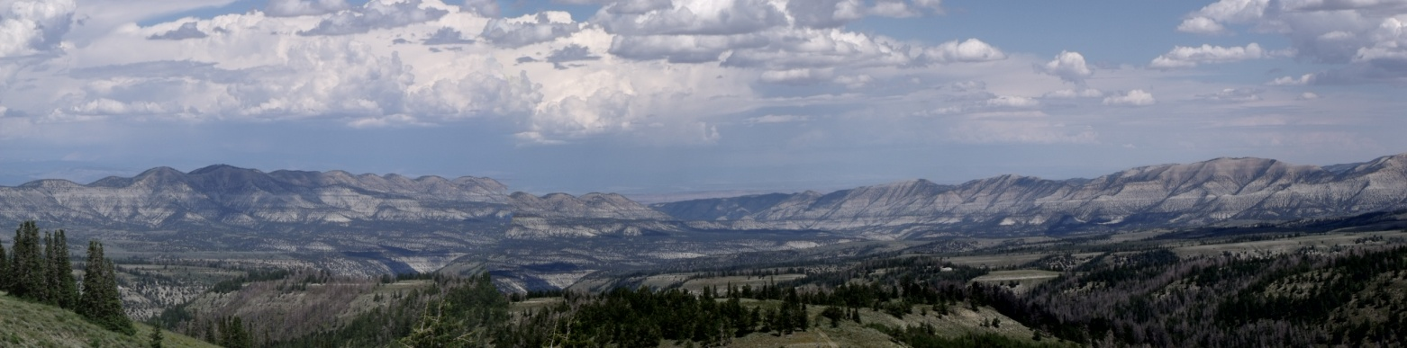
The Duchesne/Roosevelt Ranger District is seeking candidates for the Supervisory Rangeland Management Specialist position. This 690,000+ acre Ranger District has an extensive range program with all the excitement, challenges and gratification that goes along with managing grazing (both cattle and sheep) in some incredible country including the High Uintas Wilderness in north/central Utah. The duty station is Duchesne, Utah; a small town in the Uintah Basin.
Major Duties: The person selected will serve as the District range and weed program leader, supervising a GS 9 rangeland management specialist, a range technician, and a varying range seasonal workforce. They will have responsibility for overall management of 41 allotments, including permit administration and long-term monitoring; overseeing completion of environmental analysis; implementing decisions regarding grazing authorizations; and coordinating with Duchesne County and Cooperative Weed Management Areas. This position works closely with other personnel on the District and across the Forest. The position will oversee an extensive monitoring program associated with grazing and ecosystem management. Excellent monitoring, technical, and oral and written communications skills are critical in accomplishing these duties.
Ashley National Forest
Ashley National Forest - With headquarters in Vernal, Utah, it comprises 1.3 million acres located in the northeastern portion of Utah and southwestern portion of Wyoming. National Forest System lands are located in three major areas: the northern and southern slopes of the Uinta Mountains, the Wyoming Basin, and the Tavaputs Plateau.
The Ashley National Forest is bordered by the Uintah and Ouray Ute Indian Reservation, the Uinta and Wasatch-Cache National Forests, private property, and lands administered by the Bureau of Land Management and State of Utah. Dinosaur National Monument is located approximately 10 miles east of the Forest.
The Ashley National Forest was established by President Theodore Roosevelt in 1908. Its forest and range lands are protected and managed to ensure timber, grazing, minerals, water, and outdoor recreation for the American people.
The vast Uinta Mountains watershed within the Forest boundary provides vital water supplies for power, industry, farm, and city use in Utah, Nevada, Wyoming, and California. Sheep, cattle, and horses graze under permit on over a half million acres of the Forest each season. Timber is managed in harmony with other resources to insure a continuing supply and a quality environment. Over 2.5 million visitors come to the Forest each year to participate in outstanding outdoor recreation activities, such as boating, fishing, camping, hiking, backpacking, horseback riding, cross-country skiing, and snowmobiling.
Forest landscape ranges from high desert country to high mountain areas. The elevation varies from a low of 6,000 feet to a high of 13,528 feet above sea level at the summit of Kings Peak.
Topographical diversity and intensive land management has served to protect the visual quality on the Forest. The existing vegetation patterns and the geological formations further add to the aesthetic value. The Forest boundaries include places such as the Sheep Creek Geological Area, the High Uinta Wilderness area, the Green River, and the Flaming Gorge National Recreation Area. Ashley National Forest - Home
Duchesne/Roosevelt Ranger District

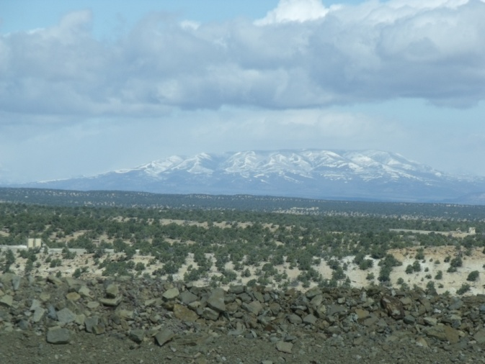
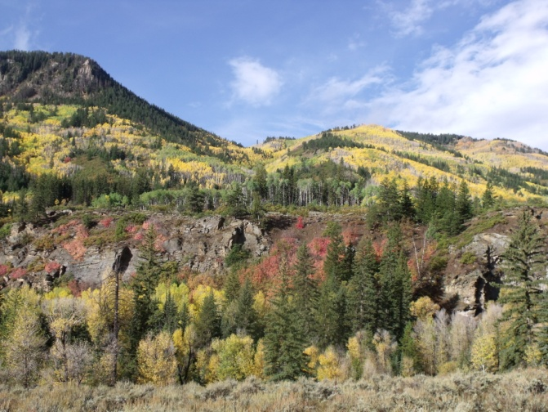

The Duchesne/Roosevelt Ranger District has 27 permanent employees and covers approximately 690,000 acres of National Forest land. There are 19 developed recreation sites and a number of dispersed sites, a wide variety of system trails, and lead management responsibilities for the 456,000 acre High Uintas Wilderness.

About Duchesne, Utah

Duchesne (pop. approximately 1700) is a fast growing community with a high quality of life located within the Uintah Basin. Duchesne is located about two hours East of Salt Lake City, Utah, a half hour west of Roosevelt, UT and an hour west of Vernal, UT. The main street in Duchesne is U.S. Highway 40, which is one of the main routes between Denver, Colorado and Salt Lake City, Utah. Main Street was recently renovated to include, brick sidewalks, unique gas lamp style lighting, park benches and shrubbery. Starvation State Park/Reservoir is located just outside of the city limits.
Schools
Elementary School – Kindergarten through 6th Grade.
High School – Grades 7 through 12.

Utah State University-Uintah Basin (Vernal and Roosevelt) offers 13 complete bachelors degree programs and 7 complete masters degree programs. Uintah Basin Applied Technology College offers Certificates of Competency for technical, entry-level work.
Health Care
Duchesne has a small local clinic. In Roosevelt, 29 miles to the east, there is a fully staffed hospital and clinic with many doctors who specialize in all fields of medicine. There are also many dentists in Roosevelt. Duchesne has local EMTs, a Fire Department, and 911 services.
Housing
There is no Government housing available in Duchesne. There are a few homes for sale and rent. For current realty information, contact local real estate agencies.
Recreation
Duchesne has its share of parks that include tennis courts, baseball fields and picnic areas. There is a swimming pool and a bowling center. Duchesne offers a full range of spring, summer, fall and winter activities. There is an old-fashioned County Fair and Rodeo each summer. There is boating, fishing and an annual Walleye Fishing Tournament at Starvation Reservoir 5-10 minutes northwest of town. Hunting includes deer, elk, moose, antelope, bear, pheasant and doves.
Churches
Churches that provide services in Duchesne include Catholic, Baptist, and Latter Day Saint.
Business/Shopping
Restaurants; Fast Food/Convenience Stores; Grocery Store; Automotive Repair; Service Stations; Hardware Store; Motels
Economic Base
Agriculture - Ranching and Farming, Oil Industry, and Tourism
Climate
Spring, summer, and fall are mild and beautiful, with temperatures reaching 90-95 degrees in July and August. Winter temperatures may go to 20 below zero in December and January.

If you are interested in this position or have any questions, please complete the attached “Outreach Form” and submit to:

Kristy Groves
PO BOX 981
Duchesne, UT 84021
kgroves@fs.fed.us
435-781-5203

OUTREACH NOTICE FORM

Reply Due: November 15, 2012:
Kristy Groves, District Ranger, 435-781-5203, kgroves@fs.fed.us

Ashley National Forest
Duchesne/Roosevelt Ranger District
Supervisory Rangeland Management Specialist
GS-454-11

NAME:_________________________________________________________________

E-Mail:______________________________________________________________

MAILING ADDRESS:______________________________________________________________

____________________________________________________________

TELEPHONE NUMBER:____________________________________________________________

AGENCY EMPLOYED WITH: USFS BLM OTHER

TYPE OF APPOINTMENT: PERMANENT TEMPORARY TERM
VRA PWD OTHER

CURRENT REGION/FOREST/DISTRICT:

CURRENT SERIES AND GRADE:

CURRENT POSITION TITLE:

IF NOT A CURRENT PERMANENT (CAREER OR CAREER CONDITIONAL) EMPLOYEE ARE YOU ELIGIBLE TO BE
HIRED UNDER ANY OF THE FOLLOWING SPECIAL AUTHORITIES:

______ PERSON WITH DISABILITIES
______ VETERANS READJUSTMENT
______ DISABLED VETERANS W/30% COMPENSABLE DISABILITY
______ VETERANS EMPLOYMENT OPPORTUNITIES ACT OF 1998
______ FORMER PEACE CORPS VOLUNTEER
______ STUDENT CAREER EXPERIENCE PROGRAM
______ OTHER

Thank you for your interest in our Vacancy!

