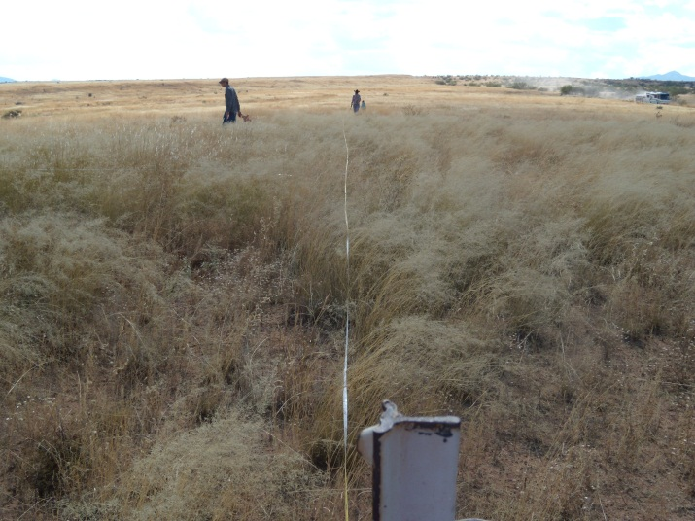
LAS CIENEGAS UPLAND MONITORING
Come help BLM with Upland Monitoring and practice range monitoring skills
What: BLM Upland Monitoring.
When: Tuesday, October 2nd
Thursday October 4th
Friday October 5th
Tuesday, October 9th
Friday, October 12th
Tuesday, October 16th
Thursday October 18th
Friday, October 19th
Tuesday, October 23rd
Thursday, October 25th
Friday October 26th
Tuesday, October 30th
Thursday, November 1st 2012
8:00 a.m. to 4:00 p.m. (hopefully)
Where: We will meet at Empire Ranch Headquarters at Las Cienegas National Conservation Area.

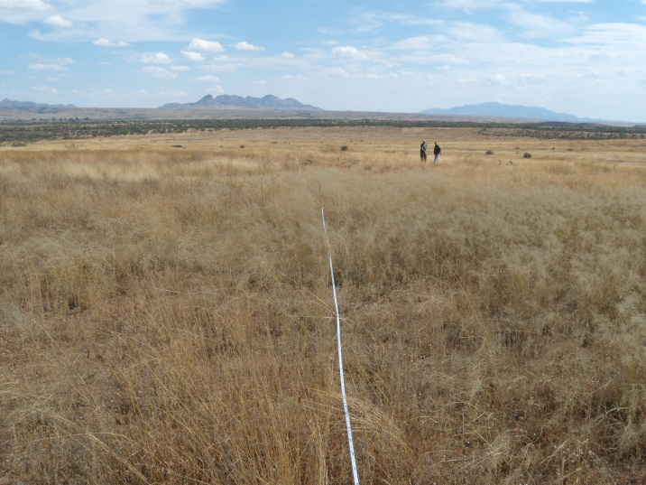

Experience identifying range forbs and grasses is a plus but not required. It will be a full day of field work in the sun. To sign up to volunteer for one of more of our upland monitoring days, or for more information including detailed time and place instructions, please contact Amy Markstein at the Tucson BLM office 520.258.7231 or amarkstein@blm.gov . Each volunteer will need to complete an individual volunteer agreement with BLM. For volunteers under age 18, a parent or guardian must sign the form.
What to bring:
Hat, sunscreen, plenty of water, and a lunch. Sturdy shoes that can withstand prickly grass seeds. Long pants and shirt recommended. You might also want your camera, binoculars, etc. We'll provide maps, instructions, pencils and other field equipment.

Directions to Empire Ranch Headquarters from I-10 East:
- Exit 281, to Sonoita, Hwy 83
- Head south on Hwy 83 to the Las Cienegas National Conservation Area entrance, which is just after mile marker 40, about 19 miles south of the I-10 exit.
- The entrance is to the left (east) and is a graded dirt road. Look for the Highway sign for Historic Empire Ranch which directs you to the entrance road.
- Follow entrance road (LC900) for about 3 miles to the Empire Ranch Headquarters. These are 1st buildings you see to your left. Park in large parking area near public restrooms.

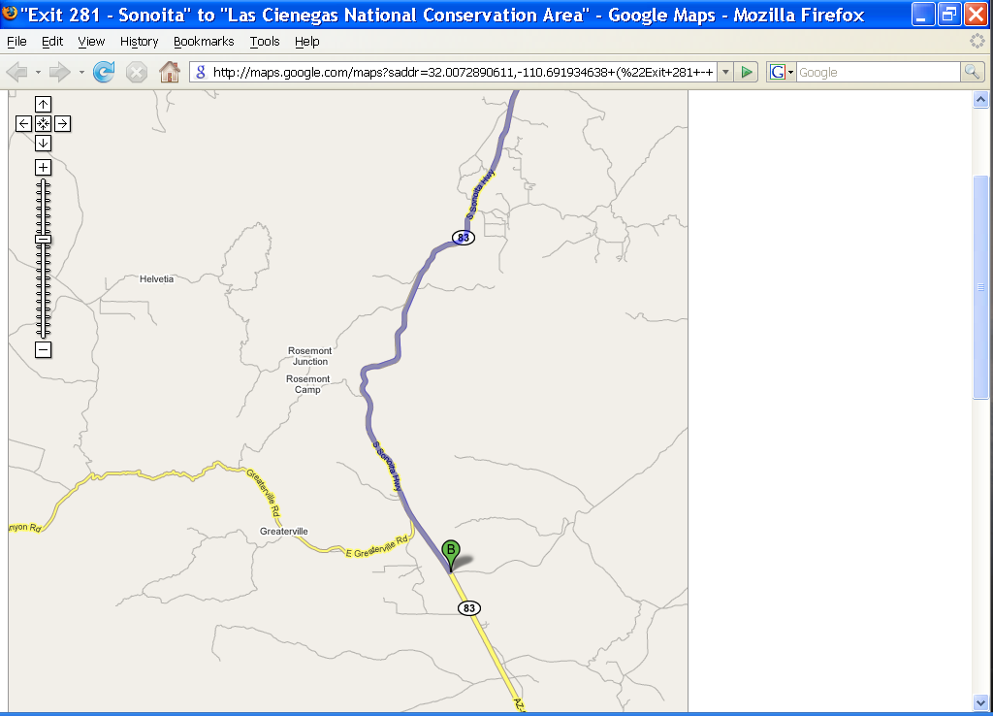
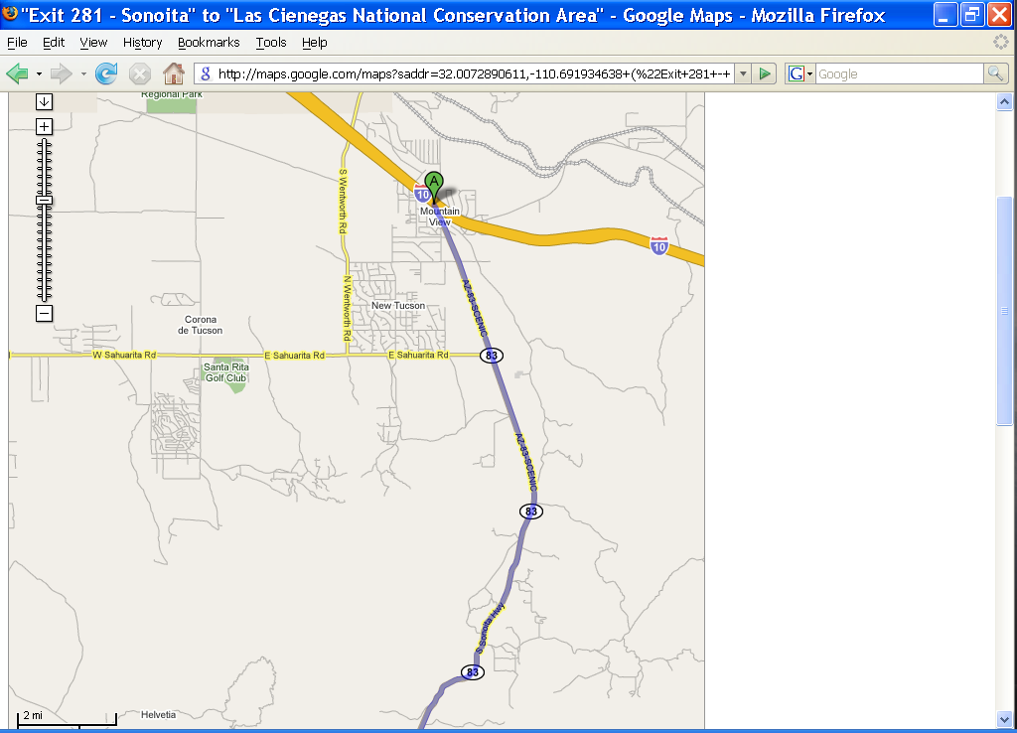
Las Cienegas NCA – Empire Ranch HQ

