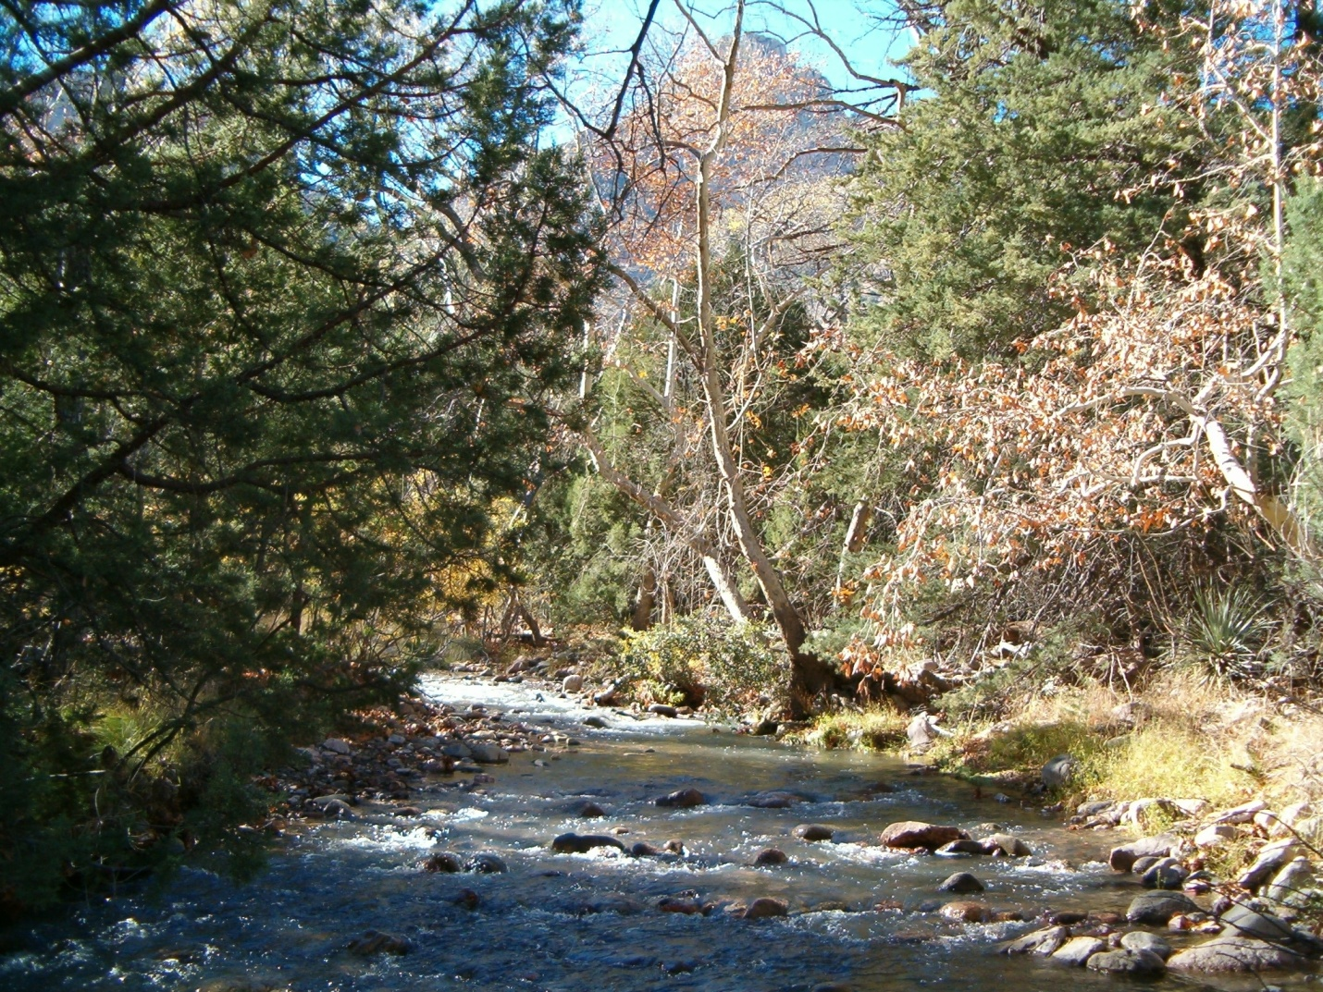
Forestry Technician – Wilderness Ranger – GS-0462-05 (Temporary)
Coronado National Forest
Douglas Ranger District

O
U
T
R
E
A
C
H

Outreach Open Date: 04/13/2012 Outreach Close Date: 06/13/2012

This is a temporary position and will not exceed 1040 hours per year.

The Coronado National Forest will soon be advertising for two GS-5 Forestry Technician (Wilderness Ranger) positions to be based in Douglas, Arizona. The announcement will be placed on www.usajobs.opm.gov.

These positions support the South Zone Trails and Wilderness Program of the Coronado National Forest by accomplishing a variety of recreation monitoring and forest protection tasks in the Chiricahua, Miller Peak, Mt. Wrightson, and Pajarita Wilderness areas. The incumbent’s primary responsibilities are recreation site monitoring, organization of data, direct public contacts, and compliance.

These positions will also be open to students who meet the terms of the Student Temporary Employment Program (STEP). Key requirements for students are as follows:

- U.S. Citizen
- Suitable for Federal Employment, determined by Background Investigation
- Be at least 16 years of age
- Mobility is required to all recreation sites
- Must have a valid Motor Vehicle Operators License
- Enrolled or accepted for enrollment as a degree-seeking student
- Enrolled at least half-time
- Have a cumulative grade point average of 2.0 or better

These responsibilities encompass the strategies for succeeding with wilderness areas in the 10-Year Wilderness Stewardship Challenge. In 2004 the Chief challenged our agency to successfully manage all 407 national forest wilderness areas for air quality, invasive species, fire, opportunities for solitude, recreation site monitoring, education and other criteria. As we rise to the Challenge, our wilderness rangers are becoming stewards of a broader landscape of ideas and information. We help manage a whole place instead of separate resources.

Duties

- Explains and enforces use regulations according to the Wilderness Act.
- Inspects wilderness and backcountry areas to determine compliance with regulations or specifications.
- Providing public information.
- Promotes environmental education in “Leave No Trace” techniques and wilderness stewardship.
- Assisting with data collection of backcountry camping areas.
- Evaluates permitted outfitter/guides.
- Assists in the development and implements the logistics required for completion of wilderness projects and backcountry programs as based on approved direction in land management plans.
- Assists with backcountry site cleanup and naturalizing, completing condition surveys, and making recommendations for improvements.

The positions are full time and will require weekend and holiday work. The ability to work in remote locations with rough topography will be required. Additionally, applicants should be able to perform these duties in extreme working conditions (i.e. heat, humidity, rain, wind, etc.).

About the Douglas Ranger District

The Douglas Ranger District encompasses three mountain ranges: the Chiricahua Mountains (291,496 acres), the Dragoon Mountains (54,211 acres) and the Peloncillo Mountains (87,986 acres). These mountain ranges are part of the Coronado National Forest “Sky Island” landscape with some of the most diverse wildlife and plant life in Arizona. The District is located in the southeastern corner of Arizona and the southwestern corner of New Mexico. As the heartland of the Chiricahua Apache, the Douglas District is the custodian of many unique historic and pre-historic cultural resource sites.

Ecological types range from Sonoran and Chihuahuan deserts to spruce-fir forests, as elevations rise from about 4,500 feet to over 9,700 feet. The Chiricahua Mountains alone sport 47 designated hiking trails both inside and outside of the 87,700 acre Chiricahua Wilderness.

The monsoon (rainy) season is a very important part of the ecosystem. Running from July through September, the monsoon provides about nine inches of precipitation on average with the remaining seven inches generally in the winter. Temperatures range from the low 20’s in winter to high 90’s for summer.

During the summer season, the District employs an average of 45 people. There are 20 full-time staff, including the fire, range, wildlife, recreation and law enforcement organizations.

Recreation activities on the Douglas Ranger District are nearly as diverse as the people who come to visit. The most popular activities are hiking, camping, bird watching, horseback riding, picnicking, sightseeing, and visiting historic areas. The district has 11 campgrounds, 2 cabin rentals, and over 50 trails.

Coronado National Forest - Home Page at http://www.fs.usda.gov/coronado


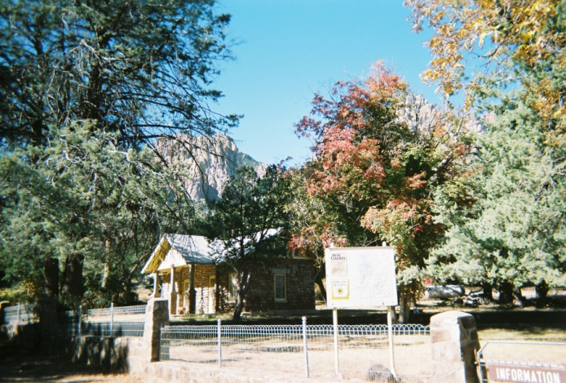
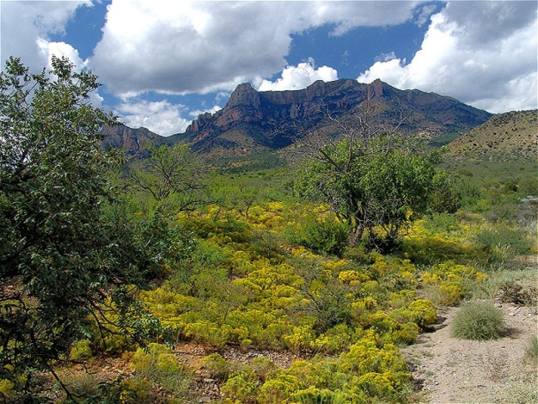

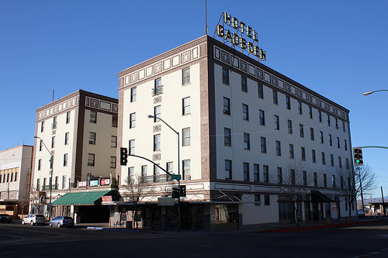
About the Community

Douglas, Arizona is located 118 miles southeast of Tucson (population 486,700) on the US-Mexico border with a population of approximately 15,000. Serving as Arizona’s gateway to Mexico, Douglas is full of history, architecture, minerals, artifacts, and fossils.

We have five elementary schools, two middle schools and one high school. Douglas also has Charter Schools open for enrollment. Located just 10 minutes outside of town, Cochise Community College has its Douglas Campus. The University of Arizona Extension is available through the City of Douglas Library. The Southeast Arizona Medical Center is located three miles west of town, and the city boasts a new dialysis center. Private physicians and medical clinics are available in town. Douglas has a full complement of religious congregations, including Roman Catholic, Methodist, Baptist, Lutheran, LDS, Church of Christ, Church of God, and Jehovah Witness. The Elks Lodge, Lions Club, VFW Post and the Bushmasters Club are all active and visible in the community.

Visitors comfortably walk and tour Agua Prieta, Sonora Mexico, Douglas’ friendly sister city. The adventurous explore our famous Chiricahua Mountains (part of the Douglas Ranger District), and the San Bernardino National Wildlife Refuge. Visitors have a choice of hotels, choosing the historic Gadsden Hotel, opting for the Border Motel, Motel 6 or Travelers’ Motel, or soon booking a room at the Best Western now under construction.

A full range of services and shopping is found locally. Safeway, Super Wal-Mart, PayLess Shoes, Denny’s, KFC, McDonald’s, Taco Bell, and Burger King occupy our shopping district to complement the many locally-owned shops located on G Avenue, Douglas’ “Main Street”. Additional opportunities are located in Bisbee, about a half-hour’s drive west and Sierra Vista, which is about an hour’s drive away. Although there is no government housing available, the local housing market has a wide range of choices. Average home prices are $145,000. Rentals average $700.00 per month.

Scheduled community events include the Cochise County Fair, The Two Flags Arts Festival, The Light Parade in December and County and College rodeos.

Additional Information

Douglas Chamber of Commerce 520-364-2477

www.douglasaz.gov


Those desiring further information about the position or the district should contact:

Robert Walter, Dispersed Recreation Manager
5700 N. Sabino Canyon Rd.
Tucson, AZ 85750
Office: 520-749-7737 or e-mail rdwalter@fs.fed.us

OUTREACH NOTICE RESPONSE FORM
CORONADO NATIONAL FOREST

Douglas Ranger District – Douglas, Arizona

Title, Series, and Grade of Position:
Forestry Technician – Wilderness Ranger GS-0462-05

NAME: _______________________________________________
EMAIL: ________________________________________
MAILING ADDRESS: ___________________________________
_______________________________________________________
TELEPHONE NO: _______________________________________
AGENCY EMPLOYED WITH:______________________________
TYPE OF APPOINTMENT: ____PERMANENT ___TEMPORARY ___ OTHER
CURRENT REGION/
FOREST/DISTRICT
OR MAILING ADDRESS: ____________________________________
CURRENT SERIES AND GRADE: ________________________
CURRENT POSITION TITLE: ____________________________

IF NOT A CURRENT PERMANENT (CAREER OR CAREER CONDITIONAL) EMPLOYEE, ARE YOU ELIGIBLE TO BE HIRED UNDER ANY OF THE FOLLOWING SPECIAL AUTHORITIES;

_____ Person with disabilities
_____ Veteran's Reemployment Act
_____ Disabled Veteran's w/30% compensable disability
_____ Veteran's Employment Opportunities Act of 1998
_____ Former Peace Corps Volunteer
_____ Other
Thank you for your interest in our vacancy!

Return form to:
Robert Walter, Dispersed Recreation Manager
Santa Catalina Ranger District
5700 N Sabino Canyon Rd
Tucson, Arizona 85750
rdwalter@fs.fed.us
FAX (520) 749-7723

