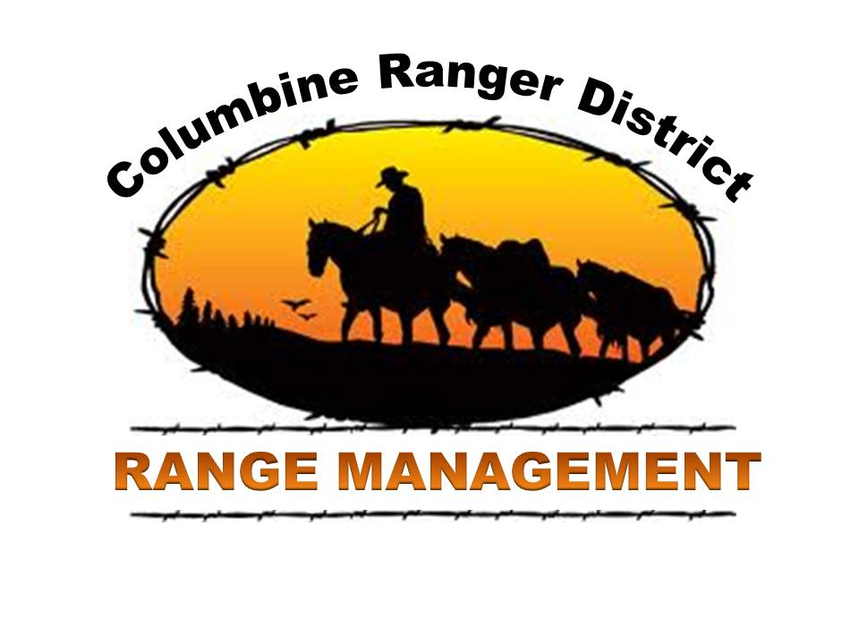

**********************************************
OUTREACH NOTICE
Range Technician
GS-0455-6/7

Region 2
San Juan National Forest
Columbine Ranger District
Bayfield, Colorado

December 21, 2011
********************************************************
The San Juan National Forest, Columbine Ranger District, may be filling a GS-0455-6/7 Supervisory Range Technician position. This position will be a permanent seasonal position 13/13 (13 pay periods in pay status) with a duty station in Bayfield, Colorado. This notification is being circulated to inform prospective applicants of this upcoming opportunity AND TO DETERMINE INTEREST IN THE POSITION. FOREST SERVICE EMPLOYEES ON THE WORKFORCE REDUCTION AND PLACEMENT LIST WILL RECEIVE PRIORITY CONSIDERATION AND CTAP/ICTAP CANDIDATES WILL RECEIVE THE APPROPRIATE CONSIDERATION.
The position will be advertised under merit promotion procedures and DEMO.

OUTREACH RESPONSE

Interested applicants, or those desiring further information, should contact Jared Whitmer by phone 970-884-1416, or by E-mail at: jwhitmer@fs.fed.us. Please respond by no later than January 28th, 2012.

*******Hiring will occur on-line through AVUE Digital Services at www.avuedigitalservices.com. Announcement numbers to apply for 2012 have not been issued to date. It is strongly encouraged to update your profile in AVUE in the mean time. Please select BAYFIELD, CO as your duty station when applying. Hiring will begin in February or as soon an OCR numbers are issued for 2012 and continue as needed through the winter. For more information on how to apply or for additional information about the positions please contact the hiring official listed in this outreach announcement.******

THE POSITION

This position is located on the Columbine Ranger District of the San Juan National Forest. The primary purpose of this position is to assist with the management of the rangeland, botany, and noxious weeds programs on the district. Generally the employment period is from April through October annually. The work required of this position includes noxious weed treatment, contract administration, supervision of weed crews (as funding allows), grazing permit administration, rangeland monitoring, management of the unit’s noxious weeds database, and design/implementation of rangeland improvement projects. The ability to work with other resource area specialist, landowners, and permittees is a must for this position. The position is supervised by a GS-454-11 range management specialist. Extensive hiking, ATV, and horse use in the field is necessary to administer this program.

Additional desired abilities include: Applicator’s License for spraying noxious weeds. Knowledge of range and wildlife management principles in order to deal with resource management problems. Ability to install and read transects, clipping cages, and other instruments for gathering data in range and wildlife management. Knowledge of ArcGIS, working with Trimble and Garmin GPS units, mapping and aerial photo interpretation to map out and delineate essential allotment boundaries, range improvements and allotment analysis data. Skill in the operation of hand and hand-held power tools and equipment in order to perform and/or lead others in the construction and maintenance of range improvements. Knowledge of range and wildlife improvement structures in order to build, supervise, or inspect work when constructing improvements. Knowledge of trailering, packing, riding, and caring for livestock and tack in order to reach sections of range land inaccessible by motor vehicle.
COLUMBINE RANGER DISTRICT

The Columbine District covers over 650,000 acres of forest service land. Approximately two-thirds of the Weminuche Wilderness Area lies within the jurisdiction of the Columbine District. The District manages part of the 61,850 Piedra Management Area. The mountainous terrain contains three peaks over 14,000 feet and several more over 13,000 feet. The District has a complex Range Management Program, along with Recreation, Fire, Heritage Resources and Minerals. For additional information about the San Juan National Forest or Columbine Ranger District please visit: http://www.fs.usda.gov/sanjuan/

The City of Durango, located in La Plata County, is in the southwest corner of the State of Colorado. The population of Durango is approximately 18,000, while the population of La Plata County is over 44,000. The elevation of Durango is 6,512. Durango is situated to allow for many forms of recreation. While we are within 30 miles of Durango Mountain Resort ski area we are also with 2-4 hours of Canyon Lands and Lake Powell. Durango receives an average of 70 inches of snow each year, but also has 300 sunshine days a year. The area offers unlimited recreation opportunities including hiking, camping, mountain biking, fishing and four wheeling and golfing.
Real estate prices in Durango vary, but in general are in excess of 280,000 plus. Rentals are available. Condominiums are available to purchase or rent.

Durango is a full service community with excellent health care facilities and a major hospital. Durango has seven Elementary schools, two middle schools, one high school and one charter school. Fort Lewis College, a four year liberal arts college, is also located in Durango.

The town of Bayfield, also located in La Plata County, is 20 miles East of Durango. The population of Bayfield is approximately 2,500. The elevation is 6,900. Bayfield is situated to allow many forms of recreation. The town is within 50 miles of the Durango Mountain Resort Ski area; 55 miles of Wolf Creek Ski Area; and 15 miles of the Vallecito Nordic ski trails. Bayfield is also with 2-4 hours of Canyonlands and Lake Powell.

Bayfield receives an average of 70 inches of snow each year, but also has 300 sunshine days a year.

Real estate prices in Bayfield vary, but in general are in excess of 200,000. Rentals are limited. Bayfield is a full service community with excellent health care facilities. A major hospital is 13 miles to the West located just outside of Durango. Bayfield has an elementary school, middle school, and a high school. The town has a grocery store, pharmacy, bank, restaurants, recreation department, churches, and a town park with walking trails.

The economy of Durango/Bayfield and La Plata County is based primarily on tourism, agriculture and recreation. The primary recreation attraction in Durango is the Durango and Silverton Narrow Gauge Railroad. Archaeological sites are extensive in the Four Corners area and Mesa Verde National Park, home of the ancient cliff dwellings is 45 miles southwest of Durango.

For info about Durango please visit: www.durango.com.
For info about Bayfield please visit: http://www.bayfieldchamber.org/

