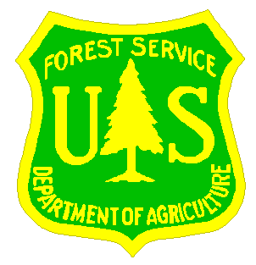
SHASTA-TRINITY NATIONAL FORESTS

Outreach Form

Name:________________________________________________________________

Date:________________________________________________________________

Position and Location Interested In:______________________________________

Email Address:_______________________________________________

Mailing Address:______________________________________________________

______________________________________________________

Telephone Number:_____________________________________________________

Current Employer:_____________________________________________________

Current Region/Forest/District:_________________________________________

Type of Appointment: __________________________________________________

(If Usfs) Series and Grade:______________________________________________

Current Position Title:__________________________________________________

HOW DID YOU HEAR ABOUT THIS Opportunity? ___________________________

If not a current permanent (career or career-conditional) employee, are you eligible to be rehired under any of the following special authorities?

___persons with disabilities

___veterans readjustment

___disabled veterans with 30% compensable disability

___veterans employment opportunities act of 1998

___former peace corps volunteer

___student career experience program

___other:

Thank you for your interest in our vacancy!

