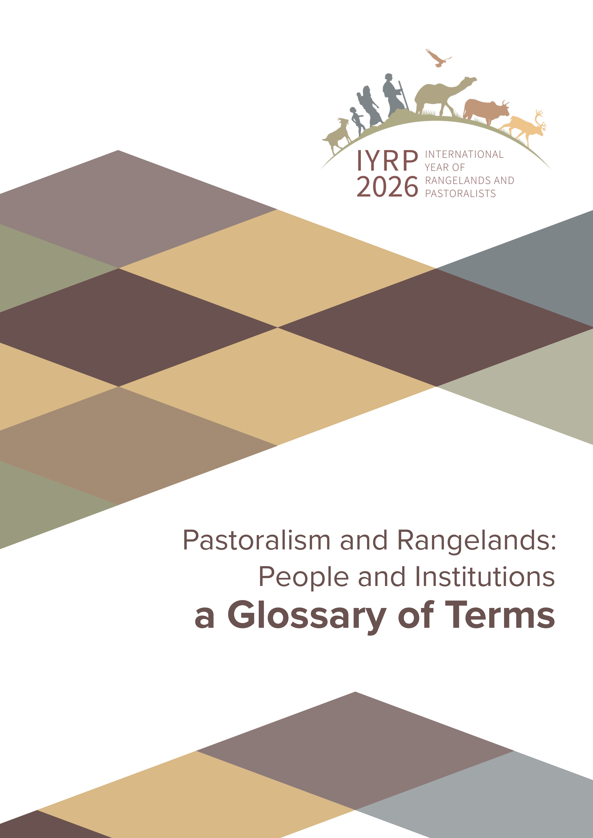

Information Note for GEF Small Grants Programme

International Year of Rangelands and Pastoralists (IYRP) 2026

What is the IYRP?
In 2021, the United Nations General Assembly declared 2026 as the International Year of Rangelands and Pastoralists (IYRP), with FAO designated as the lead agency. With the support of the IYRP Global Alliance, the Government of Mongolia led the initiative, which is either sponsored or endorsed by 106 UN Member States.
Aligned with the call of the UN Resolution upon all Member States and organizations of the United Nations system and all other actors, the IYRP Global Alliance is a collaborative partnership—a coalition of over 380 organizations representing pastoralist associations and communities, civil society, academia, research institutions, local governments, and private sector actors—dedicated to:
- Raising global awareness of the vital role rangelands and pastoralists play in conserving and enhancing biocultural diversity, tackling land degradation, fostering sustainable food systems, advancing climate action, contributing to economies, and supporting the socio-ecological resilience of millions of people;
- Filling gaps relating to rangelands and pastoralism and promoting innovative solutions for the sustainable management and ecological restoration of rangelands, taking into account the traditional knowledge of pastoralists;
- Stimulating increased investment in achieving healthy rangelands and sustainable pastoralism.

Why was IYRP Proposed?
The experience of the global nature conservation movement over recent decades has led to an emerging shift—still only partly achieved—towards recognizing that humans, with their cultural diversity, are an integral component of landscapes, and there is a strong linkage between the conservation of sustainable land use systems including pastoralism and the conservation and maintenance of landscapes including rangelands.
Rangelands—covering more than half of the Earth’s land surface and among the most imperilled and least protected ecosystems on Earth—are those areas where the vegetation is made up of natural grasses, shrubs, tundra, etc., that are grazed by livestock and wildlife. The productivity and environmental health of rangelands are critical for the livelihoods and cultures of more than 500 million pastoralists. “Pastoralists” are people who—as their primary source of living—raise livestock, wild or semi-domesticated animals on rangelands. Billions more people, farmers and non-pastoralists, benefit from these areas and the practice through manure for their farms, animal products, tourism, wildlife and biodiversity conservation, renewable energy, and other uses and services.
The strong linkage between the maintenance of pastoralism and the conservation of rangeland ecosystems has been supported by a growing body of scientific evidence. Pastoralism, which is entirely different in essence from intensive livestock production systems, offers the most sustainable way to make the most of the Earth’s rangelands.
Accordingly, rangelands maintained by pastoralists not only contribute to biodiversity conservation but also deliver benefits in terms of ecosystem services, as well as contribute to the well-being of the local people including those engaged in agriculture and forestry. These areas, which can be conceptualized as Socio-Ecological Production Landscapes (SEPLS), Cultural Landscapes, Territories of Life, are key in achieving multiple targets of the GBF—from area-based conservation, ensuring sustainable production, consumption and management practices, to ensuring equity and inclusion of women, IPLCs, youth.
However, despite being among the most pressing needs at the global level, conservation and sustainable management of rangelands and pastoralism have not been paid attention to by global and national policy frameworks.
IYRP 2026 is built on momentum towards responding to this urgent need for conserving these ecosystems of high biodiversity importance and sustainable pastoralism, which has been a major agent in the evolution and maintenance of these ecosystems for thousands of years.

Why the IYRP Matters?
- It could create strong momentum for achieving global environmental goals in rangelands and grasslands.
- It could raise awareness for increased investment and financing for protecting rangelands from conversion and restoring degraded lands. Rangeland restoration can contribute significantly to mitigating climate change and conserving biodiversity.
- It could improve collaboration between pastoralists and scientists to help pastoralists innovate and adapt to climate change so that their well-being is ensured.
- It could increase respect for the achievements of pastoralists around the world in producing healthy food and other products. By making pastoralists more widely known and valued, it could enhance opportunities for them—including women and youth—to generate additional income through new products and markets.
- It could strengthen pastoralist organisations and networks (local, national, and international) and make them more visible by providing a global platform:
  - to advocate for their rights to development programmes and laws that meet their needs, and
  - to exchange their knowledge and good practices.
- It could give the impetus and means for pastoralists and scientists to carry out joint research to generate good data about the situation of pastoralists and rangelands. This information would be useful for pastoralists in managing land and water and in lobbying for their rights, and for governments in planning and executing projects and programmes.

IYRP and the Global Biodiversity Framework (GBF)
The IYRP contributes directly to multiple targets of the Kunming-Montreal Global Biodiversity Framework (GBF), especially:
- Target 2: Restoration of degraded ecosystems, including rangelands & grasslands;
- Target 3: OECMs and other area-based conservation measures in rangelands & grasslands;
- Target 4: Protection of endangered species and genetic diversity and sustainable management of human-wildlife conflicts;
- Target 8: Climate adaptation and mitigation;
- Target 10: Enhancing biodiversity and sustainability in agriculture and forestry;
- Target 18: Elimination of harmful subsidies and promotion of incentives;
- Target 19: Resource mobilization.

Opportunities for SGP in the IYRP
The IYRP strongly aligns with the SGP OP8 framework, particularly the priority to support community-led action in globally significant landscapes. Many rangelands are target landscapes under OP8—such as drylands, mountains, grasslands, and grazing commons—and qualify as SEPLS due to the presence of:
- Traditional ecological knowledge and sustainable practices;
- Community governance systems and customary tenure systems;
- Multifunctional landscapes that integrate production, conservation, and cultural heritage.
SGP’s targeted investments in such areas can help:
- Enhance biodiversity conservation and ecosystem services;
- Support sustainable livelihoods, particularly among vulnerable and marginalized groups;
- Foster resilience to climate change and land degradation.

IYRP Global Alliance Activities
The IYRP Global Action Plan includes, but is not limited to:
- Global and regional gatherings of pastoralists, including women and youth, to share knowledge and strengthen advocacy;
- Development of a global rangelands data platform and joint research initiatives;
- A Rangeland Stewardship Council and Learning Labs;
- Awareness-raising campaigns, films, and cultural events;
- Advocacy for policy reforms at the CBD, UNCCD, UNFCCC, CMS, etc.;
- Promotion of rights-based, community-led conservation, restoration, and sustainable use practices.
Twelve monthly themes will guide coordinated events and campaigns throughout 2026. These will highlight key issues such as:
- Conservation, restoration, and resilience of rangelands;
- Land tenure and access to commons;
- Pastoralist women and youth leadership;
- Climate adaptation and ecosystem-based solutions;
- Biocultural diversity and traditional knowledge systems.

How Can SGP National Offices Engage?
2026 is a unique opportunity for SGP to bring more attention to a neglected landscape and people, and to ensure that GEF financing creates significant impact. The UNCCD COP 16 has adopted a decision to support rangelands and pastoralists, thus mandating GEF involvement.
SGP National Coordinators are encouraged to:
- Prioritize rangelands and other pastoral landscapes that meet OP8 landscape selection criteria;
- Support proposals aligned with IYRP objectives—especially for gatherings, capacity-building, and community-based rangeland conservation and restoration;
- Collaborate with IYRP Global Alliance partners as grantees and co-implementers;
- Coordinate with GEF Operational Focal Points to promote funding synergy and visibility.
In the short term, support is needed for activities such as:
- Global, regional and national gatherings of IYRP Global Alliance constituents (pastoralists, supporting NGOs);
In the long term, support is needed for:
- Enhancing socio-ecological resilience;
- Community-led rangeland conservation and restoration;
- Climate adaptation and biodiversity-friendly practices;
- Empowering pastoralist communities and organizations;
- Advocacy and governance work;
- SEPLS documentation and landscape assessments;
- Knowledge-sharing events;
- Compilation and dissemination of good practices.
Co-financing opportunities can be explored with IYRP Global Alliance members.

Looking Ahead
2026 presents a significant opportunity to channel global attention and financing into neglected rangeland ecosystems and the pastoralist communities that steward them. With strong alignment to SGP’s mission and the OP8 framework, this International Year offers a strategic entry point for durable impacts on biodiversity, climate resilience, and community empowerment.

For more information and coordination:
Visit: www.iyrp.info
Contact: iyrp@iyrp.info

