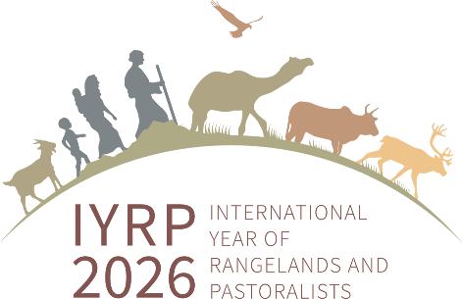

Western and Central Africa (WCA) RISG

Activity report

March 2023

From December 2022 to March 2023, in addition to the ongoing activities of the last report (November 2022), WCA RISG members have been mainly committed in the following new activities.
- CGIAR Initiative on Agroecology
This Initiative aims to develop and scale agroecological innovations with small-scale farmers and other agricultural and food system actors across different socio-ecological contexts in seven low- and middle-income countries. In territories referred to as “Agroecological Living Landscapes,” the Initiative will engage with diverse stakeholders, including farmers’ associations or communities, researchers from multiple disciplines, private companies, international and national NGOs and local, regional, and national policymakers. This Initiative will work in the following countries: Senegal and Burkina Faso from the WCA region; India, Kenya, Laos, Peru, Tunisia, and Zimbabwe from other regions of the world.
The objective will be achieved through food actors: 1) Co-creating agroecological innovations (practices, business models and institutional arrangements) and assessing which work best, where, why, and for whom; 2) Identifying business opportunities and financial mechanisms for local enterprises to deal with agroecological innovations; 3)Determining the most suitable policies and mechanisms of policy integration for promoting effective and sustainable agroecological transitions; 4) Developing strategies and action plans that encourage and support sustainable behavior change oriented to agroecological principles and transitions.

“Milk from the Walo” Fair (first edition), Richard-Toll – Senegal, January 27-28, 2023
Based on the dynamics around the dairy sector in the Dagana dairy basin (Northern Senegal), the Dagana Milk Innovation Platform (PIL), in partnership with the PPZS, the GRET and other actors, has initiated activities with the aim of promoting the milk sector in the department of Dagana, mainly based on pastoralist livelihoods. After several exchanges and consultation with the various players in the sector and the competent administrative authorities, PIL and its partners organized this first edition of the “Milk from the Walo” fair. This event, part of the roadmap of this platform, saw the participation of various development actors, research institutions (ISRA, CIRAD), private companies (Laiterie du Berger, Compagnie Sucrière Sénégalaise), and non-governmental organizations (GRET). More information can be found here: https://www.ppzs.org/actualites/foire-lait-du-walo-richard-toll

Promotion of local milk in West Africa and the Sahel
Stakeholders in the livestock sector from several African countries met in conclave, in Thiès (Senegal), from January 24 to 26, around a workshop to review the three-year action plan, the advocacy and communication plan of the regional innovation platform for the promotion of local milk in West Africa and the Sahel, organized by the Association for the Promotion of Livestock in the Sahel and Savannah (APESS) in collaboration with its partners. More information can be found here: https://www.seneweb.com/news/Afrique/promotion-du-lait-local-en-afrique-de-l-_n_399847.html

Ninth session of the Africa Regional Forum on Sustainable Development (ARFSD)
The WCA RISG was represented by its chair Harouna Abarchi at the ninth session of the Africa Regional Forum on Sustainable Development organized by the United Nations Economic Commission for Africa in Niamey (Niger) from February 28 to March 3, 2023. This represented an opportunity to speak out about the IYRP and raising awareness on the importance of rangelands and pastoralism.

Improving governance of the WCA RISG
The two main regional pastoralist organizations (Réseau Billital Maroobé – RBM, and Association pour la Promotion de l'Élevage au Sahel et en Savane – APESS), as well as the regional research stakeholder Pole Pastoralisme et Zones Sèches (PPZS), have been involved in the superintendence of the WCA RISG. They are now part of the Steering Committee of the group, jointly with the two co-chairs. The Steering Committee is defining an action plan to reach pastoralists and raise field-level awareness on the up-coming IYRP.

