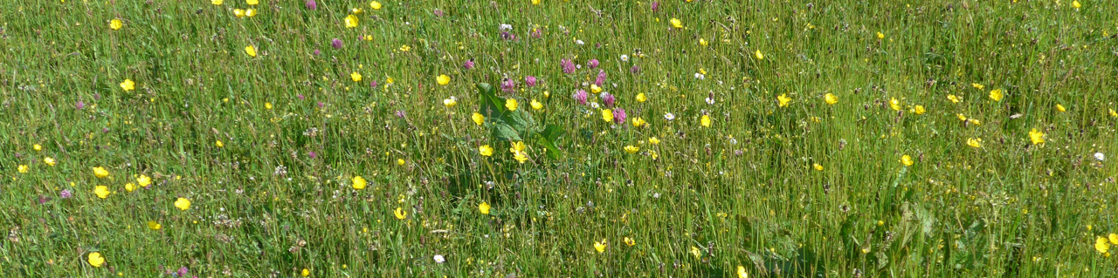
Global Grassland and Savannah Dialogue Platform
Terminology of grasslands, savannahs and rangelands

Tuesday, March 21st, 2023:

Time: 14.30-16.00 CET / 13.30-15.00 GMT / 9.30-11.00 Brasilia / 09.30-11.00 EST / 16.30-18.00 Nairobi

An email dialogue on the terminology used to describe grassland and related habitats stirred up some passionate responses, with both ecological and social implications. Further, during the January 2023 Dialogue Platform meeting, we began a discussion on this topic. We have collated the main findings and a major part of the March 2023 meeting will be in presenting this and discussing the options for harmonising terminology in the future. Additionally, the meeting will introduce the concept of Important Plant Areas (IPAs), flagging an issue that will be discussed in detail in a following session.

Focus of the meeting:

- Update on recent key events relating to climate, biodiversity and grassland ecosystems
- Explore ecological and social issues relating to terminology
- Introduce the concept of Important Plant Areas

Agenda:

When | What | Who
14.30-14.35 | Welcome | Martina Fleckenstein, WWF
14.35-14.45 | Introduction of new participants | All
14.45-15.00 | Update on developments since Conference of Parties (COP) 27 of the United Nations Framework Convention on Climate Change (UNFCCC) and COP 15 of the United Nations Convention on Biodiversity | Martina Fleckenstein, WWF  Jenny Hawley, Plantlife International
15.00-15.40 | What’s in a name?  Presentation of and discussion about consolidated comments on terminology used in this field | Hannah Timmins, Equilibrium Research, and all
15.40-15.50 | Presentation of the concept and history of Important Plant Areas | Plantlife International (to be confirmed)
15.50-16.00 | Discussion, AOB | All

