Dates & location
April 17-20, 2023
Kansas State University in Manhattan, Kansas or virtual

Registration
Link: https://marketplace.uidaho.edu/C20272_ustores/web/store_main.jsp?STOREID=128&clearPreview=true&SINGLESTORE=true

Hotel
Aggieville Courtyard by Marriott, 715 N 12th Street, Manhattan, Kansas
9-minute walk to Hale Library
$117/night + taxes/fees
Includes free breakfast and parking
ROOM BLOCK
EXPIRES MARCH 17
Hotel reservation link: https://www.marriott.com/events/start.mi?id=1676412328549&key=GRP
Let Livia Olsen (livia@ksu.edu) if there aren’t any rooms left in the block, it’s likely that more could be added to the block

Travel/airports
Manhattan, Kansas (8 miles)
Airlines: American, daily flights to Dallas & Chicago
Transportation: There is no hotel shuttle but you can schedule a ride with the aTa bus. It must be scheduled at least 24 hours in advance but no more than two weeks in advance. Their phone number is (785) 537-6345. More information. Or you could rent a car or take Uber or Lyft.
NOTE: If you don’t want to fly into Manhattan, the only airport that has shuttle service to Manhattan is Kansas City (MCI). I don’t know how reliable or fast it is. It drops people off at a hotel on the west side of Manhattan so you would have to schedule a ride with the aTa bus or take Uber or Lyft to get to the hotel. You could coordinate a ride with someone who is renting a car at the same airport you’re flying into.
Salina, Kansas (77 miles)
Airlines: United, daily flight to Denver & Chicago
Kansas City, Missouri (131 miles)
Airlines: Many
Shuttle to Manhattan: https://arivalshuttle.com/manhattan/
Wichita, Kansas (136 miles)
Airlines: Several
Lincoln, Nebraska (137 miles)
Airlines: United

Weather
Regular Kansas weather is very irregular, especially in April, so be sure to check the forecast before you travel. Our average temperatures for mid-April are highs in the 60s and lows in the 40s. April can also be rainy or snowy or cold or hot.

Meeting location
Hale Library – the main library on campus
Room 181, it is right beside the first floor café
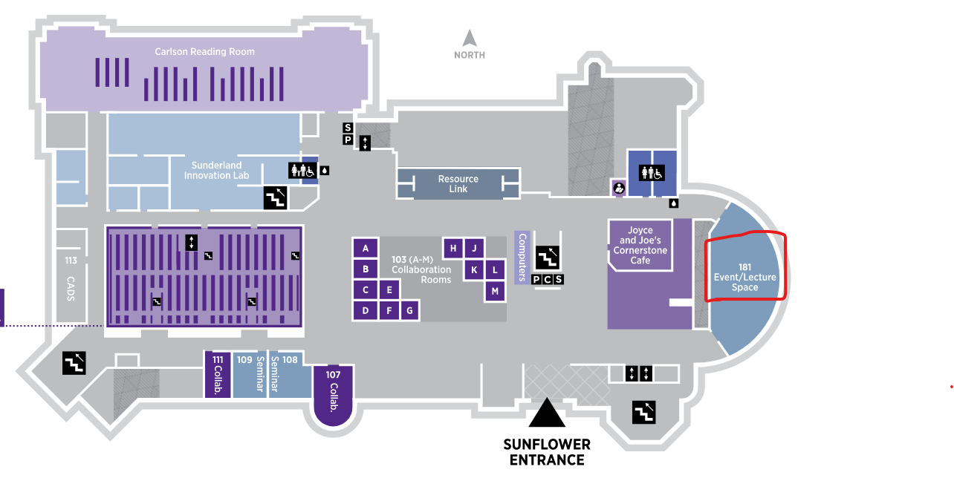
Recommended restaurants in Aggieville or on campus (walking distance)
Coffeeshops, etc.
- Joyce & Joe’s Cornerstone Café – Hale Library
- Radina’s – Locations in the Student Union, Leadership Studies, & Business Building
- Bluestem Bistro
- The Dusty Bookshelf – Coffeeshop/bookstore
- Call Hall ice cream store
- Varsity Donuts
Restaurants
- Tacho Lucha
- So Long Saloon
- JP’s – in the Student Union
- Rockabelly Bar & Deli
- Green Tea Sushi
- Houlihan’s – By the Holiday Inn
- Tasty China House

Downton restaurants – Drive, unless you really like walking
- Radina’s Bakehouse
- AJ’s Pizza
- Bourbon & Baker
- Manhattan Brewing Co.
- El Patron
- Wine Dive + Kitchen

Cool things to see
- The Meadow by Beach Museum
- Green roofs – The largest are on Memorial Stadium, the old football stadium
- K-State Gardens & Insect Zoo
- The Flint Hills Discovery Center
- Konza Prairie public hiking trails – No dogs or wheels allowed (guide to the Nature Trail, the shortest trail at 2.6 miles)

