Grasslands-Climate Training – January 24-25, 2023 – USFWS Region 6 Office, Lakewood, CO
Regional Office address: 134 Union Blvd, Lakewood, CO 80228
Travel Options:
We encourage all Training participants to travel light, minimizing your carbon impact to the extent possible. Please consider bringing reusable water bottles, coffee mugs, etc and using public transportation.
Light Rail
RTD Denver provides convenient transportation from/to Denver International Airport to Federal Center Station – a short walk to the Regional Office. Use the Trip Planner as an easy way to schedule your train ride. An app (ezRide Denver RDT) is also available (at least on iPhone).
One-way fare between DIA and the Federal Center station is $10.50. You may need to transfer at Union Station (downtown Denver). Trains run from about 4 am – 1 am.
The route to walk from Federal Station to the USFWS Regional Office (RO):
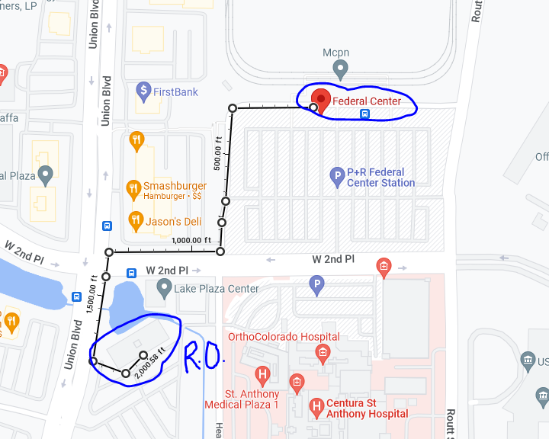

Lodging
Several options within easy walking distance of the RO include:
Homewood Suites
139 Union Blvd, Lakewood, CO 80228
(303) 716-5737

Sheraton Denver West
360 Union Blvd, Lakewood, CO 80228
(303) 987-2000

Hampton Inn
360 Union Blvd, Lakewood, CO 80228
(303) 969-9900

Fairfield Inn & Suites
140 Union Blvd, Lakewood, CO 80228
(303) 233-3133

Dining
There are many dining options within a short walk from the RO, including national and regional chain restaurants as well as local establishments. Options will be discussed during the training workshop.

