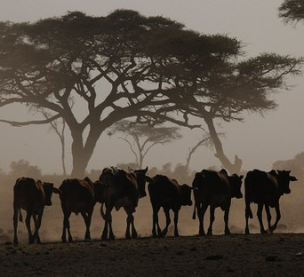  Photo: Peter Prokosch/GRID-Arendal  A case of benign neglect  Knowledge gaps about sustainability in rangelands and pastoralism | Draft report for Review  Dear reviewer,  Thank you for taking time to review this draft report on knowledge gaps about sustainability in rangelands and pastoralism.  We are interested in your feedback on issues that can help improve the quality of the report. Please share comments, questions or concerns you might have about the text, the graphics, the working title of the report, etc. The final version will include photos, and we are grateful for any suggestions about suitable images that can help illustrate the diversities within rangelands and pastoralism.  Larger versions of some the graphics can be viewed here: https://bit.ly/2N2UPjj  Graphics will be further mainstreamed prior to the publication. And more details about the methodology used will be published in a separate Methodology Report.  We are on a tight schedule for finalization of the report, therefore we would be most grateful if you could provide us your feedback within the next couple of weeks (by Thursday 20th September). Please send any comments and input you might have to kathrine.johnsen@grida.no  Sincerely,  The editorial team:  Kathrine I. Johnsen, GRID-Arendal  Maryam Niamir-Fuller, Advisor on Sustainability  Abdelkader Bensada, UN Environment

Table of contents

1 Foreword 2
2 Executive summary 2
3 Acronyms 2
4 Introduction 3
4.1 Global significance of pastoralism and rangelands 3
4.2 Justification for and objective of the report 6
5 Methodology 7
5.1 What is a gap analysis? 8
5.2 The scope of the gap analysis report 8
5.3 Keywords 11
5.4 Timeframe for the analysis 14
5.5 Sources and sampling of information 15
5.6 Availability, accessibility and confidence level 18
5.7 Participation and review process 20
6 Findings of the study (by source) 20
6.1 Global environmental assessment 20
6.2 Global environmental and socio-economic databases and websites 25
6.3 Project information 31
6.4 Academic papers 36
6.5 Survey of stakeholders 42
7 Conclusion 47
7.1 Availability, accessibility and confidence level of information and data on rangelands and pastoralism 47
7.2 Information on the provision of technical support 49
7.3 Challenges and opportunities for filling information gaps 50
7.4 Local, indigenous and traditional knowledge and technology 51
8 Recommendations addressing the observations made 52
8.1 Recommendations for filling the gaps in information on pastoralists and rangelands 52
8.2 Recommendations for filling the gaps in provision of technical support to pastoralists 53
8.3 Recommendations on how to involve pastoralists in the integrated global assessment 54
9 References 55

Foreword
[Text will be added after review]

Executive summary
[Will be written after the review]

Acronyms

Acronym | Full name
CBD | Convention on Biological Diversity
CCD | Convention to Combat Desertification and Drought
DIMA | Database for Inventory, Monitoring and Assessment
FAO | Food and Agriculture Organization of the United Nations
FAOSTAT | Food and Agriculture Organization Corporate Statistical Database
GEF | Global Environment Facility
GIAHS | Globally Important Agricultural Heritage Systems
ICARDA | International Center for Agricultural Research in the Dry Areas
ICRAF | International Council for Research in Agroforestry
ICT | Information and Communication Technology
IFAD | International Fund for Agricultural Development
ILC | International Land Coalition
ILRI | International Livestock Research Institute
IPBES | Intergovernmental Science-Policy Platform on Biodiversity and Ecosystem Services
IUCN | International Union for Conservation of Nature
IYRP | International Year of Rangelands and Pastoralists Initiative
LIKT | Local and indigenous knowledge and technologies
MEA | Multilateral Environmental Agreement
ODA | Overseas Development Assistance
OECD | Organisation for Economic Co-operation and Development
SDG | Sustainable Development Goals
UN Environment | United Nations Environment
UNEA | United Nations Environment Assembly
UNESCO | United Nations Educational, Scientific and Cultural Organisation
WB | World Bank
WHO | World Health Organization
WISP | World Initiative for Sustainable Pastoralism

Introduction

Global significance of pastoralism and rangelands
Pastoralism is increasingly recognised as one of the most sustainable production systems on the planet, playing a major role in safeguarding ecosystems and biodiversity in natural grasslands and rangelands (McGahey et al., 2014, p. viii). Mobility of animals is a key feature that distinguishes pastoralism from other livestock production systems (Krätli & Schareika, 2010). Mobility is possible only when rangelands are contiguous and not fragmented, and access rights are clear and un-hindered. In other words, pastoralism is possible when there is access to extensive grazing lands, or rangelands. The terms “rangeland” and “pastoralist” are defined in this report to include a wide diversity of systems in the world (See Text Box 1).

Extensive grazing and mobility have been shown to promote healthier ecosystems and greater wildlife compatibility (Galvin et al., 2008; Niamir-Fuller et al., 2012). Research in Morocco and Mongolia has shown that mobile pastoralists are better able to adapt to extreme climate variability than their sedentary counterparts (Freier et al., 2014; Rueff & Rahim, 2016).

Where data is available in official statistics, there are indications that pastoralism is a significant contributor to national GDP in some developing countries (for example, contributing 10–44% in African countries, 30% in Mongolia) and to agricultural GDP (for example, 80% in Sudan) (data from 1993 reported in Hatfield & Davies, 2006). Pastoralism also benefits around 1.3 billion people along the value chain worldwide (Ouedraogo & Davies, 2016). Meat and dairy products from pastoralism are significant but under-exploited commodities; for example, FAO estimates the world trade in camel-milk to be 5.3 million tons, a fraction of that for cow’s milk, but that it has the potential to be a $10 billion market (FAO, 2012).

While pastoralism’s share of GDP in more developed countries may be relatively small, the rangelands they use are a relatively high percentage of “marginal” lands, and they often specialize in organic meat and dairy products. Desert-margin rangelands support 50% of all global livestock production (Allen-Diaz et al., 1996). Pastoralism remains a viable livelihood for many rural dryland populations. Strong land tenure security gives pastoralists the incentive to be environmental stewards of rangelands.

Rangelands incorporate a diversity of ecosystems that are grazed or have the potential to be grazed by wild animals and domesticated livestock. Rangelands provide important benefits to humans – they are the main feed resource for traditional livestock rearing systems in many parts of the world and offer a livelihood to millions of people (Lund, 2007). Davies et al. (2015, p. 1) explain that rangelands are “often highly unpredictable environments in which both nature and human societies have evolved, leading to unique biological and cultural diversity” which contribute to goods, services, knowledge and heritages that benefit humans beyond the herding communities. Such benefits include: food security, medicine, local and regional economies, wildlife, biodiversity, tourism, regional climate through carbon sequestration, and land and water rehabilitation.

Research and documentation of threats to the productivity and socio-ecological integrity of these lands and their caretakers are available but sparse. Such evidence paints a picture of threats that are common to both developed and developing countries including: restrictions on moving animals, programmes to settle pastoralists, unsustainable grazing practices, expansion of arable farming into areas best suited as rangeland, breakdown of common property systems, lack of land tenure security, land fragmentation, generational succession and rural exodus, damaging fire, invasive species, and harmful subsidies and policies. Similarly, pressures on rangelands are increasing through a combination of one or more of the following: climate change, land degradation and fragmentation, land conversion and demands for outdoor recreation, hunting, water supply, conservation (Lund, 2007), mining, fracking and generation of renewable energy (wind farms, solar fields).

Evidence suggests that the need for sound ecosystem management and improved livelihoods is becoming more urgent, with many areas around the world reporting severe environmental crises very often linked to severe conflicts and human insecurity. For example, FAO states that long-lasting and recurrent conflicts have changed the grazing patterns of pastoralists in East Africa, and when combined with extreme climate variability, have led to loss of resilience and coping strategies, leading to long-term food insecurity (FAO, 2017).

As this gap analysis shows, information about rangeland ecosystems and pastoralism is scanty compared to information about tropical and temperate forests or crop farming. Furthermore, the historical adaptation and current evolution of rangelands and pastoralists have been poorly understood in the past half-century. As a result, well-intentioned development activities have led, in many cases, to further degradation, poverty and conflict (Davies et al., 2015).

Providing social or economic services to mobile and remote populations is not the same as doing so for sedentary populations (Weibel et al., 2011), and yet it is likely that, with better communications and transport infrastructure, providing high-quality mobile services is no longer as big a challenge as before. With accurate data and information, appropriate policies and programmes that nurture and support such mobility can be developed.

Text box 1: Definitions of rangelands and pastoralists used in this report

This report uses the terms rangelands and pastoralists as defined by the Steering Committee for the International Year of Rangelands and Pastoralists Initiative (IYRP) (see Open Flyer “Calling for Your Support to designate an International Year of Rangelands & Pastoralists”, available here: https://bit.ly/2A3fOgI):

According to the ecological definition, rangelands are those lands on which the indigenous vegetation consists predominantly of grasses, grass-like plants, forbs, shrubs, or trees that are grazed or have the potential to be grazed or browsed, and which are used as a natural ecosystem for raising grazing livestock and wildlife. Rangelands may include native grasslands, savannas, shrublands, deserts, woodland and forests in drylands, steppes, pampa, llanos, cerrado, campos, veld, tundra, alpine communities and marshes (adapted from Allen et al., 2011).

Pasturelands/grasslands are synonymous when referring to modified/improved ecosystems that are managed for grazing. They can include meadows managed for hay and silage, cultivated and permanent pasturelands, and naturalised and semi-natural grasslands (adapted from Allen et al., 2011). Natural grasslands are a type of rangeland.

Pastoralists are people who raise livestock or wild animals on rangelands, including ranchers, nomads and transhumant herders (McGahey et al., 2014). In some societies, “pastoralist” is an ethnic label, denoting an indigenous person. The gap analysis focuses on people who are directly engaged in pastoralism, i.e. animal husbandry on rangelands.

In general, there is a lack of consensus on the definition of pastoralism – especially on categorising the range between subsistence and commercial, between land-intensive and land-extensive, between pastoral and agro-pastoral, etc. This study adopts the following categorisation of pastoralists depending on how mobile they are: nomadic is a term used when mobility is high and in irregular patterns; transhumant refers to pastoralism with regular back-and-forth movements between relatively fixed locations; and sedentary for pastoralists who are more place-bound but still practice some form of rotational land-use (Rota & Sperandini, 2009). The types of livestock kept by pastoralists depend on climate, environment, access to water and other natural resources, as well as geographical area, and may include – in alphabetical order: alpacas, camels, cattle, goats, horses, llamas, reindeer, sheep, vicunas and yaks (Rota & Sperandini, 2009).

This analysis includes all types of rangelands, and it covers those pastoralists who use land-extensive systems (rotational grazing, mobile nomadism, etc.). Those agro-pastoralist societies whose livestock production is land-extensive and dependent on the use of rangelands are also included in the scope of the study. In this report, we use the terms pastoralists and pastoralism to refer to both pastoralists/pastoralism and agro-pastoralists/agro-pastoralism.

Defining local and indigenous knowledge and technologies is challenging because there are cultural and national differences in how indigenous is recognised, as well as linguistic differences in describing the concepts of indigenous knowledge, traditional knowledge, traditional ecological knowledge, local knowledge, etc. As a consequence, the study will adopt a broad understanding and use the term local and indigenous knowledge and technologies (LIKT).

One of the main challenges is the myriad of definitions of the two concepts pastoralists and rangelands. For example, on one hand, McGahey et al. (2014) and Blench (2001) say that pastoralism is conducted across a quarter of the world’s land area, and Jenet et al. (2016) state that “estimates of the numbers of pastoralists worldwide range from 22 million to more than 200 million, depending on the definition used and the age and quality of the data”. On the other hand, UNEP and IUCN (2009) state that pastoralism is practiced by between 200 and 500 million people worldwide. Likewise, there are many different figures for the extent of the world’s rangelands. Allen et al. (2011) found that estimates of the coverage of rangelands vary from 18% to 80% of the world’s land surface. For example, large taiga areas in Siberia used for reindeer husbandry are often left out of global maps of pastoralism (see for example, Nori et al., 2005). Figure 1 presents different maps of rangelands.

Referring to the extent of rangelands, Lund (2007) rhetorically asks: “If we do not know what we have, how can we monitor it and develop a strategy for management?” There have been attempts to develop a uniform terminology for rangelands (for example, Lund, 2007; Allen et al., 2011) but it would be extremely challenging to develop a standardized terminology, and as this Report shows, differing definitions are still used.

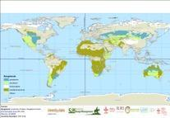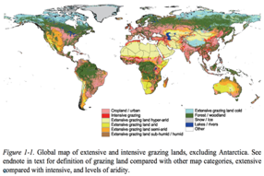
Figure 1: Maps presenting the geographical distribution of rangelands and pastoralism. [Here, we will add – upon permission – a couple of maps using different definitions for “rangelands”]

Justification for and objective of the report
More than 150 country representatives who met at the United Nations Environment Assembly (UNEA) in May 2016 recognised the dearth of information about pastoralism and rangelands. Many developing country representatives supported the resolution that, among other things, asked the UN Environment to conduct a global assessment of rangelands and pastoralists. However, some other country representatives questioned whether existing and ongoing assessments would cover this need, such as by the Intergovernmental Science-Policy Platform on Biodiversity and Ecosystem Services (IPBES). As a result, the UNEA resolution 2/24 “Combating desertification, land degradation and drought and promoting sustainable pastoralism and rangelands” in its Operative Paragraph 9 (Text Box 2) called for a gap analysis of available information, as a first step to any further assessments. The main objective of this report therefore is to explore and identify where there are:

- Gaps in environmental and socio-economic information and assessments of rangelands and pastoralism
- Gaps in current provision of technical support in promoting sustainable pastoralism and rangelands

Text Box 2: Operative Paragraph 9, UNEA Resolution L.2/24

Requests the United Nations Environment Programme, within its mandate and subject to available resources, in partnership with Member States and United Nations agencies and programmes and other relevant stakeholders, including civil-society organisations, to explore whether there are gaps in the current provision of technical support and environmental and socioeconomic assessments of grasslands, rangelands, soil erosion, land degradation, land tenure security and water security in drylands, including the ongoing assessments of the Intergovernmental Platform on Biodiversity and Ecosystem Services, in order to better understand the implications for sustainable livelihoods, while taking into consideration local and indigenous knowledge and technologies

The resolution full text is available here: https://bit.ly/2LenbXT

This report is a direct response to the UNEA Resolution. It presents the approach taken to identify the information gaps, presents the findings of the gap analysis, and provides a set of recommendations for filling the gaps identified. The study looked into a variety of publicly available information sources to assess the availability and accessibility of data related to rangelands and pastoralists. These sources are discussed in more detail in the next section. The timeframe and funding available meant that some sources of information had to be excluded, especially off-line sources such as grey literature, project reports, and many government statistics. Only information and data that were publicly available online and freely accessible were reviewed, subject to a sampling framework. Where permission, membership or passwords were required to gain access to sources, these were not included, but were duly noted for future reference.

In the past decade, Member States and civil society have increasingly recognised the significant need for highlighting the case of pastoralism and rangelands. Some are concerned with continuing poverty, injustice and neglect of pastoralists. Others are concerned with increasing insecurity, conflict, criminality and lawlessness – with pastoralists often taking the blame whether rightly or wrongly. Livestock production and consumption are under scrutiny for their impact on greenhouse gas emissions, biodiversity loss and chemical pollution. All of these issues have been captured in the 2030 Agenda for Sustainable Development, and the time left to achieve them is drawing ever closer. Increasingly vocal and organised communities of pastoralist associations are interested to be part of this global conversation and action. Verifiable, comprehensive and publicly accessible information and data on rangelands and pastoralists are therefore more in demand than ever before. For this reason, this Gap Analysis was conducted as a rapid assessment so as to deliver pertinent recommendations in a timely basis.

Information and data on mobility of livestock and rangeland management by pastoralists are a vital element of developing sound sustainable policies and investments in drylands. Mobile livestock husbandry however is not an archaic system frozen in time. There are signs of it both increasing in some places and deteriorating in others (Myint & Westerberg, 2014; Niamir-Fuller, 2016). There is also documentation of mobile livestock husbandry changing and adapting to stress and threats (for example, Köhler-Rollefson, 2016). Thus, information and data collected decades ago may not be entirely relevant for today’s needs. The Gap Analysis therefore also looked at the relevance of the available information.

Methodology
The gap analysis on which this report is based was conducted in 2017–2018. The report explores what data and information are available about rangelands and pastoralists, as well as what level of confidence different actors have in the data and information. It looks into types of technical support provided by multilateral agencies, and ODA through OECD countries. The report assesses different sources of information: assessments, datasets, project information, and scientific publications. The gap analysis is also informed by a participatory survey of different organisations and pastoralists’ perspectives, which included issues such as how they use and collect information, their perception of confidence level or gaps in information, as well as provision of technical support for pastoralists and rangeland management. This section outlines the scope, data sources and sampling of the Gap Analysis. Findings of the study are presented in the next chapter through texts and illustrations. A more detailed presentation of the methodology is available in the Methodology Report. [Will be available when the Gap Analysis Report is ready.]

What is a gap analysis?
A gap analysis determines the space between where something is and where it is desired to be. It serves as a means to bridge this space by identifying what has to be done in order to reach this desired state.
(Borit & Olsen, 2016, p. 2).

Informed by IPBES (2015), we define gaps as: information that has low “fitness of use” for policy-makers, low data confidentiality, usage restrictions, limited accessibility of datasets, remoteness of ecosystems or data integration and quality issues, scarcity of long-term data and the challenges this presents for evaluation of long-term trends. FAO (2008, p. 104) explains that an information gap analysis involves matching the available information to information needs, and thereby identifies gaps in available information. Available information refers to existing types of information, as well as the quality of this information. Further, a gap analysis focuses on factors that may explain poor information quality, i.e. information that is not timely, not valid or reliable, un-interpretable, poorly managed or not easily accessed. Identifying reasons for poor information quality is important for designing actions to improve the information systems (FAO, 2008).

However, we acknowledge that different actors have different needs for information and will therefore have different perspectives of the adequacy and availability of the information. For example, for a policymaker, national data might be important for making informed decisions about laws and regulations; NGOs might need regional data to target activities; researchers might need access to materials from different locations to analyse and contextualise issues affecting pastoralists and rangelands. Also, pastoralists might require access to local information to make informed decisions about herding strategies, or they might need international information for policy lobbying, knowledge sharing and networking. Faced with such ambiguity and diversity of audience, the study team spent considerable effort in first defining the information needs by determining the scope or system boundary.

The scope of the gap analysis report
The scope or system boundary of the Gap Analysis is determined through three overarching strategic guidelines. First and foremost is the UNEA-2 Resolution L.2/24, which, in addition to the Operative Paragraph 9 that specifically calls for a gap analysis, also discusses in its preamble and other operative paragraphs a wide range of issues that concern countries regarding pastoralist livelihoods and health of rangeland ecosystems. Secondly, the study team considered only topics and subjects that fall within the mandate of UN Environment to conduct integrated assessments and analyses. Thirdly, the team sought guidance from the 2030 Agenda for Sustainable Development, which is mentioned as a guiding principle in Resolution L.2/24, and specifically from the Sustainable Development Goals (SDGs) and their targets and indicators relevant to rangelands and pastoralism.

An adapted version of the IPBES conceptual framework guided the definition of the scope and depth of the gap analysis (see Figure 2). This scope was reviewed and endorsed at a stakeholders’ working meeting in Arendal, in November 2017. It contains the following issues as relevant for the gap analysis of information on rangelands and pastoralist livelihood sustainability:

- Pastoralist wellbeing (including: culture, technical knowledge, population, health, education, participation, conflict, security)
- Rangelands (including: diversity, climate, water, soils, degradation, productivity, condition)
- Ecosystem services of rangelands (including: grazing animals, energy, wild harvest/gathering, cultural value, alternative income, water regulation)
- Pastoral management (including: indigenous practices, mobility, resilience, income, market)
- Direct drivers (including: land-use change, climate change, disaster risk, pollution, management change)
- Indirect drivers (including: policy, law, institutions, political representation, international obligations).

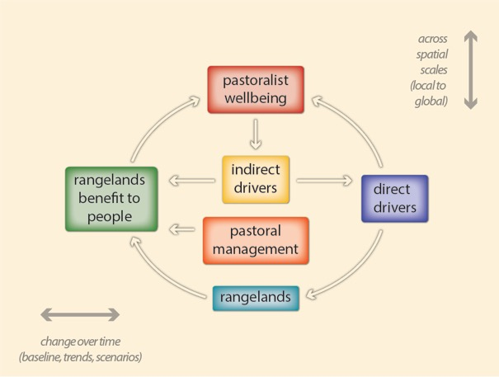
Figure 2: The conceptual framework for the gap analysis, adapted from the IPBES conceptual framework (Díaz et al., 2015). Solid arrows denote influence between elements. Interactions between elements change over time (top-right arrow) and occur at various scales of space (bottom-left arrow).

In terms of the gaps in provision of technical support, the main guidance was obtained from the UNEA 2/24 resolution, as well as feedback from workshop participants. Text Box 3 provides a full list of issues. In general, the issues identified as priority in terms of provision of technical support for sustainable rangelands and pastoralism cover social and economic services, capacity building and institutions, livestock health and inputs, rangeland health and improvement, and access to ICT and energy.

Text Box 3: Types of technical support addressed by the Gap Analysis sorted by how they related to the systems boundaries (see Figure 2)

Pastoral wellbeing
- Health
- Education
- Vocational training
- Exchange between communities

Rangelands
- Rangeland improvement
- Biodiversity
- Carbon capture
- Water

Rangelands benefit to people
- Supplemental feed
- Energy
- Watershed management

Pastoral assets
- Capacity building
- Veterinary
- Credit/loan
- Market
- Information and communication technology (ICT)

Indirect drivers
- Institutional development

As far as possible, the study examined the inclusion of local and indigenous knowledge and technologies (LIKT) in the information sources screened. Through a survey, we collected different actors’ opinions on LIKT.

Several issues were identified as outside the system boundary because they did not meet the three strategic principles described above; therefore, these were not included in the gap analysis. Many of these could be flagged for inclusion in a future global assessment of rangelands and pastoralists (see Text Box 4).

Text Box 4: Issues not addressed by the Gap Analysis

- Spiritual satisfaction of pastoralists
- Rituals and taboos
- Presence/absence of freedom of choice
- Autonomy
- Ecological evolution of rangelands
- Food-webs
- Provision and regulation services of ecosystems in relation to: production of oxygen, photosynthesis, atmospheric regulation, etc.
- Some cultural services: totemic species, cultural landscapes,
- Production of some consumed goods from rangelands (clothes, building materials)
- Animal welfare
- Reproductive cycles and breeding of livestock
- Land-intensive livestock production systems
- Some gender issues (reproductive rights, etc.)
- Disease epidemiology and control
- Biosecurity
- Level of crime and access to criminal justice system

Keywords
In order to identify relevant publications and records in the databases, websites and project portfolios, we searched the information sources with keywords. The keywords were chosen as synonyms and metonyms related to rangelands, pastoralism and the key concepts within the systems boundary of the study (see Figure 3). A synonym is a word that has the same or nearly the same meaning as another word; and metonym is a word or expression used as a substitute for something else with which it is closely associated.

We categorised the keywords related to rangelands and pastoralists (and their metonyms) as first-tier. Keywords that reflect the conceptual framework were categorised first as second- and then as third-tier, where the second-tier words were more general terms (for example, health) and the third-tier words were more specific (for example, nutrition). If a first-tier keyword was identified within a source, then the search was conducted for second-tier keywords and then for third-tier keywords. If a source did not have any of the first-tier words or their metonyms, then the search through that source stopped.

The choice of keywords and their metonyms is of particular importance in this study because of the immense variation in definitions and usages across regions of the world and across languages. A total of 136 keywords were used in this study. The keywords and their metonyms were vetted through the Arendal working meeting, the Advisory Committee of the study and the Peer Review. We recognise that another set of keywords could have given a different result. However, we have used the same keywords throughout the study, which makes it possible to make some generalisations about the findings from our searches through the information sources. (An overview of the first, second- and third-tier keywords is presented in a separate Methodology Report).

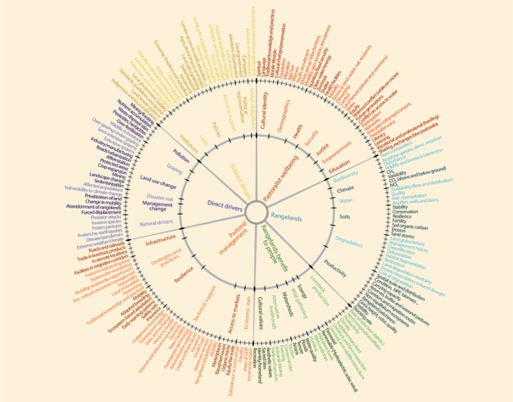
Figure 3: The system boundary of the Gap Analysis

A word cloud analysis of the first-tier keywords and their metonyms, as available in Google, is provided in Figure 4. The coverage of rangelands is dwarfed by that of woodlands. The terms rangeland and, to a greater extent, pastoralist are far less commonly used in scholarly work than their metonyms (for example, desert/meadow and livestock/grazing, respectively). Any future global assessment will have to be very mindful of the language and definitional challenges.

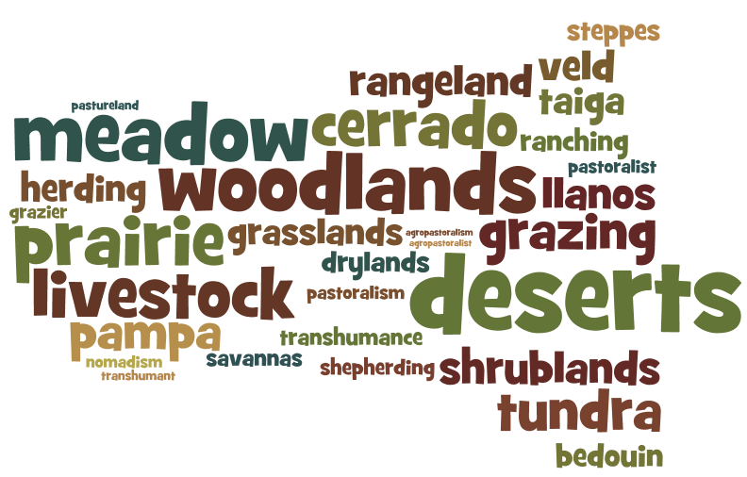
Figure 4: Word cloud presenting different metonyms to pastoralist/ pastoralism and rangeland according to how often they appear in Google searches. The more often the words appear, the bigger they appear in the word cloud. Created with: wordle.net

Moreover, using Google Trends we find variations in how the metonyms are perceived and used in different regions. For example, over the last five years, the term herders was googled 46 times on an average day, while pastoralists was googled 18 times per day globally. Google Trends allows us to find out which were the top 30 or so countries that searched these terms. The term pastoralists was most often used in Google searches by people in Ethiopia, followed by Tanzania, Kenya and Zimbabwe. The term herders was most often used in searches by people in Bhutan, followed by Netherlands. In a few countries, such as Australia and United Arab Emirates, both terms were used equally (see Figure 5). However, we cannot use Google Trend as a tool to estimate general interest in the issue of pastoralism because the tool only synthesises data from the Google search engine. Data from alternative search engines, in a different timespan and different language might have given a different result in the popularity of the terms. Still, the results in Google Trends shows that the terms pastoralists and herders are regionalized; that is, there are geographical preferences in how the terms are used.

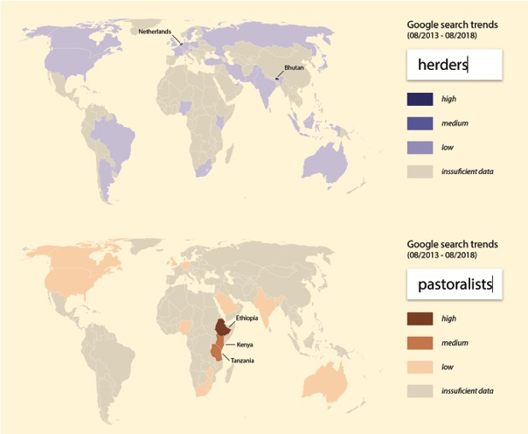
Figure 5: The maps present the top 32 countries were the terms pastoralists and herders are most often used in Google searches during the last five years (2013-2018). A darker shade indicate were the terms have the highest probability of being searched. Search term popularity is relative to the total number of Google searches performed at a specific time, in a specific location. Thus, a higher value means a higher proportion of all queries, not a higher absolute query count. Source: Google Trends

We also attempted to translate the first-tier keywords into French and Spanish. However, it was difficult to achieve a full consensus among stakeholders on the translations and more time would be needed to complete this exercise. Therefore, the keyword searches were conducted only in English. Future global assessments on rangelands and pastoralism should consider to complete this exercise to ensure a better geographical coverage of available data and information.

Timeframe for the analysis
The timeframe for the analysis was set to information published from year 2000–2018. Stakeholders at the Arendal working meeting debated on the best timeframe for sampling, using an analysis of the chronology of information available through Google Scholar search (see Figure 6). It is acknowledged that older publications may not yet be fully digitized and entered into Google Scholar.

Figure 6: Accumulated hits in Google Scholar for the search “pastoralism AND rangeland” over 55 years. Source: Google Scholar, 11 September 2017

It was recognised that, in or around the year 2000, there was a relative increase in research and documentation about pastoralists and rangelands, including a shift in paradigms and theoretical innovations. Participants also noted that the situation of pastoralists and rangelands has evolved considerably in the past two decades, especially as evidenced from research showing major land-use change, desertification and drought in some places, greening in other places, etc. For example, researchers have shown that the Sahel has gone through at least two cycles of drying and greening since 1972 and the so-called “desert boundary” line has shifted considerably (Mueller, 2011). Thus, participants felt that any data older than the year 2000 would probably not be immediately relevant for today. However, it was also recognised that any future assessment would need to collect older information so as to be able to analyse trends and patterns wherever comparable data are available.

Sources and sampling of information
The information sources examined for this report include global assessments and databases, academic publications and project information from multilateral agencies. While the identified global assessments were screened in a more thorough way, the other written sources were – when possible – examined by Boolean searches of the keywords related to rangelands and pastoralists. The use of keywords helps to search the coverage of topics and subject matters in peer reviewed literature, but does not indicate whether quantitative statistics are present or not. Keywords are also helpful when searching databases and websites for thematic coverage of topics, but the search for quantitative data is carried out separately as a second step once a database is shown to have relevant information.

In addition to written sources, this report is informed by a questionnaire survey of rangelands and pastoralism stakeholders. Through the survey and our own assessment of the examined sources, we also sought to determine the relevance and usefulness of the information available.

Global environmental assessment
A search was made for the existence of global environmental or integrated assessments since the year 2000 relevant to rangelands and pastoralism. The assessments were identified in three ways: a simple Google search using keywords, a search through the websites of FAO and UNEP, and through questions targeted to survey respondents, workshop participants, the Advisory Board, the Steering Committee of IYRP – a total of 73 eminent researchers and stakeholders. Furthermore, some assessments were identified through the search on databases. Due to resource limitations, a sample of 13 global environmental assessments more relevant to pastoralism and rangelands was identified for in-depth review. The review was done by searching through the assessments for the first-tier keywords and reading carefully through the sections with hits. After that all sections with related information (for example, deserts, dryland forests, cropland etc.) were also reviewed.

Databases and websites
A number of global databases and websites store and maintain statistics and data sets on global, regional and national economic, social or ecological status and trends. This study examined the inclusion of information related to rangelands and pastoralists in a set of global and regional online databases accessible to the general public. A list of databases and websites was drawn up through two methods: a Google search using the term “database” and by consulting a set of researchers and stakeholders chosen because of their affiliation with the International Rangeland Congress, the Commission for Nomadic Peoples, the World Initiative for Sustainable Pastoralism, the FAO Pastoralist Knowledge Hub, and the Steering Committee of the International Year for Rangelands and Pastoralists (IYRP). The researchers and stakeholders, about half of which focus on socio-economic issues and the other half on biophysical issues, were asked to identify as many global and regional databases that they were aware of that could contain information on pastoralism and rangelands.

Through this process, 100 databases and websites were identified and screened. The databases and websites were categorised according to the format of the information they provided: 81 datasets and statistics, three GIS portals and 16 knowledge repositories. Out of the 100 databases and websites, only 33 provided hits for keywords related to pastoralism and/or rangeland. These were assessed further. Eight sources were inaccessible.

Academic publications
An increasing number of academic papers on rangelands and pastoralists are published online. We sampled these by limiting our study to examine relevant publications available in Scopus. Scopus is the largest abstract and citation database of peer-reviewed literature. According to the Scopus website, it includes over 71 million records from scientific journals, books and conference proceedings.

We screened for first-tier and second-tier keywords within the title, abstract and the keywords for the publications within Scopus in order to identify to what degree issues related to rangelands and pastoralists were covered within scientific writing. We identified 96,414 records that cover issues related to rangelands or pastoralism. 79,245 records concerned only rangelands; 19,133 concerned pastoralism and 1,644 agro-pastoralism. Only 2,658 publications covered both rangelands and pastoralism/agro-pastoralism. Given the integrated nature of the system boundary of this Gap Analysis, it was decided to further review the 2,658 publications that covered both topics. The sample was screened through Boolean searches for the second-tier keywords.

Project information related to provision of technical support
Projects gather information, develop know-how and provide technical support. The study assessed the online project portfolio of ten multilateral agencies, and consulted 585 documents. By searching for first-tier keywords, we identified projects relevant to pastoralists and rangelands, the thematic focus of these projects and their budgets and target countries. The following multilateral agencies were screened – in alphabetical order:

- Food and Agriculture Organization (FAO)
- Global Environment Facility (GEF)
- International Fund for Agricultural Development (IFAD)
- United Nations Development Programme (UNDP)
- United Nations Environment (UN Environment)
- United Nations Educational, Scientific and Cultural Organisation (UNESCO)
- United Nations Children's Fund (UNICEF)
- World Food Programme (WFP)
- World Health Organization (WHO)
- World Bank (WB).

In addition, we explored the project database of the International Livestock Research Institute (ILRI) and the International Council for Research in Agroforestry (ICRAF), also known under the brand name “World Agroforestry Centre”, as well as International Center for Agricultural Research in the Dry Areas (ICARDA). These sources were included in the analysis on account of their strong focus on supporting smallholder farmer, pastoralist livelihoods and drylands in the Global South.

While, the methodology was effective in identifying the use of keywords related to technical support, it was less effective in differentiating between available information and quality of provision of technical support.

Survey of stakeholders
In order to include stakeholders’ perspectives in the gap analysis, we developed an online survey to explore how different organisations regarded available information about, and technical support for, pastoralism and rangelands. The survey also asked questions about the organisations’ use of LIKT, and it invited the respondents to make recommendations on how to address potential gaps in data on rangelands and pastoralism, provision of technical support and inclusion of LIKT.

A questionnaire was prepared and distributed to 20 pastoralist organisations and 16 government representatives. A slightly revised questionnaire was distributed to approximately 300 additional email addresses to individuals interested in issues related to pastoralism and rangelands. In total, we received 58 responses, therefore 18% coverage.

Sources not included in the study
One initial idea was to approach and interview CEOs or Corporate Social Responsibility (CSR) persons of a handful of multinational large-scale corporations working on issues related to rangelands and pastoralists. The purpose of approaching the corporations was to find out if, and what kind of information on pastoralists and rangelands they collect and whether, they offer technical support to pastoralists. The thinking was that the corporations were likely to have a sustainability agenda and therefore might be collecting data on pastoralists and rangelands. Recognising that they may consider such information confidential, the review adopted an interview format. Information from the business sector could have complimented information screened from other sectors. Unfortunately, we faced a challenge in identifying a sufficient sample of relevant corporate entities to engage.

Grey literature from civil society organisations, unpublished literature and material that is not peer reviewed are vast and difficult to sample. Moreover, the stakeholders’ working meeting in Arendal in November 2017 had a relative low level of confidence in the information coming from these sources. The study also did not include hard copies as these are difficult to access, or the media because information is often not detailed enough or comparable.

Another source of information concerns the impact of national and regional policies on pastoralists and rangelands. There are many scientific articles and strategic analyses of these impacts that can be obtained online, including through multi-lateral websites. However, the Gap Analysis did not include them as a separate source because of methodological challenges – the method of keywords does not lend itself well to teasing out direct impacts of policies (for example, poverty among pastoralists could be a result of policies, but also a result of environmental degradation, lack of access development, etc.). Such sources need to be studied individually and in detail in order to synthesize the impacts.

Availability, accessibility and confidence level
Our assessment of the availability, accessibility and confidence level of the sources and the information we identified was based on subjective observations during the screening, using a few replicable principles.

For example, the purpose of the review of the global environmental assessments was to ascertain:

- availability = whether the assessment contained quantitative statistics and data on rangelands and pastoralism and if so to what level of detail or disaggregation;
- accessibility = whether the assessment was easily accessible, including its raw data; and
- confidence = whether the assessment was based on primary field data collected for the purpose of the assessment, or whether it was a compilation of other assessments and research data.

The three criteria were then rated for each assessment on a 1-3 scale. The bar is higher in reviewing the global assessments than the global databases because of the ability to go more in-depth in the review.

Concerning the databases and websites, accessibility of information and data depends on whether they are made public, are password protected, links are functional or broken, or the website had been taken down. When screening for project information, we realised that there is a great diversity in how and to what degree the multilateral agencies share information with the general public online. Some of the project portfolios can be easily accessed through online searches; others can be accessed only indirectly through the facilitation of staff, while some project portfolios could not be accessed at all. We rated accessibility from 1 (high) to 3 (low) depending on how easy it was to access the information and data online without additional effort.

If we could access a source, the next step was to examine the availability of information concerning pastoralism or rangelands and whether information provided was disaggregated to a level where it could inform decision-making on pastoralism or rangelands. We rated the availability based on the appearance of the first-tier keywords and their metonyms. The sources were then rated from 1 to 3 such that: 1 = where both pastoralists and rangelands keywords were present; 2 = presence of keywords for either pastoralists or rangelands; and 3 = no presence of any of these first-tier keywords. It is, however, important to note that scale is also a factor that affects the availability and relevance of data. For example, the relevance of the information available in the databases for decision-making will depend on the type of information provided. Data could lose their relevance at an aggregated level as it becomes more generalised.

Data, information and knowledge on rangelands and pastoralism are subject to observation and sampling errors that affect their quality. There might be uncertainties to the data, information and knowledge, and they can be limited by scope or inherent biases. All of these issues affect the level of confidence and generality that can be attached to the conclusions they support. Failing to quantify, document, verify and source data could lead to false conclusions or unwarranted actions based on analysis of trends or on prioritisation (IPBES, 2015). Supporting effective decision- and policy-making relies on careful and clear delineation and communication of these limitations.

The original plan was to assess all sources by evaluating data and information validity, i.e. examining the type, quantity, quality and consistency of the information (in the existing peer-reviewed literature and grey literature); and the level of agreement (the level of concurrence in the data, literature and amongst experts, not just across the author team) (IPBES, 2015, p. 7). However, this became too resource demanding to implement for this report and, therefore, the level of confidence was assessed only for databases and assessments. A high level of confidence (rating 1) was given if there was evidence that the information available was directly collected from the field (primary data) and/or verified by a third (and neutral) party.

The level of confidence was also a topic discussed by the stakeholders’ working meeting in Arendal in November 2017, which factored into the choice of sources. In general, the participants had high confidence in data from published, peer-reviewed literature, and organisations part of, or with a consultative status at, the UN. While the participants had a medium level of confidence in information from pastoralist organisations, civil society organisations and development projects, they saw these as important sources because they are closer to the local realities and are likely to collect disaggregated data relevant for the gap analysis.

Participation and review process
The study draws on advice and support from ongoing discussions within a large community of scholars, pastoralists, government officials and other experts, including the global membership of the International Rangeland Congress, the UN Permanent Forum for Indigenous Peoples, and the Steering Committee for the IYRP. A total of 48 eminent scholars from around the world who are engaged in research on rangelands and pastoralism were contacted individually to obtain information about the availability of databases, assessments and research datasets. Many of these scholars in turn canvassed their network of colleagues.

In addition, several partners and experts participated in the stakeholders’ working meeting in Arendal, Norway in November 2017, where the methodology and design of the gap analysis was refined, verified and endorsed. During four days of debate, participants not only helped establish the scope and system boundary of the study, but also recorded critical issues and urgent concerns where the perceived lack of information and data was acute. The study team has built upon insights gained in this working meeting as a way to counteract some of the resource limitations it faced.

The questionnaire survey drew responses from 58 people, including stakeholders such as pastoralists, scientists and development experts. The conclusions and recommendations of this Gap Analysis are based primarily on the findings, but have also been enriched by the opinions expressed by workshop participants, survey respondents, peer reviewers and Advisory Committee members.

[We will add a description of the peer review when it is finalized.]

Findings of the study (by source)

Global environmental assessment

Observations
The majority of global assessments reviewed were very accessible, including in many cases access to raw or underlying datasets. Confidence was generally high, but some global assessments were concerned with lack of adequate field verification of data (see Figure 7). None of the 13 global assessments reviewed had sufficient statistical information regarding rangelands and pastoralism to warrant the highest rating. The majority mentioned pastoralism and rangelands only in passing or none at all.

Figure 7: The global assessments rated according to accessibility, availability and confidence level.

The final IPBES report “Assessment of land degradation and restoration” (2018) collected a large body of existing information and data and used a conceptual framework similar to the one used in this Gap Analysis. They also rated their findings and conclusions according to the level of confidence (defined as quality and quantity of evidence vs degree of agreement). In general, the IPBES assessment presents comprehensive information on land degradation and restoration, but it is not disaggregated to a level where it can inform decision-makers about rangelands and pastoralism. Land degradation is defined in terms of loss of biodiversity and ecosystem functions and services, as agreed to at the Third IPBES Plenary. While this definition can cover many of the issues relevant to pastoralism and rangelands, it does not cover all. For example, a rangeland may show high levels of biological diversity but if the plant composition is dominated by unpalatable and invasive species then it would be considered as degraded from a pastoral point of view.

A section on grazing and land degradation provides important conclusions on the effects of land tenure security, climate change, poverty, conflict and other direct and indirect threats on rangelands and pastoralism. However, the report also notes that due to lack of information, it is not possible to ascertain whether the estimated 50% loss of global livestock production from extensive systems is due to decline in fodder quality or due to loss of rangelands.

Much of the evidence is based on case studies and research reports, sometimes with divergent conclusions; for example, Chapter 6 states that globally rangeland degradation is caused by overstocking and poor grazing management and goes on to conclude about the importance of introducing good grazing management by adjusting stocking rates and densities, while Chapter 3 provides evidence that land tenure security, enabled transhumance mobility and rangeland rotation, and strong community institutions can and have prevented land degradation.

The chapter on definitions points to the challenges of comparing statistics across different research methodologies and conflicting definitions. It also highlights the importance of scale – where information collected at the local level may give higher rates of land degradation than information collected at the global level. Chapter 4 states that the global extent of rangeland degradation remains contentious.

The 3rd Edition of the “World Atlas of Desertification” edited by Cherlet et al. (2018) has recently been released by the European Union Joint Research Center. It provides a historical overview of assessments on drylands since the publication of the first World Map of Desertification in 1977. It enumerates many assessment challenges that are also relevant to this study, such as the challenge of contextualization and collection of field data to complete remotely-sensed information, the lack of consensus on definition of ‘land degradation’, and different methodologies for estimating land cover (for example, estimates of the world’s cropland ranges from 15 to 28 million km²). The assessment was based on comprehensive compilation of existing research and assessments and “converging” them to form a global picture. A web-enabled platform will be established that can be used to download specific datasets and statistics.

It reports that globally there are 29 million km² of rangelands and that 15% of all rangelands are degraded. Grazing systems that rely on rangelands for more than 90% of production occupy 26% of the world’s ice-free land surface. The Atlas also provides statistics on livestock production and consumption sourced mostly from FAO, and on groundwater, soil organic carbon and salinization, nutrient balance, atmospheric dust, fire frequency, etc. These are valuable data that define the ecosystem dynamics impacting on rangelands. However, the Atlas does not distinguish the different forms of pastoral production, or the different types of rangelands, and how land degradation affects them differently.

The Atlas describes the contrasting viewpoints of researchers and policy makers on the ‘desertification paradigm’ with some stressing continuing land degradation while others focusing on resilience and re-greening. It highlights the limitations of a global assessment/atlas in providing prescriptive solutions to policy makers because degradation is contextual and highly variable. It cautions against using a blueprint methodological approach to understanding land degradation at the local level.

“Trees, forests and land use in drylands – The first global assessment. Preliminary findings” (FAO, 2016b), better known as the “Global Drylands Assessment”, was based on interpretation of satellite imagery for 213,795 plots of 0.5 hectare in all continents. It provides valuable primary data, however, the authors caution that the data still needs to be verified through field checking. Raw data is expected to soon be available for free download.

The assessment was done through the lens of forest management, and most of the statistics presented are about tree cover. There is no disaggregated information about rangelands or pastoralism. The report asserts that trees are important yet under-estimated element of drylands, and describes in general terms the benefits of trees for agro-sylvo-pastoralism.

The assessment reports that 31% of the global dryland area is grassland, which is defined as any area with less than 10% tree cover but as it also includes ‘recreational areas’ it cannot be equated directly with rangelands. Furthermore, some of the other land use categories can also be grazed or used by pastoralists. For example, pastoralists do use pockets within “Other land” (which covers 34% of drylands and is defined as bare soil, rock, and ice), dryland forests (18% of dryland area), and even wetlands (2%). Croplands (14% of dryland area) also provide grazing resources for pastoralists. The methodology used by the assessment is however an important and innovative one that merits consideration for any future global assessment.

“The State of the World’s Forests 2018: Forest pathways to sustainable development” (FAO, 2018) is a short policy-oriented assessment summarizing existing analyses and data that link the state of the world’s forests to the achievement of the SDGs. It mentions rangelands and pastoralism in a few places but in general terms and with no statistics. Rangelands and pastoralism are associated mostly with overgrazing and a cause of deforestation. One case study provides percentage cover data for grassland ecosystems in Italy. The “Global Forest Resources Assessment 2015” (FAO, 2015) is a comprehensive assessment of available statistics and data related to forest resources. No specific information regarding drylands, rangelands or pastoralism is available. It only mentions ‘grazing’ once, and in relation to deforestation.

“The State of Food Security and Nutrition in the World 2017: Building resilience for peace and food security” (FAO et al., 2017) focuses on developing countries. It provides a good coverage of issues related to pastoralism, including loss of mobility, livelihoods, and effects of conflicts on land degradation. However, no particular statistics or data are provided. The state of nutrition and food security among pastoralists vs farmers is not differentiated. “The State of Food and Agriculture 2016: Climate change, agriculture and food security” (FAO, 2016a) focuses on the impacts of climate change. Pastoralists (and metonyms such as ‘herder’) are mentioned several times as relevant stakeholders, but there is no disaggregation of the many global statistics provided. One case study reports on an innovative analysis of rates of return from rangeland improvement in Qinghai, China. Modelling and future scenario data is also available for rural areas as a whole. Similarly, rangelands are mentioned a few times but in general terms in relation to impacts of climate change, or in relation to benefits of grazing management and rehabilitation of rangelands for carbon sequestration. The assessment provides more detailed information, at the national scale, on net emissions from grasslands for 2014, as well as net emissions from agriculture (which includes grazing, manure left on pastures). However, neither grasslands nor croplands can be equated with rangelands although there are overlaps. It reports that there are lower enteric emissions from livestock in the Mediterranean region and in the tropics, than elsewhere, and that efforts to substantially reduce enteric emissions face challenges such as use of substances that are illegal, or the lack of production gains. There are more references to managed pastures than to rangelands, including large emissions from manure left on pastures. Apart from the carbon emissions data which is sourced to FAO, the assessment relies on existing scientific publications often done on sample sites or modelling.

“Food Systems and Natural Resources” (UNEP, 2016) summarizes information contained in other global assessments and scientific publications, with the intent to draw conclusions regarding resource efficiency and decoupling of growth from environmental degradation. There is some mention of pastoralism, extensive beef systems and of grazing management but most of the focus is on analysing resource use efficiency of particular products (beef, dairy). Statistics provided on feed efficiency do not differentiate rangeland systems from more intensive systems. An analysis of research results on land use and greenhouse gas (GHG) emissions per protein source shows very large variability of data points and little consensus among researchers. For example, there are two data points for land use per protein from extensive beef and veal systems, one reporting about 160 m² of land per kg of protein and the other 2100 m²/kg. Similarly, 12 data points on GHG emissions in extensive beef and veal systems range from about 60 kg of CO² equivalent per kg of protein to 640 kg CO²eq/kg (UNEP, 2016, p. 97). Such a large variation in data points can lead to very different conclusions and recommendations.

“Agriculture at a Crossroads. International assessment of agricultural knowledge, science and technology for development (IAASTD): Global report” (McIntyre et al., 2009) continues to operate a well-kept website that focuses on key issues such as the footprint of intensive livestock systems and land grabbing, and offers links to institutions working in these areas. The report was instrumental in highlighting major global challenges in agricultural production. While the report highlights the importance of traditional systems of pastoralism and the challenges they face, it does not provide detailed statistics nor disaggregate the many different forms of pastoralism. It states that there is insufficient research, science and technology in areas such as: access by pastoralists to animal genetic resources; rangeland management (rather than technology); and improvement of rangeland resources.

“Global Environment Outlook 5: Environment for the future we want” (UNEP, 2012b) provides insights on agricultural land use and production systems and distinguishes pastoralism as a potentially sustainable form of production. It provides some case studies on pastoralism, including land tenure security and rangeland restoration through rotation. While it covers statistics related to intensive livestock production (especially in relation to its footprint), it does not do so for extensive livestock systems. Rangelands (using the metonym pastureland) are discussed in relation to land degradation, crop expansion, and overgrazing, but there are no detailed statistics.

“The Emissions Gap Report 2017: A UN Environment Synthesis Report” (UNEP, 2017) includes information about GHG emissions and mitigation related to the livestock sector. It provides global statistics obtained from UN agencies and research data, on carbon sequestration and emissions from grazing lands. However, it does not disaggregate rangelands and pastoralism.

“Avoiding Future Famines: Strengthening the Ecological Foundation of Food Security through Sustainable Food Systems” (UNEP, 2012a) draws on a wide array of existing research and peer reviewed information. However, it does not provide specific statistics on rangelands and pastoralism. The report mentions rangelands in a general way, and discusses pastoralism in the context of experiences with the Savory Cell system in Australia.

“Energy Access Outlook 2017: From Poverty to Prosperity” (IEA, 2017) provides valuable information regarding the differences between rural and urban populations on access to electricity and other energy related services. It shows the importance of using renewable energy to reach remote rural areas in developing countries. However, it does not disaggregate pastoralists, and therefore it is not possible to ascertain how energy-poor they are in comparison to sedentary populations, or whether renewable energy can help them to gain access while still practicing grazing mobility.

Key messages related to availability of information about rangelands and pastoralists
- Differences exist on estimates of total rangeland area, and the extent of rangeland degradation is contentious. For example, the World Atlas of Desertification (2018) quotes 29 million km², while FAO in 2011 estimated 34 million km². A publication widely quoted, Gabathuler et al. (2009), estimates 73% of rangelands are degraded, while the World Atlas of Desertification (2018) estimates 15%. It is not clear whether these figures represent actual statistical reductions over the years, or differences in definitions, sampling methodology and data collection. Without a clear understanding of such large-scale phenomena, it will not be possible to devise appropriate policies in regards to not only pastoral development and rangeland management, but also wider phenomena such as the increase in sand and dust storms.

- The global assessments done on forest resources, while relevant to understanding overall habitat health and trends, do not provide sufficiently detailed and disaggregated data to assess the extent and status of rangelands. Some of the assessments reviewed stress the benefits of trees to agricultural systems including pastoralism, while others focus on the effects of overgrazing on forest systems.

- The global assessments done on agriculture contain useful information regarding livestock systems, however there is generally a lack of disaggregation of rangeland and pastoral systems.

- Several assessments on drylands (including land degradation and desertification) provide valuable insights on ecosystem change, threats and opportunities, however, they generally lack sufficient disaggregation of pastoral systems (transhumance, nomadic, ranching, agro-pastoral, etc.) and their rangelands.

- Existing assessments often provide valuable information on controversial and timely topics but these are mostly based on scientific research conducted on samples of sites or populations, rather than data collected consistently and globally. As a result, they sometimes generate conflicting data conclusions and recommendations.

- Remote sensing method used by the Global Drylands Assessment, and the “convergence” method used by the 3rd World Atlas of Desertification and IPBES are innovative methodologies, especially considering the advances in availability of satellite imagery, and should be replicated/verified through field data.

Global environmental and socio-economic databases and websites

Observations
The 100 identified and publicly accessible databases and websites screened for the study were rated according to disaggregation, accessibility and confidence level. A rating of “high” meant that data were available specifically about both pastoralists and rangelands (or their metonyms), that they could be easily searched and accessed, and that they were verified by a third party or by some other scientific method. A rating of “low” meant that data were not disaggregated but only provided general information about populations or ecosystems, that the data were difficult to access, and that no attempt at verification was visible. In eight cases labelled “N/A”, it was not possible to rate one or more of these indicators because of insufficient information or password protection or because the website was under construction. In total, 92 databases were screened. Out of these, 59 databases that had no hits for any of the metonym keywords were rated as “No Info” (see Figure 8).

Figure 8: The 100 data sources rated according to accessibility, availability and confidence level. Databases under construction or for other reasons could not be accessed are labelled “N/A”

The majority of databases are easily accessible, although searchability varies. Boolean searches were not possible within all search engines, where some search paths were limited to single words. Some datasets can be searched only via a specific geographical site, a specific species or according to pre-set subjects. Some databases had sections that were password protected and some needed training to understand how to navigate the site. Consequently, it was very time-consuming to screen the sites for relevant information.

Most of the databases were rated as having only a medium confidence level, as they are not subject to rigorous verification – most are based on some form of self-reporting. Thus, they may be biased in what they report.

The category of databases and websites includes a variety of different sources. Within the 33 sources that provided hits for keywords related to pastoralism and/or rangeland, we categorized 21 as datasets and statistics, one as a GIS portal and eleven knowledge repositories. The knowledge repositories contained collections of published and unpublished literature, news and media reports, manuals and guidelines, case studies and other documents.

Just as with the Google word cloud (Figure 4), screening the databases for pastoralist (or pastoral) and rangeland brought up less information from the 92 screened databases than their metonyms did. However, this increased the uncertainty in availability of information, as many of the metonyms do not necessarily relate to pastoralism or rangelands. For example, the term pasture could relate to either natural (rangeland) or cultivated pastures (not rangeland), and the two are not distinguished in the data. The term nomad in Eurostat was used in conjunction with the terms vagrants and homelessness, and not at all about pastoralism. The World Database of the Key Biodiversity Areas platform does label some of its sites as ranch, but contains information only about biodiversity. FAO has developed a digital interface called the “Statistical Data Warehouse” that collects all of the FAO digitised maps and statistics in one place. However, its search engine is not sensitive to the first-tier keywords (the term rangeland brings up any kind of land-cover map; the term pastoralist brings up information on irrigated pastures).

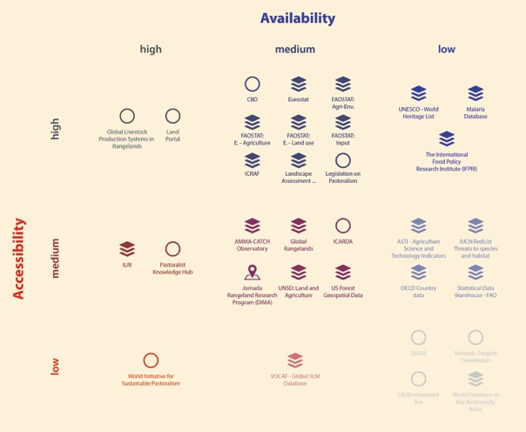
Figure 9: Visual presentation of the availability of data on rangelands and pastoralism in the 33 databases and Websites reviewed.

Only 33 of the 92 screened databases contained information about either pastoralist or rangeland. Figure 9 gives an overview of these databases. Of these, only five were rated as “high” availability as they contained information about both pastoralists and rangelands: The Pastoralist Knowledge Hub, the World Initiative for Sustainable Pastoralism (WISP), the Global Livestock Production Systems in Rangelands, the International Livestock Research Institute (ILRI) Database Portal, and the Land Portal. The Land Portal provides links to a rich portfolio of land-related downloadable datasets from a broad variety of organisations. However, as is the problem with most of the sites we screened, most data are not disaggregated to a level that makes it relevant to this study. The indicator map of the Global Livestock Production Systems in Rangelands visualises relevant issues, but it has no search engine.

The ILRI Data Portal, the Land Portal, WISP, the Pastoralist Knowledge Hub, and the Global Rangelands initiative and the ICARDA give access to a number of scientific articles and popular reports related to rangelands and pastoralism. For example, the ILRI Data Portal provides information related to livestock, rangeland soil and livestock insurance. The ILRI GIS (Global Information Systems) Portal contains information about rangeland productivity, cover, condition, etc. Analyse Multidisciplinaire de la Mousson Africaine - Couplage de l’Atmosphère Tropicale et du Cycle Hydrologique (AMMA-CATCH) has long-term data on pastoralism and/or rangelands. But all of these databases are challenging to search through. For example, the ILRI map viewer does not present the selected databases and the data cannot be downloaded from the Portal.

Most of the 92 databases are topic specific with little integration of physical and social issues (for example, savanna carbon emissions, disease epidemiology). Metonyms for rangeland appeared more often (in 31 websites) than pastoralist metonyms (23 websites); but a majority of the databases we examined (64%) did not contain any hits for any of our metonyms for rangeland and pastoralist. Sixteen sources were rated medium availability as they provided some disaggregated information about rangelands or pastoralism. The main focus of these databases was on livestock productivity and health, and rangeland condition. However, most databases – for example, UNESCO, FAOSTAT, World Protected Areas, Globally Important Agriculture Heritage Systems (GIAHS) and IUCN Red List – contain information relevant for understanding the broader context, but they do not address rangelands and pastoralism directly, nor do they distinguish between different types of rangelands and pastoralism.

As of May 2018, the World Overview of Conservation Approaches and Technologies (WOCAT) “Global Database on Sustainable Land Management” contained 1810 fact sheets recording the impacts of projects and programmes. Very few of these seem to be related to pastoralism. The database is difficult to search and, when a search is made for pastoralism, the search engine can bring up crop farming examples.

FAO’s Global Livestock Production and Health Atlas (GLiPHA) and the “Gridded Livestock of the World”, developed in collaboration with the Environmental Research Group Oxford (ERGO), provide in-depth statistics about livestock production, including animal disease, nutrition and trade issues, but do not disaggregate pastoral production systems. FAO’s Globally Important Agricultural Heritage Sites (GIAHS) provides site-specific factsheets about agricultural systems worldwide, including pastoral systems. This is a useful tool, but it does not provide a search engine so it is time-consuming identifying the relevant cases. The FAO portal “Legislation on Pastoralism” contains an impressive set of copies of 619 legal documents from around the world directly relevant to pastoralism, including grazing quotas and land-use regulations.

Eurostat provides considerable information on the overall livestock sector in Europe focusing on livestock population and productivity, and some on extensive grazing, but it does not distinguish between transhumant and sedentary livestock raisers, nor does it disaggregate social indices such as education and health of pastoralists. Several of the FAOSTAT sites provide data on types of land cover and land-use that fit the definition used for rangelands in this report. However, the statistics do not have a separate category for rangelands and, therefore, it is not clear if the data provided concern grazing lands. Eurostat, FAOSTAT sites, and OECD Country Data contain information about the geographical distribution and types of livestock, but none of the sources differentiate the type of livestock operation. However, the FAOSTAT guidance on agricultural censuses to be carried out by countries in the period between 2016 and 2025 includes some pastoralism-specific items, for example, type of livestock system.

The Convention on Biological Diversity (CBD) site does not provide datasets but contains reference to a number of site- and topic-specific case studies relevant for both rangelands and pastoralism, for example, the case “Autonomous adaptation to droughts in an agro-silvo-pastoral system in Alentejo” (2016) targeting the livelihood of 20 people in the south of Portugal. However, many of the links to the CBD case studies are partly broken and the available information is often not comprehensive enough to inform decision-making on rangelands and pastoralism. Searching for our predefined metonyms, we could not identify datasets for rangelands and pastoralist within UN Environment Live, but we did find a couple of assessment reports that describe relevant and integrated information: “Pastoralist Participation and Networking in Policy Dialogue” and “Changing Taiga: Challenges to Mongolian Reindeer Husbandry”. The WHO Malaria Database does not provide disaggregated data that can inform decision-making on pastoralism, however, WHO has issued a bulletin highlighting lessons learned and challenges to data collection in highly mobile pastoralist households in the Chad (Weibel et al., 2011).

Several country databases had specific data on rangelands (for example, in the USA Bureau of Land Management, United States Forest Service, and the Jornada Rangeland Research Programs’ “Database for Inventory, Monitoring and Assessment” datasets), which often look only at biophysical data. We rated the accessibility of these last two as medium because special software is required and permission is needed to download data.

Land degradation Assessment in Dryland Areas (LADA) and Global Land Degradation Information System (GLADIS) offer detailed information on land degradation in drylands; however, the study team was unable to gain access through these websites. Also, some of the websites under construction – for example, the Group on Earth Observations Global Agricultural Monitoring initiative (GEOGLAM) “Rangeland and Pastoral Productivity” and the FAO “Land Resource Planning Toolbox” – could potentially be very useful sources for data on rangeland trends worldwide. Further, the “Pastoralist-Driven Data Management System” (P4D), which FAO is developing, could provide an important data source on pastoralism in the future.

The study went on to examine the texts of 14 convention, protocols and targets. These were:

- Aichi Targets
- Sustainable Development Goals (SDGs)
- Basel Convention
- Stockholm Convention on Persistent Organic Pollutants (POPs)
- Rotterdam Convention
- Kyoto Protocol
- Paris Agreement
- Convention on International Trade in Endangered Species of Wild Fauna and Flora (CITES)
- Convention on the Conservation of Migratory Species of Wild Animals (CMS)
- International Treaty on Plant Genetic Resources for Food and Agriculture (ITPGRFA)
- Ramsar Convention
- United Nations Convention to Combat Desertification (UNCCD)
- United Nations Framework Convention on Climate Change (UNFCCC)
- Convention on Biological Diversity (CBD).

Only the indicators text of the Sustainable Development Goals (SDG) provided hits for first-tier keywords; that is, pastoral and drylands.

The twelve multilateral environmental agreements (MEAs) (excluding the Aichi Biodiversity Targets and SDGs) regularly collect reports from countries and these reports are a potential source of information on national status and trends on issues related to rangelands and pastoralists. On the basis of rangeland statistics provided by the University of Idaho, we identified the countries with the highest percentage of rangelands as share of national land surface. We selected a total of ten countries representing all continents with the aim to screen their national reports to the conventions since the year 2000. However, there were several obstacles making it challenging to screen the national reports. Regularly submitted national reports were only available for UNCCD, CBD, UNFCCC, CMS and the Ramsar Convention. Further, not all countries report to all the conventions and as such, a (statistical) comparison between the results in the different conventions is not possible. Yet another obstacle we faced concerns the language in which the reports were written. Within our sample of countries, the countries reported in French, Spanish, Russian and Arabic, in addition to English. Therefore, our method of using English keywords and metonyms could not be used in the screening of the different reports.

Key messages related to availability of information about rangelands and pastoralists
- There exists a broad variety of statistics and datasets for environmental and socio-economic issues, but only a third of the sample reviewed provide some information about pastoralism and rangelands, and only a few of these provide it in a manner that could inform decision-makers on sustainable livelihoods and ecosystem management. In the majority of the sources screened in the study, data are not disaggregated in a way that could inform us about the wellbeing of the ecosystem, land-use, herding strategies, migration, distribution and ownership of pastures and livestock, and other types of information relevant for decision-making.

- More integrated information is often provided by specific assessments and online knowledge repositories, but the information is most often site- and topic specific and does not provide a holistic assessment of pastoralism in a country or worldwide. Also, information was often difficult to access due to broken links, password protection and non-existing or non-intuitive search engines. Quite often, the search engines were not programmed to be sensitive to the first-tier keywords and their metonyms, and brought up information that was not at all relevant. In addition to the 100 databases and assessments reviewed, we found a few more databases that were either closed down (for example, GLADIS) or only just being created.

- Many databases are not available without a password, although they provide direction on how passwords can be obtained. We also found several relevant databases that were maintained by individual scientists or organizations, but were not publicly accessible. Any future assessment will have to establish partner agreements early on so as to obtain passwords and in some cases appropriate software to such sources.

- Confidence in the veracity and viability of existing data and information is medium to high, especially as these were global or multilateral databases that normally go through some form of review and verification process.

- Country statistics that are routinely reported in UN portals focus on livestock production only, including animal numbers, types, offtake and export, but not specifically on pastoral livestock production. Statistics on rangelands are rarely disaggregated out of broader land-use types, so it is difficult to separate out natural rangelands and grasslands. Socio-economic statistics on pastoralists are not disaggregated at all except in a few countries where pastoral production dominates the agricultural sector. Even then, there is no distinction between the different categories of pastoralist mobility.

- The limited resources for the study did not allow an exhaustive listing of all potential sources, but this would be a very useful exercise in the future. Furthermore, it would be practical and pragmatic for one or two global institutions championing pastoralism and rangelands to agree to establish such a comprehensive repository of information.

- A future assessment could invest considerable resources in seeking deeper into existing datasets, assessments and other knowledge repositories. However, it is likely that the information extracted would still be inadequate for a thorough assessment due to low disaggregation, out-dated information and unverified statistics. For example, anecdotal evidence suggests that despite reduction in the size of rangelands due to crop expansion, the same older numbers for rangeland coverage are being used and reported on. Science-based and accurate field data collection is vitally important in the subject areas identified, not just for gap filling, but also for updating information in the face of rapid change in the system.

- There is no standard method, process or structure for the databases, and therefore comparability across statistics and datasets is impossible. There are attempts to create global comprehensive databases (for example, the “Land Resources Planning Toolbox”); however, these are sector-specific and do not provide a comprehensive integrated approach to understanding pastoralism and rangelands.

- Long-term monitoring platforms for rangelands are available in several developed countries, but we were not able to find any publicly available for developing countries. GEOGLAM is an exception as it is a global monitoring site, but it is still under development. Similar disaggregated information on pastoralists is even harder to come by. Most countries do not distinguish pastoralists from farmers.

- A large part of the challenge of seeking information is due to the inconsistency in how terms are used. The terms pastoralist and rangeland are defined in many different ways and, while these terms are relevant in some parts of the world, their metonyms are used in others. A future assessment could help clarify terminology and definitions, thus making future data collection more efficient, consistent and comparable.

- Most convention texts of the MEAs do not show hits for keywords related to pastoralism and rangelands, except one SDG target that mentions pastoralists.

- Country reports are submitted in different UN languages. Any future assessment would have to make available sufficient resources to cover translation of sources with such data.

Project information
The accessibility of project information differed significantly between the agencies. Only four of the agencies – WB, GEF, IFAD and UNESCO – had searchable project portfolios available online. The WB and the GEF were the most accessible agencies and provided easy online access to project titles, objectives, status, budgets and target countries. The other agencies were contacted by email and access to the project archives were requested. FAO provided overviews of relevant projects and UN Environment gave access to abstracts for all current projects. We searched through the abstracts to identify the number of projects relevant to pastoralism and/or rangelands.

Additionally, the study looked at the project portfolio of three international agricultural research centres part of the CGIAR system, namely ILRI, ICRAF and ICARDA. Most of the hits within the ICRAF portfolio were from project titles, which might indicate that the search tool is not as effective in screening project descriptions. If this is true, the hits we identified are not representative of the project portfolio. The project databases of the CGIAR agencies are less accessible than WB and GEF in providing information about the funding granted to each project. Table 1 presents the result for the screening of the thirteen organisations.

Table 1: The results of the screening of project portfolios

Multilateral organisations | Accessible project portfolio | Total number of projects | Number of relevant projects
FAO | no | not available | 60*
GEF | yes | 10 051 | 124
IFAD | yes | not available | 27
UNDP | no | not available | not available
UN Environment | no | 439** | 8**
UNESCO | yes | 1 351 | 4
UNICEF | no | not available | not available
WFP | no | not available | not available
WHO | no | not available | not available
World Bank | yes | 13 190 | 354
ILRI | yes | 108 | 5
ICRAF | yes | 185 | 4
ICARDA | no | 29* | 29*

* Not publicly accessible; identified and shared by FAO and ICARDA
** Not publicly accessible; accessed through URL provided by UN Environment

Observations
Not all countries are eligible for funding from multilateral agencies and, as such, this source of information is biased against certain parts of the world. Still, project documents can be an important source of information of what is happening on the ground and recommendations for improving the sustainability of rangelands and pastoralism.

We identified a total of 585 projects (ongoing from year 2000 until today) that included one or several keywords related to pastoralists and/or rangelands. However, there is a possible overlap in the projects identified, as the donor agencies are sometimes partners in projects. Therefore, it was not possible to obtain an accurate figure for percentage share of projects compared to all projects that are related to pastoralism and rangelands. For example, five of the donor agencies are partners of the GEF. Therefore, we decided to further explore the project portfolio of the GEF.

We identified 124 GEF projects in the portfolio that were relevant to pastoralism and/or rangelands. These included projects at different stages and some projects that were not approved. Hence, the study focused on 107 projects with the status completed or approved in its exploration for activities providing technical support. We found that the total GEF grant allocation to the 107 projects was 406,885,166 US dollars. On average, each of the identified projects received a grant of 3.77 million USD. The total amount of GEF grants for any project in the same period (from year 2000–2018) is 17,122,496,329 US dollars. In short, the GEF projects on rangelands and pastoralism are 1.22% of the GEF’s project portfolio and receive 2.38% of the total GEF grants. Figure 10 presents the geographical distribution of GEF grants allocated to pastoralism and rangelands projects since 2000.

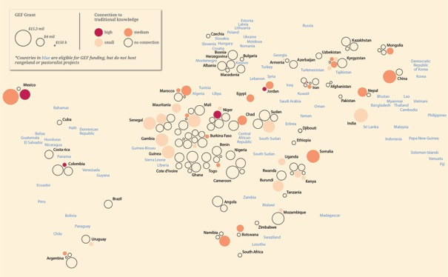
Figure 10: Graphic presenting the geographical distribution of GEF projects. The circles indicate the number and size of project per country and the red colour indicates inclusion of traditional knowledge.

The relevant 107 GEF projects were categorised according to the type/types of technical support they provided. Most of the projects covered more than one of the topics within our scope. More than half included capacity building activities, and more than 40 projects focused on biodiversity conservation (especially emphasising mitigation and adaptation to climate change) and institutional development. The latter category was often in combination with capacity building and exchange of knowledge. Less than five projects focused on health, credit or loan, vocational education, supplemental feed and ICT (see Figure 11).

To identify the significance of “traditional knowledge” (LIKT) within the relevant GEF projects, a further in-depth search was conducted by tracking hits for this metonym within the project documents. Out of the 107 approved ones, 52 projects include the term traditional knowledge or a related keyword (see Figure 10). In most cases, the term is used as a strategic statement to support conservation of biodiversity, or improve capacity building and adaptation management. Specific outputs that reflected LIKT were not found in the project documents, but 2% of the projects were rated as actively engaging in the use/development of LIKT.

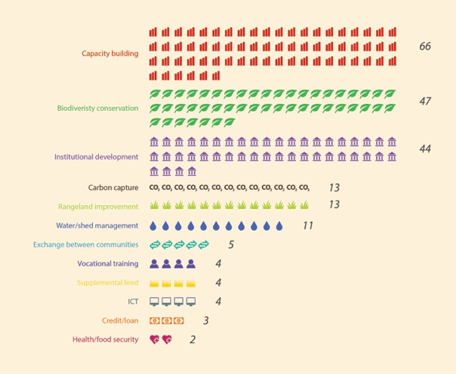
Figure 11: Focus area of the technical support provided in GEF projects that includes rangeland and pastoralist keywords.

Further, the Gap Analysis explored the technical support provided by international donors through overseas development assistance (ODA) to help developing countries achieve the MEA goals and action plans. OECD tags ODA according to a few keywords representing sectors. There are two categories directly relevant to pastoralism and rangelands: livestock and livestock/veterinary. However, there is no indication of disaggregation beyond these two sectors and therefore it was not possible to find out what ODA was given to pastoralists and for rangelands specifically. The website also cautions against adding up the figures across MEAs because of the potential for double-counting. Nevertheless, Table 2 provides the results of this sampling.

Table 2: Distribution of OECD-donor aid for MEA goals in 2015 (millions of US dollars). Data compiled from OECD (2018).

 | Biological diversity | Combat desertification and drought | Climate change adaptation | Climate change mitigation | Environment* | Total
All aid in 2015 (principle**) | 220 | 4 160 | 3 474 | 9 150 | 12 634 | 29 638
All aid in 2015 (significant**) | 1 918 | 4 625 | 11 635 | 10 461 | 17 558 | 46 197
Total all aid in 2015 | 2 138 | 8 785 | 15 109 | 19 611 | 30 192 | 75 835
Aid for livestock (principle) | 0,3 | 6,9 | 31,8 | 0,6 | 30,3 | 70
Aid for livestock (significant) | 54,1 | 26,2 | 38,8 | 13 | 30,8 | 163
Aid for veterinary services (principle) | 0 | 0 | 0 | 0 | 0 | 0
Aid for veterinary services (significant) | 0,02 | 0,8 | 4,8 | 0,6 | 18 | 24
Total aid for livestock and veterinary services | 54,4 | 33,9 | 75,4 | 14,2 | 79,1 | 257

* “Environment” includes capacity building, governance, national reporting, etc.
** “Principal” and “significant” refer to categorisation of projects where their “principal” objective was livestock/veterinary, or where these were only a significant part but not all.

The OECD information suggests that, in 2015, out of a total of about 76 trillion US dollars, only 257 million (0.3%) of ODA was dedicated towards covering livestock and/or veterinary issues through projects that address all the MEA goals. What portion of this went for pastoralism and rangelands is unknown. Of the portion that covered livestock and/or veterinary issues, the highest shares (30%) was allocated for capacity building, governance and national reporting, and another roughly 30% for climate change adaptation issues. This sector under desertification received 21%.

Key messages related to the provision of technical support for rangelands and pastoralists
- There is a large difference in the accessibility of project information of the multilateral agencies and, in general, it is difficult to find information about technical support to pastoralists and rangeland activities through the agencies’ websites.

- Among the relevant GEF projects, which were only 1.2% of the entire GEF portfolio, most focused on capacity building, biodiversity conservation and institutional development.

- Some countries receive substantially more support on rangeland and pastoralism issues than others from the GEF. Sudan is the single country that received most GEF grants and, as a continent, Africa is the main recipient region.

- “Traditional knowledge” is embedded in half of the relevant GEF projects and predominantly mentioned in a smaller to a medium extent. The term was mostly used in connection with supporting adaptation management to mitigate effects of climate change, to improve capacity building or to help conserve biological diversity.

- Development projects typically collect field data such as population numbers of their target zones, or geography and land-use patterns, livestock numbers, etc. However, such data are not readily available on their websites. A future analysis could potentially benefit from availability of such data, especially if they have been vetted and confidence levels are high.

- Participants of the Arendal working meeting noted that there are quite a lot of “known unknowns”. In other words, long-held biases can influence what information is recorded in project documents. For example, a project to establish or expand a protected area into a rangeland area will not always consider the impact of such an expansion on pastoralists’ livelihoods and mobility patterns.

- In order to fully understand the extent of international development support for pastoralists and rangelands, it would be necessary to conduct an exhaustive and complete analysis of the project portfolios of all development organisations. Sampling of a few does not provide a complete picture.

- Technical support through OECD countries to developing countries for achieving MEA goals appears to have been only 0.3% of total aid in 2015 for livestock and/or veterinary sectors. This figure combines pastoralists and all other livestock raisers.

Academic papers

Observations
The search for rangelands and pastoralism metonyms in Scopus identified only 96,414 records, out of a possible cohort of 71 million records. There were 79,245 records for rangelands, 19,133 for pastoralism and 1,644 for agro-pastoralism. A total of 19,626 records provided metonyms for pastoralism or agro-pastoralism, while only 2,658 publications covered both rangelands and pastoralism (see Figure 12).

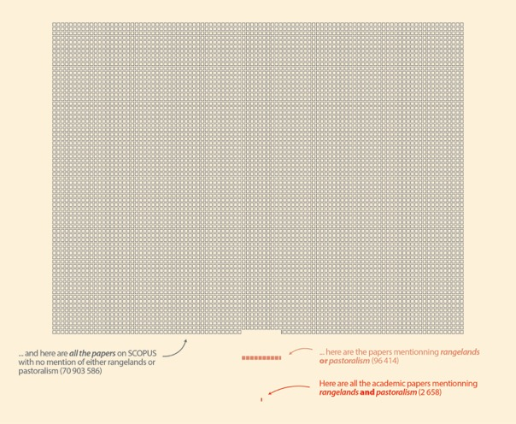
Figure 12: Number of publications in SCOPUS addressing rangelands and/or pastoralism from 2000-2018.

According to the Scopus search, the publications on rangelands and pastoralism appear to be increasing since 1980, with a substantial spike starting in 1995 – although it is not clear how much of this is due to the lack of digitisation of publications in the earlier years or a general increase in all academic literature (see Figure 13). For example, anthropologists have studied pastoralism since the early 1900s. Another interesting trend is the increase in integrated approaches since 2005 (where both rangelands and pastoralism were mentioned in the same publication).

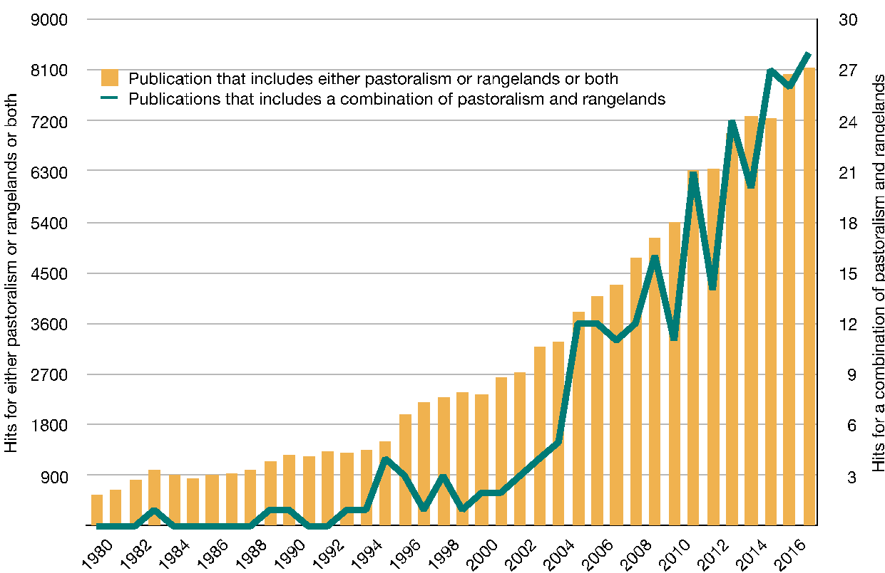
Figure 13: Graphic presentation of the publication of rangeland and pastoralism literature in Scopus per year since 1980.

Based on the systems boundaries for the study, we looked further into the sample of 2,658 publications that covered both rangelands and pastoralism – hereafter referred to as the sample. The number of hits found for different keywords within the sample gives an indication of what subjects are given more attention in scientific writing about rangelands and pastoralism (see Figure 14).

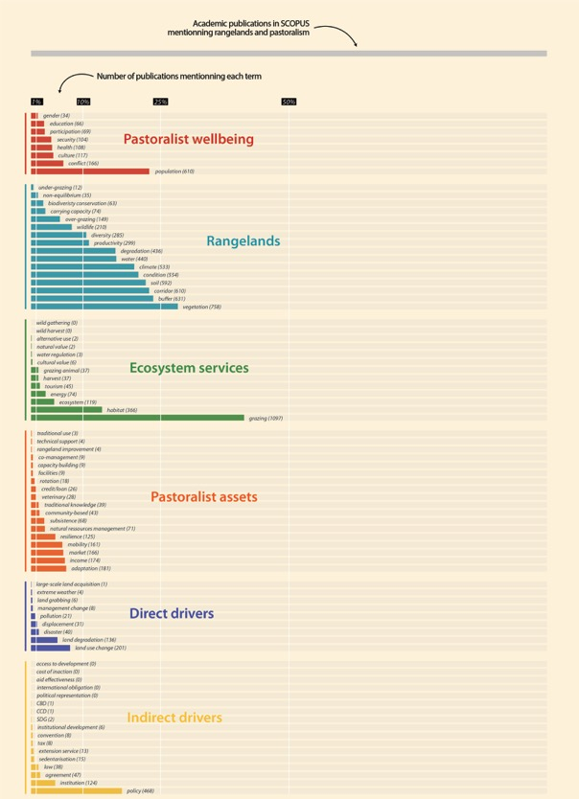
Figure 14: Number of hits in SCOPUS publications on 2nd and 3rd Tier keywords.

When searching for second- and third-tier keywords related to pastoralists’ wellbeing, we find the population, adaptation and conflict were the three most popular keywords (610, 181 and 166 hits respectively). The three least popular keywords were participation, education and gender (69, 66 and 34 hits), while culture, health and security (117, 108 and 104 hits) had medium popularity.

Within the sample, we find that issue of the nature of rangelands has the highest coverage. Here, the three most popular keywords were vegetation, buffer and corridor (758, 631 and 610 hits respectively) and the three least popular keywords were over-grazing, and under-grazing (149, 63 and 12 hits).

Further, we explored the sample to look for terms related to rangeland ecosystems services. Of the keywords we explored, we find that grazing (1097 hits) was the most used keyword independent of subject. Other popular keywords within the sample and related to ecosystems services were habitat, ecosystems services and energy (366, 119 and 74 hits). Cultural value got six hits, while natural value got only two hits. There were no hits for wild gathering or wild harvest, while harvest got 37 hits.

On the subject of pastoralist assets, the most popular keywords were income, market and mobility (174, 166 and 161 hits respectively). The number of publications on market is also an interesting case, because there is a perception that more is done about meat marketing than dairy marketing in pastoral systems. However, the Scopus search shows more publications focusing on dairy (667) than on meat (608). Of course, a Scopus search only indicates presence or absence of data, not the depth or variety of data.

We find that the number publications (within the sample) using terms often associated with the non-equilibrium theory of drylands has generally increased since year 2000 (see Figure 15). The term non-equilibrium ecology was mentioned 99 times in publications since 2000. The terms corridor (usually associated with livestock movement) and buffer (usually associated with grazing territories between groups of pastoralists) show a steady increase since the year 2000. The term mobility also shows an increase albeit a smaller one, but the term rotation does not show significant change over the years.

When searching for traditional knowledge and community-based within the sample, we identified 39 and 43 publications respectively and find an increasing trend in hits since the year 2000. Still, the number of publications is limited to a maximum of six or seven per year and indicates a poor integration of this notion in academic literature about rangelands and pastoralism up to the present. When searching the sample for traditional use and co-management we identify only three and nine publications respectively since year 2000.

Figure 15: The number of hits for terms used in SCOPUS publications related to non-equilibrium ecology in rangelands, distributed per publishing year.

Keywords related to technical support do not occur often in the sample. Within this subject, veterinary, credit/loan and extension service are most frequent (28, 26 and 13 hits respectively). Capacity building, institutional development and rangeland improvement occur less than ten times (9, 6, 4 and 4 hits), while there are no hits for access to development, aid effectiveness or cost of inaction. Except for veterinary and credit/loan, we find that most keywords representing provision of technical support occurred in publications in the later 2000s. Given that the terms rangeland productivity, rangeland degradation and rangeland condition under the “nature of rangelands” category get far more hits (299, 436 and 554 respectively) it is safe to assume that earlier publications did talk about providing technical support in one form or another but did not label it as such. Furthermore, the topic of credit/loan gets much attention in academic publications, but less so under the banner of technical support in GEF projects. Therefore, the methodology of keyword searching is not the best for analysing gaps in provision of technical support. As the issue of technical support touches upon one of the main objectives of this gap analysis, this presents an important observation for future work.

Among the keywords used to examine the topic of direct drivers, the two most often used are land-use change (201 hits) and land degradation (136 hits). Disaster, displacement and pollution have 40, 31 and 21 hits respectively. The least used keywords are land grabbing, extreme weather and large-scale land acquisition (6, 4 and 1 hits respectively). While the keyword searches in Scopus are a proxy indication of the level of interest of researchers in certain topics, it is also an indication of how little is known about rangelands and pastoralism. For example, there were 2,363 articles since the year 2000 on the topic of land grabbing, an issue that is both new and topical. However, only six of these were about rangelands and pastoralism.

On the subject of indirect drivers, the most used keywords were policy and institution (468 and 124 hits respectively). Carrying capacity (representing the ‘old’ paradigm of grazing management) has more than twice as many as non-equilibrium (74 and 35 hits). The term agreement and convention occur 47 and eight times, while SDG occur twice and CBD and CCD only once. There are no hits for international obligation or political representation.

We also screened the Scopus sample for country names to assess the distribution of geographical focus within the records on rangelands and pastoralism. In general, countries are mentioned very few times. Most countries are mentioned less than five times, but some countries stood out with more than 100 hits: China (406 hits), Mongolia (246 hits), Australia (224 hits), Kenya (163 hits) and Ethiopia (128 hits) (see Figure 16).

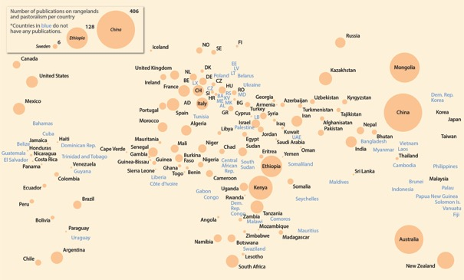Figure 16: Mention of countries in Scopus publications on rangelands and pastoralism. The orange circle indicates the number of times a country was mentioned. Blue countries were not mentioned.

Key messages related to availability of information about rangelands and pastoralists
- More than 96,000 academic peer reviewed publications cover rangelands and/or pastoralism since the year 2000. However, this pales in comparison to the 71 million records in the same time period.

- There is far more information in academic publications on issues such as grasslands and livestock than specifically on pastoralism and rangelands. Nevertheless, the amount of information available has increased considerably since the year 2000.

- Compared to literature on rangeland issues, there is little coverage of issues related to pastoralism, and very few publications cover rangelands and pastoralism in an integrated way. Within all publications about pastoralism and rangelands, the vast majority (82%) included one or several keywords related to rangelands. Only 20% mentioned keywords related to pastoralism and 3% covered both rangeland and pastoralism issues.

- Keywords that are typically related to natural sciences get more hits than subjects typically belonging to the social sciences. Furthermore, there appears to be more information regarding basic descriptors (for example, pastoral population, rangeland vegetation, grazing) than there is for more specific issues such as tourism, traditional use, or education.

- We found only two hits for SDG (one from 2013 and one from 2017) and one hit each for CBD and CCD (both from 2009).

- There were very few publications related to issues of technical support. Of these, most of the terms used were veterinary and credit/loans. None or very few publications talked about to aid effectiveness, cost of inaction, or rangeland improvement.

- There is a large difference in coverage of countries in the Scopus publications on both pastoralism and rangelands. The best coverage is of China, Mongolia, Australia, Kenya and Ethiopia with more than 100 hits in each case. However, most countries had only one hit.

Survey of stakeholders

Observations
Out of the 58 individuals that responded to the survey, the largest number (21) represented a university or a research institution. Twelve respondents had an affiliation with an NGO, eleven were part of a ministry or an agency, and seven represented a pastoralist organisation (see Figure 17).

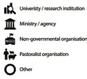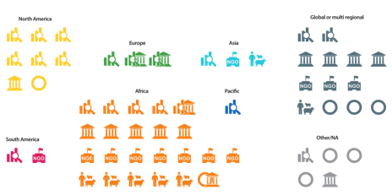
Figure 16: Overview of the respondents’ affiliation and geography.

According to the survey results, the respondents worked more with sedentary and semi-nomadic pastoralists than with fully nomadic pastoralists. Most respondents stated that they work within a single country (30 respondents) and only seven work globally. Most of the respondents (32) work in Africa; between 11–14 work in Asia and in North and South America. In their work, the respondents give less attention to Europe (4), the Pacific (4) and the Arctic (1).

22 respondents collect information about rangelands and pastoralism on an annual basis and ten respondents collect information every 2–5 years. Only four respondents report that they never collect information. The type of information collected is broad, with most respondents collecting information related to pastoral herd structure, livestock numbers and production. Respondents also tend to collect data about the status and trends regarding rangelands ecosystems, land-uses and land-use conflicts. Also, water management, pastoralist economy, livestock health, and information on pastoralist household economics are popular topics.

Many respondents collect information related to gender, youth and elders, mobility and access to pastures, and LIKT (see Figure 18). All respondents draw – though to a varying degree – from LIKT to enrich the relevance of their projects, programmes and policies. Less attention was given to issues of education, participation, technical support for pastoralists, and pastoralist health and wellbeing. Very few collect information related to pastoralists’ rights. A majority of the respondents collected information related to herd structure (including type, age and sex of livestock), livestock numbers and production, as well as data about rangeland improvement and/or biodiversity conservation. Less than a handful collected information about loss of grazing land, climate change or other environmental changes, laws and policies, and cultural aspects of pastoralism. However, different results may have been obtained if each respondent had been asked to list the types of information collected, without any “prompting” from a questionnaire.

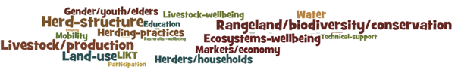
Figure 18: Word cloud presenting the distribution of information collected by the respondents by topic. The topics collected by only one respondent are too small to appear in the figure. Created with: wordle.net

The respondents report (without prompting from the questionnaire as to categories) that they make the information collected available through different means: leaflets, scientific papers, annual reports, online newsletters and websites, public gatherings, radio, television, emails to participants and networks, through statistical departments, through social media, and upon request.

In addition to collecting their own information, 42 respondents also use information collected by other organisations. The survey shows that the respondents regard information provided by pastoralist organisations as most relevant, and they were also most confident in the quality of information from this source. The respondents regard the relevance of information from community-based organisations and non-governmental organisations as being high to very high, and the quality of the information as medium-high. They perceive government and donor information as relatively relevant, but have less confidence in the quality of the information. The respondents regard information from the business sector of medium relevance, and have only medium-low confidence in information from this source.

The respondents shared information on upcoming assessments that they were aware of. Almost all of them are either national scale (for example, India’s Pastoral and Forest Inventory, Lesotho’s national rangeland baseline assessment, and the United States survey of range and forestry extension personnel) or sub-national (for example, annual surveys of rangeland condition and household wealth and livestock numbers in the South Gobi region of Mongolia). A few globally relevant tools are being developed, such as the Land Portal, and the Pastoral Development Toolkit. But there are only two global-scale integrated assessments underway: assessment of conflicts through the International Institute for Environment and Development (IIED) and mapping of land tenure and land-use change in rangelands by the International Land Coalition (ILC). [This finding on future global environmental/integrated assessments to be verified through the Final Peer Review.]

We asked the respondents to share their perspectives on gaps in information about, and provision of, technical support for rangelands and pastoralism. The results show a gap in all information and support subjects. The respondents also thought that there were major gaps in availability of information on impact of policies and laws and information on voices of pastoralists (see Figure 19). Interestingly, the latter topic was also rated as the one with the smallest information gap. There seems to be a consensus that the smallest information gap is within the topic livestock information, such as number of animals. Concerning technical support, the largest gap was within capacity building and marketing. Also, large gaps were identified in rangelands improvement and vocational training. The smallest gaps in technical support were related to water issues and exchange between communities (see Figure 20).

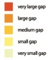
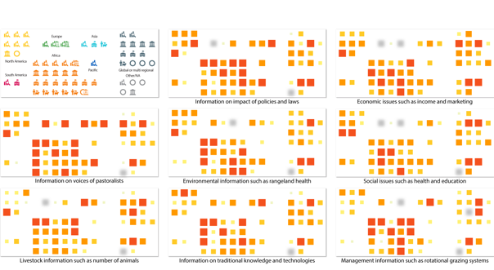
Figure 17: Knowledge Gaps identified by the survey respondents

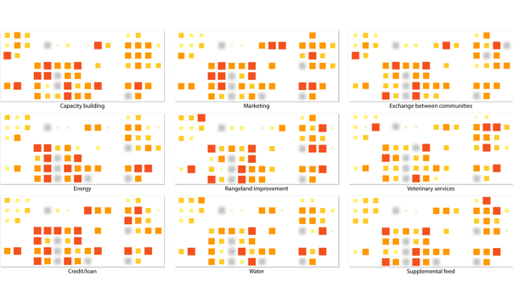 Figure 20: Gaps in the provision of technical as identified by the survey respondents

Although we find certain trends in the survey responses, respondents perceive the information gaps and gaps in technical support very differently. For example, credit/loan was rated as a technical support measure with both the smallest and the largest gap, and information on voices of pastoralists was rated as having the smallest and the largest information gap. One reason for this discrepancy might be that the respondents have interpreted the questionnaire differently – but it is also likely that they hold very different experiences in the status of information and technical support. We know that most of the respondents have a country focus, and their responses will be based on their local experiences.

Respondents made a number of recommendations (all of which are presented in the Methodology Report). Highlights of these recommendations most relevant to the gap analysis are available in Text Box 3.

Key messages related to the provision of technical support for and the availability of information about rangelands and pastoralists
- A lot of data and information seems to be collected by the respondents contacted but could be made better available for future use by external users.

- In general, the respondents have the most confidence in information provided by pastoralist organisations.

- There is a general gap in information on technical support.

- The inconsistency in how issues are rated indicates that individuals in different locations experience different gaps and that there are different needs for reducing gaps in information and support. A future assessment could – in addition to presenting global issues of rangelands and pastoralism – provide local and contextualised information to present the diversity.

- According to the returns on the questionnaire, an online survey might not be the most efficient way of engaging pastoralist organisations. Just as with the Arendal working meeting for this Gap Analysis Report, any follow-up work to this study should also seek to engage with pastoralists more directly throughout the planning, implementation and evaluation phases.

Text Box 3: Highlights of the respondents’ recommendations most relevant to the gap analysis

The conclusions and recommendations of this Gap Analysis have been enriched by the opinions expressed by workshop participants, survey respondents, peer reviewers and Advisory Committee members. Below is a synopsis of recommendations from the survey respondents.

Recommendations for filling the gaps in information on pastoralists and rangelands:

Enhance the availability of existing information and increase the awareness of decision-makers and the general public about the challenges of pastoralism and rangelands by encouraging governments to better disaggregate information about rangelands and pastoralists, and by requiring all publicly funded projects, research and workshops to disclose information in an easily accessible way.

Leverage the Internet through ways to facilitate information exchange, such as through an online open-access platform, or through cell phones, or by producing regular information booklets, brochures, and using media such as social media, for all actors, including both genders, all generations, illiterate or not.

Broaden the understanding of the natural and cultural value of rangelands and pastoralism, and the effects of environmental change on pastoralist livelihoods and approaches to enhance sustainability and resilience, through an accurate and up-to-date assessment of rangeland health/condition, and by better and regular targeted surveys on the diversity in pastoral systems, by integrating indigenous knowledge, by facilitating exchange of experience and good practice in land-use and natural resource management, and by providing support for postgraduate research.

Enhance pastoralists’ voices by building the capacity of pastoralist communities/organisations to collect, analyse, store and package information on pastoralism and rangeland management.

Recommendations for filling the gaps in provision of technical support to pastoralists:

Support all forms of education and capacity building for pastoralists, including post-secondary education and extension programmes, informal sessions and small-scale hands-on workshops, exchange programmes, demonstration sites and household demonstrations, inspirational programmes for pastoralist youth, and developing guidelines relevant to pastoralism and mobility of livestock

Empower pastoralists and ensure their participation by supporting local autonomous institutions operated by pastoralists to engage in making laws, policies, programmes and projects relevant to pastoralism

Obtain recognition from authorities that positive discrimination is a good means to achieve real equality – i.e. that extra measures benefiting pastoralists are needed; provide more long-term support including donor support; provide a national-level helpline or knowledge hub and develop mobile information resource centres; provide pro bono assistance for managing legal issues, including land titles; make more credit and resources available; and raise investment in pastoralist livelihoods and rangeland improvement

Enhance communication for development by conducting surveys in villages and in the native language, not online and in English; establish country focal points who can translate reports and recommended actions into local languages and facilitate a two-way flow of information; and publish information in magazines, radio, text phones and websites targeting pastoralists.

Conclusion

Availability, accessibility and confidence level of information and data on rangelands and pastoralism
There are far more assessments of forests and cropland than of rangelands. In fact, we were unable to locate any specific global assessment of rangelands or pastoralism. Furthermore, almost all of the assessments reviewed largely use the same sources of information thus reinforcing the same conclusions over again. Recognizing the need for new data, some of the more recent global assessments have innovated with satellite imagery methodologies, but without field data verification confidence in their results and conclusions is relatively low.

The Assessments reviewed by this Report often do not provide sufficient detail and disaggregation to inform about specific issues related to rangelands and pastoralists. It is important not to aggregate such systems because of the different needs of livestock keepers from farmers or forest dwellers, the difference in how land is used and livestock mobility is practiced among pastoralist groups, and the different ways in which natural resources are managed and utilized. These assessments often provide valuable information on controversial and timely topics, such as enteric carbon emissions from livestock, carbon sequestration from rangelands, extent of rangeland degradation and its causes, and costs of inaction, but these are mostly based on scientific research conducted on samples of sites or populations. As confirmed by our study of Scopus scientific publications, there are indications of gaps in both geographical and thematic coverage about rangelands and pastoralists. As a result, there are often very conflicting data, conclusions and recommendations emanating from existing information. This lack of comprehensive coverage should be addressed at the global scale through a concerted effort to collect primary data, so as to allow these controversies to be resolved and to support effective policy decision-making.

In addition to such gaps, the global assessments that were reviewed were able to uncover the degree to which there is (or is not) agreement among datasets and research results. In many cases, such agreement is quite low because of differences in definitions, methodologies and standards used.

Due to resource limitations, the study team was not able to collect and archive an exhaustive list of relevant global assessments. Such an exercise would be important to do during a full assessment.

There are indications that some national or sub-national level assessments and research are being planned or underway on rangelands and pastoralism. There are two global-scale assessments also underway: one on conflicts and the other on land tenure and land-use change in rangelands. Thus, any future assessment will be able to rely on some information being newly generated. [Sentence subject to verification after Final Peer Review.]

The study was unable to find credible and publicly available data on most rangeland and pastoral systems in the world in the sampled assessments, datasets and websites, project documents and academic publications. The number of pastoralist populations worldwide, and comparable geospatial information, including global maps, are severely lacking – especially when compared to similar information on forests or cropland. The study identified several global maps of rangelands and pastoralism, mostly produced by scientific and academic researchers. However, even according to their authors, there is limited confidence in the information provided because of lack of sufficient field data and differences in terminology. The level of disaggregation of data is very poor, with most data being available on livestock production in general, but not for any other socio-economic and ecological issues related to rangelands and pastoralism. There are “known unknowns” and biases that influence the type of information and data that is recorded and stored in project documents, databases and assessments. Developed countries are able to benefit from long-established monitoring platforms on rangelands (for example, BLM in the USA), but similar disaggregated information on pastoralists in developing countries is harder to come by.

Information from academic studies and projects is available, but is not comprehensive enough, and some developing countries are far more informed than others. Only about half of the multilateral agencies surveyed provide an open project database with a range of information such as objectives, budget, targeted countries or regions of their projects.

Within the information sources screened for this study, the level of confidence in existing data is medium to high, as most sources have protocols and procedures to ensure verification of information. Therefore, the main challenge in filling gaps is less related to confidence issues than to the need to disaggregate data to a degree that deeper knowledge about land management and degradation, land tenure or water security, and livelihoods could be acquired. By contrast, respondents to the survey had more confidence in information provided by pastoralists and their organisations than from most other sources, but such information is not readily accessible.

The methodology adopted for this study is such that while we can conclude with confidence as to how little the terms rangelands and pastoralism are covered in assessments, databases, and academic publications, we can only provide some indications of what the gaps might be in more detailed thematic issues. These can be summarized as follows:

- There is far less information on pastoralists and rangelands compared to farmers or woodlands. Of the information that is available, most of it is descriptive (such as population size, livestock holdings, etc.) There are even larger gaps on deeper issues such as access to education, participation, mobility of livestock, etc. that would normally inform decision-making.

- There are more information gaps in socio-economic issues related to pastoralism than in biophysical issues related to rangelands.

- There are large information gaps in thematic topics specifically challenging for remote and mobile populations, such as provision of education and health services; participation in local representation and national politics; alternative livelihoods; access to development; provision of facilities and infrastructure; within-country and transboundary mobility of livestock, etc.

- More recent topics important to pastoralism and rangelands are less covered than ‘conventional’ topics. For example, the issue of under-grazing (thought to be a major cause of rangeland degradation) is much less covered than over-grazing. While much attention is being paid to land use change (especially conversion of rangeland to agriculture or protected areas) less attention is being paid to land grabbing or large-scale land acquisitions that dispossess pastoralists. There is relatively little coverage of non-equilibrium solutions for grazing management although it appears to be increasing.

- Two recent topics – that is, conflict and adaptation to climate change – are relatively more covered than other topics due to the nature of global interest in these topics, and could serve as a vehicle to better mainstream information and data on pastoralists and rangelands into government data and decision making.

- There are large information gaps in understanding or cataloguing of local and indigenous knowledge and technologies among pastoralists. Gender issues are relatively less covered than other issues.

- While there is considerable focus on land degradation, rangeland condition and productivity, there is less coverage of specific issues such as pollution, or disasters, displacements, and management change.

- Academic publications provide more coverage of policies that affect rangelands and pastoralists, than of other topics. However, specific policy issues such as taxation and sedentarisation seems to be less covered (the latter may have been better covered in the pre-2000 period).

Some countries have substantial information on rangelands and pastoralism, especially when the information available from databases, assessments, projects and academic publications is aggregated. However, it is impossible to ascertain if there are countries with absolutely no information (“black spots”) because there are at least some forms of data available even if not fully disaggregated. For example, even if FAO data on livestock are not disaggregated fully among pastoralists vs non-pastoralists, it is fair to assume that in a country such as Mongolia or Sudan, most of the livestock data will be about pastoralism.

Current innovations and paradigm changes are generally not reflected in the information available in databases, assessments and project documents. For example, recent scientific research on non-equilibrium ecosystems, benefits of livestock mobility to ecosystems, economic valuation of environmental benefits, and impacts of the Internet and telecommunications are not reflected or captured. But there is evidence of an increase of their coverage in scientific publications since the year 2000. That they exist primarily in academic publications also means that such concepts have less impact on policy- and decision-making than they otherwise could. Any future assessment would need to design a strategic approach that bridges the old and new paradigms.

There are some opportunities where existing information could be enhanced. For example, the level of disaggregation of datasets of multi-lateral agencies is a direct function of the level of disaggregation of statistics provided by member states. Such disaggregation seems to be very low at the moment in relation to rangelands and pastoralists. In order to enhance data availability, government data collection could be better disaggregated using targeted indicators. Similarly, the review of project documents indicates that a development project infrastructure is a potentially important means for data collection (for example, through their baseline studies and monitoring/evaluation exercises), and that this information could be made more accessible to the public.

Information on the provision of technical support
Information on what type of technical support is provided to pastoralists was difficult to obtain. The main tool for collecting this information was the survey, supplemented by a screening of keywords in Scopus and within the GEF projects, an analysis of OECD DAC data and discussions during the Arendal working meeting. The response on the questionnaire was relatively low (58 respondents). The study focused on international donor support. However, national governments and local organisations also give a considerable amount of technical support through projects, programmes, subsidies, extension services and more. Any future assessment should also include such sources in its methodology.

The coverage of technical support to rangelands and pastoralists in scientific publications seems to be very low compared to all other publications in the same period. And although the study was not able to conduct an exhaustive survey of all donor support to pastoralists, the results of the sampling of the GEF portfolio show that direct support to pastoralists and rangelands is only 2% of available funding, with most of it focusing on capacity building and governance issues. Sampling of ODA shows that the portion aimed at the livestock sector is marginal compared to other sectors, and not commensurate with the estimated importance of the sector in the world economy (see Table 2). What portion of this ODA reaches pastoralists and rangelands is impossible to tell because of lack of disaggregation of data.

Much of the technical support provided through GEF projects focus on capacity building, and institutional development, with biodiversity conservation, rangeland improvement and watershed management being moderately covered. But gaps were found in areas outside of these conventional areas – for example in community exchanges or provision of credit and loans to pastoralists. It is interesting to note however, that the issue of credit/loan receives moderately high attention in academic publications.

Survey respondents had largely differing views on what should be priority topics for technical support. However, taken all together, their recommendations focused on: capacity building and education of pastoralists; empowerment and participation of pastoralists; provision of mobile services; financial and legal support; and rangeland improvement. Some survey respondents from developing countries recommend a positive discrimination approach so that pastoralists (and rangelands), which have long been neglected, receive a much fairer share of development assistance. Respondents from developed countries did not think that provision of technical support to pastoralists was a priority for their countries.

Crop farmers and pastoralists alike face many similar challenges in developing countries, and programmes for technical support should be continued. However, the needs of mobile pastoralists are often different and the challenges they face in engaging with the modern world such as obtaining a niche in export markets, or having the collateral for credit and loans for investment purposes, can be daunting (McGahey et al., 2014).

Challenges and opportunities for filling information gaps
The gap analysis selected 136 keywords that best described the scope of issues to be reviewed. While such a large number of keywords was a feasible choice for conducting fast online, automated searches in assessments and databases, it would not be as easy for other means of data collection, such as field data or country statistics. For pragmatic reasons, any future assessment may want to be more selective in how it defines its system boundary and scope. However, this runs the risk of reducing the integrative, holistic, nature of the assessment.

The majority of online, publicly available databases and assessments screened used secondary sources of information – in effect, reiterating what has already been published. Science-based and accurate primary field data collection is vitally important in the subject areas identified, not just for gap filling but also for updating information in the face of rapid change in the socio-economic and environmental systems. Very few datasets were found that had relevant, verified, primary data and statistics on pastoralism and rangelands. Such datasets may be “behind” the public interface, or held by individual scientists and organizations however, and accessible only through partnerships. While we have high confidence in the methodology used for identifying different data sources use of first-tier keywords (that is, the rangelands and pastoralism metonyms), our confidence diminishes as we move into the more specific terms that make up the second and third-tier keywords.

The immense diversity in methodology, data storage, terms and definitions means that information from different sources (and over time) is barely comparable. Language differences, ambiguity of terms used, and preference for aggregation rather than disaggregation pose challenges for any assessment. The subject matter (rangelands and pastoralists) is far less studied than other subjects (for example, forests) and has been much less subject to debate in international environmental arenas (for example, out of the multilateral conventions, protocols and targets screened, only the SDGs specifically mention pastoralists). Any future assessment will need to take the time and resources necessary to first build a global consensus on terms and definitions. However, it will still be faced with the challenge of retrofitting existing information to the consensus terms.

The study found very high diversity of opinions expressed in the survey of stakeholders, with some holding extreme and opposing views on gaps in information and technical support for sustainable rangelands and pastoralism. This is not surprising given the geographical differences, the diversity and ambiguity in terminology, general lack of data availability, and insufficient national or global dialogue space on the topic of rangelands and pastoralists. While this diversity can be seen as a challenge in communicating future needs for filling information gaps, it should also be seen as an opportunity for engaging a diverse set of stakeholders into the process.

Local, indigenous and traditional knowledge and technology
The study found that the documentation of LIKT is limited in availability through databases, assessments, academic papers and projects screened. However, the recognition of the value of such knowledge to development work, investment, empowerment, etc. is high as evidenced by the survey responses and to a lesser degree in the project analysis. Therefore, any future assessment would best ensure the full participation of pastoralists and their direct organisations, as a means to ensure that local, indigenous and traditional knowledge, information and technology are available to the assessment.

The study sought the views and participation of pastoralists in its design stage, in data collection and in final review of the report. Through the assistance of the Advisory Board and the IYRP Steering Committee, the study was able to develop the most comprehensive list of regional pastoralist organisations known today. (An overview of the regional pastoralist organisations is presented in a separate Methodology Report). However, the study faced some challenges in achieving full participation by pastoralists, including: inadequate representation of pastoralists and their own organisations in global platforms; young and developing pastoralist organisations who are still struggling to achieve full legitimacy and internal cohesion and therefore were unable to furnish the required information or data; language difficulties; and non-responsiveness by some pastoralist organisations likely because of a lack of a full understanding of the objectives of the study, or lack of time and resources. The study did not have the resources to also seek out national or even local pastoralist organisations, where the language and communications challenges are amplified; however, this should be an important aspect of any future assessment.

Recommendations addressing the observations made

Recommendations for filling the gaps in information on pastoralists and rangelands

Conduct an integrated global assessment
- Provide sufficient funding and resources for a science-based, multi-year, holistic and integrated, participatory, integrated global assessment on pastoralism and rangelands that covers both socio-economic and biophysical issues, as well as both historical and future perspectives. The assessment could be conducted on a regular basis, and be required to do so with the best disaggregation level possible so as to separate out information relevant to rangelands and pastoralism

- Ensure that the global integrated assessment covers all the descriptive and thematic gaps identified in this study. In particular, descriptive information on the extent of land considered as rangeland and on populations and communities considered as pastoralist is a vital first step, as is the trend over time.

- Ensure that the integrated global assessment has the ability to collect verifiable and high-quality existing data and information as well as new information, including primary field data on the gaps where data were not collected before, and incorporation of new paradigms and innovative thinking. It is recommended that the gaps of information be closed through a combination of remotely sensed data and local level data collection.

- Ensure that the integrated global assessment, by being sensitive to the ambiguity and regional and national differences of keywords, is able to contribute to consistency and comparability in terms and definitions, methodologies, and mapping protocols, by using semantic ontologies. In this way the global assessment can lay the basis for harmonisation of data collection and monitoring on pastoralism and rangelands worldwide

- Ensure that governments provide direct access to existing local and national statistics and primary data on rangelands and pastoralists to the integrated global assessment, so as to help better disaggregate existing data wherever possible

- Provide sufficient funding, time and resources for the integrated global assessment so as to address the methodological and preparatory challenges identified in the gap analysis, including inclusion of indigenous and local pastoralists in a participatory process for comparability of terms and development of a lexicon, selection of the most appropriate system boundary, scope and methodology in a participatory manner, and establishment of bilateral partnerships for accessing data not freely available online.

- Provide sufficient funding, time and resources for the integrated global assessment to directly access local and national government statistics (including with translation), to collect new primary field data in areas and themes with gaps and on unreported themes, and to analyse the impact of national government policies and subsidies on rangelands and pastoralists.

Enhance the availability and quality of existing information
- Ensure that governments and all publicly funded projects, workshops and research projects provide access to verifiable, disaggregated data and information on pastoralists and rangelands.

- Regularly conduct assessments of the impact of government policies, laws and regulations on pastoralism and rangelands, and especially new or revised ones Issues of global concern, such as conflict, adaptation to climate change, and land grabbing

- Mainstream pastoralism and rangeland issues in all government activities, and in particular, ensure that issues of global concern, such as conflict and human security, adaptation to climate change, and large-scale land acquisition, also address pastoralism and rangelands

- Encourage pastoralist organisations and NGOs that work with them to document data and information on rangelands and pastoralists and make them available, including LIKT

- Encourage one or two global institutions to agree to establish a comprehensive repository of information on rangelands and pastoralism, while ensuring high accessibility, availability, comparability and confidence in the information

Broaden the understanding of pastoralism and value of rangelands
- Increase funding and resources for participatory research on pastoralism and rangelands, especially in developing countries and areas where data and information are lacking, through regular surveys and statistical collection, in-depth research studies and frequent analysis of remotely sensed data, and south-north exchanges

- Ensure that data and information are collected and shared that focus on non-typical topics – go beyond livestock to rangeland mobility; from classical education to vocational and practical education; from income to investment, etc.

- Organise a conference on global rangelands and pastoralism that brings together pastoralists, scientists and governments, to broaden understanding and develop a consensus on strategic approaches, priority strategies and policies for data collection and management, comparable and consistent terminologies and methodologies for sharing information and data; consider follow-up activities or action plans and appropriate international protocols where relevant.

- Encourage all relevant global environmental agreements, protocols and conventions, as well as other relevant international conventions, to explicitly address the issues of rangeland health and sustainable pastoralism as relevant to their goals and obligations.

Recommendations for filling the gaps in provision of technical support to pastoralists

Conduct a detailed assessment of provision of technical support to pastoralists
- Analysing gaps in technical support needs a very different methodology than analysing gaps in information and knowledge. Thus, the two issues should be decoupled in the future.

- The system boundary (thematic scope) for an analysis of gaps in provision of technical support should be clearly established by Member States prior to its commencement, drawing on the views expressed by the survey of stakeholders in this Study. The results show that there is a large difference in how the respondents perceive gaps in provision of technical support for pastoralists and rangelands. A full assessment should bear in mind the vast diversity of challenges faced by pastoralists and rangelands worldwide.

- Any future assessment of the provision of technical support should cover not only international donor support, but also support from national governments and local organisations in its methodology.

- The portion of ODA funding that reaches pastoralists and rangelands is impossible to tell because of lack of disaggregation of data. Still, available information indicates that pastoralists and rangelands receive a very small portion of available donor support. A full assessment should include an overview of topical and geographical support to pastoralists and rangelands.

Recommendations on how to involve pastoralists in the integrated global assessment
The survey respondents provided important recommendations on how to involve pastoralists in integrated global assessment. These and other insights from the study lead to the following recommendations:

- From the beginning of the global assessment, build on existing knowledge and capacity of existing pastoralist organisations (that have access to internet) and NGOs that work predominantly with pastoralists, and focus on empowering pastoralist communities to “speak” and “act” for themselves

- Build on the list of regional pastoralist organisations to develop a comprehensive global list including national and local ones, and work through these networks to create constituencies that can be closely involved in the global assessment

- Conduct new peer-reviewed scientific research in collaboration with pastoralists, local extension agents, livestock organisations and other pastoralism- and rangeland-related actors

References
Allen, VG, Batello, C, Berretta, E, Hodgson, J, Kothmann, M, Li, X, McIvor, J, Milne, J, Morris, C, & Peeters, A. (2011). An international terminology for grazing lands and grazing animals. Grass and forage science, 66(1), 2–28.
Allen-Diaz, B, Chapin, F, Diaz, S, Howden, M, Puigdefabregas, J, & Smith, M. (1996). Rangelands in a Changing Climate: Impacts, Adaptations, and Mitigation. In R Watson, M Zinyowera, & R Moss (Eds.), Climate Change 1995. Impacts, Adaptations, and Mitigation of Climate Change: Scientific-Technical Analyses (pp. 131–158). New York: Cambridge University Press.
Blench, R. (2001) Pastoralism in the new millennium. Animal Production and Health Paper 150. Rome: FAO.
Borit, M, & Olsen, P. (2016). Seafood traceability systems: gap analysis of inconsistencies in standards and norms. Fisheries and Aquaculture Circular No. 1123. Retrieved from http://www.fao.org/3/a-i5944e.pdf
Cherlet, M, Hutchinson, C, Reynolds, J, Hill, J, Sommer, S, & von Maltitz, G (Eds.). (2018). World Atlas of Desertification. Luxembourg: Publication Office of the European Union.
Davies, J, Ogali, C, Laban, P, & Metternicht, G. (2015). Homing in on the Range: Enabling Investments for Sustainable Land Management. Technical Brief 29/01/2015. Retrieved from Nairobi:
Díaz, S, Demissew, S, Carabias, J, Joly, C, Lonsdale, M, Ash, N, Larigauderie, A, Adhikari, JR, Arico, S, Báldi, A, Bartuska, A, Baste, IA, Bilgin, A, Brondizio, E, Chan, KMA, Figueroa, VE, Duraiappah, A, Fischer, M, Hill, R, Koetz, T, Leadley, P, Lyver, P, Mace, GM, Martin-Lopez, B, Okumura, M, Pacheco, D, Pascual, U, Pérez, ES, Reyers, B, Roth, E, Saito, O, Scholes, RJ, Sharma, N, Tallis, H, Thaman, R, Watson, R, Yahara, T, Hamid, ZA, Akosim, C, Al-Hafedh, Y, Allahverdiyev, R, Amankwah, E, Asah, ST, Asfaw, Z, Bartus, G, Brooks, LA, Caillaux, J, Dalle, G, Darnaedi, D, Driver, A, Erpul, G, Escobar-Eyzaguirre, P, Failler, P, Fouda, AMM, Fu, B, Gundimeda, H, Hashimoto, S, Homer, F, Lavorel, S, Lichtenstein, G, Mala, WA, Mandivenyi, W, Matczak, P, Mbizvo, C, Mehrdadi, M, Metzger, JP, Mikissa, JB, Moller, H, Mooney, HA, Mumby, P, Nagendra, H, Nesshover, C, Oteng-Yeboah, AA, Pataki, G, Roué, M, Rubis, J, Schultz, M, Smith, P, Sumaila, R, Takeuchi, K, Thomas, S, Verma, M, Yeo-Chang, Y, & Zlatanova, D. (2015). The IPBES Conceptual Framework — connecting nature and people. Current Opinion in Environmental Sustainability, 14, 1–16. doi:http://dx.doi.org/10.1016/j.cosust.2014.11.002
FAO. (2008). Assessing existing information systems and information needs: Information gap analysis Methods to Monitor the Human Right to Adequate Food: An overview of approaches and tools. Volume 2 (Vol. 2, pp. 97–111).
FAO. (2012, 25 September). AGA News: Milking the Camel. Retrieved from http://www.fao.org/ag/againfo/home/en/news_archive/2006_camel.html
FAO. (2015). Global Forest Resources Assessment 2015: Desk reference. Rome: FAO.
FAO. (2016a). The State of Food and Agriculture 2016: Climate change, agriculture and food security. Rome: FAO.
FAO. (2016b). Trees, forests and land use in drylands - The first global assessment. Preliminary findings ( 978-92-5-109326-9). Retrieved from http://www.fao.org/3/a-i5905e.pdf
FAO. (2017). The state of food security and nutrition in the World: 2017. Retrieved from http://www.fao.org/3/a-I7695e.pdf
FAO. (2018). The State of the World’s Forests 2018: Forest pathways to sustainable development. Rome: FAO.
FAO, IFAD, UNICEF, WFP, & WHO. (2017). The State of Food Security and Nutrition in the World 2017: Building resilience for peace and food security. Rome: FAO.
Freier, KP, Finckh, M, & Schneider, UA. (2014). Adaptation to new climate by an old strategy? Modelling sedentary and mobile pastoralism in semi-arid Morocco. Land, 3(3), 917—940. doi:10.3390/land3030917
Gabathuler, E, Hauert, C, & Giger, M. (2009). Benefits of sustainable land management. Retrieved from https://boris.unibe.ch/69739/1/CSD_Benefits_of_Sustainable_Land_Management%20.pdf
Galvin, KA, Reid, RS, Behnke, RHJ, & Hobbs, NT (Eds.). (2008). Fragmentation in semi-arid and arid landscapes consequences for human and natural systems. Dordrecht: Springer.
Hatfield, R, & Davies, J. (2006). Global Review of the Economics of Pastoralism. Retrieved from Nairobi: https://cmsdata.iucn.org/downloads/global_review_ofthe_economicsof_pastoralism_en.pdf
IEA. (2017). Energy Access Outlook 2017: From Poverty to Prosperity: International Energy Agency (IEA).
IPBES. (2015). Guide on production and integration of assessments from and across all scales. Retrieved from http://www.ipbes.net/sites/default/files/downloads/IPBES-4-INF-9_EN_0.pdf
Jenet, A, Buono, N, Di Lello, S, Gomarasca, M, Heine, C, Mason, S, & Saavedra, R. (2016). The path to greener pastures: pastoralism, the backbone of the world’s drylands. Retrieved from http://vsf-international.org/wp-content/uploads/2016/09/Pdf-WEB-Pastoralism-English.pdf
Köhler-Rollefson, I. (2016). Innovations and diverse livelihood pathways: alternative livelihoods, livelihood diversification and societal transformation in pastoral communities. Revue scientifique et technique (International Office of Epizootics), 35(2), 611-618. doi:10.20506/rst.35.2.2529
Krätli, S, & Schareika, N. (2010). Living off uncertainty: the intelligent animal production of dryland pastoralists. The European Journal of Development Research, 22(5), 605–622.
Lund, HG. (2007). Accounting for the world's rangelands. Rangelands, 29(1), 3–10.
McGahey, D, Davies, J, Hagelberg, N, & Ouedraogo, R. (2014). Pastoralism and the Green Economy – a natural nexus? Status, challenges and policy implications. Nairobi: IUCN and UNEP.
McIntyre, BD, Herren, HR, Wakhungu, J, & Watson, RT (Eds.). (2009). Agriculture at a Crossroads. International assessment of agricultural knowledge, science and technology for development (IAASTD): Global report. Washington DC: Island Press.
Mueller, P. (2011). The Sahel is greening. The Global Warming Policy Foundation – Briefing Paper No 2. Retrieved from https://www.thegwpf.org/images/stories/gwpf-reports/mueller-sahel.pdf
Myint, M, & Westerberg, V. (2014). An economic valuation of a large-scale rangeland restoration project through in Jordan (Report for the ELD Initiative by International Union for Conservation of Nature). Retrieved from https://www.researchgate.net/publication/278672871_An_economic_valuation_of_a_large-scale_rangeland_restoration_project_through_the_Hima_system_in_Jordan
Niamir-Fuller, M. (2016). Towards sustainability in Extensive and Intensive Livestock Sectors. Revue scientifique et technique, 35(2), 371–387. doi:10.20506/rst.35.2.2531
Niamir-Fuller, M, Kerven, C, Reid, RS, & Millner-Gulland, E. (2012). Co-existence of widlife and pastoralism on extensive rangelands: competition or compatibility? Pastoralism: Research, Policy and Practice, 2012(2), 8. doi:10.1186/2041-7136-2-8
Nori, M, Switzer, J, & Crawford, A. (2005). Herding on the brink: Towards a global survey of pastoral communities and conflict. Retrieved from http://www.iisd.org/pdf/2005/security_herding_on_brink.pdf
OECD. (2018). Aid activities targeting Global Environmental Objectives. OECD.Stat. Retrieved from https://stats.oecd.org/viewhtml.aspx?datasetcode=RIOMARKERS&lang=en
Ouedraogo, R, & Davies, J. (2016). Enabling sustainable pastoralism: policies and investments that optimise livestock production and rangeland stewardship. Revue scientifique et technique, 35(2), 619–630. doi:10.20506/rst.35.2.2544
Rota, A, & Sperandini, S. (2009). Livestock and pastoralists. Livestock – Thematic Papers. Tools for project design. Rome: International Fund for Agricultural Development (IFAD).
Rueff, H, & Rahim, I. (2016). Enhancing the economic viability of pastoralism: the need to balance interventions. Revue scientifique et technique, 35(2), 577–586. doi:10.20506/rst.35.2.2542
UNEP. (2012a). Avoiding Future Famines: Strengthening the Ecological Foundation of Food Security through Sustainable Food Systems. Nairobi: United Nations Environment Programme (UNEP).
UNEP. (2012b). Global Environment Outlook 5: Environment for the future we want. Malta: Progress Press Ltd.
UNEP. (2016). Food Systems and Natural Resources. A Report of the Working Group on Food Systems of the International Resource Panel: UNESCO.
UNEP. (2017). The Emissions Gap Report 2017: A UN Environment Synthesis Report. Nairobi: United Nations Environment Programme (UNEP).
UNEP, & IUCN. (2009). Sustainable Pastoralism and the Post 2015 Agenda – Opportunities and barriers to pastoralism for global food production and environmental stewardship. Retrieved from https://sustainabledevelopment.un.org/content/documents/3777unep.pdf
Weibel, D, Béchir, M, Hattendorf, J, Bonfoh, B, Zinsstag, J, & Schelling, E. (2011). Random demographic household surveys in highly mobile pastoral communities in Chad. Bulletin of the World Health Organization, 89, 385-389.

In many developed countries, but also increasingly in developing countries, the younger generation is unable or unwilling to take over their family’s livestock- or crop-farming operations.
Boolean logic (named after mathematician George Boole) is a system of logic designed to yield optimal search results. The Boolean operators, AND, OR, and NOT, help you construct a logical search. For example, a Boolean search could be “rangelands AND pastoralism”. This would limit the search results to only those documents containing the two keywords. Source: University of Minnesota, https://hsl.lib.umn.edu/biomed/help/boolean-operators
However, there are many other global assessments that focus on wellbeing issues that would be relevant to pastoralism, such as UNICEF’s State of the World’s Children reports, or WHO reports on health matters.
The IYRP Steering Committee is an open-ended initiative that in 2018 consisted of the following partners – in alphabetical order: Australian Rangeland Society, CELEP, Conservation International, Continuing Committee of the International Rangeland Congress, European Space Agency, FAO Pastoralist Knowledge Hub, GRID-Arendal, ICARDA, IFAD, ILRI, International Grassland Congress, International Land Coalition, IPICYT, IUCN, The Rangelands Partnership, Society for Range Management, UN Environment, and WISP.
The working meeting participants represented the following institutions – in alphabetical order: Agrecol/CELEP, Eastern and Southern Africa Pastoralists Network, European Shepherds Network (Italy), GRID-Arendal, International Centre for Reindeer Husbandry (Norway), International Livestock Research Institute, International Rangeland Congress/Conventry University, JASIL – Environment and Development Association (Mongolia), Princeton University, Red Pastoramérica (Peru), Soil Conservation Service of Iceland/UNU Land Restoration Training Programme, UN Environment, and the Yolda Initiative.
The ten countries sampled are in alphabetical order: Argentina, Australia, Burkina Faso, Iceland, Liechtenstein, Senegal, Syria, Turkmenistan, Uruguay, USA

