2018 Rangelands Partnership  Annual Meeting Agenda  May 17-20, 2018 | 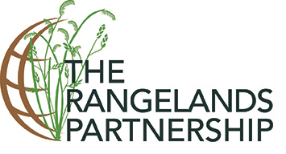

THURSDAY, May 17: Best Western Plus University Inn, Palouse Room

5:00 – 7:00pm - Welcome Reception and Mixer (Joint Reception w/ AgNIC)
John Tanaka - Welcome on behalf of WERA
Jeremy Kenyon - Welcome on behalf of University of Idaho

FRIDAY, May 18: University Library, Rm 120 (online: https://uidaho.zoom.us/j/796363229)

8:00 am RP Executive Board Greetings and Overview of Rangelands Partnership 2018 Meeting
[Jeremy Kenyon, Chair, ID]

8:10 am Introductions [Jeremy Kenyon, ID]
- Special Welcomes
- Meeting Logistics
- Attendee Icebreaker (Jeanne Pfander, AZ and Retta Bruegger, CO)

9:00 am State Updates [Jeremy Kenyon, ID – Facilitator] – Updates on last year’s activities related to rangelands research, teaching, and outreach at your institution; website updates, user statistics, and future plans (Zoom link to be provided) (~ ≤ 5-10 minutes each; continued at 10:00am)
- Alaska – Jodee Kuden
- Arizona – Sarah Noelle
- California (Humboldt State) – Susan Marshall
- Colorado – Retta Bruegger
- Hawaii – Mark Thorne
- Idaho – April Hulet
- Kansas – Livia Olsen, Walt Fick
- Nebraska – Mitch Stephenson (virt. tentative)
- Nevada – Amy Shannon
- New Mexico – Cynthia Watkins
- North Dakota – Nicole Juve
- Oklahoma – Laura Goodman (virt. tentative)
- Oregon – Yvette Gibson (virt.)
- Utah – Beth Burritt
- Texas – Carolyn Jackson
- Washington – Tip Hudson (written)
- Wyoming –David Kruger, John Tanaka, Derek Scasta (virt. tentative)

9:30 am Morning Break

10:00 am State Updates (continued, see above) - [Jeremy Kenyon, ID - Facilitator]

11:00 am Other Organizations Updates
- Sustainable Rangelands Roundtable [Kristi Maczko, WY]
- Range at a Distance [Yvette Gibson, OR (virt.)]
- Careers & Education [Susan Marshall, CA]
- Teaching Clearinghouse [Karen Hickman, OK (virt. tentative)]

12:00 pm Lunch (Integrated Research and Innovation Center Atrium)

1:15 pm Workshop: ESRI Story Maps for Communicating Science [Jeremy Kenyon and Bruce Godfrey, ID]

2:45 pm J. C. Penney: The Man, the Store, and American Agriculture [David Kruger, WY]

3:15pm Afternoon Break

3:45 pm Sustainable Working Rangelands – Management Research Partnerships to Create Usable Science [Leslie Roche, CA]

4:15 pm RREA Strategic Plan Project Results [Amber Dalke and Sheila Merrigan, AZ]

4:30pm International Range Activities/Discussion [Barb Hutchinson and Jeanne Pfander, AZ]
- International Year of Rangelands and Pastoralists
- International Land Coalition/Rangelands Initiative Global (Mark Thorne, HI)
- Other Partners International Activities

5:00 pm Logistics for Evening and Next Day [Jeremy Kenyon, ID]

Adjourn for the day

6:00–9:00 pm Dinner at the 1912 Center
Speakers: Brenda Erhardt, conservation planner, Latah Soil and Water Conservation District: “Palouse Prairie” & David Benscoter, fruit explorer: “Lost and Found: Heirloom Apple Varieties in the Inland Empire”.
Music: Karen Launchbaugh & Friends

SATURDAY, May 19: University Library, Rm 120 (online: https://uidaho.zoom.us/j/184595919)

8:30 am Welcome Back and Logistics for the Day [Jeremy Kenyon, ID]
Start times for Tuesday sessions may vary based on amount of discussion needed.

8:40 am RP Business Meeting [Tip Hudson, RP Vice Chair - Facilitator]
- Report from the Chair - [Jeremy Kenyon, ID]
- Administrative Update on WERA - [John Tanaka, WY]
- Secretary-Treasurer Report - [Retta Brueger, CO]
- Election of New Secretary-Treasurer - [Jeremy Kenyon, ID]
- Transition to 2017/2018 Executive Team - [Jeremy Kenyon, ID]
- Announcements of locations for 2019 & 2020 meeting - [Jeremy Kenyon, ID]
- Membership discussion (states in transition)
- Communication outlets (newsletter, listserv, publications, other)
- Other Business
- RSEC Update [Karen Launchbaugh, ID]

9:30 am Action Groups
- Introduction to 2017 Groups
  - Marketing and Social Media [Amber Dalke, AZ]
  - Content Development/Collection Management Policy [Nicole Juve, ND or Jodee Kuden, AK]
  - Partnership Sustainability [Barb Hutchinson, AZ]
- Art of Range [Tip Hudson, WA]
- NRCS CIG and JournalMap [Jason Karl, ID]
- Discuss the 3 action groups
  - Are these the Action Groups we need?
  - What else should the Partnership focus on?
    - Content developers listserv?
- Review ideas and determine 2018 Action Groups
- Sign up for a group

10:00 am Morning Break

10:30 am Action Group Work
- Marketing and Social Media
- Collection Management/Content Development
- Partnership Sustainability
- Others from earlier discussion

11:45 am Action Group Lightning Reports: Progress Made and Suggested Next Steps
[Tip Hudson, WA]

12:00 pm Lunch (UI Library Second Floor)
Website & Database Training (with dessert) (Sheila Merrigan, AZ - AZ Tech Team available to assist in adding records to database or updating state rangelands websites)

1:30 pm Topics Pages Work Session [Sheila Merrigan, AZ - AZ Tech Team to facilitate and assist]
    - Review of Google Analytics for specific topic pages
    - Review of past year’s work
    - Discussion of priority pages
    - Work time

2:30 pm Mission/Vision/Audience Discussion [Executive Committee]

3:00 pm Afternoon Break

3:30 pm Action Plan for 2017/2018 - [Facilitator – Tip Hudson]
- Action Groups
- Suggestions for Topics Pages and Highlighted Topics
- Ideas for the good of the Partnership

4:30 pm Closing Session / Wrap-up [Tip Hudson, 2017/2018 RP Chair]

5:00 pm Adjourn

SUNDAY, May 20:

On Sunday, May 20, the tour will include a trip to Benton Meadows, near Lewiston, Idaho. We will hear from Fish and Game Biologist Andrew Mackay, Cindy Vaughan of USDA NRCS, and others that work on the Craig Mountain Wildlife Management Area. They will discuss the history of Craig Mountain and the WMA, and we will visit two sites, an area that burned and is undergoing rehabilitation, and an area that is grazed and managed for wildlife habitat.

We will depart at 8:00am and return at about 4:00pm.

The $40/person fee includes transportation and lunch. Tour vehicles will depart hotel at 8:00am.

Questions?
Jeremy Kenyon
email: jkenyon@uidaho.edu
Cell: (812) 340-3036

Possible route from Best Western to University Library (Meeting Site)
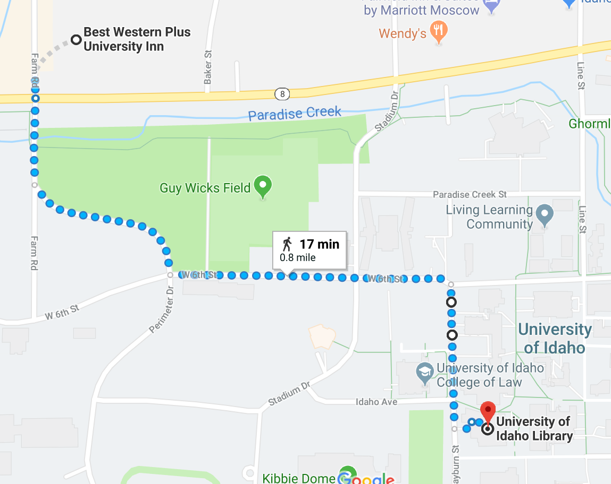

Guest Speakers’ Biographies (Dinner, May 18th):

Brenda Erhardt
Brenda is originally from Kansas, but after 18 years on the Palouse she now calls Moscow home. Brenda did her undergraduate work at the University of Kansas and received her Masters degree in Rangeland Ecology from the University of Idaho in 2007. Brenda has been working for the Latah Soil and Water Conservation District for 7 years and enjoys the diverse mix of work offered to her as well as the colleagues and landowners that she is fortunate to work with. Her projects focus on Palouse Prairie restoration, Spalding's catchfly recovery efforts, and wetland restoration for steelhead habitat.

David Benscoter
David Benscoter, a retired FBI and IRS Criminal Division agent, has ties to Pullman, having graduated from Pullman High and WSU. He became interested in apples after a Chattaroy, Washington, neighbor asked for help with the old trees on her property. Since then David has been on the lookout for apple varieties that have become extinct. His investigative nature led him to search for the origin of these heirloom trees throughout the Palouse.

Possible routes from Best Western to 1912 Center (Friday Evening Dinner Site)
(straight shot - follow Highway 8 until it becomes 3rd Street; no turning)
Walking = approx. 30 min
Driving = approx. 5 min

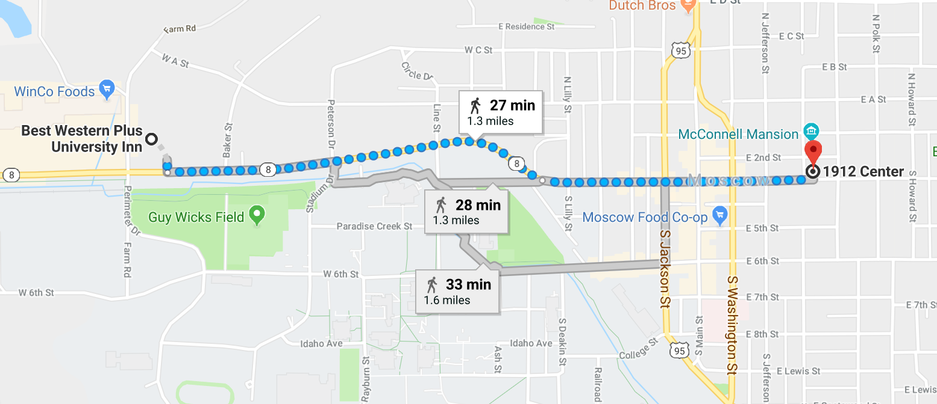

Rangelands Partnership Mission/Vision Survey
The Executive Committee has prepared a Vision Survey for the Rangelands Partnership. At the 2017 Annual Meeting, members asked the Executive Committee to review our mission, vision, audience, and by-laws. To do this, the EC needs your feedback!

https://bit.ly/2HYT8BO

