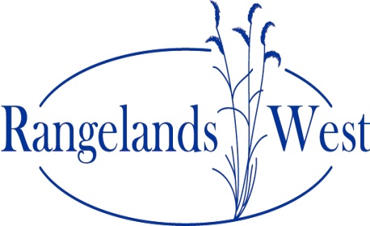
Preliminary DRAFT 2011 Annual Meeting Agenda
Western Rangelands Partnership
Montana State University – Bozeman, MT
May 22-24, 2011

SUNDAY, May 22: Best Western Gran Tree Inn (Room TBD)

6:00-8:00 pm Opening Reception: Mix, mingle and enjoy food.

MONDAY, May 23: Montana State University , Animal BioSciences Building ( ABB), Room TBD

8:30 am WRP Welcome and Overview of Rangelands West 2011 Meeting:
Amy Shannon, WRP Chair - University of Nevada - Reno

8:40 am Montana Welcome & Introductions
- Dean/Department Head welcome
- Meeting Logistics: Rachel Frost, Montana State University
- Attendee Quick Self -Introductions (~< 1 minutes each)

9:30 am SRM Conference report
- Special seminar session
- Discussions with Allen Press, Jornada LTER, and others

10:00 am Morning Break (ABB Atrium)

10:30 am Year in Review
- Project Reports:
- eXtension Rangelands update and overview
- RSIS
- HEC teaching tools project
    - Learning objects (also for Global Rangelands)
- ISE Global Rangelands
    - Overview: "new" Rangelands West/Global Rangelands sites
    - Video projects
    - Australia Rangelands video
    - Outreach for Development
    - Allen Press Journals

12:00 pm LUNCH: Montana State University (ABB Atrium)
Presentation on Gus Hormay Collection (Renne Library, Montana State University)

1:30 pm New Member Presentation(s)
- Australia
- Other - to be confirmed

2:00 pm State updates (changes to RW sites, user feedback, new content, tech support, etc.) [~10 minutes each? ~ 6/hr] – Amy Shannon, Facilitator (virtual presentations will be held during first session 2-3 pm)
-
3:00 pm Afternoon Break (ABB Atrium)

3:30 pm State Updates (continued)
- Include discussion of state site maintenance and support from AZ (template, database, etc.)

5:00 pm Adjourn for the day

6:30 pm MONDAY EVENING SUPPER: The Woodlands
Leave hotel by 6:00. The Woodlands is 10 miles south of Bozeman on Cottonwood Canyon Road.
Guest Speakers/Performers: Rick Kuntz, Cowboy Poet
Trailblazer Award

TUESDAY, May 23 Montana State University (Meeting Room ##)

8:30 am Welcome back, and logistics for the day: Rachel Frost, Montana State University

8:45 am WRP Business Meeting / Organizational Issues
- Chair and Vice Chair report
- Treasurer / SRM liaison report
- Secretary report
- Election of new secretary (rotates into Vice Chair/Chair positions, a 3 year commitment)
- Update on WERA: Colin Kaltenbach, University of Arizona
- Orientation for afternoon brainstorming session

9:45 am Morning Break

10:00 am Hands-on Workshop (& Webinar): Entering original content into the new Rangelands West database (ABB 234)

12:00 pm TUESDAY LUNCH (ABB Atrium)
Speaker: TBD

1:00/1:30 pm Brainstorming Session
Possible topics include: communications; marketing; sponsorships; member participation; new members; funding opportunities, assessment; website enhancements, etc.
- Brainstorming
- Groups form around topics and discuss brainstorm ideas
  - Review, add, summarize ideas for reporting
- Group reports

2:30 pm New proposal/project opportunities

3:00 pm Afternoon Break

3:30 pm Action Planning (turning ideas into next steps)

4:30 pm Closing Session / Wrap-up

5:00 pm Adjourn

6:00 pm TUESDAY EVENING SUPPER
Dinner on your own or as group, to be determined at meeting.

