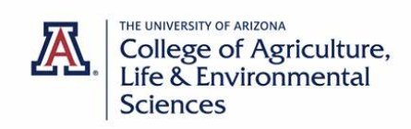


New Undergraduate Certificate:

THE sCIENCE OF cANNABIS

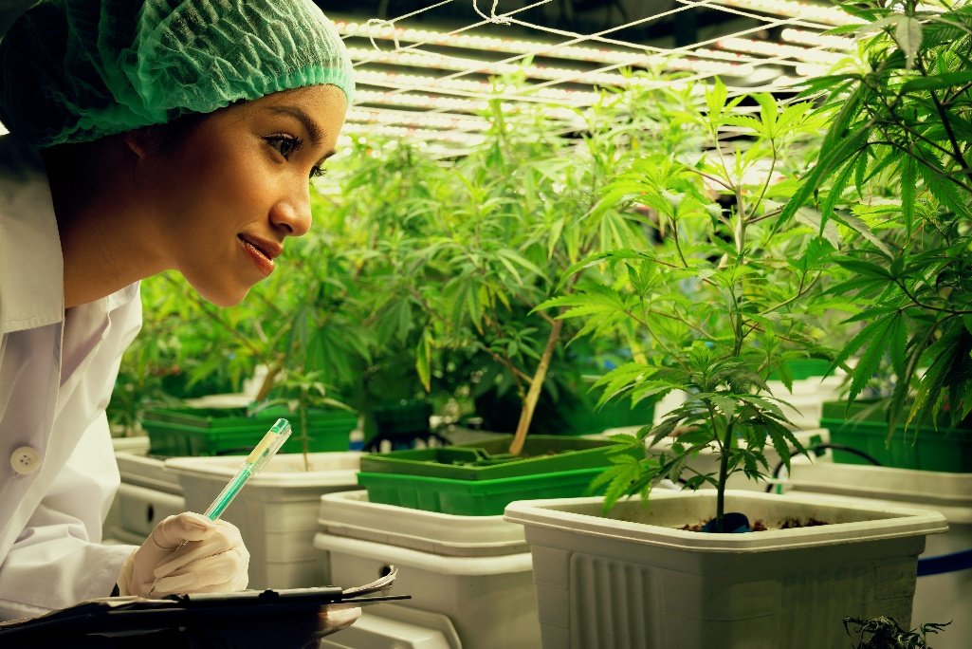
This certificate focuses on the biology, physiology and cultivation of cannabis to train students for careers in the cannabis industry

INSTRUCTORS:
- Dr. Matthew “Rex” Recsetar (lead)

- Dr. Manuel Aregullin

- Dr. Triston Hooks

- Dr. Tanya Quist

Certificate Requirements: 14 Credits
- BE 217 – Intro to Hydroponics (Fall)
- PLS 302 – The Science of Cannabis (Spring)
- PLS 475A – Applied Plant Physiology (Spring)
- BE 420 – Cultivation of Cannabis (Fall)
- + Internship/Lab (2 credits)
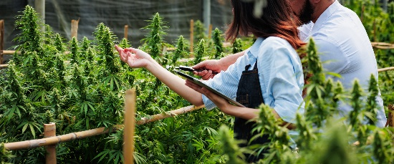

Application and certificate questions contact:
Dava Jondall,
Academic Program Manager
davaj@arizona.edu
or schedule an appointment:
https://trellis.arizona.edu/login
Through this certificate students will gain hands on experience through an internship at a local cannabis operation!

