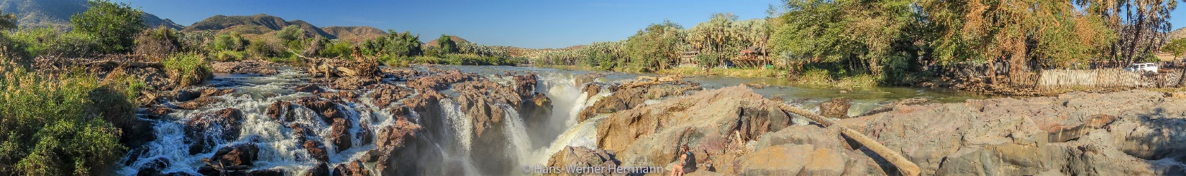
Desert Ecology and Conservation Biology in Namibia, Africa
13 May to 03 July 2024, running since 2008

RNR 495F/595F | UA Faculty-led | Summer | 6 Units, Minimum GPA: 2.5
Application deadline for the 2024 program: February 25, 2024
Spend your summer break exploring the African savanna with the unique megafauna and inspiring people while earning six UA credits. You will stay in roof tents on 4x4 vehicles at well-equipped campsites and learn about biodiversity and conservation research. Meet the people and understand human-wildlife-challenges.
RNR 495F/595F: Desert Ecology and Conservation Biology in Namibia, Africa https://international.arizona.edu/study-abroad/program/desert-ecology-and-conservation-biology
Follow us on FACEBOOK Study Abroad: Namibia and INSTAGRAM studyabroad_biodiversity.
Watch a short video introduction the program on Facebook: https://www.facebook.com/beardownabroad/videos/1595134250544796
Here you can find some photos from previous years: https://photos.app.goo.gl/ZYQfSznHLu68SxsP7 and https://photos.app.goo.gl/qDWS2YNqsG3h2LW39

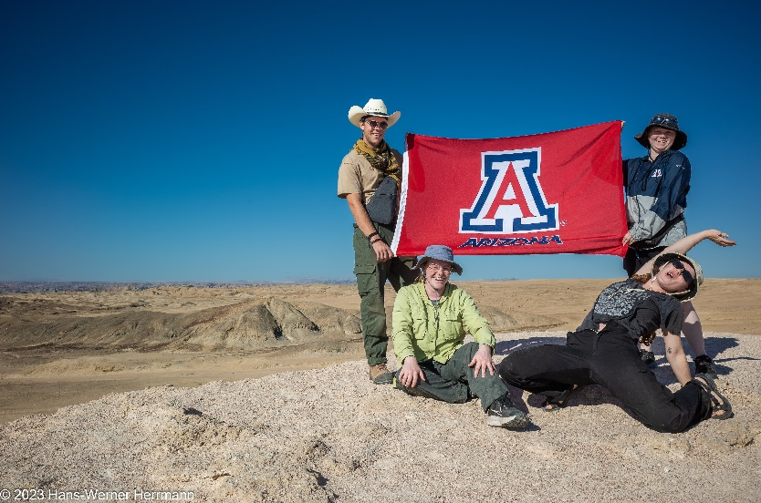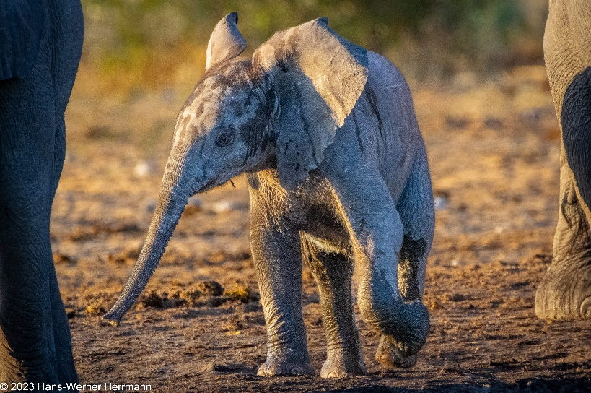
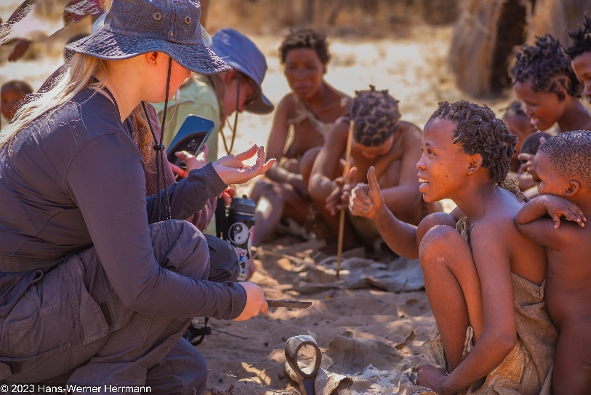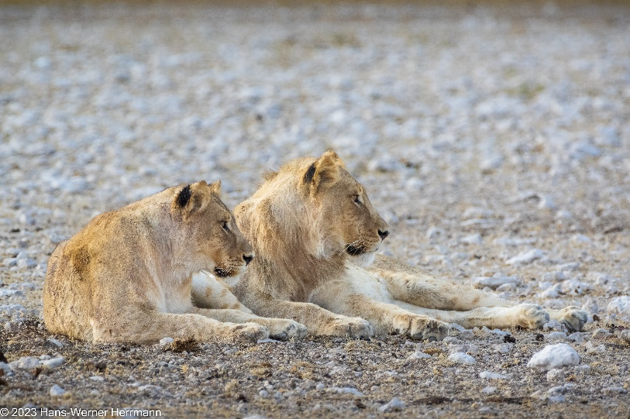

The program credit can be applied towards the UA International Environmental Conservation Undergraduate Certificate ( https://nature.arizona.edu/undergraduate/international-environmental-conservation )
This UA certificate program allows you to develop international experience in field settings related to conservation biology and environmental conservation and can be added to your transcripts and resume. It emphasizes:
--Cultural immersion --Experiential learning --Student engagement outside of the classroom --Field experiences in remote international settings --Hands-on learning while participating in international conservation
It requires 12 units of coursework that can also be used to satisfy Major or Minor requirements, including participation in one or more of our Study Abroad classes, and 3 – 6 units of course work related to environmental science and natural resources.
The program also counts towards the Department of Ecology and Evolutionary Biology (EEB) field school requirements.
For more information contact:
Dr. Hans-Werner Herrmann
School of Natural Resources and the Environment
University of Arizona
hwh@arizona.edu
(520)780-1440

