Summer Internship/Scholarship at PPP/Native Plant Nursery
Tucson Cactus and Succulent Society
Proposal (seeking TCSS Board Approval for summer 2021)
Funding to be from Educational Outreach to the Institution of Student Choice

Pima County Native Plant Nursery
5845 N. Camino de la Tierra
Tucson AZ

TCSS would like to encourage young people by providing hands-on experience at PPP/Native Plant Nursery that would impact and leave them with lasting effects and knowledge on our Sonoran Desert Plants. TCSS would in exchange provide scholarship funds to the educational institution supporting the student’s education.

Students will establish flexible hours of 20 hours/week for 8 weeks over the summer season. TCSS will pay the accredited educational institution $2000. PCNPN is open from 6 am until 2:30 pm Monday through Friday. Funding to be from Educational Outreach in coordination with the TCSS Treasurer.

Students eligible for this Scholarship to be ages 16 through college age. Funds will be provided to the educational institution of the student’s choice. The student must be enrolled in school in the fall or spring semesters following the summer internship.

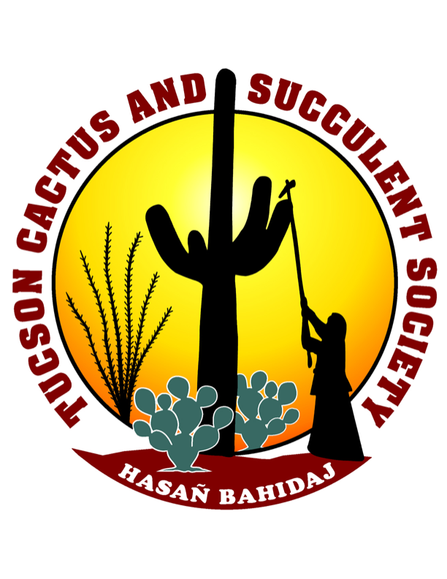
Amy Belk, manager of the Pima County Native Plant Nursery will supervise the student. Amy and other NPN professional staff will provide “real world” experiences to support conservation and horticultural education. With the interactions and feedback, the student will experience problem solving in a professional nursery.

The selected student will maintain a log of hours, a daily log of activities and will submit and present a one-page report related to the experience to the TCSS Board of Directors at the end of the assignment. The student will be required to sign a liability waiver. If the student is under the age of 18, a parent or guardian must also sign the liability waiver.

Amy Belk will provide this flier/application to a variety of sources and will be available to answer any questions to applicants. The flier/applications will be made available through TCSS newsletter, posted on Pima County Parks and Recreation, PCPR Facebook, and with local educational institutions.

The benefits to TCSS include student education with the expertise of the Pima County Native Plant Nursery team, real world experiences with Sonoran Desert plants and conservation efforts, along with a range of experiences with Pima Prickly Park and the Tucson Cactus and Succulent Society.

Summer Internship/Scholarship at PPP/Native Plant Nursery APPLICATION
Name ________________________________________________
Address ____________________________________ City _______________ Zip code ____________
Phone ________________________________ Email _______________________________________

Application to be limited to one page. The applicant will submit background experience and his/her interest in this position. A visit to the Pima County Native Plant Nursery in advance is acceptable and encouraged. Applications must be submitted to Amy Belk (Amy.Belk@pima.gov) by May 1, 2021 to be considered for this internship.

