Ecology of Water Harvesting

Fall 2019 | RNR 496B-002 | RNR 696A-004 | 1(+) credits

Thursdays 9:00-09:50 am
First meeting 9:00am, August 29, 2019 in ENR2 N350

Laura Meredith, School of Natural Resources and the Environment (laurameredith@email.arizona.edu)

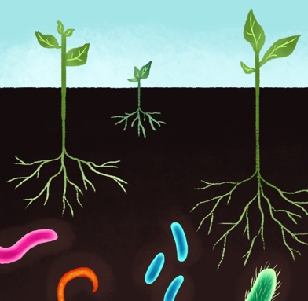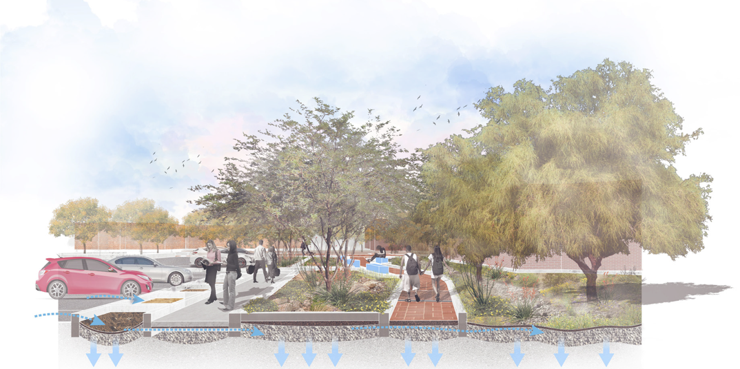
Green infrastructure
Soil microbial ecology

How do rainwater harvesting landscape designs affect urban ecology?

To find out, join us in this new collaborative and hands-on course and study the soil ecology of iconic rainwater harvesting buildings on campus.
Working with landscape design students (LAR 612, Design Studio V, Prof. Bo Yang), students enrolled in this course will develop an experimental design to evaluate intersections between landscape design and ecology. They will gain hands-on experience collecting, processing, and analyzing environmental data. This year, specific questions will include impacts of design on the microbial communities, diversity, and health of soils. Ecological and design dimensions will be compared against social dimensions including social experience, attention-restoration effects, and human well-being.

Grassroots Teaching Initiative integrating concepts from landscape design and ecology to put science to work and provide evidence-based design for the built environment. Results to be incorporated into the national EPA RainWorks Challenge Design Competition. Students from all disciplines welcome! Max enrollment: 10 students.

Supported by College of Architecture, Planning & Landscape Architecture
Teaching Innovation Grant

