Complete your Engineering Requirement for BE 221

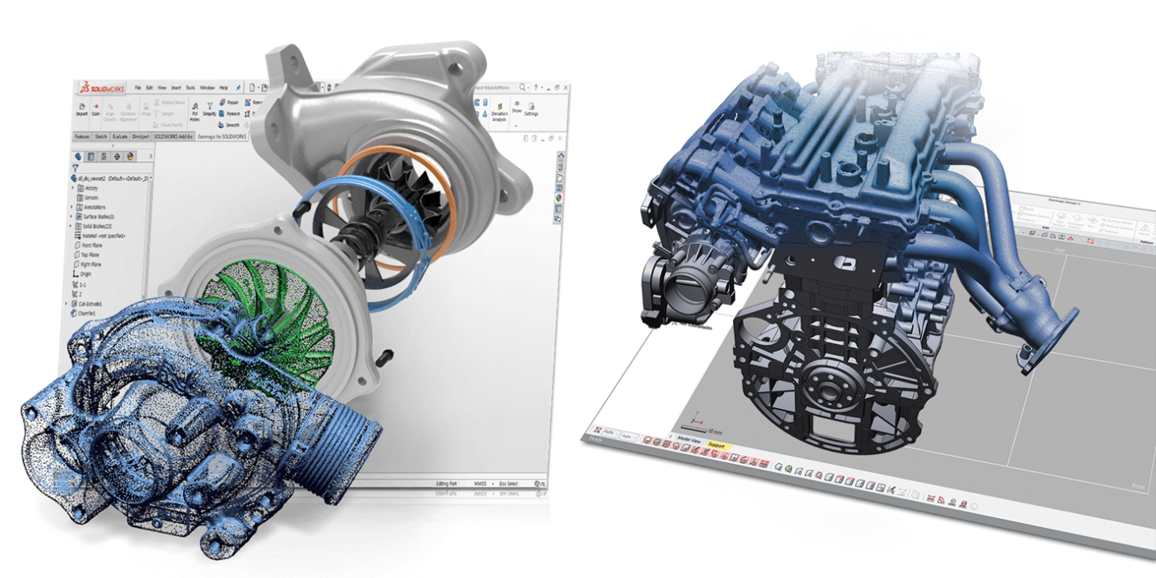

BE 221 Introduction to Computer Aided Design

Get 3 units while learning and developing skills on Computer Aided Design with SolidWorks

The course is a Hybrid course the lecture is taught online, with open optional lab times. Students may attend any of or all of the scheduled lab times in one of two ways:

- In person, in Shantz 338, Monday through Friday,
- Online via “d2l/zoom”, during lab sessions or make arrangements with instructor

We want to see students succeed in the class: Students should use their Lab times to do homework, get questions answered, and/or take required exams.

The following topics will be covered:

- Sketch Entities and Tools
Creating 2D sketches, Using the sketch tools, Creating complex shapes by combining individual sketch tools

- Features
Feature tools, Drawing 3D objects, Using features to create objects.

- Orthographic Views
Use two-dimensional views to define a three-dimensional model, ANSI standards and conventions, Drawing section and auxiliary views.

- Assemblies
Creating assembly drawings, Create an exploded assembly drawings, creating a part list, Animation of assembly, and Edit title block. Using mates to assemble multiple parts.

- Using the design library Tools: Threads, Fasteners and Gears
Thread terminology and conventions, Draw threads, Size both internal and external threads, Use standard-size threads, Use and size washers, nuts, and screws. Concept of power transmission, Fundamentals of gears, Drawing and animating gears

- Dimensioning
Dimensioning objects, ANSI standards and conventions, Dimensioning different shapes and features, and Fundamentals of 3D dimensioning

- 3D Printing
Developing a model for printing, Converting file format, Use the driver software, Filament types and use, Issues with 3D printing.
