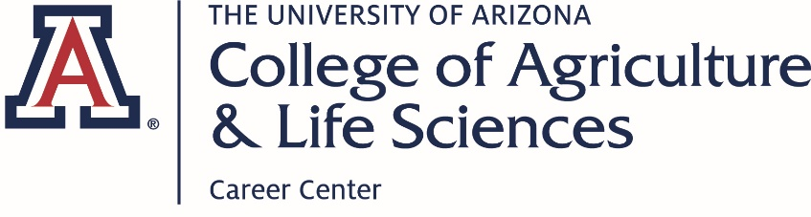

Student Guide to
Preparing for Career Fairs

Table of Contents
Career Fair Preparation Checklist 3
Resume Tips 4
Fall 2018 CALS Career Fair Employers 5
Prepare Your Elevator Pitch 7
Dress for Success 8
Career Fair Follow-Up 9

Career Fair Preparation Checklist
- Prepare your ONE page resume and print at least 10 copies. (The CALS Career Center staff are happy to help review your resume)

  - Know your goals for the fair
  - Learn about possible careers.
  - Meet recruiters in your field of interest.
  - Find an internship opportunity.
  - Find a job for after graduation.

- Research who will be at the career fair.

- Look for potential open positions with the organizations that are of interest.

- Prepare your elevator pitch.

- Dress for success

- Have a positive attitude

- Be confident

- Follow-up after

Resume Tips
- Let them know who you are (list your first and last name), and how to get ahold of you (minimum phone number and professional email address; optional contact information includes LinkedIn URL and Street Address).

- List your education first
University of Arizona, Tucson, AZ Expected Graduation (Month) (Year)
Bachelor of Science in (Major Name) with an emphasis in (Emphasis Area)
Minor (Subject)
- Show your relevant experience
Employer Name, City, State
Position Held, (Month/Year)-(Month/Year)
- List unique duties, skills, and accomplishments as bullet points
- Each bullet should be written in 3rd person, past tense (yes even for your current position), and active voice
- Whenever possible utilize numbers to demonstrate tangible results from your work

- Showcase involvement, awards, and certifications
- Involvement: list the full name of the organization, your role within the group, and unique responsibilities or roles.
- Awards received, list criteria for selection
- Certifications list the type of certification and when it expires

- Keep in mind you won’t be in the room to explain what the information on your resume means. Be clear but be concise in your descriptions.

- Avoid the temptation of templates. They are helpful at times to get started but templates online and built into software can often encourage space to be used poorly and information to be place in non-standard locations.

- Check and recheck. Sometimes spellcheck and grammar check can miss items so have a friend, roommate, or professional look over your resume.

- Keep it to one page. Remember your resume is an advertisement for your skills and abilities for an employer to consider. You have less than 10 seconds to make a positive first impression through your resume.

- Items to leave off of your resume: References or “References Available Upon Request,” Objective (they are usually too vague to add value), Photos (Save your photo for LinkedIn, in the U.S. photos are not acceptable on resumes)

Fall 2018 CALS Career Fair Employers
Table # | Employer Name | Industry | Internships?
1 | Enterprise Holdings | Travel/Leisure | Yes
2 | Elanco | Animal Healthcare | Yes
3 | Project CENTRL | Leadership | No
4 | 5 Rivers Cattle Feeding | Livestock Production | Yes
5 | AXA Advisors | Financial Services | Yes
6 | Shamrock Food Company | Food Service Distribution | Yes
7 | Rillito Park Foundation | Non-profit/Horse Racing | Yes
8 | US Fish and Wildlife Service | Government Agency | No
9 | USDA APHIS PPQ | Government Agency | Yes
10 | RDO Equipment/ RDO Water | Equipment Sales and Service | Yes
11 | Vanguard | Financial Services | Yes
12 | Bayer Crop Science | Plant Products | Yes
13 | Accelerate Diagnostics | Medical Diagnostics | No
14 | JV Smith Farms | Vegetable Production
15 | Barkley Ag Enterprises | Vegetable Production
16 | Stantec Inc. | Water/Design Consulting | Yes
17 | Riverview LLP/ Coronado Dairy | Dairy Production | Yes
18 | Merck Animal Health | Animal Health | Yes

Prepare Your Elevator Pitch

An elevator pitch is one of the most useful skills you can develop for attending a career fair. It allows you to quickly and precisely introduce yourself while letting the recruiter know what your goals are for the conversation. How do you put together an excellent elevator pitch?
- First, you have to define your objective for the interaction. Know why you are introducing yourself to them before you even approach the recruiter. Are you looking for an internship? Are you hoping to be hired full-time after graduation? Etc.

- Second, tell them who you are. Start your elevator pitch off by telling them your name (first AND last name). Then let them know where you are in your academic career (freshman, sophomore, junior, senior, graduate student). Finally, what you are studying.

- Third, let the recruiter know what your career goals are. Letting them know what profession you would like to pursue will set the stage for the rest of the conversation and hopefully clarify what your objective is to the recruiter.

- Fourth, inform the recruiter what activities you are involved in outside of the classroom. One of the most commonly asked questions by recruiters is “What are you doing other than being a student?” Are you involved in clubs? Leadership programs? Internships?

- Last, state where you want the conversation to go next. “I would like to know more about the internships you have to offer” or “Can you tell me more about your entry level positions” or…. Well, there are many variations on the first two examples.

- Bonus tip, practice your elevator pitch, know what you want to say, but don’t sound rehearsed. Showing you are genuine and a real person rather than a stiff programmed cyborg will help recruiters connect with you.

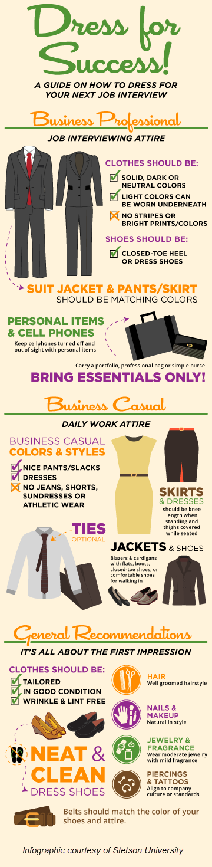
Dress for Success

Career Fair Follow-Up

Following up after the career fair is just as important as attending. Once you make a connection with a recruiter or hiring manager the responsibility to follow-up and maintain the connection begins with you, the student. How do you maintain the relationship and build your professional network?
- Send an email, it can be as simple as sending an email letting the recruiter know you enjoyed talking to them. Remember to mention one or two key things you talked about so they remember who you are, career fairs mean meeting dozens or even hundreds of students. Follow-up emails are a chance to remind them who you are.

- Connect on LinkedIn. Almost every sector of the economy has a presence on LinkedIn. It is a quick and easy way to connect with colleagues and recruiters in a professional format. When adding professionals as a connection write a quick note to personalize the request. Avoid using the basic pre-written message!

- What if you forget to follow-up for a couple of weeks? Still send the message and remind them where you met and what you talked about. It is understandable; sometimes you aren’t going to be able to follow-up right away, but if you want to develop a rapport and show that you are a serious candidate a follow-up connection is key.

