Bridgestone Americas, Inc.
4140 West Harmon Road
Eloy, Arizona 85131
Phone: (520) 494-3682
Fax: (520) 494-3688

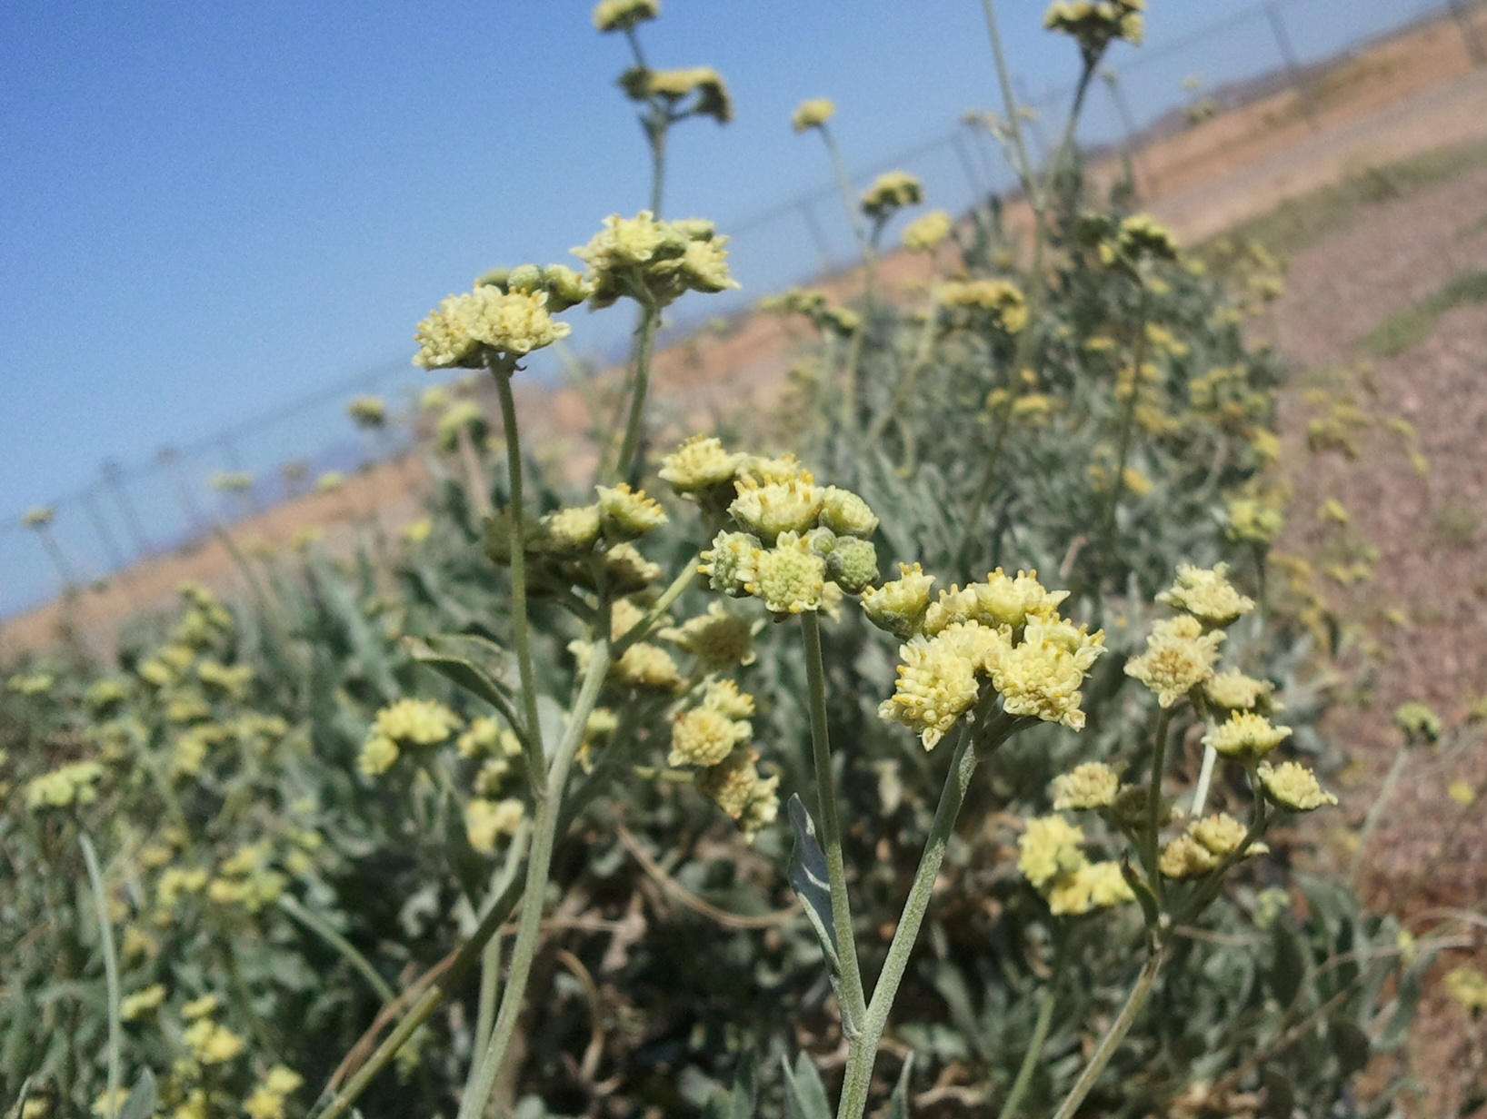 | Now Hiring:  Breeder–Agronomist Assistant (Scientist I)  Location: Eloy AZ 85131  Send Résumes or questions to:  Lori Sullivan  Human Resources Coordinator  Bridgestone Americas, Inc.  sullivanlori@bfusa.com

Objective

Bridgestone has a research program to commercialize guayule as an alternative source of natural rubber for tires. This position will support the breeding and agronomics. Specific experience / interests include crop research and production, and data management experience using MySQL or Access. Ability to adapt new and existing data capture technologies to local research needs.

Responsibilities

-Assist with plant breeding database management.

-Establishment and maintenance of field sites.

-Plant sampling and field measurements.

-Harvest and processing of field collections.

Project Summary

Guayule is a desert perennial shrub native to Southwest USA and Northern Mexico. The plant reproduces predominately by apomixes but some types have normal sexual reproduction. Our breeding and agronomic management is geared toward lowering the costs of production and increasing the rubber yield. Our research farm includes laboratory, greenhouses, and production fields. We have other production fields and experimental sites throughout Arizona.

