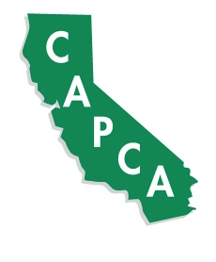
CAPCA DESERT VALLEYS CHAPTER
SCHOLARSHIP INFORMATION

Each year the Desert Valleys Chapter of the California Agriculture Pest Control Advisors Association (CAPCA) awards two scholarships to deserving students who reside in the desert areas of Southern California and/or Western Arizona. The Desert Valleys Chapter includes members from Coachella, Imperial, Bard and Blythe Valleys of California, as well as the Yuma, Gila, Dome, Wellton-Mohawk and Parker Valleys of Arizona.

One $2,000 scholarship is specifically for a graduating senior high school student and who has an interest in the field of agriculture including agronomy, entomology, soils, or related fields with the objective of a career in pest management, agronomy, plant breeding or farming.

One $2,000 scholarship is specifically for a college student who has an interest in the field of agriculture including agronomy, entomology, soils, or related fields with the objective of a career in pest management, agronomy, plant breeding or farming.

Your application must be filled out and postmarked by May 1st, 2015. Complete the application in full, attach your transcripts and mail to:

Desert Valleys Chapter CAPCA
C/O Chris Denning
1909 S. 37th Ave
Yuma, AZ 85364

For general information please contact:
Chris Denning 928-366-0182 cdenning@gowanco.com

Regional Contact Information
El Centro, Imperial, Calexico | Frank Miranda | 760-457-5758 | fmiranda@rockwoodchemical.com
Holtville | Pedro Velasquez | 760-272-6448 | velasquezagriculture@yahoo.com
Brawley, Calipatria | Bryce Smith | 760-550-4307 | smithbm@helenachemical.com
Coachella | Sergio Ocampo | 760-427-2311 | sergio.ocampo@cpsagu.com
Blythe | Rich Wellman | 760-835-2561 | cropcare@aol.com
Yuma, Gila, Dome, Wellton-Mohawk, Bard | Chris Denning | 928-366-0182 | cdenning@gowanco.com
Parker | Brad Griffin | 928-923-9606 | bgriffin@wilburellis.com

