
  
  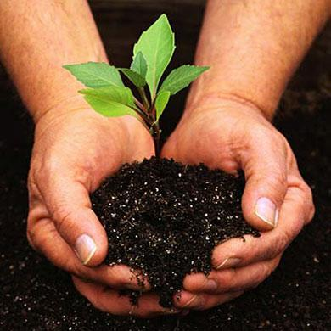
  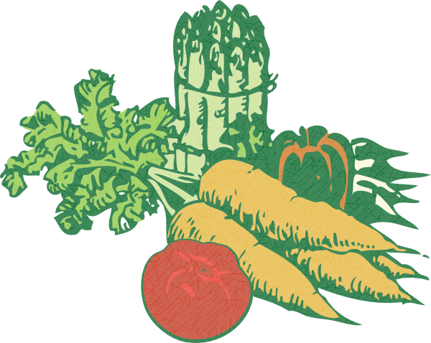
  february 25th
  first garden Club meeting!
  Are you interested in sustainable urban agriculture, water harvesting, and soils? If so, come down to the first UA Garden Club meeting! Help us build this club as we host workshops, lectures, and work days for students and the community. We will strive to be a warm, welcoming space for people who love and/or want to learn more about gardening!
  5-6 PM
  Cesar Chavez rm. 400
  We will hold workshops, lectures, and work days at the UA Community Garden to teach and learn more about urban agriculture.
  The garden is located on Highland and Mabel (right behind the Highland Parking Garage)
  There will be COOKIES!
  Everyone is welcome!

