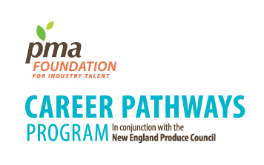
Sponsored by:

PMA Foundation Career Pathways
in conjunction with the
PMA Tech Knowledge
2015 Schedule

Monday, May 11, 2015
By X:XX pm Students and Faculty arrival in Monterey, CA Portola Plaza Hotel
12:00 p.m. – 1:00 p.m. Lunch/Ice Breaker
1:00 p.m. – 2:00 p.m. Student Orientation
2:00 p.m. – 3:15 p.m. Industry Overview –
A “30,000 ft. view” of the Produce Industry

3:15 p.m. – 4:45 p.m. Jump Start Your Career Path Panel

4:45 p.m. – 5:15 p.m. Meet your Career Ambassador

5:15 p.m. – 6:00 p.m. Tech Knowledge Reception Learning Lounge

6:15 p.m. Informal Dinner and Networking
(Students, Faculty, Staff)

Tuesday, May 12, 2015
7:45 a.m. – 8:30 a.m. Tech Knowledge Breakfast
8:30 a.m. – 9:45 a.m. General Session
9:55 a.m. – 10:55 a.m. Concurrent Break Out Session 1
10:55 a.m. – 11:25 a.m. Refreshment Break/Learning Lounge
11:25 a.m. – 12:25 p.m. Concurrent Break Out Session 2
12:25 p.m. – 2:00 p.m. Lunch/Learning Lounge
2:00 p.m. – 3:30 p.m. Young Professionals: A Glimpse from the Inside
3:30 – 5:30 p.m. Shark Tank
5:30 – 7:00 p.m. Reception

Wednesday, May 13, 2015
7:45 a.m. – 8:30 a.m. Networking Breakfast
8:30 a.m. – 9:30 a.m. Concurrent Break Out Session 3

9:30 a.m. – 10:45 a.m. General Session
10:45 a.m. – 11:15 a.m. Refreshment Break/Learning Lounge
11:15 a.m. – 12:00 p.m. Tech Knowledge Wrap-up/Year Ahead
12:00 p.m. – 1:00 p.m. Career Pathways – Wrap Up and Adjourn

