Horticulture Internship

Located in Cheyenne Wyoming, Cheyenne Botanic Garden is Wyoming’s only public garden. Interns participate in a variety of learning activities in the botanic and children’s gardens including: horticulture, education, volunteer management, landscape design, pest management, greenhouse production, and conservatory gardening. This season, interns will also be exposed to the construction process as Cheyenne Botanic Gardens will break ground on a new conservatory in April 2015. Internship will run for 12 weeks from May to August.

Position Summary: Working under the supervision of staff, interns will be expected to:
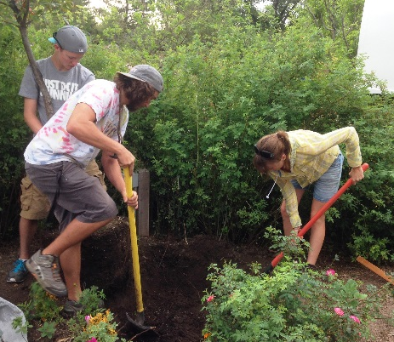
- Design, prepare, plant, and maintain annual and perennial beds on and off-site
- Develop educational materials
- Assist with events
- Maintain plant records
- Manage volunteers

Qualifications
- Currently in or recently completed Bachelor’s or Master’s program in or related to horticulture, or public gardens.
- Capable of kneeling, standing, and bending for extended periods of time
- Capable of lifting 50lbs unassisted
- Must have valid driver’s license with good driving record
- Must be able to work with people from all backgrounds, and abilities.

Please visit our website for more information
http://www.botanic.org/about-us-mission-statistics/internshipsemployment/

Contact: Allie Byrd Skaer, Assistant Director, allie@botanic.org, 307.631.656

