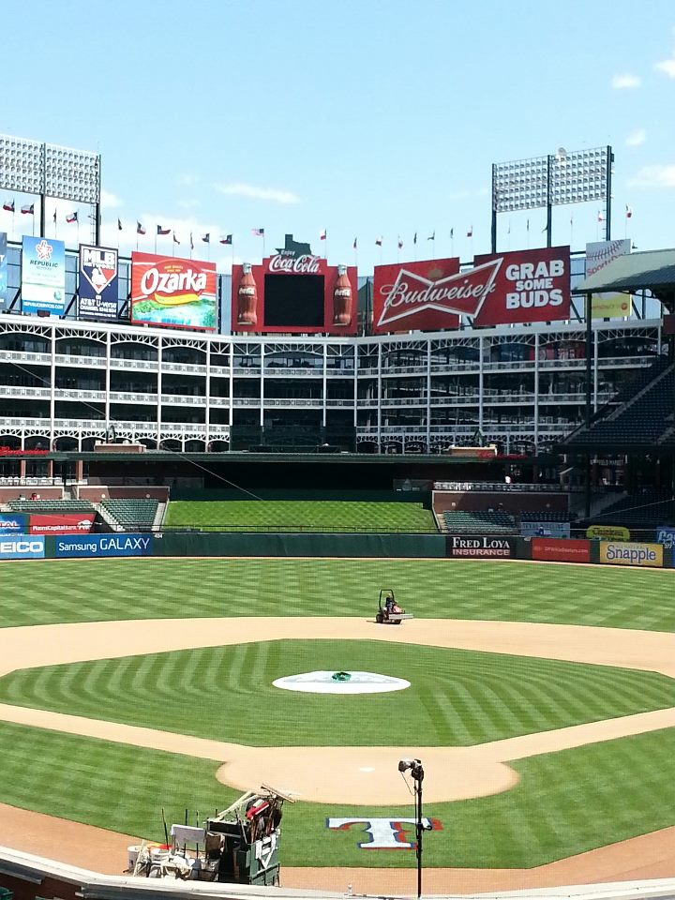
Rangers Ballpark in Arlington
Sports Turf Management Internship – 2015 Season
Job Description:
The Texas Rangers are seeking two (2) highly motivated individuals for the 2015 season. Applicants are encouraged to have a turf background and be currently enrolled in a 2 or 4-year university turf program. Applicants should be able to work well with others in an environment which may include long hours and possible stressful situations. Applicants must be able to lift 50 lbs. This is a seasonal position lasting from March 1st through November 1st. College students graduating in May are encouraged to apply as well. Starting and finishing dates are flexible based on availability.

Duties for this position include, but are not limited to: mowing, edging, resodding, mound and home plate repair, infield surface maintenance, application of fertilizers, batting practice setup and break down, basic equipment maintenance, irrigation repair, and management of cultural practices. Applicants will work home games, as well as special events held on the playing surface. These special events may include commercial shoots, youth camps, corporate field days, and high school baseball games. These positions will provide an excellent opportunity to gain hands on experience for young professionals interested in advancing in the sports turf industry.

Compensation:
These two positions are paid hourly with time and a half paid after 40 hours. Interns will be paid $8.50/hour and are expected to work 40 hours/week, with an additional 10 hours/week of overtime. Additional employment perks available.
Contact Information:
All interested candidates please mail in résumé and cover letter by December 15th, 2014.

Stephen Lord – Assistant Director of MLB Grounds
Texas Rangers Baseball
1000 Ballpark Way
Suite #400
Arlington, TX 76011
Work Phone - (817) 273-5054
Fax - (817) 273-5157

