Fulfill your Tier 2 Arts Requirement ONLINE during Winter Session! December 22- January 13

ARH 201: Survey of Western Art I:
Ancient through Medieval

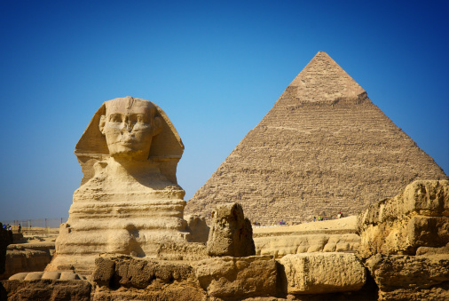

ARH 201 provides an ONLINE overview of the art and architecture of western civilization from the Ancient through the Medieval periods.

Professor J.-A. Plax jplax@email.arizona.edu

