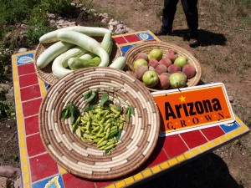
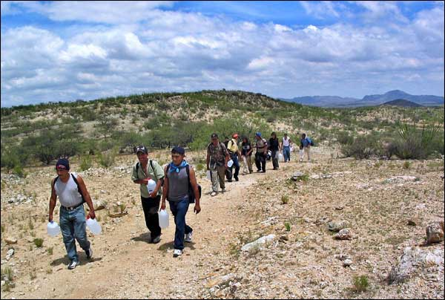
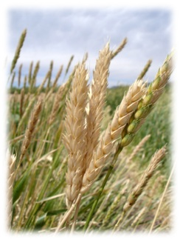
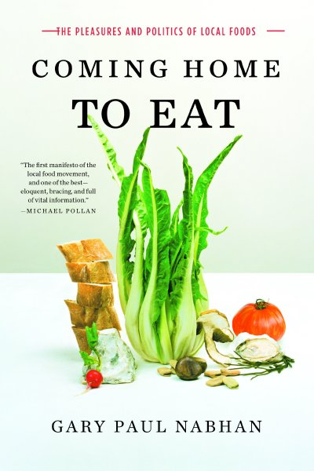
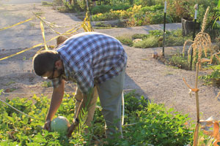
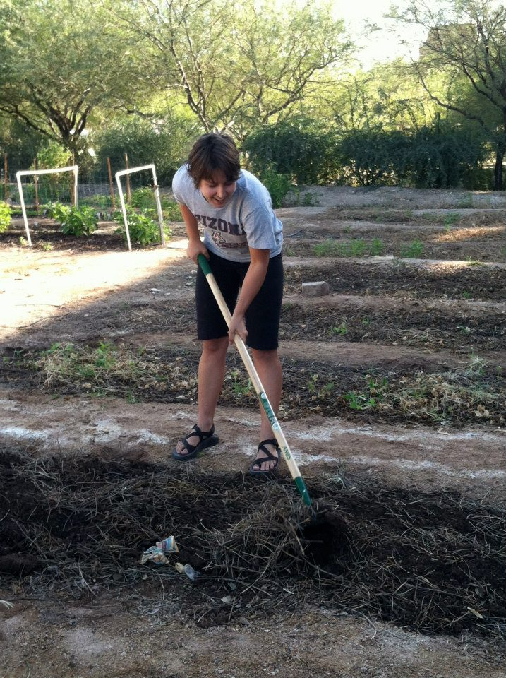
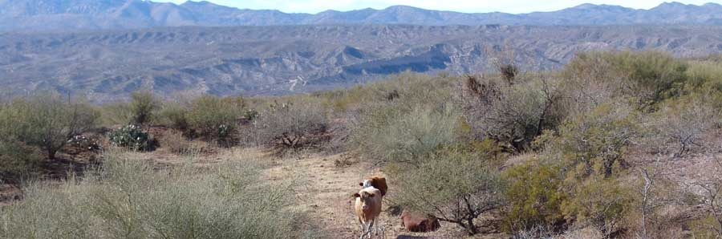
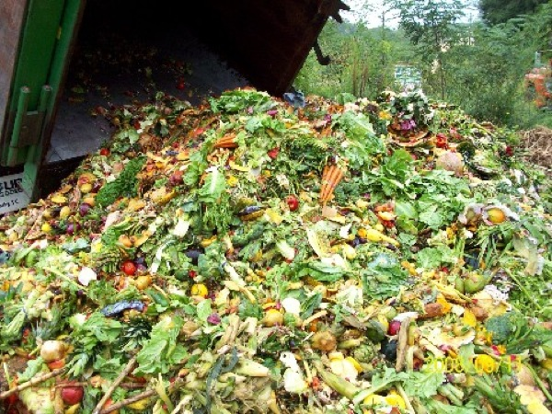
Spring 2013

MW 2-3:15
Instructors: Gary Paul Nabhan & Chester F. Phillips

By eating we vote for what kind of food system we want to live within. In southern Arizona, thousands of pounds of food cross the Mexican border on a daily basis, yet many people lack access to healthy food. Obesity and diabetes rates are among the highest on the continent, urban sprawl drives local farmers and ranchers under, and poverty impacts many in both urban and rural communities. Rising costs, declining land health, and shifting climate patterns threaten the security of our global systems of production.

Yet both locally and across the nation, farmers, ranchers, gardeners, and food activists are working toward more sustainable models of food production and distribution. This course encourages students to critically examine regional food systems to understand where our food comes from now and what might be done to improve the ecological sustainability and security of local food systems and make healthy food accessible to all.
To register: email Chester Phillips: cfp@email.arizona 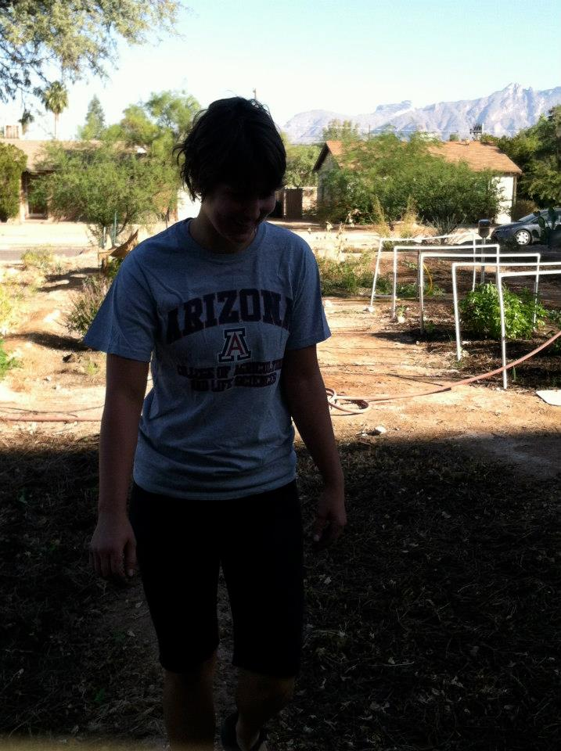.edu

