New Course for Fall 2011!
NROS 310: Molecular and Cellular Biology of Neurons
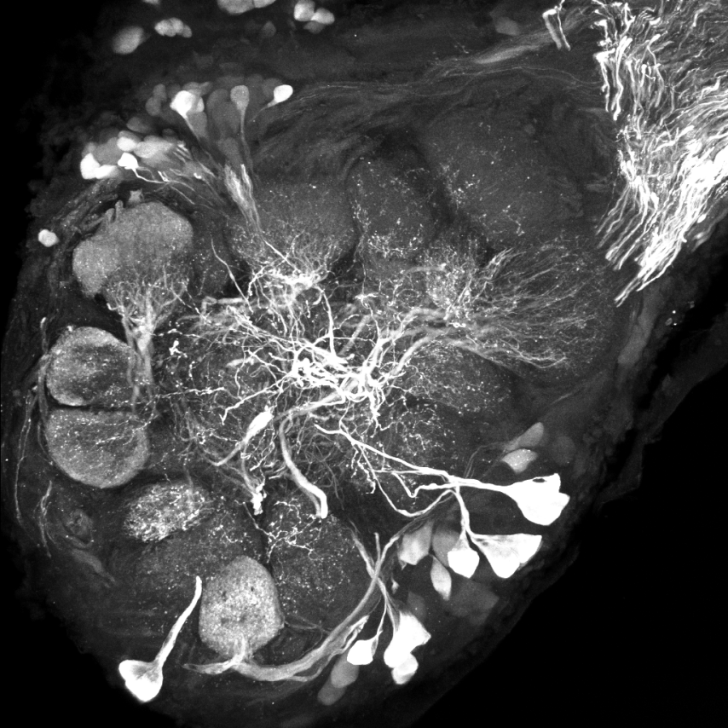
This course condenses the main concepts of molecular genetics and cell biology in one three credit course using neurons as example cells.
Course Objectives: This course is designed to provide students with an understanding of molecular and cellular functions and structures. Emphasis will be on how macromolecules assemble and cooperate to carry out common cellular processes including molecular genetics, movement, signal transduction, organelle assembly, and cell division. The course will include a focus on the use and interpretation of experimental data using neurons as model cells.
Expected learning Outcomes:
At the completion of this course students will understand:

- The basics of genetics and heredity
- Regulation of transcription and translation
- Dynamic functions of membrane
- Regulation of the targeting of macromolecules within cells
- The structure and regulation of the cytoskeleton
- Regulation of cell division
- Cell signaling and signal transduction

Instructor: Dr. Alan J. Nighorn, Neuroscience
Lecture: MWF, 3:00-3:50, Chavez 110
Prerequisites: MCB 181/ECOL 182 and CHEM 151/152

