March 28th -April 1st
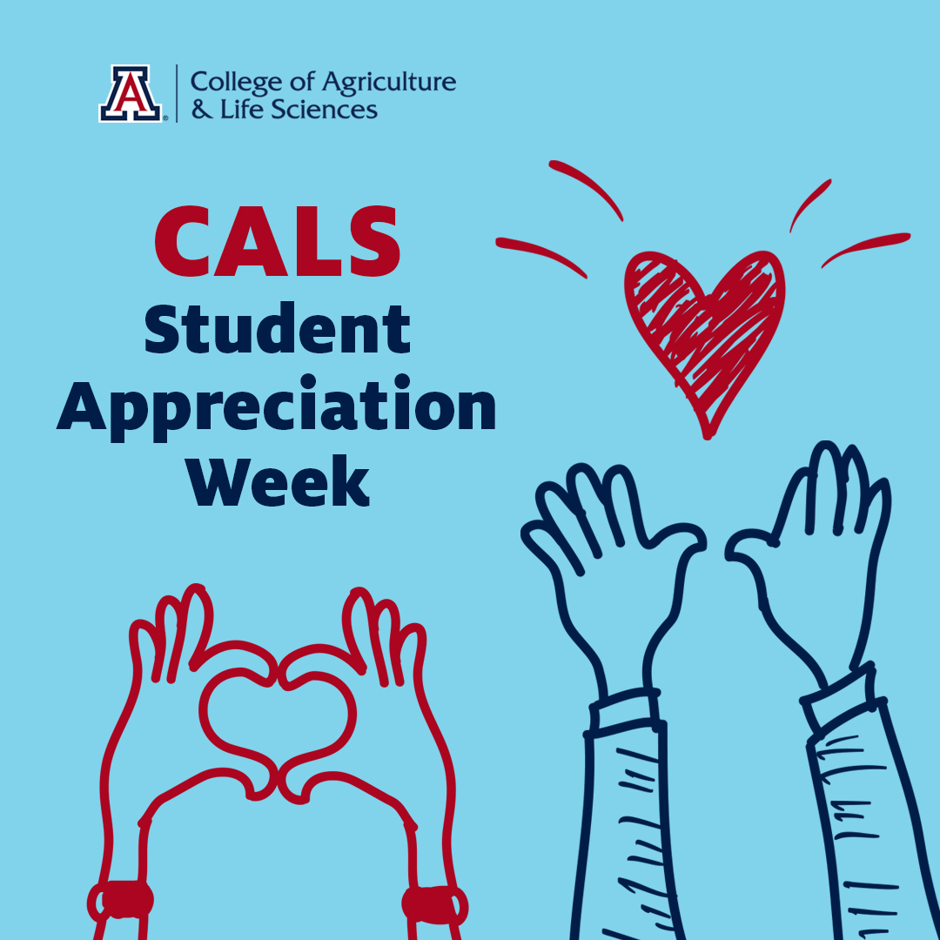
Please visit the following link for more details:
https://cals.arizona.edu/calendar/month

