

THE UNIVERSITY OF ARIZONA

School of Natural Resources

and the Environment

Spring 2021 Seminar Series: Indigenous Knowledge and Tribal Natural Resource Management

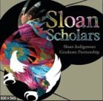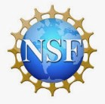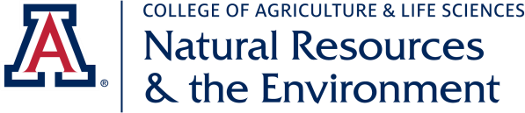

The School of Natural Resources and the Environment

1064 E. Lowell St. ENR 2 Ph.: (520) 621-7255

| Fax (520) 621-8801 [www.snre.arizona.edu](http://www.snre.arizona.edu/)

SPONSORED BY UARIZONA- SLOAN INDIGENOUS GRADUATE PARTNERSHIP

& INDIGENOUS FOOD, ENERGY, WATER, SECURITY AND SOVEREIGNTY-KARLETTA CHIEF, PI

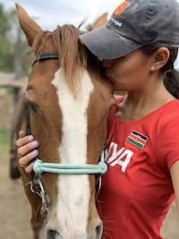Animals, Lands & More than Human Agency in Natural Resource Management

SPEAKER: Kelsey Dayle John

DATE: Wednesday, February 10th

TIME: 3:00-4:00 pm

LOCATION: https://arizona.zoom.us/j/355039068

BIO: Kelsey Dayle John is an assistant professor with a joint

appointment in American Indian Studies and Gender and

Women’s Studies. Her work is centered on animal relationalities, particularly horse/human relationships as ways of knowing,

healing, and decolonizing education. Alongside her work in

Indigenous animal studies, Kelsey’s research interests also include: Indigenous feminisms, decolonizing methodologies, and Tribal College and Universities. She finds her theoretical locations within transnational feminism, Indigenous studies, settler colonial studies, Dine’ Studies, and foundations of education.

Previously, Kelsey taught in the Dine’ Studies department at Navajo Technical University on Navajo Nation. For her dissertation research, she worked in partnership with the Navajo

Nation community to think about how horse knowledges and relationalities can help improve tribal university research and outreach. As a Ph.D. student, she was a National Science Foundation Graduate Research Fellow and a National Academy of Education/Spencer Foundation Dissertation Fellow. Kelsey’s work in her community consists of organizing an

annual Horse Conference as a space to promote dialogue about the sacredness of horses and to connect tribal universities with the community.

