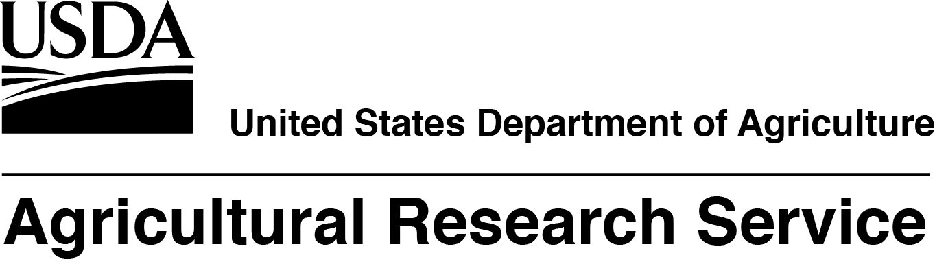

The USDA, Agricultural Research Service, Beltsville Agricultural Research Center, Molecular Plant Pathology Laboratory in Beltsville, MD, is seeking a full time, permanent, Research Plant Pathologist. The salary for this position is at the GS-13 level, $96,970 - $126,062 per year. The incumbent will be responsible for leading research addressing new and emerging plant diseases caused by cell wallless bacteria including phytoplasmas and spiroplasmas, unique pathogens that cause crop diseases affecting commodities and trade worldwide. Research objectives/duties include: developing biomarkers of pathogens and pathogen-host interactions in plant diseases caused by phytoplasma or spiroplasma; devising new and improved methods for pathogen detection, identification, and classification; formulating innovative and interdisciplinary approaches for identification of molecular targets for disease control; and transferring developed technologies to action agencies; gaining and communicating new knowledge pertaining to emerging phytoplasmal and spiroplasmal diseases, pathogen genetic

diversity, and disease management strategies with a variety of individuals, including government officials, national or international scientific organizations, and diverse community and non-government groups; and preparing written documents based on research to be published in peer-reviewed scientific journals and/or presented in national and international meetings.

**OTHER POSITION INFORMATION** **This announcement will open 8/13/2018 and will close on 8/24/2018.** U.S. Citizenship is required.USDA/ARS is an equal opportunity provider and employer.

If you have any questions regarding the additional duties of this position please contact Dr. Robert Davis at (301) 504-5745 or [Robert.Davis@ars.usda.gov](mailto:Robert.Davis@ars.usda.gov).

If you have any questions regarding the application process for this position please contact

Heather Lee, Human Resources Specialist, at 301-504-1410 or [heather.lee@ars.usda.gov](mailto:heather.lee@ars.usda.gov).

To view additional details about this position and complete application instructions, go to the USAJobs Web site: <https://www.usajobs.gov/> and refer to announcement number **ARS-D18E-0133.** Please note that the announcement number will not be accessible until **8/13/2018**.

YOUR REQUEST TO USE THE ABOVE ADVERTISEMENT IS APPROVED.

Heather Lee 8/2/18

­___________________________________________________________________

Human Resources Specialist Date