|  |  |
| --- | --- |
| Graduate and Professional Student Council | 1303 E. University Blvd. |
| Student Union Memorial Center Room 323 | P.O. Box 210017 |
|  | Tucson, AZ 85721-0017 |
|  | Tel: (520) 626-7526 |
|  | http://gpsc.arizona.edu |



# Graduate and Professional Student Council Travel Grants Program

# Evaluation Rubric

Dear GPSC Travel Grants Judge,

Thank you for serving as a GPSC Travel Grants Judge. The GPSC awards travel grants for travel related to graduate and professional students’ professional development. Event types covered by the grant include but are not limited to**:**

* Travel to present at academic or professional conferences
* Travel to conduct field work or research
* Travel to participate in summer schools or workshops
* Travel to participate in practicums, internships, or other types of experiential learning
* Travel for a job interview or campus visit
* Travel for study abroad or international study

As you complete your review of the applications, please follow the GPSC Travel Grant Evaluation Rubric below. The applications are evaluated on the following criteria:

1. Impact Statement: 10 points
2. Experience Summary: 10 points
3. Funding and Budget: 10 points
4. Overall Evaluation: 10 points

Total Points: 40 points

Please follow the guidelines and materials in the Judges’ Online Evaluation Training Manual found on the Travel Grants website under ["Evaluation Criteria"](http://gpsc.arizona.edu/travel-grants) when completing your evaluations through the online portal.

Travel Grants are competitive and the available funds are limited. Please give careful attention to the evaluations, and provide general comments in the space provided in the online evaluation form for the applicants’ reference, should they not receive GPSC travel grant funding for this round.

Please do not hesitate to contact us at [UNION-gpscfunding@email.arizona.edu](mailto:UNION-gpscfunding@email.arizona.edu), if you have any questions as you evaluate the assigned applications.

The GPSC Travel Grants Program team

# Score 1: Impact Statement

The applicant must provide a statement of how attending this event will contribute to all four of the following entities:

* Applicant’s own knowledge, professional development, or career
* Applicant’s field or discipline as a whole
* UA and/or local community
* National and/or global community

|  |  |
| --- | --- |
| **Criteria** | **Rating** |
| Applicant successfully addresses all four key areas with supportive details (i.e. names of organizations, people, or developments within the applicant’s field of expertise). The statement clearly demonstrates a seriousness of purpose and the relationship between the applicant’s professional development and the event. | 10 |
| Applicant successfully addresses at least three of key areas and explains the importance of this conference/event to his or her professional development. Explanation may be slightly ambiguous or unclear, may contain some incompleteness in representation (i.e. lack of names, organizations, or people involved with the event). | 8 |
| Applicant successfully addresses at least two of key areas. Link between professional development and event attendance is mentioned but not clear. Lack of specific details (i.e. names, organizations, locations, etc) within statement. | 6 |
| Applicant successfully addresses at least one of key impact areas. Link between professional development and event attendance is not clear or mentioned. Lack of specific details (i.e. names, organizations, locations, etc) within statement. | 4 |
| Applicant does not address any of the impact areas. Applicant does not state how the conference/event will benefit applicant’s professional development. Application may be blank. | 0 |

# Score 2: Summary of Experience

The applicant must provide a summary of the experience that will be obtained during the proposed event.

The Summary must contain:

* 400 word (or less) summary of the event
  + Description of the work or activity occurring during the event without excess subject specific jargon (abstract must be included for academic and conference presentations)
  + Relationship between the event and the applicant’s current program of study/academic status

|  |  |
| --- | --- |
| **Criteria** | **Rating** |
| In the Summary, the applicant summarizes their academic, professional, or research interests in clear, precise terms that non-experts can understand as it relates to the experience. Description of research should be understood by a universal audience and free of subject specific jargon. The judge could explain the applicant’s work to another non-expert after a close reading of the summary. If abstract is included:Summary is simplified, jargon-free version of the Abstract. | 10 |
| The applicant summarizes their academic, professional, or research interests in overly general or overly specialized terms as it relates to the experience. Summary is not clear enough for judge to fully explain to a non-expert after reading, but is generally comprehensible. If abstract is included:Summary mostly replicates the contents of the abstract (greater than 50% is a copy). | 8 |
| The summary of applicant’s academic, professional, or research interests contains field-specific jargon and terminology which obscures understanding of work and relationship to the experience. If abstract is included:Summary is not differentiated enough from abstract to be comprehensible (greater than 75% is a copy). | 6 |
| The applicant’s academic, professional, or research interests are unclear or underdeveloped. No clear understanding of the applicant’s work can be gained from reading the Summary. If abstract is included:Summary is copy of abstract (90% or greater is a copy). | 4 |
| No Summary provided. | 0 |

# Score 3: Funding and Budget

To qualify for a Travel Grant, applicants must provide the following:

1. Explanation of proactive attempts to obtain funding other than the GPSC Travel Grant (may be marked “pending” or “applied”)
2. An explanation of how the budget was formulated, keeping in mind low cost solutions and reasons for the amount requested from GPSC

The budget must appear reasonable and realistic for the amount spent for each component. As such, the budget must follow the criteria below:

* The items requested include:
  + Airfare
  + Hotel (UP TO THREE NIGHTS ONLY!) according to FSO (UA Financial Services Office) rates
  + Per diem (UP TO FOUR DAYS ONLY!) according to FSO rates
  + Car and/or Local Transportation during event
  + Event registration or membership fees
  + Other (costs such as poster printing, etc.)
* Amount requested from GPSC for Per Diem cannot exceed local rates for applicant’s destination found at the following website under “M&IE”: <https://gao.az.gov/sites/default/files/5095%20Reimbursement%20Rates.pdf>
* Amount requested from GPSC for Lodging cannot exceed local rates for applicant’s destination found at the following website under “Lodging”: <https://gao.az.gov/sites/default/files/5095%20Reimbursement%20Rates.pdf>
* Funding from other sources is accurately completed
* The amount requested should match the available funds, including funding from own pocket.
* A justification memo is present if the applicant is travelling outside of the U.S., or is taking personal time during or after GPSC funded travel

|  |  |
| --- | --- |
| **Criteria** | **Rating** |
| The applicant describes at least one attempt to obtain non-GPSC funding, providing names and amount requested. If no funding is available, this should be clearly stated but should not count against the applicant. The budget explanation provides a reasonable, logical justification for expenses requested for GPSC funding. An explanation of how the most economical options and rates were chosen is clear and compelling for each item in the budget. The budget follows all of the above guidelines. | **10** |
| The applicant provides a general and clear description of efforts to secure funding, but does not specify names and amounts requested. Budget explanation is reasonable but fails to address one or more items in the budget. The budget generally follows the GPSC guidelines but may contain up to one error from the above list. | **8** |
| Description of efforts to obtain funding may be slightly ambiguous or unclear, and fails to mention any specific alternate sources of funding. Explanation of budget may contain some incompleteness in representation. | **6** |
| The applicant omits explanation of efforts to obtain additional funding or explanation of budget. The budget follows the GPSC guidelines but contains more than two errors from the above list. Applicants requesting more than $750 for domestic travel and $1000 for international travel should be given this score. | **4** |
| The applicant omits both a statement on efforts to obtain external funding and an explanation of how the budget was formulated. | **0** |

REFER TO SAMPLE BUDGET ON PAGE 7

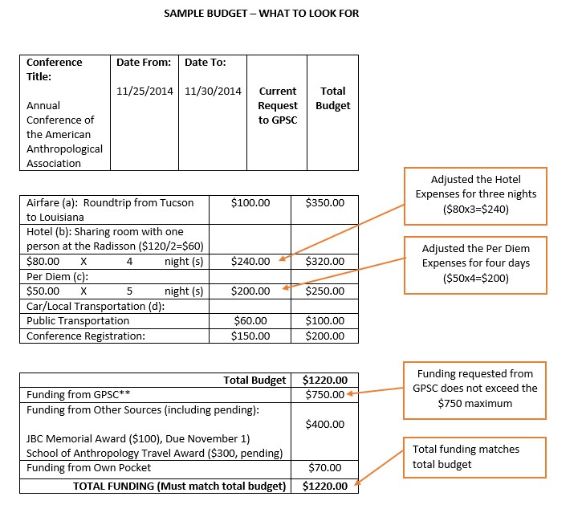

# Score 4: Overall Evaluation

This score allows the judge to provide an overall score to the application.

|  |  |
| --- | --- |
| **Criteria** | **Rating** |
| A score of 10 indicates a judge highly recommends the application for funding. Application is free of spelling, grammar, and punctuation errors. Application shows a high degree of professionalism. | 10 |
| A score of 8 indicates a judge recommends the application for funding. Application may contain a few spelling, grammar, and punctuation errors. Application shows a relatively high degree of professionalism. | 8 |
| A score of 6 indicates a judge recommends with reservations. Application may contain many spelling, grammar, and punctuation errors. Judges awarding a 6 for this category may have concerns about the degree of professionalism within the application. | 6 |
| A score of 4 indicates a judge does not recommend for funding. Application may contain a great deal of spelling, grammar, and punctuation errors. Application is not professional. | 4 |
| No application content provided (does not recommend for funding). | 0 |