How to navigate and use the PI Report
- After logging in to UA Analytics and navigating to "UA Colleges > CALS Business" dashboard, select the "Principal Investigators (PIs)" option to go to your "Summary Report".
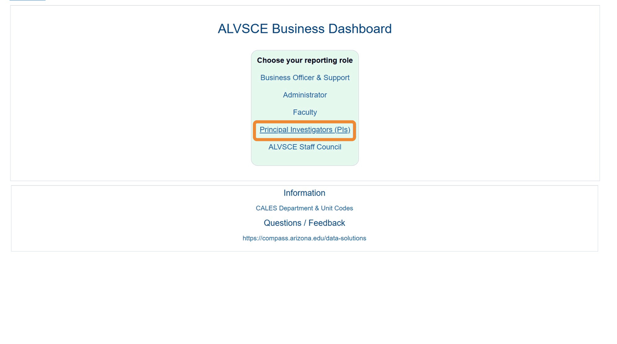
- On your summary report, the first section shows your "Budget Style Account" overview.
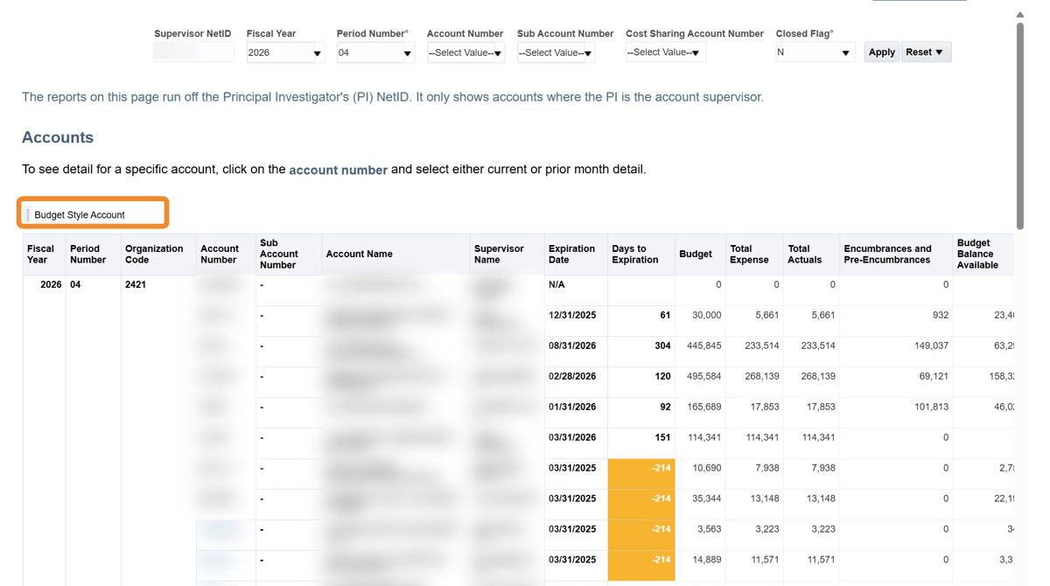
- Below that, you will find another section for your "Cash Style Account" overview.
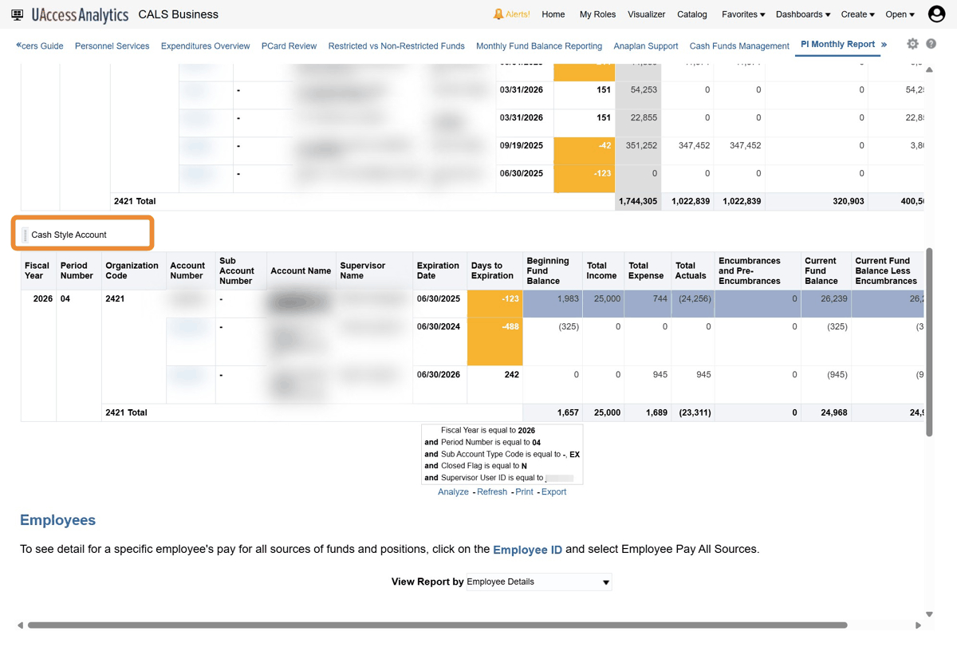
- The next area show your "Employees" report.
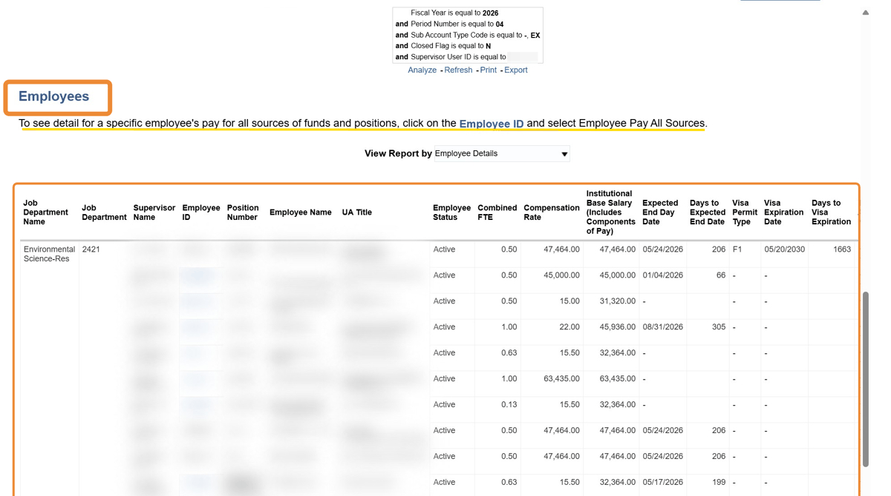
- Finally, the last section shows your Designation Campus Colleague "DCC" report.
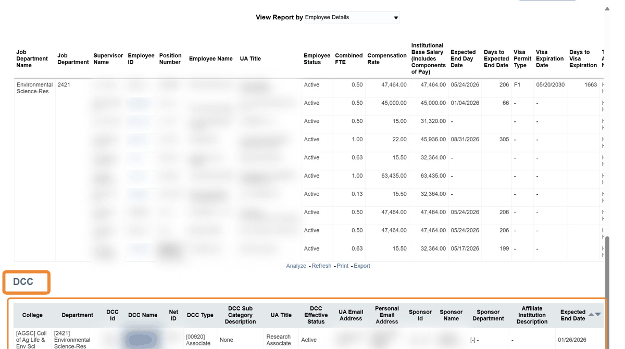
- To access an account's "Detailed Report" click on the blue account number and the report name will pop up.
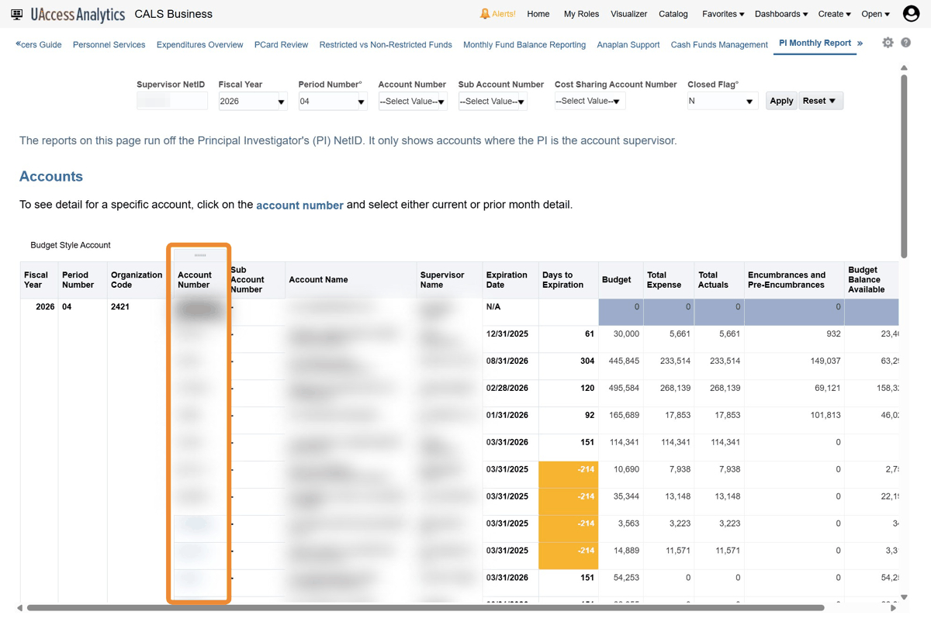
- Click "Current Month Account Detail" to generate the Detailed Report.
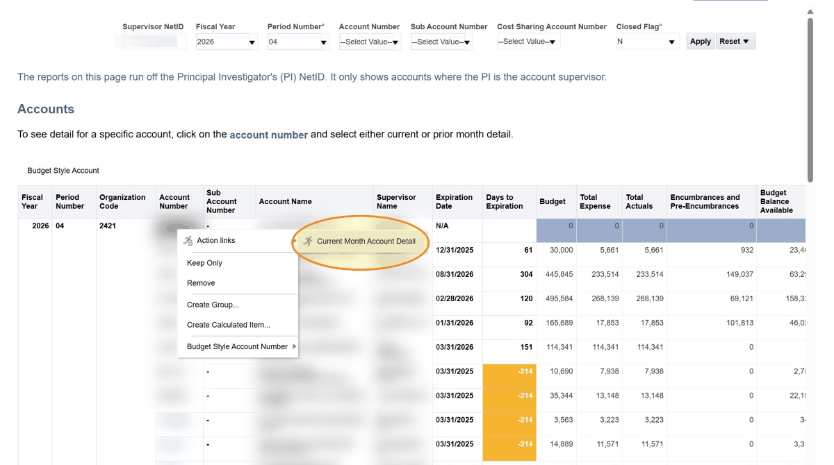
- The very first section is the "Account Details" including number, name, start/end dates, agency, IDC rates, etc.
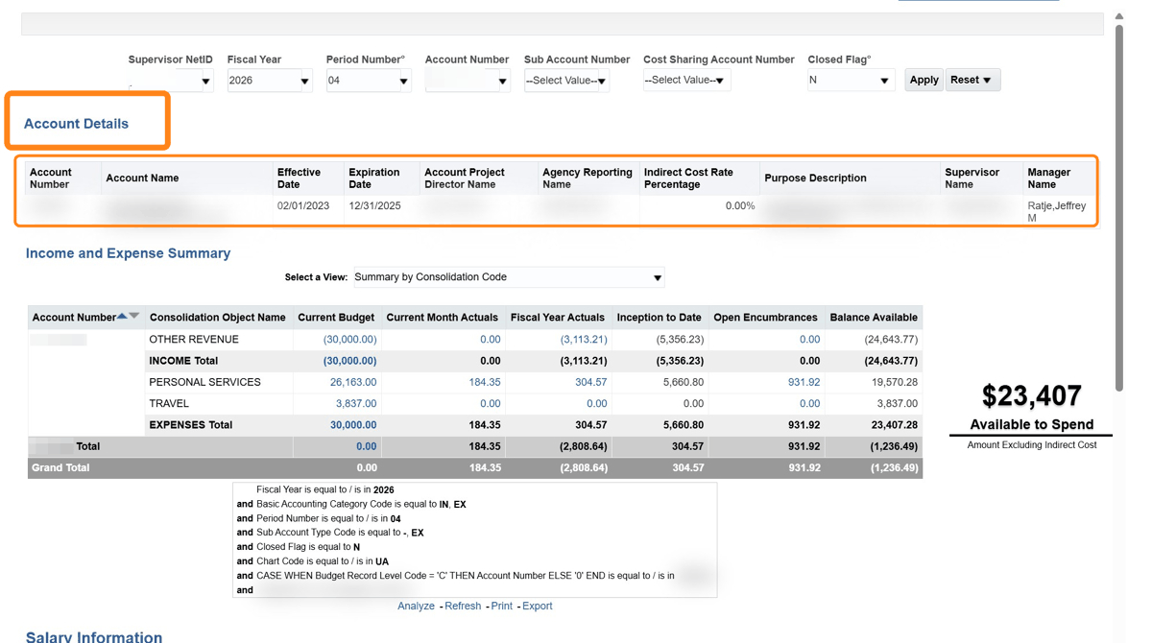
- The "Income and Expense Summary" shows financial activity based on the Consolidation categories. To the right, the "Available to Spend" box gives you your available balance (less IDC, if applicable).
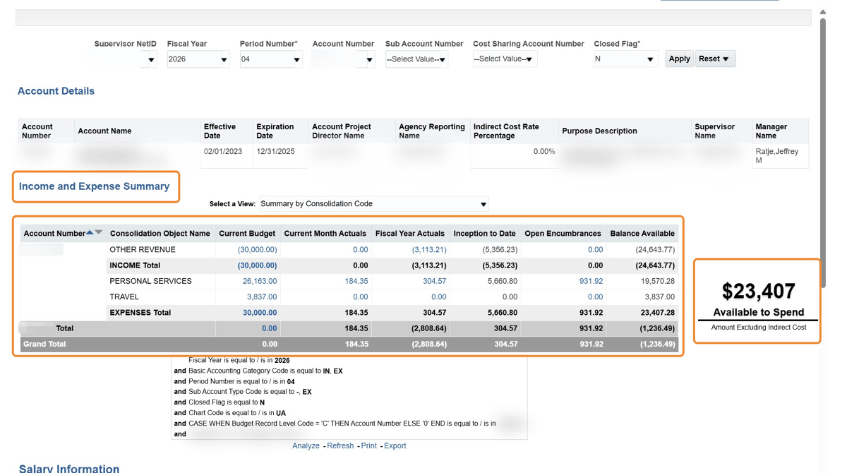
- The "Salary Information" section shows current personnel expenses and encumbrances generated via the employee record system for the year to date.
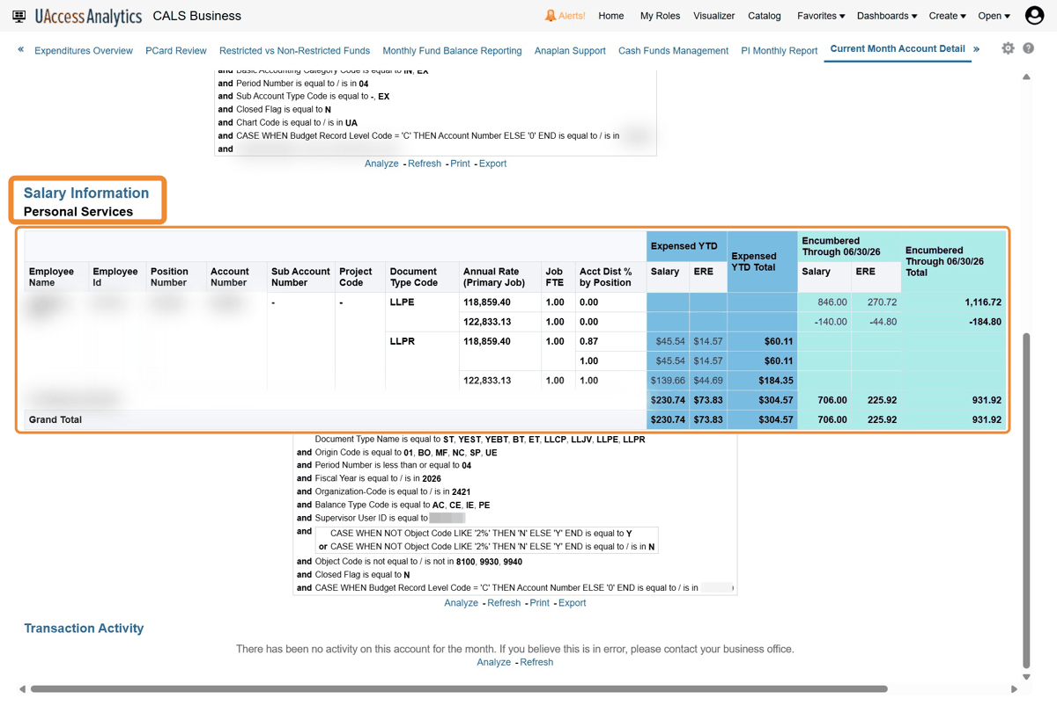
- Lastly, the "Transaction Activity" lists all operational expenses from the current fiscal period (i.e., month).
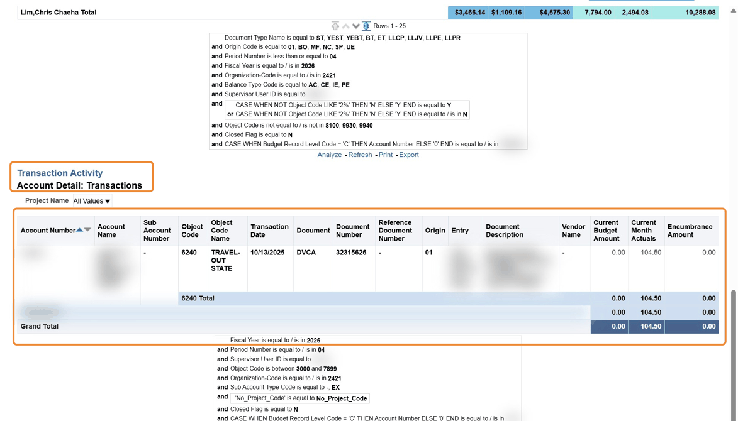
- To review Employee Funding Sources: Return to your overall "Summary Report" to access this information.
- On your "Summary Report" navigate to the "Employees" section then click on an Employee ID.
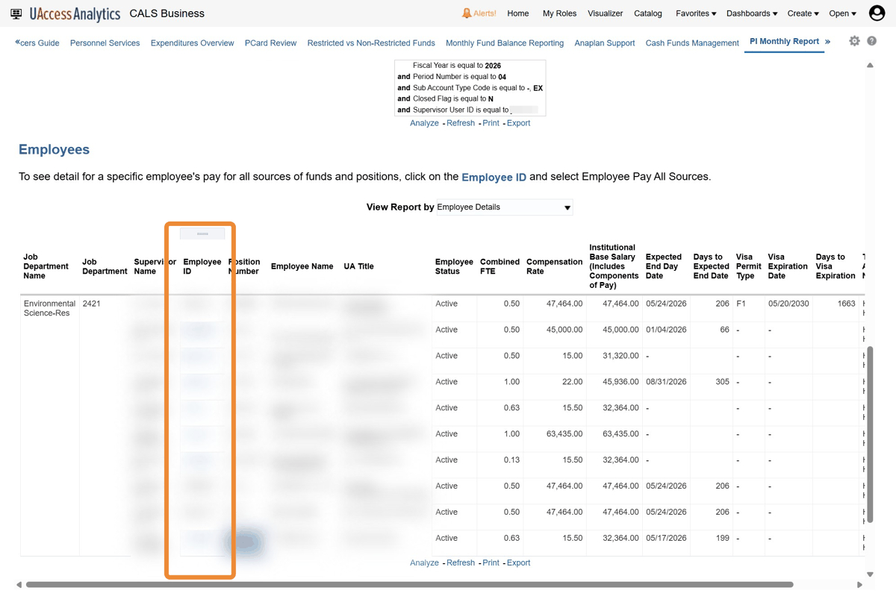
- Click "Employee Pay All Sources" to generate the "All Pay Sources for an Employee Year to Date" report.
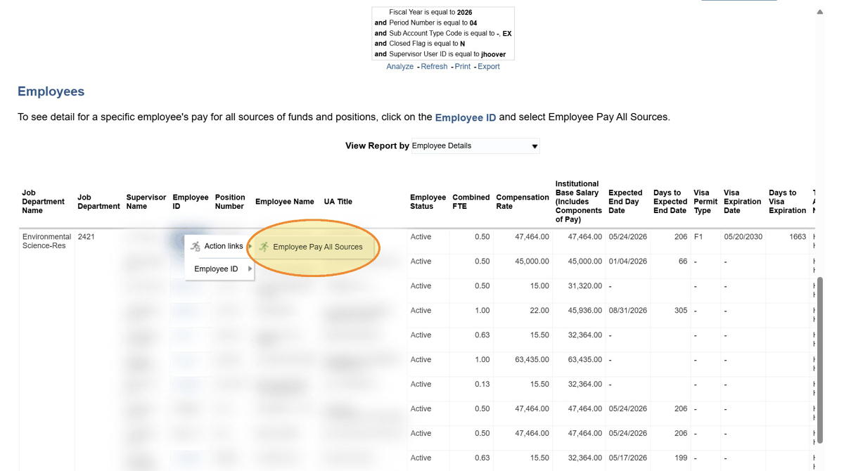
- This report will show all funding sources that an employee has been paid on in the current fiscal year (FY). The dark blue section indicates was been expensed, while the light blue/teal indicates expected encumbrances.
