Accessing the PI Report and Adding Favorite/Homepage
- Navigate to https://uaccess.arizona.edu/
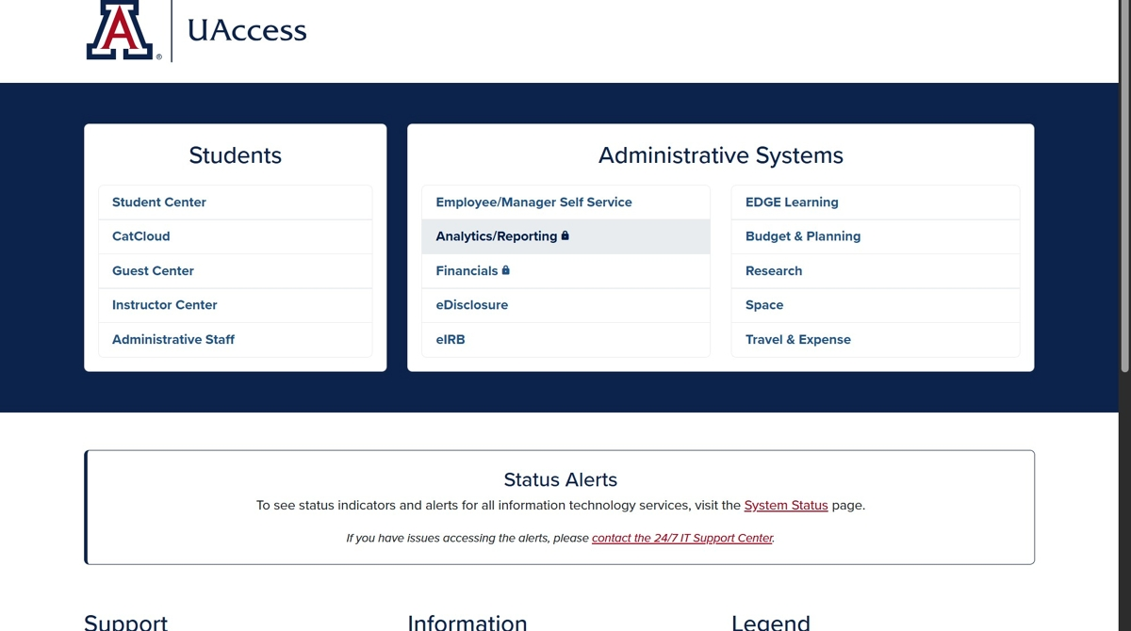
- Click "Analytics/Reporting" and log in using your Netid/password.
(Note: VPN access will be needed if off campus, see here)
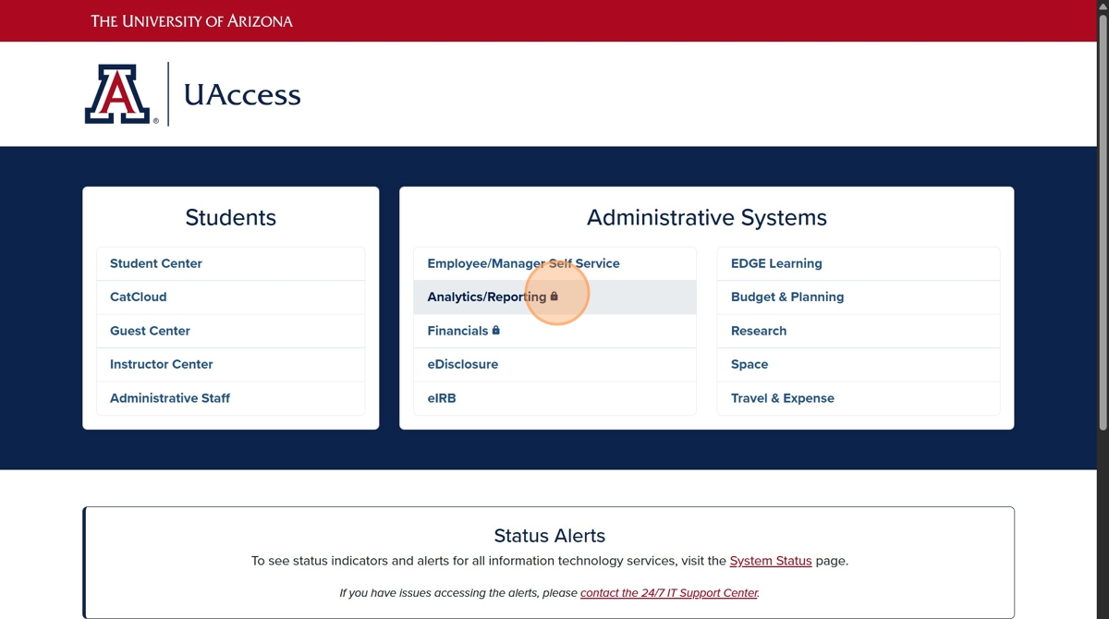
- Click "Dashboards"
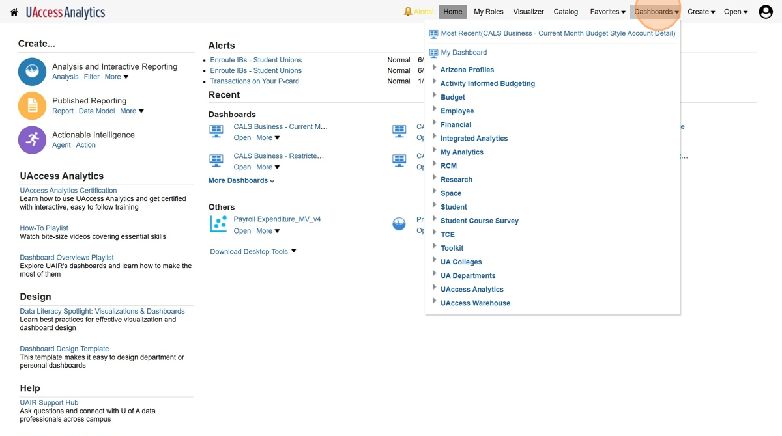
- Click "UA Colleges"
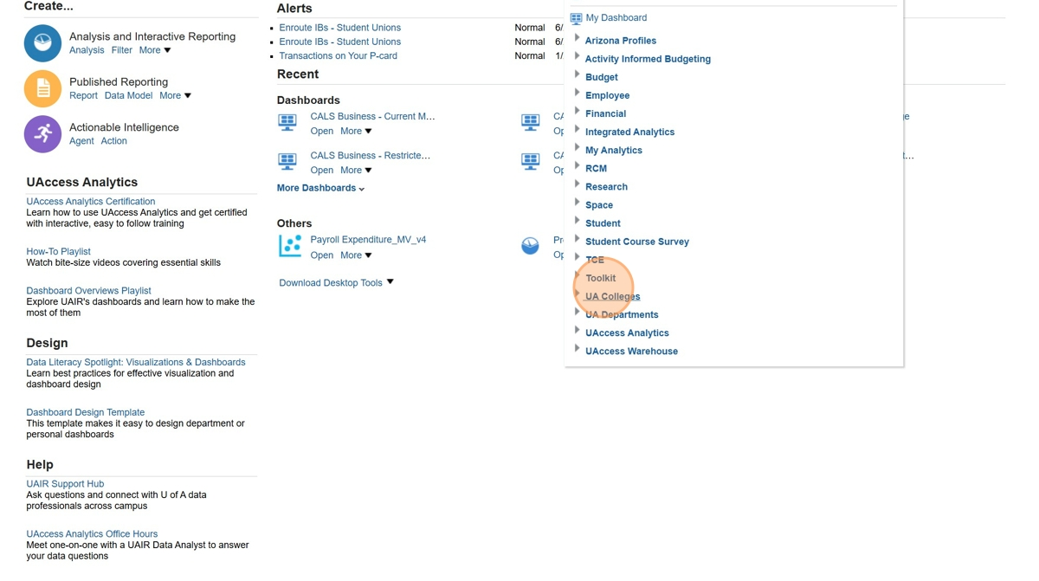
- Click "CALS Business"
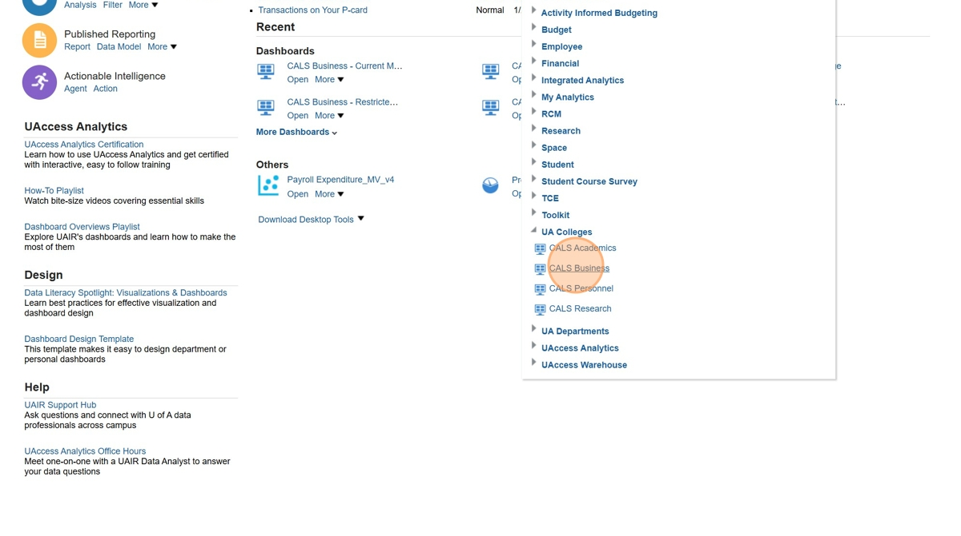
- Click "Principal Investigators (PIs)"
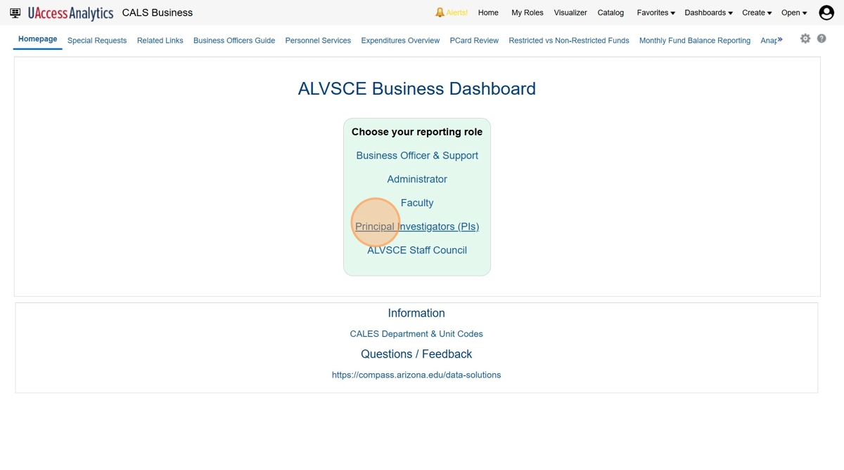
- Click "Favorites"
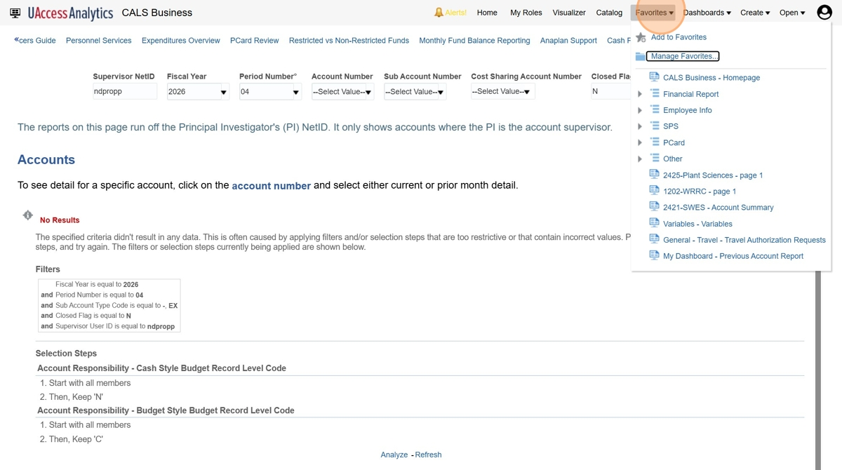
- Click "Add to Favorites"
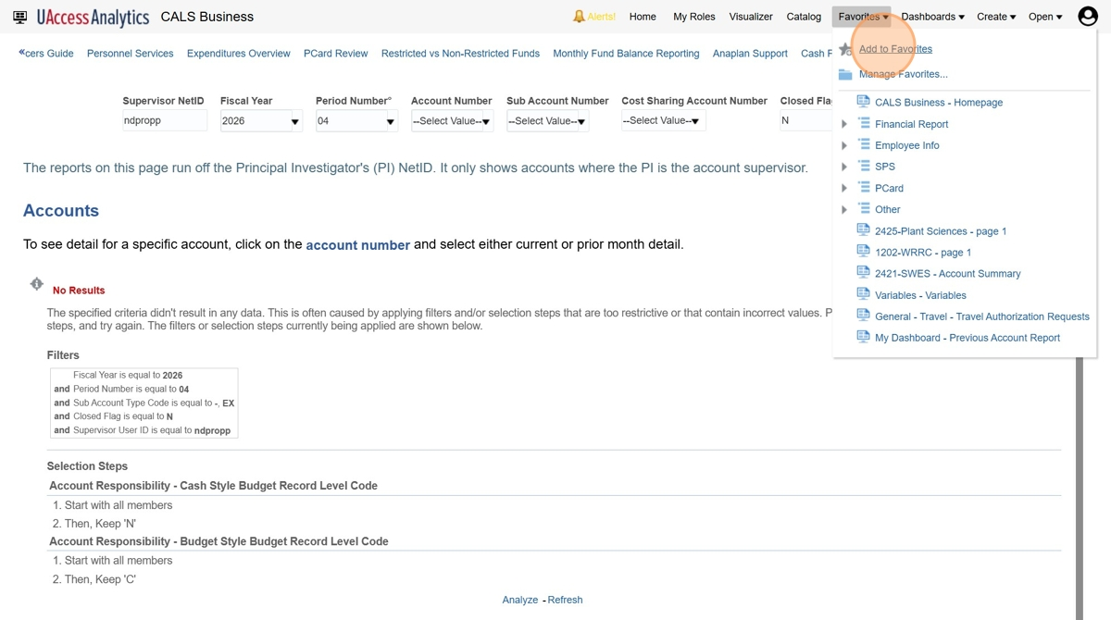
- (Optional) Too add this as your Homepage in Analytics, click this image.
(Note: This step will automatically take you to the report once you log into Analytics)
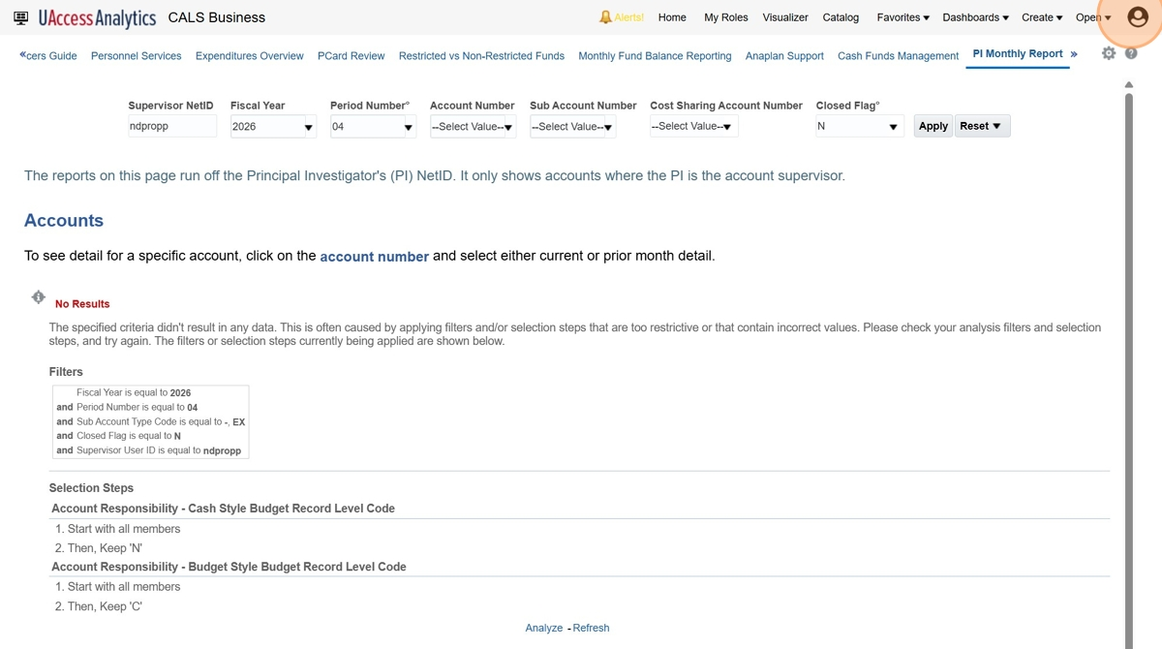
- Click "My Account"
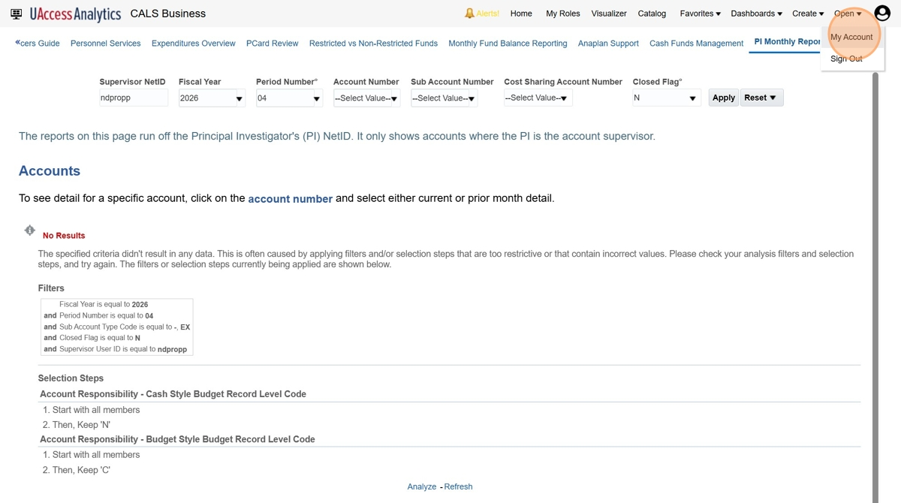
- Once the "My Account" pop up screen shows, select the "Starting Page" and select the "UA Colleges : CALS Business" option.
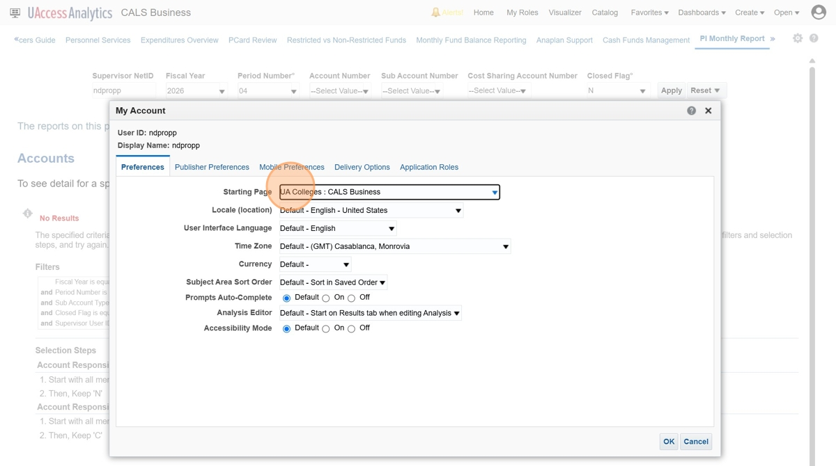
- Click "OK"
