**Responses to the survey**

**Faculty Member 1:**

Thanks for your email!

1. I do have concerns about the current UA response to COVID-19. Those are the same concerns as detailed by CAJUA (https://www.cajuarizona.com/reentry-recommendations) with the associated recommendations as how to improve the situation.
2. I want to emphasize that many of the problems identified by CAJUA have not be addressed since early August, or that the UA leadership has not been transparent about their efforts, if any (despite their weekly shows on Youtube). I think the spike we see now is very much due to UA leadership’s failure in planning and implementing an effective mitigation plan for the student population and the university community as a whole.
3. In addition, a number of new problems faced by students under lock-down are not addressed properly. UA does not have a resource list for students about what to do if they're in isolation off-campus. Also, the web resources offered by UA are rather confusing. I could not find some of the basic info easily, such as the link where students can notify UA when they've tested positive, in order for contact tracing to be implemented, and that they know that contact tracing is optional and anonymous.

**Faculty Member 2:**

1. In the spring when President Robbins talked about reopening campus and bringing students back, he said that everyone (I think he said all 6,000 people) would be tested before returning by UA.
   1. Instead, when campus reopened for students, only students who were going to be living on-campus in dorms were required to be tested, and initially, only on the day they were to move in.
   2. Faculty were not required to get tests before classes started, and tests were not available that week (as far as I remember).
2. Further, there was no plan for regular testing, so all UA had was a snapshot. And that snapshot could have been on the day a student traveled here, and could have been exposed, so would be negative then, but potentially positive within the next two weeks.
3. Students who lived off-campus were not required to get tested prior to coming to campus for in-person instruction. When I asked the VPR about this, I was told this is an open public campus so they can't require testing. But it seems they should be able to require it as a condition of in-person classes. This is a huge loophole and safety flaw.
4. Other institutions are doing regular testing which is necessary when students/faculty/staff are going off campus into the public. For example, Brandeis tests students on campus 3X/week, and students who are working remotely have to be tested before entering campus. A number of schools required students to shelter in place for 2 weeks after arriving to get through the potential incubation period before going out in public. Obviously these things cost more money, but they seem key for public safety.
5. We have not done well here. The contact tracing app, that was promised much earlier, did not get released before school started. So then, you are dependent on people signing up. It seems like there was a long time to plan, but fundamental issues were not addressed.

I could go on, but I think those are some key things.

**Faculty Member 3:**

David, my question is pretty basic. Why is the UA mitigation plan so lame? We have just delivered our son to Cal Poly, San Luis Obispo, as a freshman. He is in the dorms, yet all of his program is online for this quarter (maybe for next quarter as well). However, SLO has such a better program to monitor and respond to Covid ups and downs than the UA does. For example, every student, not just those in the dorms, needs to be tested before starting school. And then everyone, faculty, staff, and students, are required to do a morning "wellness check" on their phones. Then, following their check, each person is given a "pass" to be on campus for that day. For that day only. No pass and you cannot be on campus, period. Disciplinary actions will follow if you are on campus without a pass. Next morning, they need to do another check. And while this will not prevent someone from giving false information, it will force everyone to be cognizant as to their particular status. And it will provide a record of each and every person on campus regarding their response. It provides an opportunity for accountability and epidemiological review. And then with this information, perhaps an intelligent modification of protocol.

And there are other systems in place to follow the curve. It is so disheartening to know that the UA just doesn't have the guts to implement the robust systems that are needed. Its not rocket science; its pretty basic. Its reassuring that we are sending our son off to an institution that is actually thinking about pandemic monitoring and mitigation. Not just placating the public, students, and faculty, to support the financial bottom line. I think he is safer at SLO than at UA.

**My take on today's briefing (September 21) from Carmona and Robbins:**

1. 600 students in dorms have apparently tested positive for COVID-19, representing 16% of the population. C & R think the proportion of positives would be higher for off-campus students, but do not seem alarmed by this. Berx visited last week and thought the situation was worrying.
2. 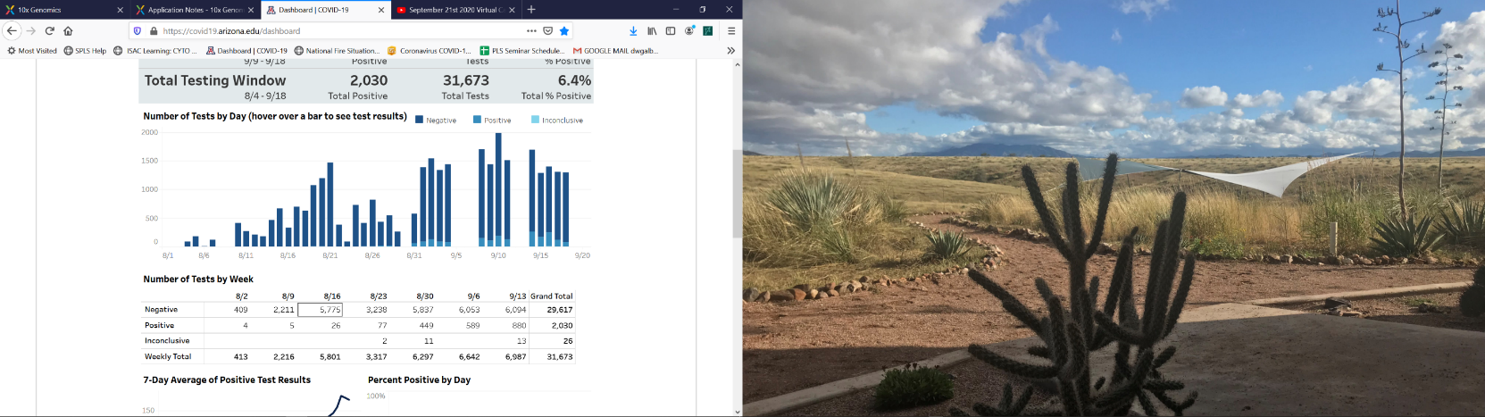Carmona in particular seemed more pleased that some members of the senior adminstration were correct in predicting the high positive incidence levels of COVID-19 on campus in comparison to other members of that same adminstration. This is not the point: we need stringent measures now in place to mitigate the pandemic and aggressively suppress situations that enhance disease transmission.
3. C &R repeatedly indicated that the new Arizona Dashboard provides daily updates of the campus COVID-19 testing status. This is clearly not the case from the snapshot taken today; there were no updates on the weekend (including the long weekend over Labor Day). It is not clear whether tests are available 24/7, and if not, why not.
4. The hands-off approach to dealing with bad actors in local student high-rises and within the Greek communities is completely inappropriate under the current circumstances. Public-health emergencies can be declared and this confers significant legal powers to suppress disease.

As a general recommendation, I think the CALS Advisory Council should organize a survey of the CALS faculty much as I have done for PLS.

Finally, I am also worried that we do not take seriously controlling a disease for which the long term ramifications are completely unknown. Young people do appear to recover with little indication of problems, but we know very little about long-term effects of viruses and particularly not this one. However, we do know that some viral infections remain latent over the lifetime and can break out to cause significant problems: HIV, shingles, HPV, mononucleosis, Epstein-Barr, the list goes on. A quick introduction can be found here: https://www.gavi.org/vaccineswork/long-term-health-effects-covid-19