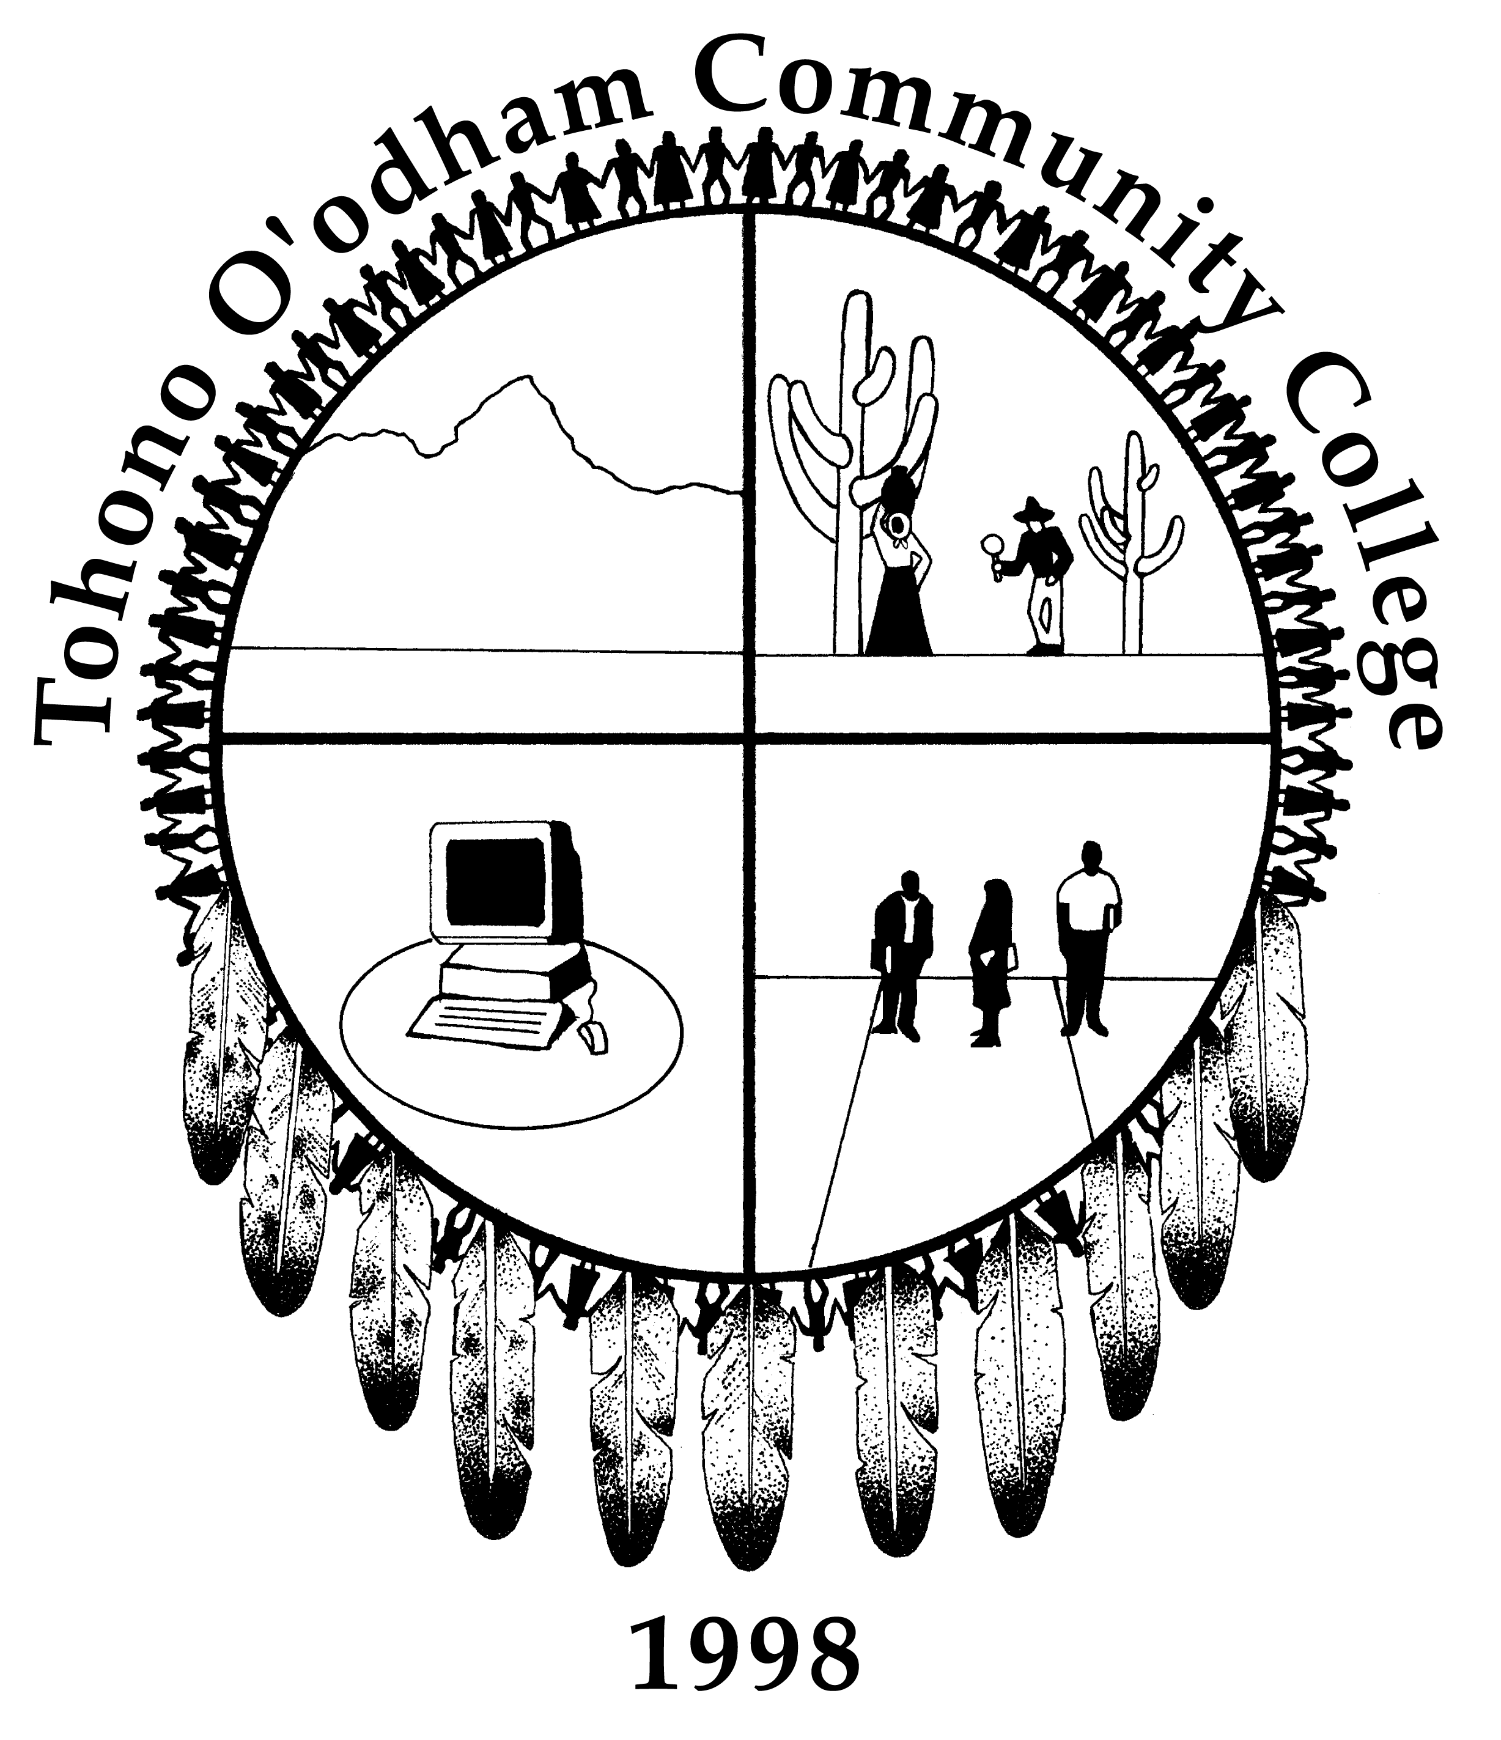

TOHONO O’ODHAM COMMUNITY COLLEGE

JOB ANNOUNCEMENT

Job Title: Agriculture and Natural Resource Program Instructor

Reports To: Department Chair of General Education
Employment Status: Full-time, Regular, Contract
Salary: $38,245.00

SUMMARY: The faculty member will be expected to teach a variety of courses relating to agriculture and natural resources, coordinate continued program development activities, and manage a teaching and demonstration farm. A variety of teaching styles including cooperative learning, self-paced, independent, and individualized instruction, and traditional classroom teaching methods may be used. Incumbents are expected to support the goals and mission of the College.

To perform this job successfully, an individual must be able to perform each essential duty satisfactorily. The education and experience requirements listed below are representative of this position’s requirements.

This list of duties and responsibilities is illustrative only of the tasks performed by this position and is not all-inclusive.

ESSENTIAL DUTIES AND RESPONSIBILITIES: (May perform other related duties.)
- Lead faculty member for the continued development of the Agriculture and Natural Resources Program.
- Collaborate with the Tohono O’odham Nation’s Department of Natural Resources and other organizations for curriculum development and outreach activities.
- Provide educational outreach to communities, organizations, and schools on the Tohono O’odham Nation; Assist in the recruitment and retention of students.
- Organize quarterly advisory board meetings and implement the board’s recommendations; Develop curriculum for and manage a teaching and demonstration farm; Support the College’s Vision, Mission, and Goals.
- Provide an effective environment for student learning through teaching assigned courses based on college approved course outlines.
- Develop, prepare, and evaluate instructional materials that promote learning.
- Evaluate student progress, provide frequent feedback to students, and refer students to appropriate college support services when needed.
- Maintain office hours in accordance with stated policies to provide assistance to students and for other related duties.
- Participate in curriculum development including developing and reviewing program requirements, course teaching materials, and text selections.
- Assess student-learning outcomes at the course and program level in order to improve teaching/learning outcomes.
- Maintains current knowledge in the subject area and in the use of alternative teaching techniques and appropriate instructional technology; participates in faculty development activities.
- Maintain student records; completes and returns required reports to the appropriate office by due date. Cooperates with other faculty and college staff in maintaining a positive professional and educational environment in the college.
- Attends and participates in assigned meetings, committees, and college activities.
- Participates in commencement day exercises in academic dress, unless previously excused in accordance with stated policy/procedures.

COMPENTENCY (To perform the job successfully, an individual should demonstrate the following competencies):
- Ability to teach agriculture and natural resource related classes incorporating a variety of teaching methodologies; Ability to integrate the values of diversity and team building into educational decision-making.
- Skilled in communications and interpersonal skills as applied to interaction with college administrators, faculty, staff and students.
- Ability to design curriculum, provide academic advising, consult with students regarding academic success, evaluate student performance, build community relations, and serve as a member of the department and on college committees.
- Establishes and maintains good working relationships with individuals of varying social and cultural backgrounds.

EDUCATION/EXPERIENCE:

Must have an earned master’s degree in teaching field, or a master’s in any teaching field with 24 upper division and/or graduate semester hours in the teaching field, or master’s in any teaching field with 18 graduate semester hours in the teaching field; EDU 161—The Arizona Community College: A Learning Institution or equivalent must be completed within two years of date of hire. Must have experience in teaching and program implementation.

Must complete the College’s Tohono O’odham History and Language Course within one (1) year of hire. Must be eligible for regular teaching certification.

ADDITIONAL CONSIDERATION MAY BE GIVEN TO INDIVIDUALS WITH THE FOLLOWING QUALIFICATIONS:
Ph.D. in teaching field; Community College Teaching Certificate
Ability to speak and understand O’odham and/or Spanish.
Knowledge and understanding in the history and contemporary issues facing Native peoples.
One year work experience with Native American communities.

WORK ENVIRONMENT: Ability to work in a multi-cultural educational setting. TOCC is located in Sells, Arizona, which is 60 miles west of Tucson on the Tohono O’odham Nation.

PHYSICAL DEMANDS:
The physical demands described here are representative of those that must be met by an employee to successfully perform the essential functions of this job. Reasonable accommodations may be made to enable individuals with disabilities to perform the essential functions.

BENEFITS: The College offers a comprehensive benefit package.

HOW TO APPLY: Applications are available on line at www.tocc.cc.az.us. Interested applicants must submit a resume, related degrees, transcripts, certificates, three (3) letters of recommendation and a completed TOCC application for employment, if claiming Indian Preference under Tohono O’odham Ordinance 01-85, submit a copy of certification or enrollment card to:

TOHONO O’ODHAM COMMUNITY COLLEGE
ATTENTION: HUMAN RESOURCES
P.O. BOX 3129
SELLS, AZ 85634
VOICE (520) 383-0055

FAX (520) 383-0029

Date: 8/4/04
Reformatted: 8/07 & 12/09 & 11/10

